1.
SANGAM SKM COLLEGE - NADI
GEOGRAPHY – YEAR 11
WEEK 4 – WORKSHEET 3

TOPIC: RELIEF – NEW ZEALAND NAME: _________________________

PART A: Plate Tectonics: Word Search
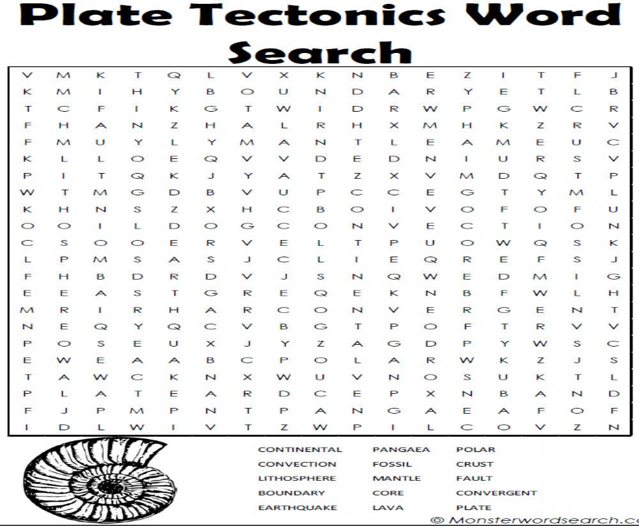

PART B: Resource Interpretation
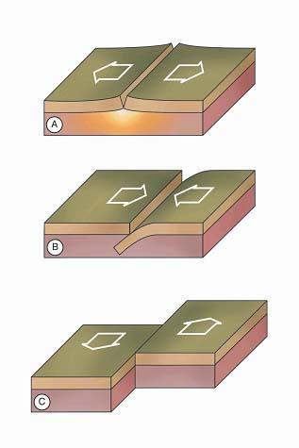

Identify and describe each plate boundary shown above:
A.] _____________________________________________________________________________
________________________________________________________________________________
B.] _____________________________________________________________________________
________________________________________________________________________________
C.] _____________________________________________________________________________
________________________________________________________________________________________________________________________________________________________________
2.

PART C: Resource Interpretation

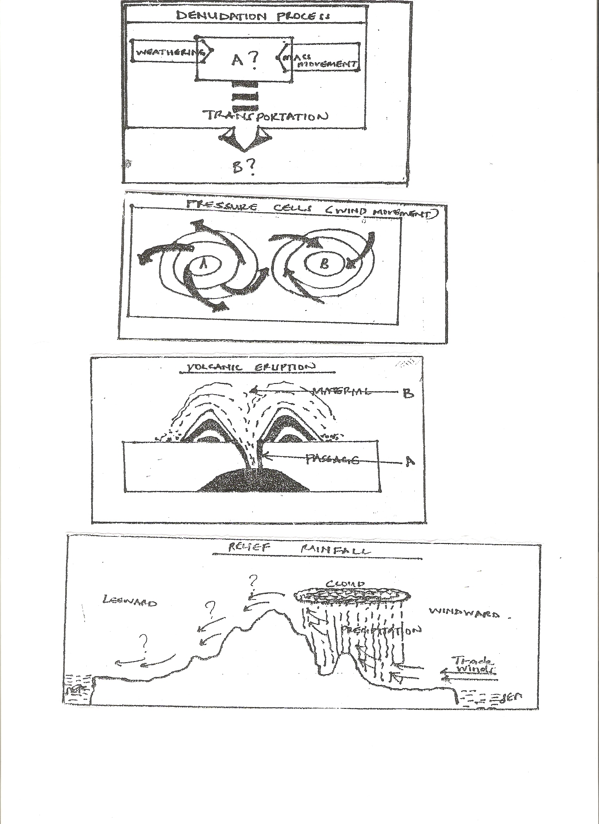

(i.) Identify passage A: ________________________ and material B: ______________________
(ii.) Two advantages of volcanoes: __________________________________________________
________________________________________________________________________________________________________________________________________________________________________________________________________________________________________________

PART D: Mapping - New Zealand
On the outline map of New Zealand; locate and name the following feature:

1.) Heretauga plain 4.) Bay of plenty lowland
2.) A volcanic plain 5.) Clarence fault
3.) Coromandel Range

