PROJECT PROGRESS – PHASE 2
Kubernetes Security Drift Intelligence Using Attack Path Analysis and Rule-Based Risk Assessment
Design Document – Functional Block Diagram and UML Diagrams
Item | Details
Course / Section
Group
Team members
Implementation | Python – Colab notebook (see Section 6); remaining files in ZIP and GitHub repository

1. Project Overview
Kubernetes clusters change continuously. A pod that was safe yesterday can become privileged today, or a network policy can be deleted without anyone noticing. This project detects that security configuration drift and turns it into a measurable security risk.
The system captures the cluster’s resources, compares them to a trusted baseline, and evaluates every difference against a set of security rules. The design is organised in three layers:
- Resource model and collection – reads pods, services and network policies from the Kubernetes API and converts them into a common resource model.
- Snapshot, baseline and drift detection – normalizes the resources into a hashed JSON snapshot, stores a trusted baseline, and produces a drift event for every added, removed or modified resource field.
- Rules, attack paths and risk – matches drift events against YAML security rules and scores their impact. Attack path analysis, risk assessment and alerting build on this layer.
Status: the pipeline up to rule-based evaluation is implemented and runs end to end. Attack path analysis, risk assessment, alerting and RBAC modelling are designed but not yet coded; they are drawn with dashed outlines throughout this document.

2. Functional Block Diagram
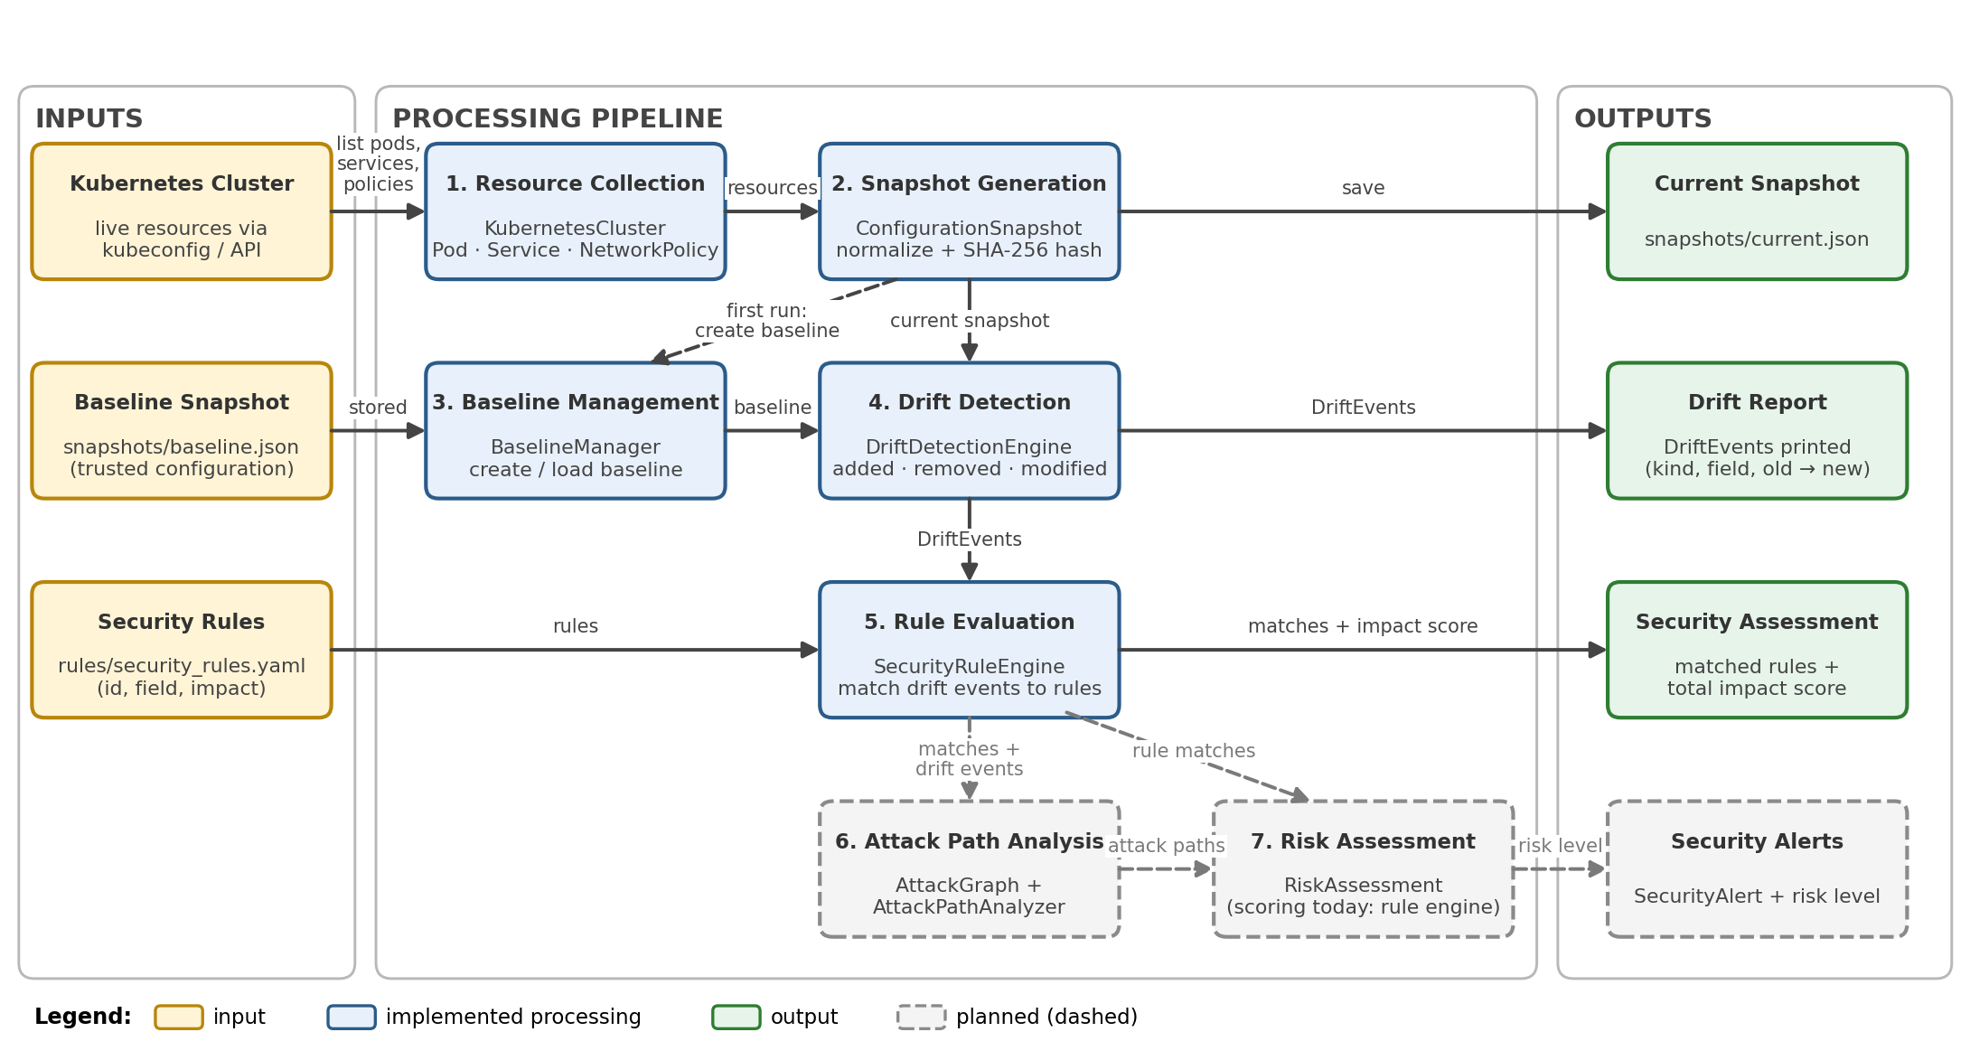
Figure 1 – Functional block diagram: inputs, processing pipeline and outputs

2.1 Description of the blocks
# | Block | Function | Implemented by | Status
1 | Resource Collection | Connects to the cluster through the local kubeconfig and lists pods, services and network policies in all namespaces. | KubernetesCluster; Pod, Service, NetworkPolicy | Implemented
2 | Snapshot Generation | Normalizes the collected resources, sorts them, computes a SHA-256 configuration hash and saves the snapshot as JSON. | ConfigurationSnapshot | Implemented
3 | Baseline Management | Stores a snapshot as the trusted baseline and loads it for comparison. | BaselineManager | Implemented
4 | Drift Detection | Indexes resources by kind, namespace and name, then compares baseline and current to emit added, removed and modified events. | DriftDetectionEngine; DriftEvent | Implemented
5 | Rule Evaluation | Matches each drift event against the YAML rules and sums the impact of every match. | SecurityRuleEngine | Implemented
6 | Attack Path Analysis | Models resources and their relationships as a graph and finds attack paths made possible or worsened by drift. | AttackGraph; AttackPathAnalyzer | Planned
7 | Risk Assessment | Combines rule impact and attack-path exposure into a risk score and severity level, and raises alerts. | RiskAssessment; SecurityAlert | Planned
Inputs are the live cluster, the baseline snapshot and the security rules file. Outputs are the current snapshot, the drift report and the security assessment (matched rules and total impact score); security alerts will be added with block 7.

3. UML Class Diagrams
The design contains 15 classes. Figure 2 shows all classes and their relationships; Figures 3 to 5 show the attributes and methods of each layer. Classes drawn with solid outlines exist in the code; dashed outlines are planned.
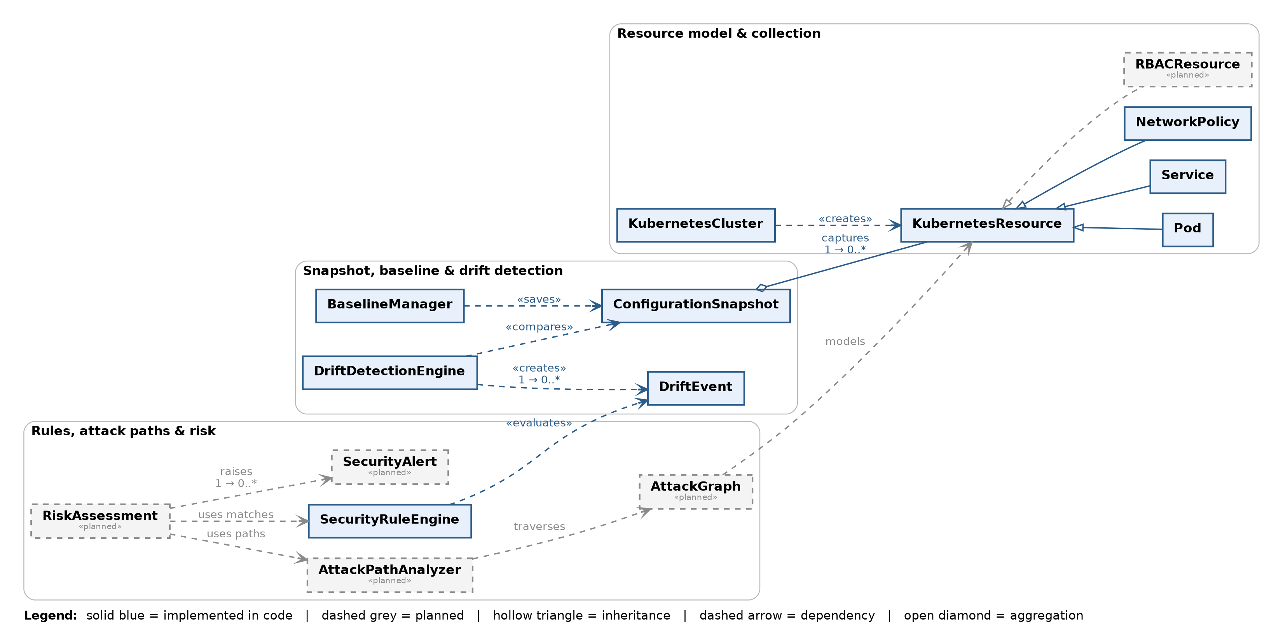
Figure 2 – Class diagram overview (all 15 classes and their relationships)

3.1 Resource model and collection
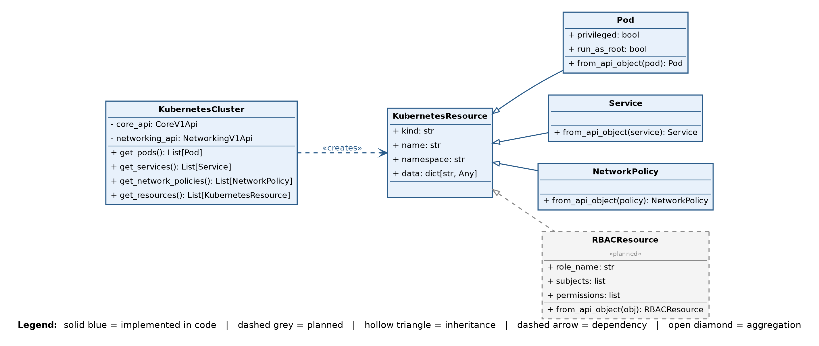
Figure 3 – KubernetesCluster and the KubernetesResource hierarchy (Pod, Service, NetworkPolicy; RBACResource planned)

3.2 Snapshot, baseline and drift detection
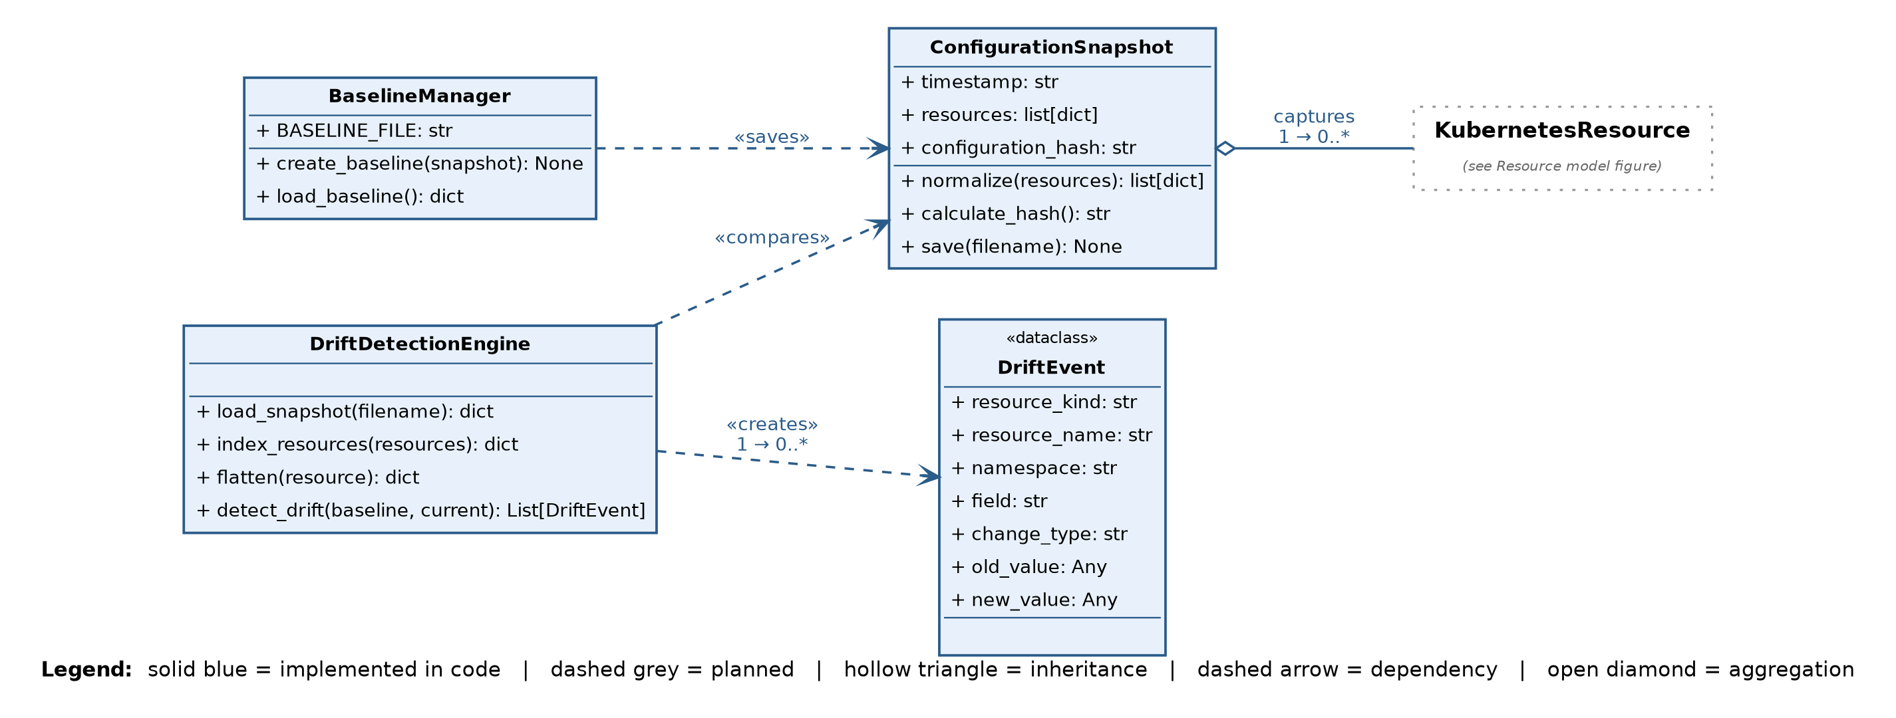
Figure 4 – ConfigurationSnapshot, BaselineManager, DriftDetectionEngine and DriftEvent

3.3 Rules, attack paths and risk
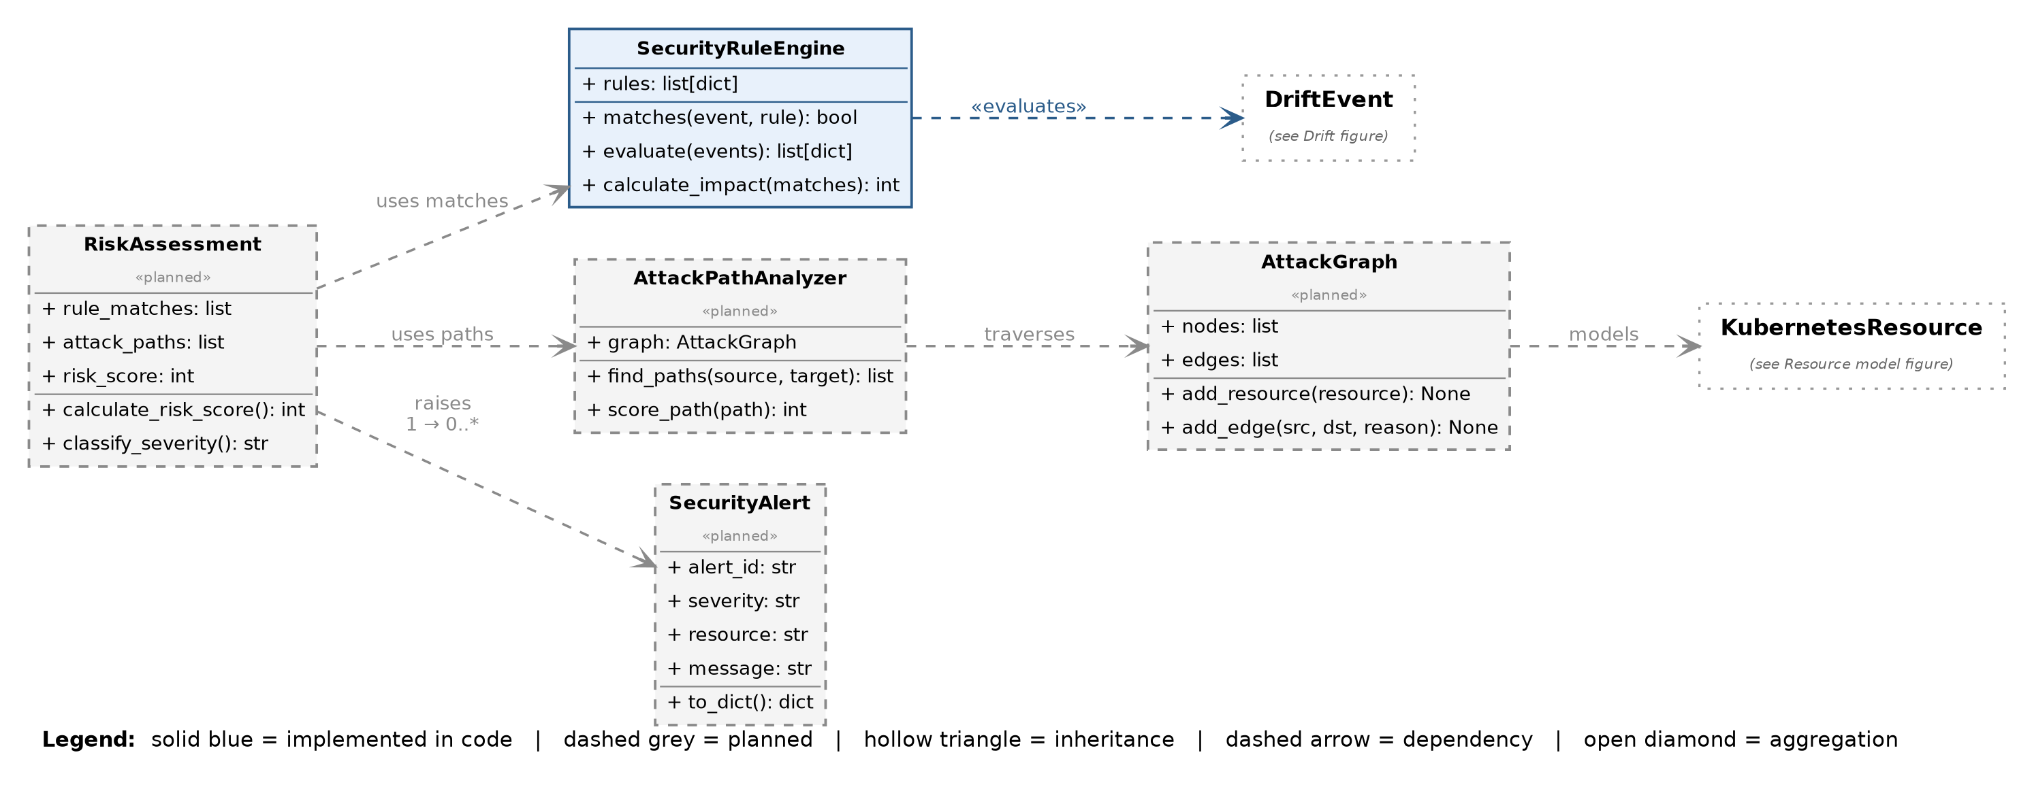
Figure 5 – SecurityRuleEngine (implemented) with the planned AttackGraph, AttackPathAnalyzer, RiskAssessment and SecurityAlert

3.4 Class descriptions
Class | Module | Responsibility | Status
KubernetesCluster | cluster.py | Loads the kubeconfig and retrieves pods, services and network policies from all namespaces. | Implemented
KubernetesResource | resources.py | Base dataclass for any collected resource: kind, name, namespace and data. | Implemented
Pod | resources.py | Stores labels plus the security flags privileged and run_as_root (runAsUser = 0). | Implemented
Service | resources.py | Stores the service type and selector. | Implemented
NetworkPolicy | resources.py | Stores the pod selector and policy types. | Implemented
RBACResource | – | Will model roles, bindings and permissions so privilege-escalation paths can be analysed. | Planned
ConfigurationSnapshot | snapshot.py | Normalizes and sorts resources, calculates the SHA-256 configuration hash and saves the snapshot. | Implemented
BaselineManager | baseline.py | Saves a snapshot as the trusted baseline and loads it again. | Implemented
DriftDetectionEngine | drift.py | Loads snapshots, flattens resources and compares them to produce DriftEvents. | Implemented
DriftEvent | drift.py | Record of one change: resource, field, change type (added, removed, modified), old and new value. | Implemented
SecurityRuleEngine | rules.py | Loads the YAML rules, matches drift events to rules and sums the impact score. | Implemented
AttackGraph | – | Graph of resources and the relationships an attacker could move along. | Planned
AttackPathAnalyzer | – | Traverses the AttackGraph to find and score attack paths. | Planned
RiskAssessment | – | Combines rule matches and attack paths into a risk score and severity. Today the impact total is computed by SecurityRuleEngine. | Planned
SecurityAlert | – | Alert raised for a risky change: id, severity, resource and message. | Planned

3.5 Relationships
- Inheritance: Pod, Service, NetworkPolicy and the planned RBACResource all extend KubernetesResource.
- KubernetesCluster creates KubernetesResource objects from the Kubernetes API responses.
- ConfigurationSnapshot aggregates zero or more resources (1 to 0..*); BaselineManager saves a snapshot and DriftDetectionEngine compares two snapshots.
- DriftDetectionEngine creates zero or more DriftEvents; SecurityRuleEngine evaluates those events against its rules.
- Planned: AttackGraph models the resources, AttackPathAnalyzer traverses the graph, RiskAssessment uses the rule matches and attack paths, and raises zero or more SecurityAlerts.

4. UML Sequence Diagram
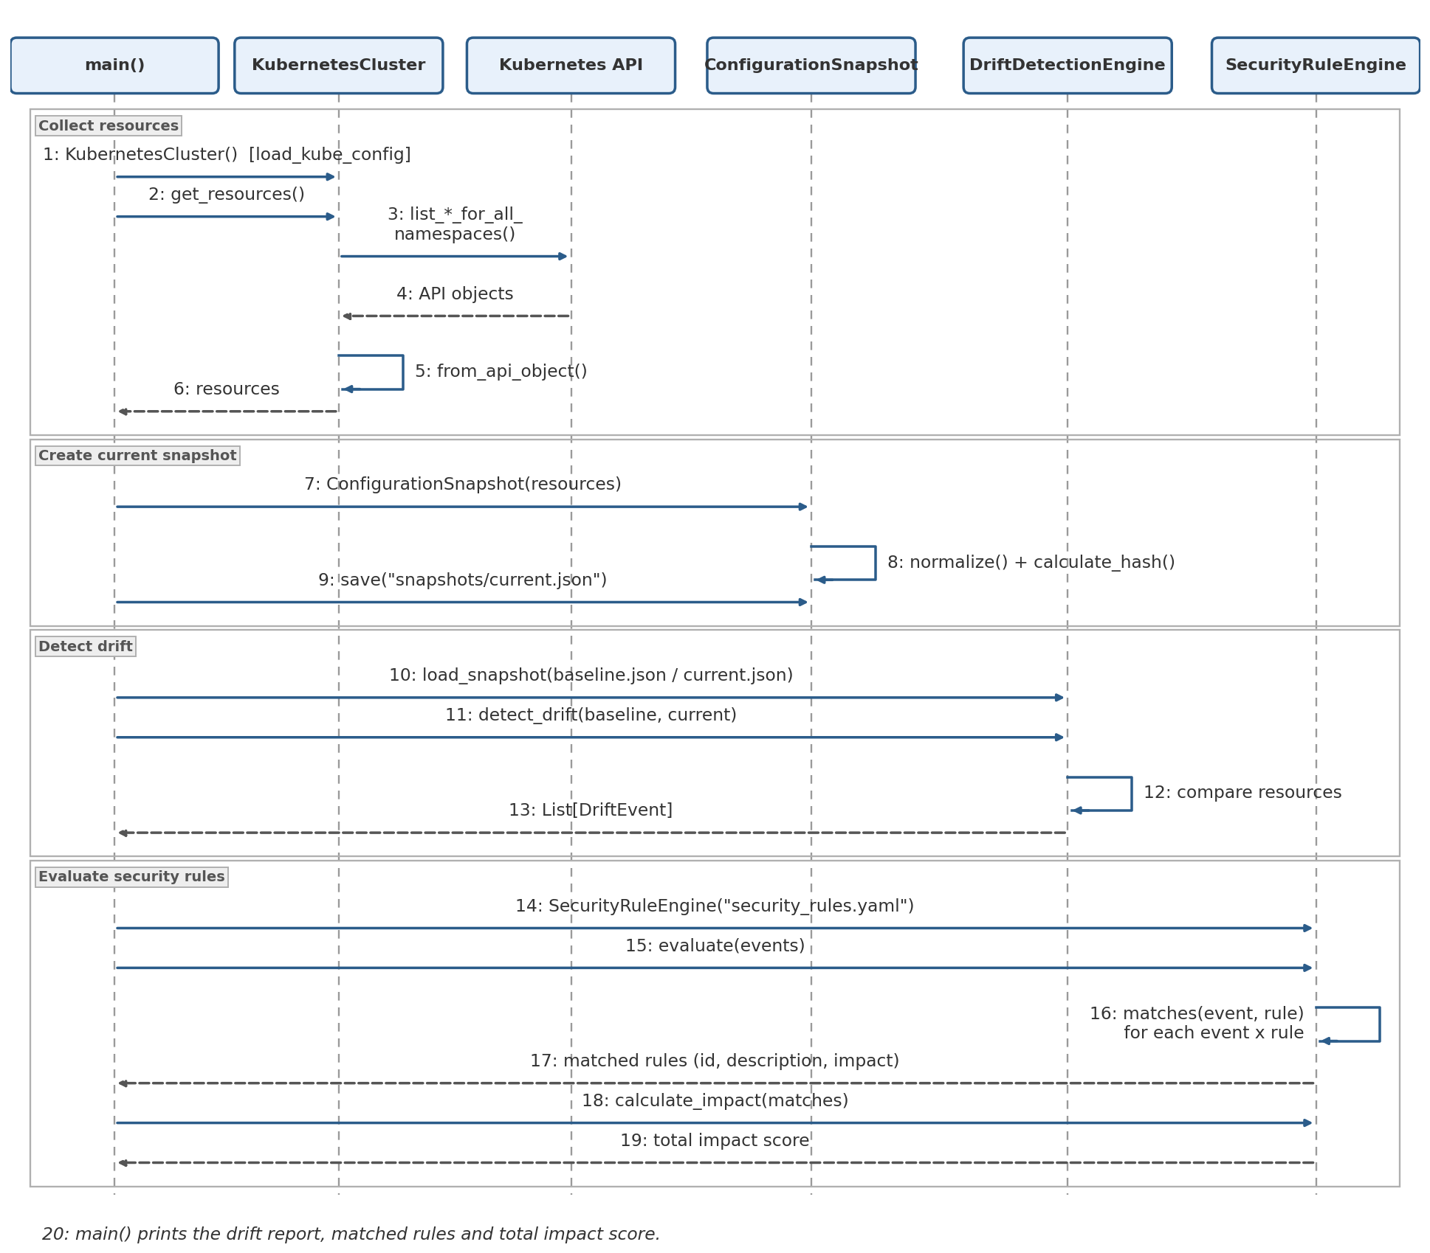
Figure 6 – Sequence diagram of a drift detection run (main.py)

4.1 Walkthrough
- Collect (1–6): main() creates KubernetesCluster, which loads the kubeconfig. get_resources() queries the Kubernetes API and converts every object with from_api_object().
- Snapshot (7–9): the resources are wrapped in a ConfigurationSnapshot, which normalizes them, calculates the hash and saves snapshots/current.json.
- Detect drift (10–13): DriftDetectionEngine loads baseline.json and current.json and returns the list of DriftEvents.
- Evaluate (14–19): SecurityRuleEngine loads the rules, matches every event against every rule and calculates the total impact score, which main() prints.

5. Design Decisions
- Snapshot-based comparison. Both baseline and current state are stored as normalized, sorted JSON, so drift detection works offline on saved snapshots and results are repeatable.
- Rules as data. Security rules live in YAML, not code. A rule names a resource kind and field, optionally a change type and old or new value, and an impact score. New rules need no code change.
- Additive impact scoring. Each matched rule adds its impact to the total; the planned RiskAssessment will extend this with attack-path exposure.
The four rules currently defined:
Rule | Triggers when | Resource | Impact
PRIVILEGED_CONTAINER | privileged changes from false to true | Pod | 30
ROOT_CONTAINER | run_as_root changes from false to true | Pod | 20
NETWORK_POLICY_REMOVED | a NetworkPolicy is removed | NetworkPolicy | 25
SERVICE_LOADBALANCER | service type becomes LoadBalancer | Service | 20
Example result on the sample snapshots: demo-pod in namespace security-demo changed from privileged = false to true, which matches PRIVILEGED_CONTAINER for a total impact score of 30.

6. Implementation Overview
Deliverable | Contents
Colab notebook | All Python modules in the app/ package (resources, cluster, snapshot, baseline, drift, rules, main), the rules file and sample snapshots. Runs top to bottom in demo mode on the saved snapshots.
ZIP / GitHub repository | Rules file, sample snapshots, demo pod manifest (pod.yaml), requirements.txt, README, diagrams and a copy of the notebook.
GitHub link

Remaining work
- Implement RBACResource and add RBAC collection to KubernetesCluster.
- Implement AttackGraph and AttackPathAnalyzer on top of the collected resources.
- Implement RiskAssessment and SecurityAlert, and move impact scoring out of SecurityRuleEngine.
- Extend the rule set and add tests for the drift and rule engines.

