**Chapter 3**

**TASKS EXECUTED**

The two projects worked on are

1. Aggression Detection and intervention in Alzheimers given by Old Dominion University.
2. Repository generation System given by PRA Groups.

**Aggression Detection and Intervention in Alzheimers**

Alzheimer’s disease is an irreversible brain disorder that slowly destroys memory, thinking skills and the ability to carry out the simplest tasks. Alzheimers’ is the most common cause of dementia among older adults. Alzheimer's is a neurodegenerative disease that causes problems with memory, thinking and behaviour. Symptoms usually develop slowly and get worse over time, becoming severe enough to interfere with daily tasks. Alzheimer's is a progressive disease.

Alzheimer's has no current cure, but treatments for symptoms are available and research continues. Although current Alzheimer's treatments cannot stop Alzheimer's from progressing, they can temporarily slow the worsening of dementia symptoms and improve quality of life for those with Alzheimer's and their caregivers.

Some of the Symptoms:

* Anxiety and Depression
* Aggression and Agitation
* Memory Loss
* Confusion

**Problem Statement**

Aggression can be defined as a state of mind in which an individual is subjected to uncontrollable anger or antipathy resulting in a hostile behavior causing harm to them and/or the people around them by the means of a physical or verbal attack, triggered by anxiety, depression, unrest, un-friendly environment sometimes un-controllable emotions whose occurrence may be sudden and due to apparent reasons.

Detection and intervention of aggression in Alzheimer’s in a clinically acceptable environment. We have to provide a solution to patients and caretakers, mainly concentrating on people suffering from Alzheimers’s and demensia.

This is done by considering various parameters such as heartbeat , EEG signals , Facial Detection , voice recognition and sweat by accurately differentiating them as primary.

**Hardware Requirements**

* Windows 8/8.1/10
* 4GB RAM
* Fitbit sensors- heart, accelerometer, orientation, gyroscope
* 64-bit operating system

**Software Requirements**

* Documentation Tool**:** MS word
* Development Tool: Fitbit studio,VSCode

**Design**

* Collection of data
  + The Fitbit API allows developers to interact with Fitbit data in their own applications, products and services.
  + The API allows for most of the read and write methods that you will need to support the application.
* Pre-processing of Data: Once the data has been collected, it should be processed in such a way that it is useful, in training the machine learning model. the data was pre-processed by cleaning and normalizing the data received by the sensors.
* Design of ML model: A machine learning using the Support Vector Machine along with the gaussian kernel was used to create a machine learning model.

**Implementation**

A dataset was created in order to detect the motion produced by the arm when we throw things. The dataset was fairly balanced as both kinds of motion were taken in equal intervals resulting in a balanced dataset. We chose to detect motion of arm because all of our team members took the CMAI test and It appeared to be the most common attribute for all the members in the team, they tend to demonstrate when they’re agitated. An ML model was created to judge whether a particular motion of the arm can be considered a throwing motion or not.

We ended up with a dataset of around 6000 instances in which around 1000 instances of the data set was used as the test set and the remaining 5000 were used learning set. The model ended up having some decent accuracy having accuracy, precision and an fscore of around 95% each.

**Approach**

* We are using a Fitbit device, equipped with multiple sensors which is on of the main components used for data analysis.
* Apart from the FitBit, we’ve been using sensors available on the phone to gather more data from external device like EEG ,EDA,Location.
* We also used speech data for detection of aggression ,we’ve worked on developing an application for same.
* Voice data is used for pitch analysis and also to check on negative words recorded to detect aggression .
* We have planned to create a dictionary of stored negative words and match it with the words recorded by the patient .
* We also plan to implement sequencing algorithm .

**Future Work**

Since we were able to detect a particular physical motion associated with an agitated person in the CMAI. We believe other physical attributes linked to a person can also be detected. This can be coupled with other attributes with priority given to the physical attributes to assign a score in fixed intervals of time. Assuming a person has a tendency of making a throwing motion, we could assign a higher score for this person on detection of this particular movement. And lower scores can be assigned for things a person doesn’t have a high tendency of doing when theyre agitated. If the summation of these things crosses a threshold, we could say, with reason that the person may have become agitated and hence, we can perform different techniques in order to intervene in the agitation of the person.

**User Interface Design**

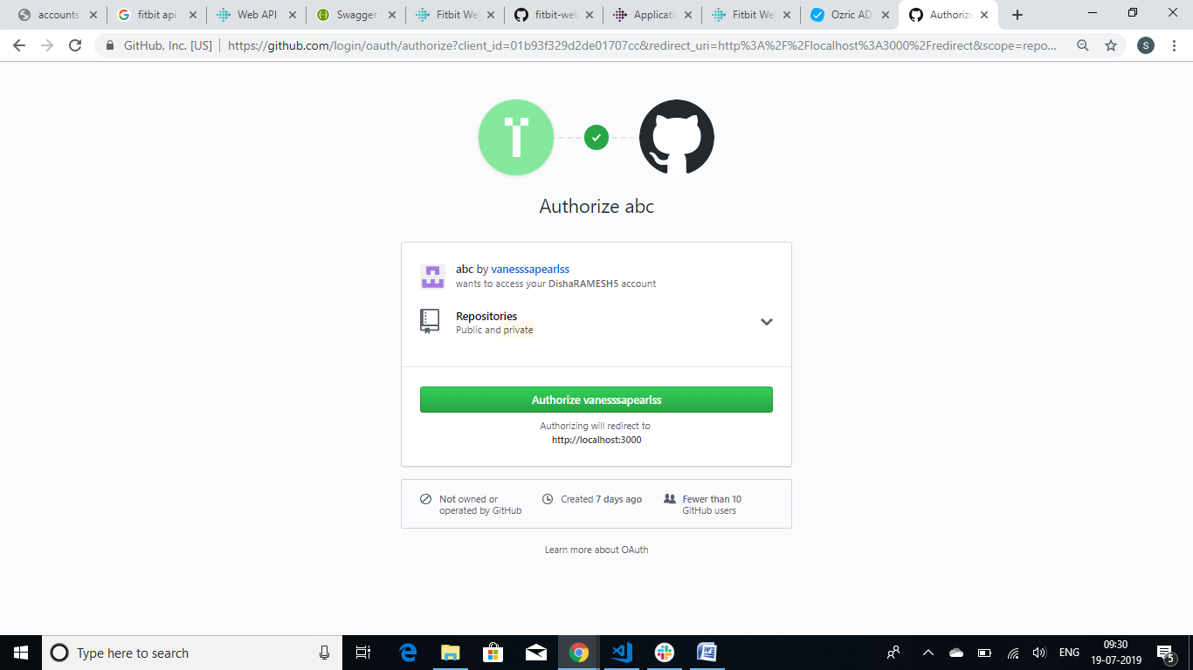

**Fig 3.1** **Authorization using OAuth 2.0**

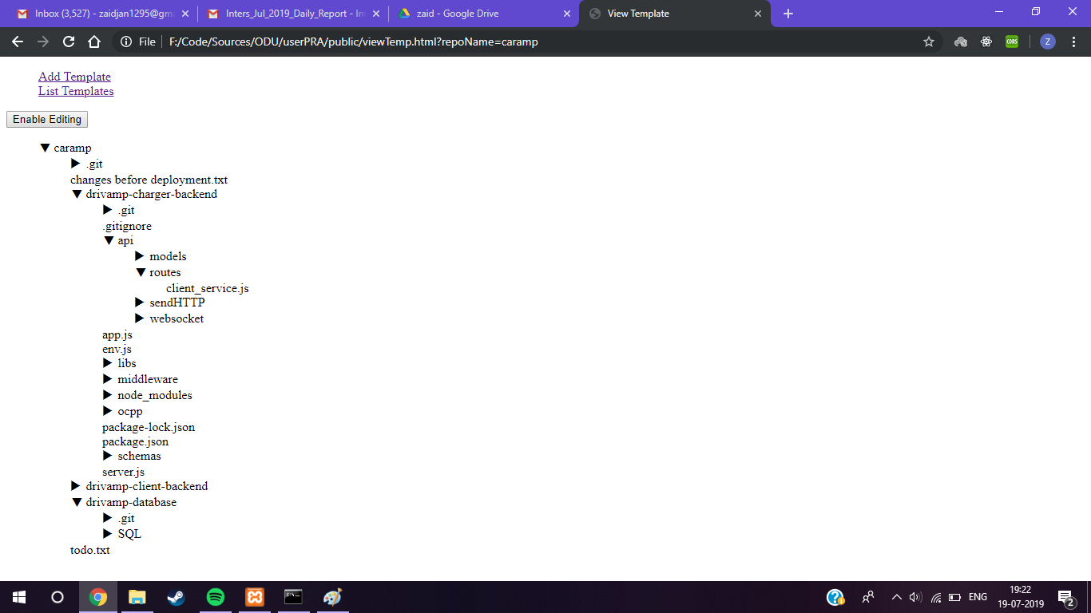

**Fig 3.2 Tree structure of files and folders**

**Repository Generation System**

GitHub is a platform that helps solve problems by building software together.

Technically it provides access control and several collaboration features such as bug tracking, feature request, task managment, and wikis for every project.

It offers all of the Distributed version Control and Source code management (SCM) functionality of Git as well as adding its own features.

**Problem statement**

To develop a software product called RGS that automates and enhances the process of repo generation based on application needs with a user friendly GUI which helps developers to create/edit templates for each type of project. The main aim of this software application is to assist software developers in creation of repositories on Github. The whole software promotes the use of version control systems for better efficiency and coordination.

**Implementation**

* The most important step in the entire project is the design of the database.
* Conversion of the directory structure to a JSON string.
* Traversing the JSON string using Depth First Search (DFS) in order to facilitate with viewing and editing of the template.
* Communication with GitHub servers using GitHub APIs
* An interactive UI for quick and easy creation and manipulation of repository templates.
* Use of Jenkins for testing and deploying of repositories.

**User Interface Design**

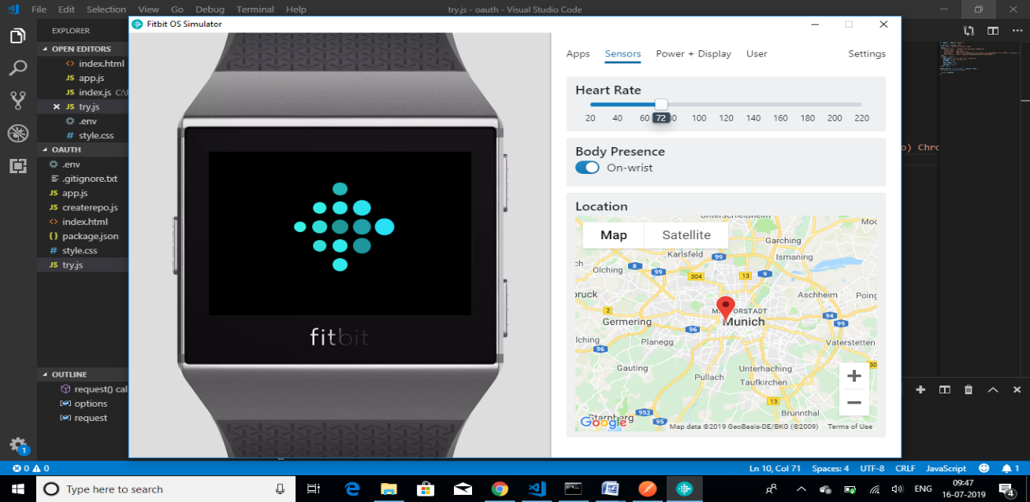

**Fig 3.3 Fitbit OS Simulator**

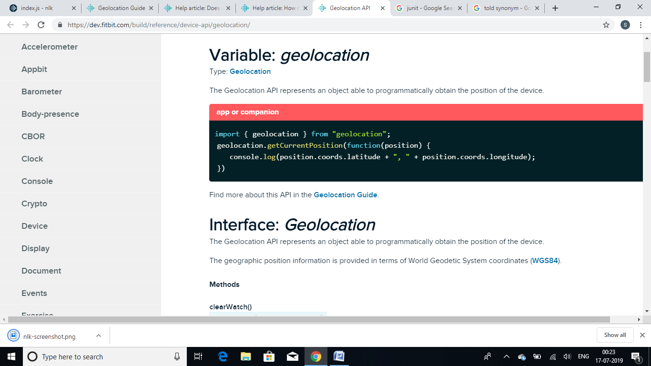

**Fig 3.4 Use of Fitbit API**