- INTRODUCTION
- WORKING ARCHITECTURE 3
  - Introduction 3
  - Invasive BCI 3
  - Partially Invasive BCI 5
  - Non-Invasive BCI 5
  - Prominent Research Successes 8
  - Cell Culture BCI’s 11
3. THE CURRENT BCI TECHNIQUES 13
  - Introduction 13
  - P300 Detection 13
  - EEG mu-Rythm Conditioning 14
  - VEP Detection 16
  - EEG Pattern Mapping 17
  - Detecting Lateral 18
Hemisphere differences
4. BRAIN GATE 19
4.1 DARPA 21
5. BCI APPLICATIONS 22
  - Introduction 22
  - The Mental Typewriter 22
  - BCI Offers Paralyzed Patients 23
Good Quality Of Life
  - Adaptive BCI for augmented 25
Cognition and action
5.4.1 Error and Conflict Perception 25
5.5.1 Working Memory Encoding 26
5.5.2 Rapid Visual Recognition 26
6. THE ABI SOFTWARE 30
6.1 Introduction 30
6.2 Work of the Software 30
6.3 The Classification Achieved 31
By This Software
6.4 Instructions 31
6.4.1 Simulation and Recording 33
6.4.2 Training 34
6.4.3 The Trial Archive 36
6.4.4 The Configuration File 36
6.4.5 Electrode Positions 37
6.4.6 Fast Testing 38
6.4.7 Considerations 39
6.5 CLASSIFIER DESIGN 33
- CONCLUSION 35
- REFERENCE 36

1. Introduction

Man machine interface has been one of the growing fields of research and
Development in recent years. Most of the effort has been dedicated to the design of user-
Friendly or ergonomic systems by means of innovative interfaces such as voice recognition, virtual reality. A direct brain-computer interface would add a new dimension to man-machine interaction.
A brain-computer interface, sometimes called a direct neural interface or a brain machine interface, is a direct communication pathway between a human or animal brain (or brain cell culture) and an external device. In one BCIs, computers either accept commands from the brain or send signals to it but not both. Two way BCIs will allow brains and external devices to exchange information in both directions but have yet to be successfully implanted in animals or humans.
Brain-Computer interface is a staple of science fiction writing. In its earliest incarnations no mechanism was thought necessary, as the technology seemed so far fetched that no explanation was likely. As more became known about the brain however, the possibility has become more real and the science fiction more technically sophisticated. Recently, the cyberpunk movement has adopted the idea of 'jacking in', sliding 'biosoft' chips into slots implanted in the skull(Gibson, W.1984).Although such biosofts are still science fiction, there have been several recent steps toward interfacing the brain and computers.
In this definition, the word brain means the brain or nervous system of an organic life form rather than the mind. Computer means any processing or computational device, from simple circuits to silicon chips (including hypothetical future technologies like quantum computing).
Research on BCIs has been going on for more than 30 years but from the mid 1990’s there has been dramatic increase working experimental implants. The common thread throughout the research is the remarkable cortical-plasticity of the brain, which often adapts to BCIs treating prostheses controlled by implants and natural limbs. With
Recent advances in technology and knowledge, pioneering researches could now conceivably attempt to produce BCIs that augment human functions rather than simply restoring them, previously only the realm of science fiction.
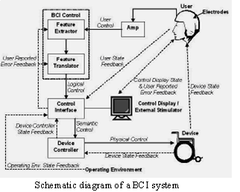
2. Working architecture
2.1. Introduction:
Before moving to real implications of BCI and its application let us first discuss the three types of BCI. These types are decided on the basis of the technique used for the interface. Each of these techniques has some advantages as well as some disadvantages. The three types of BCI are as follows with there features:

2.2. Invasive BCI:
Invasive BCI are directly implanted into the grey matter of the brain during neurosurgery. They produce the highest quality signals of BCI devices. Invasive BCIs has targeted repairing damaged sight and providing new functionality to paralyzed people. But these BCIs are prone to building up of scar-tissue which causes the signal to become weaker and even lost as body reacts to a foreign object in the brain.




In vision science, direct brain implants have been used to treat non-congenital i.e. acquired blindness. One of the first scientists to come up with a working brain interface to restore sight as private researcher, William Dobelle.
Dobelle’s first prototype was implanted into Jerry, a man blinded in adulthood, in1978. A single-array BCI containing 68 electrodes was implanted onto Jerry’s visual cortex and succeeded in producing phosphenes, the sensation of seeing light. The system included TV cameras mounted on glasses to send signals to the implant. Initially the implant allowed Jerry to see shades of grey in a limited field of vision and at a low frame-rate also requiring him to be hooked up to a two-ton mainframe. Shrinking electronics and faster computers made his artificial eye more portable and allowed him to perform simple tasks unassisted.
In 2002, Jens Neumann, also blinded in adulthood, became the first in a series of 16 paying patients to receive Dobelle’s second generation implant, marking one of the earliest commercial uses of BCIs. The second generation device used a more sophisticated implant enabling better mapping of phosphenes into coherent vision. Phosphenes are spread out across the visual field in what researchers call the starry-night effect. Immediately after his implant, Jens was able to use imperfectly restored vision to drive slowly around the parking area of the research institute.
BCIs focusing on motor Neuroprosthetics aim to either restore movement in paralyzed individuals or provide devices to assist them, such as interfaces with computers or robot arms.
Researchers at Emory University in Atlanta led by Philip Kennedy and Roy Bakay were first to install a brain implant in a human that produced signals of high enough quality to stimulate movement. Their patient, Johnny Ray, suffered from ‘locked-in syndrome’ after suffering a brain-stem stroke. Ray’s implant was installed in 1998 and he lived long enough to start working with the implant, eventually learning to control a computer cursor.
Tetraplegic Matt Nagle became the first person to control an artificial hand using a BCI in 2005 as part of the nine-month human trail of cyber kinetics Neurotechnology’s Brain gate chip-implant. Implanted in Nagle’s right precentral
gyrus(area of the motor cortex for arm movement), the 96 electrode Brain gate implant allowed Nagle to control a robotic arm by thinking about moving his hand as well as a computer cursor, lights and TV.
2.3. Partially Invasive BCI:
Partially invasive BCI devices are implanted inside the skull but rest outside the brain rather than amidst the grey matter. They produce better resolution signals than non-invasive BCIs where the bone tissue of the cranium deflects and deforms signals and have a lower risk of forming scar-tissue in the brain than fully-invasive BCIs.
Electrocardiography (ECoG) uses the same technology as non-invasive electroencephalography, but the electrodes are embedded in a thin plastic pad that is placed above the cortex, beneath the Dura mater. ECoG technologies were first traled in humans in 2004 by Eric Leuthardt and Daniel Moran from Washington University in St Louis. In a later trial, the researchers enabled a teenage boy to play Space Invaders using his ECoG implant. This research indicates that it is difficult to produce kinematics BCI devices with more than one dimension of control using ECoG.
Light Reactive Imaging BCI devices are still in the realm of theory. These would involve implanting laser inside the skull. The laser would be trained on a single neuron and the neuron’s reflectance measured by a separate sensor. When neuron fires, The laser light pattern and wavelengths it reflects would change slightly. This would allow researchers to monitor single neurons but require less contact with tissue and reduce the risk of scar-tissue build up.
2.4. Non-Invasive BCI:
As well as invasive experiments, there have also been experiments in humans using non-invasive neuroimaging technologies as interfaces. Signals recorded in this way have been used to power muscle implants and restore partial movement in an experimental volunteer. Although they are easy to wear, non-invasive implants produce poor signal resolution because the skull dampens signals, dispersing and blurring the electromagnetic waves created by the neurons. Although the waves can still be detected it is more difficult to determine the area of the brain that created them or the actions of individual neurons.
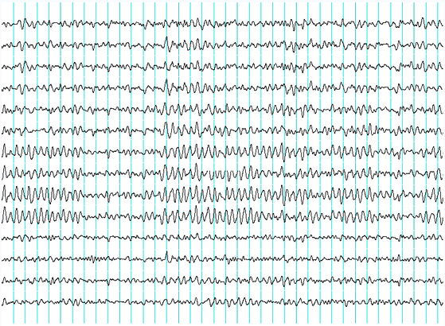

Fig. 2.4. Recordings of brainwaves produced by an electroencephalogram

Electroencephalography (EEG) is the most studied potential non-invasive interface, mainly due to its fine temporal resolutions, ease of use, portability and low set-up cost. But as well as the technology's susceptibility to noise, another substantial barrier to using EEG as a brain-computer interface is the extensive training required before users can work the technology. For example, in experiments beginning in the mid-1990s, Niels Birbaumer of the University of Tübingen in Germany used EEG recordings of slow cortical potential to give paralysed patients limited control over a computer cursor.(Birbaumer had earlier trained epileptics to prevent impending fits by controlling this low voltage wave.) The experiment saw ten patients trained to move a computer cursor by controlling their brainwaves. The process was slow, requiring more than an hour for patients to write 100 characters with the cursor, while training often took many months.
Another research parameter is the type of waves measured. Birbaumer's later research with Jonathan Wolpaw at New York State University has focused on developing technology that would allow users to choose the brain signals they found easiest to operate a BCI, including mu and beta waves.
A further parameter is the method of feedback used and this is shown in studies of P300 signals. Patterns of P300 waves are generated involuntarily (stimulus-feedback) when people see something they recognizes and may allow BCIs to decode categories of thoughts without training patients first. By contrast, the biofeedback methods described above require learning to control brainwaves so the resulting brain activity can be detected. In 2000, for example, research by Jessica Bayliss at the University of Rochester showed that volunteers wearing virtual reality helmets could control elements in a virtual world using their P300 EEG readings, including turning lights on and off and bringing a mock-up car to a stop.
In 1999, researchers at Case Western Reserve University led by Hunter Peckham, used 64-electrode EEG skullcap to return limited hand movements to quadriplegic Jim Jatich. As Jatich concentrated on simple but opposite concepts like up and down, his beta-rhythm EEG output was analysed using software to identify patterns in the noise. A basic pattern was identified and used to control a switch: Above average activity was set to on, below average off. As well as enabling Jatich to control a computer cursor the signals were also used to drive the nerve controllers embedded in his hands, restoring some movement.
Electronic neural-networks have been deployed which shift the learning phase from the user to the computer. Experiments by scientists at the Fraunhofer Society in 2004 using neural networks led to noticeable improvements within 30 minutes of training.
Experiments by Eduardo Miranda aim to use EEG recordings of mental activity associated with music to allow the disabled to express themselves musically through an encephalophone.
Magneto encephalography (MEG) and functional magnetic resonance imaging (fMRI) have both been used successfully as non-invasive BCIs. In a widely reported experiment, fMRI allowed two users being scanned to play Pong in real-time by altering their homodynamic response or brain blood flow through biofeedback techniques. fMRI measurements of homodynamic responses in real time have also been used to control robot arms with a seven second delay between thought and movement.
2.5 Prominent research successes
Phillip Kennedy and colleagues built the first intracortical brain-computer interface by implanting neurotrophic-cone electrodes into monkeys.
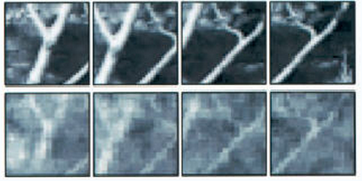
Fig.2.5Garrett Stanley's recordings of cat vision using a BCI implanted in the lateral geniculate nucleus (top row: original image; bottom row: recording)

In 1999, researchers led by Garrett Stanley at Harvard University decoded neuronal firings to reproduce images seen by cats. The team used an array of electrodes embedded in the thalamus (which integrates all of the brain’s sensory input) of sharp-eyed cats. Researchers targeted 177 brain cells in the thalamus lateral geniculate nucleus area, which decodes signals from the retina. The cats were shown eight short movies, and their neuron firings were recorded. Using mathematical filters, the researchers decoded the signals to generate movies of what the cats saw and were able to reconstruct recognizable scenes and moving objects.
Miguel Nicolelis has been a prominent proponent of using multiple electrodes spread over a greater area of the brain to obtain neuronal signals to drive a BCI. Such neural ensembles are said to reduce the variability in output produced by single electrodes, which could make it difficult to operate a BCI.
After conducting initial studies in rats during the 1990s, Nicolelis and his colleagues developed BCIs that decoded brain activity in owl monkeys and used the devices to reproduce monkey movements in robotic arms. Monkeys have advanced reaching and grasping abilities and good hand manipulation skills, making them ideal test subjects for this kind of work.
By 2000, the group succeeded in building a BCI that reproduced owl monkey movements while the monkey operated a joystick or reached for food. The BCI operated in real time and could also control a separate robot remotely over Internet protocol. But the monkeys could not see the arm moving and did not receive any feedback, a so-called open-loop BCI.

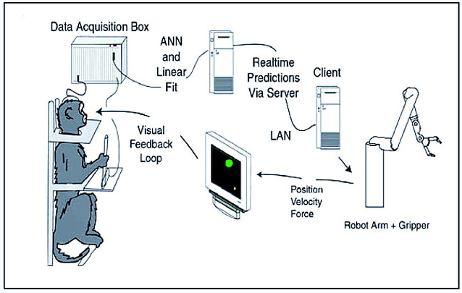
Fig.2.5. Diagram of the BCI developed by Miguel Nicolelis and colleagues for use on Rhesus monkeys.

Later experiments by Nicolelis using rhesus monkeys, succeeded in closing the feedback loop and reproduced monkey reaching and grasping movements in a robot arm. With their deeply cleft and furrowed brains, rhesus monkeys are considered to be better models for human neurophysiology than owl monkeys. The monkeys were trained to reach and grasp objects on a computer screen by manipulating a joystick while corresponding movements by a robot arm were hidden. The monkeys were later shown the robot directly and learned to control it by viewing its movements. The BCI used velocity predictions to control reaching movements and simultaneously predicted hand gripping force.
Other labs that develop BCIs and algorithms that decode neuron signals include John Donoghue from Brown University, Andrew Schwartz from the University of Pittsburgh and Richard Andersen from Caltech. These researchers were able to produce working BCIs even though they recorded signals from far fewer neurons than Nicolelis (15–30 neurons versus 50–200 neurons).
Donoghue's group reported training rhesus monkeys to use a BCI to track visual targets on a computer screen with or without assistance of a joystick (closed-loop BCI).Schwartz's group created a BCI for three-dimensional tracking in virtual reality and also reproduced BCI control in a robotic arm. The group created headlines when they demonstrated that a monkey could feed itself pieces of zucchini using a robotic arm powered by the animal's own brain signals.
Andersen's group used recordings of premovement activity from the posterior parietal cortex in their BCI, including signals created when experimental animals anticipated receiving a reward.
In addition to predicting kinematic and kinetic parameters of limb movements, BCIs that predict electromyographic or electrical activity of muscles are being developed. Such BCIs could be used to restore mobility in paralysed limbs by electrically stimulating muscles.

2.6. Cell-culture BCIs
Researchers have also built devices to interface with neural cells and entire neural networks in cultures outside animals. As well as furthering research on animal implantable devices, experiments on cultured neural tissue have focused on building problem-solving networks, constructing basic computers and manipulating robotic devices. Research into techniques for stimulating and recording from individual neurons grown on semiconductor chips is sometimes referred to as neuroelectronics or neurochips.
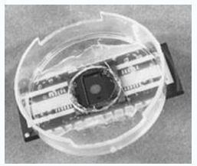
fig.2.6.1: World first: Neurochip

Development of the first working neurochip was claimed by a Caltech team led by Jerome Pine and Michael Maher in 1997. The Caltech chip had room for 16 neurons.
In 2003, a team led by Theodore Berger at the University of Southern California started work on a neurochip designed to function as an artificial or prosthetic hippocampus. The neurochip was designed to function in rat brains and is intended as a prototype for the eventual development of higher-brain prosthesis. The hippocampus was chosen because it is thought to be the most ordered and structured part of the brain and is the most studied area. Its function is to encode experiences for storage as long-term memories elsewhere in the brain.
Thomas DeMarse at the University of Florida used a culture of 25,000 neurons taken from a rat's brain to fly a F-22 fighter jet aircraft simulator. After collection, the cortical neurons were cultured in a Petri dish and rapidly begin to reconnect themselves to form a living neural network. The cells were arranged over a grid of 60 electrodes and trained to control the pitch and yaw functions of the simulator. The study's focus was on understanding how the human brain performs and learns computational tasks at a cellular level.
3. The Current BCI Techniques

3.1. Introduction:
In today’s time various techniques are used for BCI interface, there implementations and result manipulation. These techniques are headed towards the development of BCI in coming era.
3.2. P300 Detection:
Farwell [Farwell&Donchin 1988] of the Department of Psychology and Cognitive Psychophysiology Laboratory at the University of Illinois at Urbana-Champaign IL, describes a technique for detecting the P300 component of a subject's event-related brain potential (ERP) and using it to select from an array of 36 screen positions. The P300 component is a positive-going ERP in the EEG with a latency of about 300ms following the onset of a rarely- occurring stimulus the subject has been instructed to detect. The EEG was recorded using electrodes placed at the Pz (parietal) site (10/20 International System), limited with band-pass filters to .02-35Hz and digitized at 50Hz. Electro-oculogram (EOG) data was also recorded from each subject via electrodes placed above and below the right eye. The "odd-ball" paradigm was used to elicit the P300, where a number of stimuli are presented to the experimental subject who is required to pay attention to a particular, rarely-occurring stimulus and respond to it in some non- motor way, such as by counting occurrences. Detecting the P300 response reliably requires averaging the EEG response over many presentations of the stimuli. The purpose of the current experiment was to discover the minimum number of presentations at two different inter-stimulus intervals (ISI) required to detect the P300 response. The experiment presented a 36-position array of letters, plus common typing characters and controls (e.g. space, backspace), made to flash in a random sequence first by rows and then columns. Each trial consisted of a complete set of six column or row flashes. Trials contaminated with muscular or EOG response were rejected and additional trials presented until data were collected from a block of 30 good trials, during which subjects were to fixate on a particular position, and count the number of times it flashed while a control message was elsewhere on the screen. After each block the fixated letter (one of B-R-A-I-N) was added to the screen so that subjects were conscious of slowly spelling out the word "BRAIN" through a succession of five blocks. A set of five blocks was run at each ISI -- 125ms and 500ms. The two presentation rates were chosen to bracket a range of communication rates from a low of 30 averaged trials at 500ms ISI (93.6 seconds of presentation per character) to a high of one trial at 125ms (1.245 seconds of presentation per character), an effective communication rate range of .01 to .8 characters-per- second, respectively. The authors used four techniques to analyze the data for reliable P300 response detection – stepwise descriminant analysis (SWDA), peak picking, area, and covariance, and identified SWDA as leading to the greatest accuracy at the fastest presentation rate. Results indicated that a character chosen from among 36 items can be detected with 95% accuracy within 26 seconds.
3.3. EEG mu-rhythm Conditioning:
Three papers using this technique were reviewed including Wolpaw [Wolpaw et al 1991], McFarland [McFarland et al 1993], and colleagues at the Wadsworth Center for Laboratories and Research, Albany, NY, and Pfurtscheller [Pfurtscheller et al 1993] and colleagues at the Ludwig Boltzmann Institute of Medical Informatics and Neuroinformatics, Department of Medical Informatics, Institute of Biomedical Engineering, University of Technology Graz, Austria. All three papers describe subjects' abilities to move a cursor toward a target on a computer screen by manipulating their mu- rhythm, a detectable pattern in a great majority of individuals in the EEG 8-12Hz frequency range, centered about 9.1Hz. Work is based on earlier research efforts by Kuhlman [Kuhlman 1978b] who described the mu-rhythm in normal and epileptic subjects. Wolpaw describes detecting subjects' mu-rhythm amplitude, defined as the square-root of the spectral EEG power at 9Hz, using two scalp-mounted electrodes located near location C3 in the International 10/20 System and a digital signal processing board analyzing continuous EEG in 333ms segments, and using it to drive a cursor up or down on a screen toward a target placed randomly at the top or bottom. An experiment operator preset the size of the ranges and number of cursor movement steps assigned to each range for each subject during testing prior to each experimental run.
Ranges were set so that the commonest mu-rhythm amplitudes (<4 microvolt’s) left the cursor in place or moved it downwards moderately while higher amplitudes (>4 microvolt’s) moved it upwards in increasing jumps. Weights were adjusted as subjects exhibited better control of their mu-rhythm amplitudes for up and down targets in repeated trials. Wolpaw substantiates subjects' learned intentional control over mu-rhythm amplitude in three ways: by performing frequency analysis up to 192Hz on subjects during cursor movement trials and failing to find any relationship between mu-
Rhythm changes and the higher frequencies associated with muscular (EMG) activity; by subjects statements about not making contra lateral movements and observing none; and by failing to find any relationship between mu-rhythm changes and posterior scalp recordings of the visual alpha-rhythm. Four out of five subjects acquired impressive control over their mu-rhythm amplitude during 12 45-minute sessions over a period of two months. Accuracies of 80-95% target hits across experimental subjects were achieved and rates of 10-29 hits per minute. Off-line analysis of two subjects' raw EEG data (see below) provided good support for Wolpaw's experimental results. McFarland used essentially the same experimental setup and introduced greater precision constraints on four subjects' attempts to position a cursor by means of mu-rhythm control. A vertical bar target appeared in one of five different vertical positions on the left side of the screen and crossed the screen from left to right in 8 seconds. Subjects had to move the cursor (initially in the middle of the right edge of the screen) quickly to the correct one of five different vertical screen positions to intercept the target by controlling their mu-rhythm amplitude. Analysis of the average distance between the center of the target and the cursor during succeeding trials indicated that all subjects reduced the distance and three out of four significantly so. Pfurtscheller used contralateral blocking of the mu-rhythm during the 1-second period prior to a motor activity (in this case pressing a microswitch using either the right or the left index finger) to predict which response was to follow. An array of 30 electrodes spaced evenly across the scalp (two were at locations C3 and C4 in the International 10/20 System) was used to record EEG activity. An initial training period for each subject involved using data from all 30 electrodes to train the classification network. During experimental trials, a feature-vector of power values (Hilbert Transform) from electrodes at positions C3 and C4 was constructed at 5 time points and classified using a Learning Vector Quantizer (LVQ) artificial neural network of the type described by Kohonen [Kohonen 1988]. The experimenter achieved the best balance of reliability/speed of classification by using the 1/2-second prior to response and performing a multiple- classification and voting process. EEG data from two subjects in the Wolpaw experiment described above were provided to the Graz Institute for Information Processing for additional analysis described by Flotzinger [Flotzinger et al, 1993] using the Graz LVQ neural net scheme (see above) and a fixed time-segment. Cursor-movement was predicted >from raw data with 90% accuracy. Results also implied that frequency bands other than the mu and beta ranges may contain useful (i.e. target-related) information.
3.4. VEP Detection:
This technique was reviewed by Sutter [Sutter 1992] at the Smith-Kettle well Eye Research Institute in San Francisco CA, and Colliers’ [Cilliers&VanDerKouwe 1993] and colleague at the Department of Electrical and Electronic Engineering, University of Pretoria, South Africa. Sutter describes presenting a 64-position block on a computer screen and detecting which block the subject looks at, while Colliers’ work uses a series of four lights. In each case, several simultaneously presented stimuli are made to change rapidly in some controlled way(intensity, pattern, color-shift) and the subject has scalp electrodes placed over the visual cortex (back of the head) in a position to detect changes in the evoked potential(VEP) at that location. Sutter used a lengthy binary sequence to switch 64 screen positions between red and green, and in other trials to reverse a checkerboard pattern. Each screen position was shifted 20ms in the binary control sequence relative to its neighbors, and the entire sequence was auto correlated with the VEP in overlapping increments(the VEP response components last about 80ms) beginning 20ms apart, with the resultant vector stored in a 64-position array of registers. When a coefficient remains greater than all the others and above a threshold value for a certain amount of time, the corresponding stimulus is considered to have been selected. The 64 positions represent the letters of the alphabet and commonly used words in the English language. The subject can fixate on any word or letter. Whenever the subject fixates on a letter, the commonly used words change to words beginning with that letter, for quick selection of an entire word. Sutter suggests a need to optimize both electrode placement and stimulation mode for each individual subject for good target discrimination. Seventy normal subjects evaluating a prototype system achieved adequate response times ranging from 1 to 3 seconds after an initial tuning process lasting 10-60 minutes. Sutter also tested his techniques on 20 severely disabled persons and describes an experimental version involving an ALS patient using intra-cranial electrodes implanted in the space between the Dura and the skull. Cilliers' technique involves varying the intensity of four LED's modulated with a 10Hz sine wave in phase quadrature and detecting the signal in the subject's VEP using a pair of EEG surface electrodes placed on the occipital lobe. The four flashing LED's are arranged around the edge of a computer screen containing an image of a standard four-row keyboard with each row of keys in a different color. Each LED is associated with one of the colors. Fixating on one LED selects a key row, which is redisplayed in four colors for a more detailed selection. The subject can select any particular key in an average of three selections -- about 15 seconds with the current setup. A short initial training period is required where subjects fixate on each LED for 5 seconds. Cilliers' paper describes work with a quadriplegic patient with a C2-level injury.
3.5. EEG Pattern Mapping:
Several experimenters describe techniques for classifying, detecting and mapping EEG patterns. Pfurtscheller's technique used a neural net featuring learning-vector quantization (LVQ) to map EEG patterns during the 1-second interval before a signal the experimental subject was instructed to wait for. Hiraiwa [Hiraiwa et al 1993] used a back-propagation artificial neural network to study readiness potentials (RP's)-- patterns in the EEG immediately prior to the subject's uttering one of five different Japanese syllables or moving a joystick in one of four different directions. Twelve channels of EEG data taken >from scalp-mounted electrodes at locations Fp1, Fp2,Fz, C3, C4, Pz, F5, F6, F7, F8, O1 and O2 (International 10/20 system) were used to train and then test two neural networks optimized for averaged data and for single-trial, real-time analysis, respectively. High recognition rates were obtained for the averaged data. Single- trial RP recognition, though less reliable, showed considerable promise in the experimenters' view. Keirn and Aunon [Keirn&Aunon 1990] recorded EEG data from scalp-mounted electrodes at locations P3, P4, C3, C4, O1 and O2 (International 10/20 System) during accomplishment of 5 different tasks during which subjects had their eyes open or closed, for 10 alternative responses. The tasks included:
- relaxing and trying to think of nothing,
- a non-trivial multiplication problem,
- a 30-second study of a drawing of a 3-dimensional object after which subjects were to a visualize the object being rotated about an axis,
- mental composition of a letter to a friend, and
- visualize numbers being written on a blackboard sequentially, with the previous a number being erased before the next was written.
Feature vectors were constructed from the EEG patterns based on the Wiener-Khinchine method and classified using a Bayes quadratic classifier.
3.6. Detecting lateral hemisphere differences:
Drake [Drake 1993] studied induced lateral differences in relative brain hemisphere activation after subjects heard arguments through left, right or both earphones which they either strongly agreed with or strongly disagreed with, as determined by prior interviews. Subjects exhibited greater discounting of arguments they disagreed with during left hemisphere activation as measured by ratings of truth. Results supported previous work indicating asymmetries in lateral activation potential during processing persuasive arguments, however the study did not include measuring directly either activation levels or potentials in the cortex.
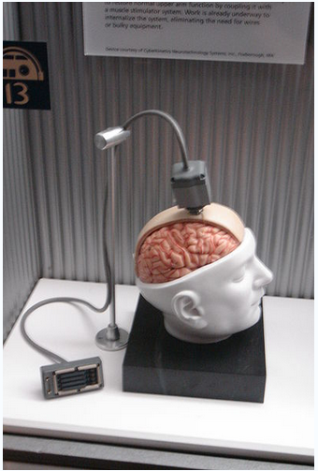

fig.4.1: Dummy unit illustrating the design of a Brain Gate interface

Brain Gate is a brain implant system developed by the bio-tech company Cyber kinetics in 2003 in conjunction with the Department of Neuroscience at Brown University. The device was designed to help those who have lost control of their limbs, or other bodily functions, such as patients with amyotrophic lateral sclerosis (ALS) or spinal cord injury. The computer chip, which is implanted into the brain, monitors brain activity in the patient and converts the intention of the user into computer commands.
Currently the chip uses 100 hair-thin electrodes that sense the electro-magnetic signature of neurons firing in specific areas of the brain, for example, the area that controls arm movement. The activities is translated into electrically charged signals and are then sent and decoded using a program, which can move either a robotic arm or a computer cursor. According to the Cyber kinetics' website, three patients have been implanted with the Brain Gate system. The company has confirmed that one patient (Matt Nagle) has a spinal cord injury, whilst another has advanced ALS.
In addition to real-time analysis of neuron patterns to relay movement, the Brain gate array is also capable of recording electrical data for later analysis. A potential use of this feature would be for a neurologist to study seizure patterns in a patient with epilepsy.
Cyber kinetics has a vision, CEO Tim Surgenor explained to Gizmag, but it is not promising "miracle cures", or that quadriplegic people will be able to walk again - yet. Their primary goal is to help restore many activities of daily living that are impossible for paralysed people and to provide a platform for the development of a wide range of other assistive devices.
"Today quadriplegic people are satisfied if they get a rudimentary connection to the outside world. What we're trying to give them is a connection that is as good and fast as using their hands. We're going to teach them to think about moving the cursor using the part of the brain that usually controls the arms to push keys and create, if you will, a mental device that can input information into a computer. That is the first application, a kind of prosthetic, if you will. Then it is possible to use the computer to control a robot arm or their own arm, but that would be down the road."
Existing technology stimulates muscle groups that can make an arm move. The problem Surgenor and his team faced was in creating an input or control signal. With the right control signal they found they could stimulate the right muscle groups to make arm movement.
"Another application would be for somebody to handle a tricycle or exercise machine to help patients who have a lot of trouble with their skeletal muscles. But walking, I have to say, would be very complex. There's a lot of issues with balance and that's not going to be an easy thing to do, but it is a goal."
Cyber kinetics hopes to refine the Brain Gate in the next two years to develop a wireless device that is completely implantable and doesn't have a plug, making it safer and less visible. And once the basics of brain mapping are worked out there is potential for a wide variety of further applications, Surgenor explains.
"If you could detect or predict the onset of epilepsy, that would be a huge therapeutic application for people who have seizures, which leads to the idea of a 'pacemaker for the brain'. So eventually people may have this technology in their brains and if something starts to go wrong it will take a therapeutic action. That could be available by 2007 to 2008."
Surgenor also sees a time not too far off where normal humans are interfacing with Brain Gate technology to enhance their relationship with the digital world - if they're willing to be implanted.
"If we can figure out how to make this device cheaper, there might be applications for people to control machines, write software or perform intensive actions. But that's a good distance away. Right now the only way to get that level of detail from these signals is to actually have surgery to place this on the surface of the brain. It's not possible to do this with a non-invasive approach. For example, you can have an EEG and if you concentrate really hard you can think about and move a cursor on a screen, but if someone makes a loud noise or you get interrupted, you lose that ability. What we're trying to make here is a direct connection. The [Brain Gate] is going to be right there and you won't have to think about it."
4.1. DARPA
The Brown University group was partially funded by the Defense Advanced Research Projects Agency (DARPA), the central research and development organization for the US Department of Defense (DoD). DARPA has been interested in Brain-Machine-Interfaces (BMI) for a number of years for military applications like wiring fighter pilots directly to their planes to allow autonomous flight from the safety of the ground. Future developments are also envisaged in which humans could 'download' memory implants for skill enhancement, allowing actions to be performed that have not been learned directly.
5. BCI Applications

5.1. Introduction
After we go through the various techniques of BCI the first question that comes to our mind is, what does BCI do to us and what are its applications. So BCI in today’s time turns useful to us in many ways. Whether it be any medical field or a field leading to enhancement of human environment.
Some of the BCI applications are discussed below.
5.2. The Mental Typewriter:
March 14, 2006 Scientists demonstrated a brain-computer interface that translates brain signals into computer control signals this week at CeBIT in Berlin. The initial project demonstrates how a paralysed patient could communicate by using a mental typewriter alone – without touching the keyboard. In the case of serious accident or illness, a patient’s limbs can be paralyzed, severely restricting communication with the outside world. The interface is already showing how it can help these patients to write texts and thus communicate with their environment. There’s also a PONG game (computer tennis) used to demonstrate how the interface can be used. Brain Pong involves two BBCI users playing a game of teletennis in which the “rackets” are controlled by imagining movements and predictably the general media has focused the majority of its attention on computer gaming applications but BCCI could equally be used in safety technologies (e.g. in automobiles for monitoring cognitive driver stress), in controlling prostheses, wheelchairs, instruments and even machinery.
On the first day of the 2006 CeBIT Computer Fair, Fraunhofer FIRST and the Berlin Charité demonstrated how the mental typewriter could be used for this purpose. On the other days of the CeBIT Fair, a simulated test setup using a shop-window dummy will be on display.
Cooperation between Fraunhofer FIRST and the Charité to develop an interface between the human brain and the computer began some years ago. The result was the Berlin Brain-Computer Interface (BBCI which uses the electrical activity of the brain in the form of an electroencephalogram (EEG). Electrodes attached to the scalp measure the brain’s electrical signals. These are then amplified and transmitted to the computer, which converts them into technical control signals. The principle behind the BBCI is that the activity of the brain already reflects the purely mental conception of a particular behavior, e.g. the idea of moving a hand or foot.
The BBCI recognizes the corresponding changes in brain activity and uses them, say, to choose between two alternatives: one involves imagining that the left hand is moved, the other that the right hand is moved. This enables a cursor, for example, to be moved to the left or right. The person operating the mental typewriter uses the cursor to select a letters field. The next step reduces the choice, and after a few more steps we arrive at the individual letters, which can be used to write words. This process enables simple sentences to be constructed within minutes. A first prototype of the mental typewriter is currently available. In a series of experiments, different spelling methods are tested in terms of their usability and are adapted to the BBCI. It will be some years, though, before the mental typewriter can be used in everyday applications. Further research is needed, in particular to refine the EEG sensors.
5.3. BCI offers paralyzed patients improved quality of life:
Tubingen, Germany. A brain–computer interface installed early enough in patients with neuron-destroying diseases can enable them to be taught to communicate through an electronic device and slow destruction of the nervous system.
Fundamental theories regarding consciousness, emotion and quality of life in sufferers of paralysis from Amyotrophic Lateral Sclerosis (ALS, also known as 'Lou Gehrig’s disease') are being challenged based on new research on brain-computer interaction. ALS is a progressive disease that destroys neurons affecting movement.
The study appears in the latest issue of Psychophysiology. The article reviews the usefulness of currently available brain-computer –interfaces (BCI), which use brain activity to communicate through external devices, such as computers.
The research focuses on a condition called the completely locked-in state (CLIS, a total lack of muscle control). In a CLIS situation, intentional thoughts and imagery can rarely be acted upon physically and, therefore, are rarely followed by a stimulus. The research suggests that as the disease progresses and the probability for an external event to function as a link between response and consequence becomes progressively smaller it may eventually vanish altogether.
Researchers have found that by implementing a brain-computer –interface before the completely locked-in state occurs, a patient can be taught to communicate through an electronic device with great regularity. The continued interaction between thought, response and consequence is believed to slow the destruction of the nervous system.
The findings are also raising a number of new questions about the quality of life amongst paralysis sufferers. Patients surveyed were found to be much healthier mentally than psychiatrically depressed patients without any life-threatening bodily disease. Only 9% of ALS patients showed long episodes of depression and most were during the period following diagnosis and a period of weeks after tracheotomy.
“Most instruments measuring depression and quality of life are invalid for paralyzed people living in protected environments because most of the questions do not apply to the life of a paralyzed person. Special instruments had to be developed,” says
Niels Birbaumer, PhD., Author of the study.

5.4. Adaptive BCI for Augmented Cognition and Action:
The goal of this project is to demonstrate improved human/computer performance for specific tasks through detection of task-relevant cognitive events with real-time EEG (Fig. 1). For example, in tasks for which there is a direct tradeoff between reaction time and error rate, (such as typing or visual search) it may be beneficial to correct a user’s errors without interrupting the pace of the primary task. Such a user interface is possible through the direct detection of EEG signatures associated with the perception of a error, often referred to as Error Related Negativity. In general such signatures may be used to dynamically adjust the behavior of human-computer interfaces and information displays.
This project advances signal analysis techniques for high density EEG to detect discrete events associated with cognitive processing. Corresponding real-time adaptive interfaces with sub-second latency are being designed to evaluate this concept of an adaptive brain-computer interface in three specific applications:
(1) Error and conflict perception:
Error related negativity (ERN) in EEG has been linked to perceived response errors and conflicts in decision-making. In this project we have developed single trial ERN detection to predict task-related errors. The system can be used as an automated real-time decision checker for time-sensitive control tasks. In the first phase of this project we demonstrated improved human/computer performance at a rapid forced choice discrimination task with an average 23% reduction of human errors (results on one subject are shown in Fig. 2). This open-loop error correction paradigm represents the first application of real-time cognitive event detection and demonstrates the utility of real-time EEG brain monitoring within the Augmented Cognition program. We will evaluate video game scenarios with closed-loop feedback at latencies of less than 150 ms where detected errors are corrected or application parameters such as speed are varied according to the measured or "gauged" conflict perception.
(2) Working memory encoding.
Transient modulation of oscillations in the theta (4-8 Hz) and gamma (20-30 Hz) bands, recorded using EEG and magneto encephalography (MEG), have been implicated in the encoding and retrieval of semantic information in working memory. In this project we will exploit these neural correlates of semantic processing to detect problems with semantic information processing. This memory gauge could be used to detect memory recall deficits, and repeat or enhance the presented information and thus better prime memory recall.
(3) Rapid visual recognition:
We are exploring the signals elicited by visual target detection, which were recently observed in rapid sequential visual presentation (RSVP) experiments. We have demonstrated that the detection of these signals on a single trial basis can be used to replace the slow manual response of a human operator, thereby significantly increasing the throughput of image search tasks (Fig 3). This paradigm has the potential to improve the performance of Image Analysts who need to routinely survey large volumes of aerial imagery within short periods of time. In addition, the approach looks to measure the "bottleneck" between constant delay perceptual processing and more variable delay cognitive processing. Thus the detected signatures can be used to "gauge" if cognitive systems are capable/incapable of assimilating perceptual input for fast decision making.
In the first phase of this project a fully automated real-time signal analysis system and hardware infrastructure has been developed that can give short latency feedback to the user within 50ms of the recorded activity. The signal processing system adaptively learns to detect evoked responses from the real-time streaming EEG signal. The current system, which is used for tasks 1 and 3, can be configured for single trial detection for any number of cognitive events such ERN, rapid visuual recognition, readiness potential, response to oddball stimulus (P300), as well as conventional visual, auditory, or somato-sensory responses. We are in the progress of applying this system to event detection in the Warship Commander - a common task set proposed for integration and evaluation by the Augmented Cognition Program.
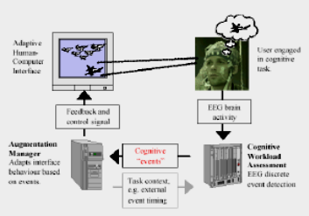
fig.5.4.1: Real-time brain computer interface system for augmented cognition and action.

The information delivery to the human is adapted to a user's cognitive processing based on cognitive events detected in real-time high-density EEG. Applications include automatic correction of perceived errors, prediction of memory performance, and rapid visual search. In the experimental system a pipelined modular processing architecture is used to collect EEG data, increase the signal-to-noise ratio (SNR), and generate a control signal that is fed back to the subject via a display. As an example consider the task of fast image search. A rapid sequence of images is presented on the display. The subject views the images with the goal of detecting a target image. The EEG signal from the high-density sensor net is sampled and processed in real-time using algorithms for artifact removal, and noise reduction. The signal is analyzed in real-time to identify the cognitive activity associated with visual target detection. The augmentation manager records the images associated with recognition events. This information is used to prioritize the large volumes of imagery that has to be analyzed. The selected images can subsequently be presented for more careful analysis without interrupting the fast visual processing of the human subjects in the initial scan. In Phase 1 of the project it has been demonstrated that improved prioritization performance is obtained as compared to selecting the image with a manual button push.
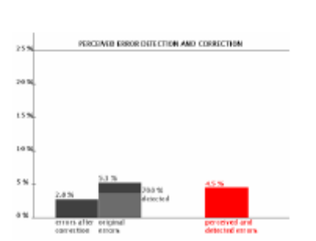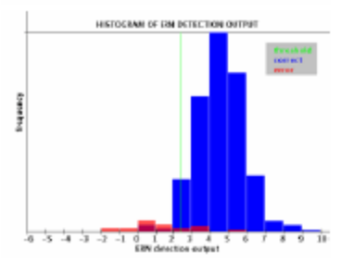
fig.5.4.2: Reduction of error by correcting a subjects response based on single trial detection of perceived reaction errors using Error Related Negativity. First two bars show reduction of error rate by a factor of 2 for one of 7 subjects. The number of perceived and detected errors (right) could be understood as an "gauge" that measures perceived task difficulty over an extended period of time (minutes).
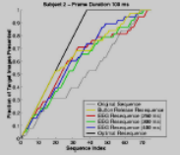
fig.5.4.3: Increase in target image throughput for detected EEG signatures compared to the covert responses (button release). Note that the detected EEG signature results in a larger fraction of the targets to be placed in the front of the image stack, thus improving image search efficiency.

6. Experimental Brain Computer Interface Software for the Modular EEG (The ABI software)

6.1. Introduction:

ABI is a simple software for the Modular EEG that implements an experimental Brain Computer Interface (BCI). Nowadays, BCI research is an highly active field, but the existing technology is still immature for its use outside of a lab's settings. The ABI software tries to provide a simple tool for hobbyists to do experiments on its own with BCI technology.
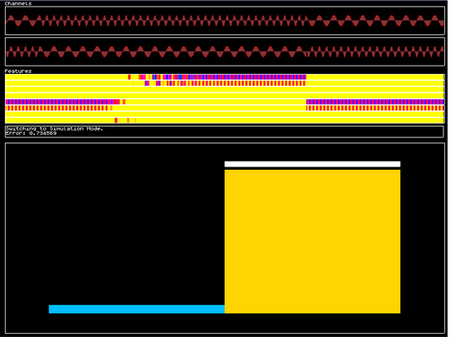

6.2. Work of the software:
The ABI is a BCI based on trials. A trial is a time interval where the user generates brainwaves to perform an action. The BCI tries to process this signal and to associate it to a given class. The association is done by feeding a neural net with the preprocessed EEG data. The neural net's output is then further processed and this final output corresponds to the given class. The neural net should be trained in order to learn the association.
The classifier's idea is heavily based on Christin Schäfer's design (winner of the BCI Competition II, Motor Imaginer Trials).
The ABI software allows you to
- •
Do simple Biofeedback. You can display raw EEG channels, narrow band frequency amplitudes and classes.
- •Simulate trials.
- Record trials for a number of choices of different classes.
- Train the interface.

6.3. The classification achieved by this software:
The method has been previously applied to the data provided by the BCI Competition II data (dataset III, Graz University, Motor Imaginary) and compared against the results obtained by the contributors. The method has outperformed the results achieved by them, obtaining a higher Mutual Information (which was the criterion used in the competition) of 0.67 bits (the winner of the competition obtained 0.61 bits).
Of course, it is very important that more people test the software and report its results to improve the method. Statistical stability can only be guaranteed if more people try it out.

6.4. Instructions:
By executing ABI, it reads a configuration file called "abi.txt" (which you can edit with a simple text editor), where the way the BCI should act is specified. ABI tries to load the trial file defined in the configuration file. The trial file is a text database containing trials for different classes. Then, the main screen is displayed:
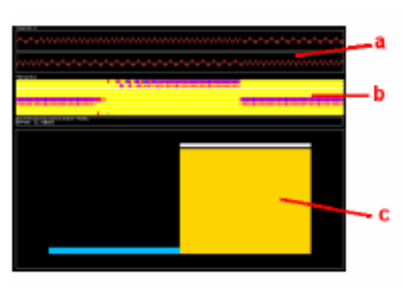
fig.6.4.1:
a) The EEG channels. The ModularEEG should be turned on. You can choose the amount of channels by setting the variable NChannels to desired value.

b) The extracted features. Each color strip indicates the intensity of a given frequency band. The variable NFeatures indicates the number of features you want to use. Channels indicate the source channels for the feature extraction. Frequencies tell ABI what frequencies should be used (in Hertz). Example: NFeatures = 4, Channels = 0 0 1 1, Frequencies = 10 20 10 20, tells ABI touse 2 EEG channels, and to extract frequencies 10 Hz and 20 Hz from channel 0 and channel 1. • c) Class bar. The variable NClasses tells ABI how many classes it should be able to discriminate. Each class has an associated bar, and its size (and color) shows how good the given class has been recognized by the system.

ABI has three operating modes: SIMULATION, RECORDING and TRAINING. You can switch between operating modes by pressing F1, F2 or F3 respectively (the software doesn't change its mode instantly, because a trial shouldn't be interrupted in the middle).
The operation is quite simple. The user records several trials for the different classes (RECORDING mode). Each class is associated to a different mental task. After recording a reasonable amount of trials (more than 50 trials for each class), the user can train the system to learn a way to discriminate between the different classes (TRAINING mode). This process can be repeated in order to improve the quality of the recognition. The system can be tested under the SIMULATION mode.
An explanation of the different modes follows.

6.4.1. SIMULATION and RECORDING
These two modes perform single trials. The SIMULATION mode is used to test the BCI. RECORDING is the same as SIMULATION, with the difference that the EEG data is recorded and used as training examples. A trial has the following structure:
Table 6.4.1 Simulation mode to test the BCI As you can see, a trial is composed of three subintervals, whose duration is defined by the variables TPreparation, TPrerecording and TrialLength, in the configuration file.

6.4.2. TRAINING

Table 6.4.2.1 Training

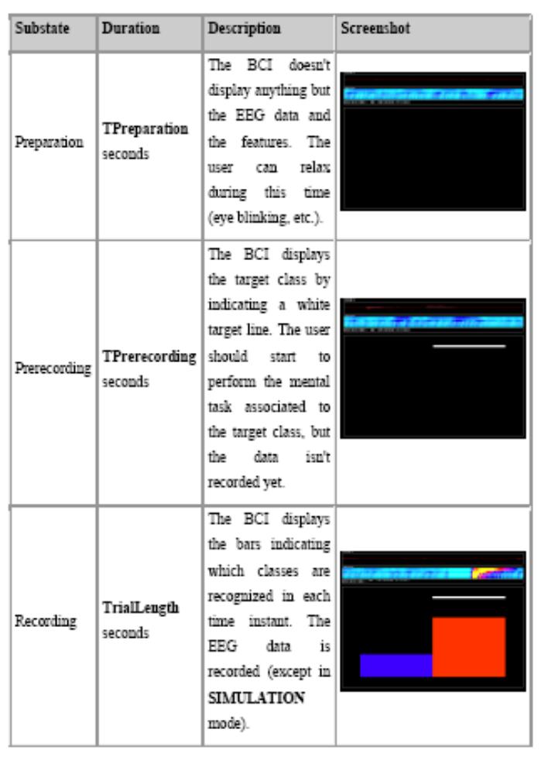
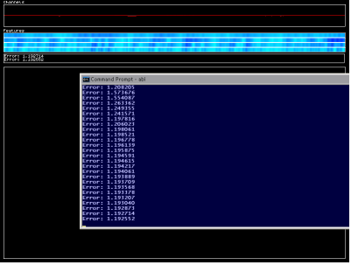
Pressing the F3 key, the system starts to train the neural net with the available data. The training set used for this purpose is the set of the last Trial Buffer recorded trials' features. Example: Suppose you have recorded 300 trials, and Trial Buffer = 100. Then the system extracts the features of the 100 last recorded trials to form the training set.
Training time depends upon the complexity of the training data and the amount of recorded data. The training data is not always separable. If the mental task for class 1 is too similar to the mental task for class 2, then the neural net won't be able to do the separation: this isn't magic :-)

6.4.3. The Trial Archive:
When exiting ABI, the EEG data recorded so far is saved into the file given by the parameter Trial Archive. You can open a trial archive with a simple text editor and see how the trial data has been recorded. Only raw EEG data and the class label is recorded: the features, which correspond to the real training data, are computed on-the-fly.
If you start ABI, it will load the trial archive specified in the configuration file if it exists, or create a new one if not. If the trial archive doesn't match the configuration file's specifications, then ABI aborts its execution. So you have to be careful to use correct trial archives and configuration files.
EEG recording between different executions of the ABI system is appended to the trial archive. This allows you to build your training set in different sessions. Be careful to use the same electrode settings. Some have reported that the recognition rate drops between different sessions.

6.4.4 The Configuration File
The configuration file tells ABI where to load the trial data from, how many channels the system should use, which features it should use, etc. You can open it with your favourite text editor and edit it. To start ABI with a different configuration file other than the default "abi.txt", invoice ABI with the following syntax at the command prompt:
- 􀂾 abi <my_configuration_file>

The configuration file basically contains a list of variables. The list of variables is: Table 6.4.4.1 List of variables in configuration file

Variable Name | Description
Device | This is the string that tells ABI how to initialize the ModularEEG. You shouldn't change it
NChannels | The amount of channels to use.
NFeatures | The number of features the ABI should extract from the raw EEG data in order to feed the neural net.
NClasses | The number of classes that the system should be able to discriminate.
Trial Archive | The name of the associated trial archive.
Channels | The index list of source channels for the feature extraction.
Frequencies | The list of frequencies to extract from the EEG data to use as features.
Hidden Units | The number of hidden units of the neural net.
Trial Buffer | The size of the training set used to train the neural net.
TrialLength | The length in seconds for each trial.
TPreparation | The length in seconds for the preparation time.
TPreRec | The length in seconds for the prerecording time.

A variable and its value should be in the same line.

6.4.5 Electrode Positions
As a reference, this is the international 10-20 system:
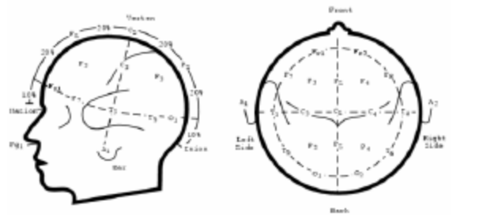

6.4.6 Fast Testing
If you want to check if the software is actually doing something, try the following simple test. This isn't a real BCI test, it's just for testing purposes.
Try to control the bars by simple teeth grinding. This is quite simple. Using just one channel over the frontal area (Fp1 and Fp2 per example), you can train ABI to discriminate between 2 different classes. Copy the following ABI configuration and start the system.
test.txt
Device = port COM1 57600; fmt P2; rate 256; chan 2;
NChannels = 1
NFeatures = 4
NClasses = 2
Trial Archive = test.txt
Channels = 0 0 0 0
Frequencies = 8 14 20 30
HiddenUnits = 4
TrialBuffer = 30
TrialLength = 5
TPreparation = 4
TPreRec = 0.5

Now, enter the RECORDING mode by pressing [F2]. Grind your teeth when the system asks you to perform the mental task associated to class 1 (the left bar). Relax for class 2. After recording 10 trials for each class, train the network by pressing [F3]. Wait until the classification error drops to a reasonable amount (per example, 1.2 bits). Then, enter the SIMULATION node by pressing [F1]. Repeat the same as when you've been recording. The system should classify the trials correctly: when you grind your teeth, the left bar should be higher than the right one, and vice versa.

6.4.7. Considerations
First of all, be patient! The system tries, by using a trainable classification method, to adapt the BCI to the user, and in this way, to simplify the learning process required by the user. Nevertheless, as any other instrument, it requires a considerable amount of time to use the BCI in order to get nice results.
BCI technology is still in its infancy, so little is known about which mental tasks are better than others for BCIs. Also, the electrode placing is important. If your electrode setting isn't appropriate, then it can happen that they even aren't recording the cortical areas related to the mental task!
Research has discovered the following changes in electrical activity during mental tasks (this list isn't complete, I hope that the OpenEEG community will discover some more):
- Motor Imaginary: Imagination of physical movement produces changes in the sensory motor cortex. In example, imagination of left and right middle finger imagination produces changes, namely (de-)synchronization on electrode positions around C3 and C4. Good features are around 10 and 20 Hz.
- Rotation of 3D objects: Literature stated that during imagination of rotation of 3d objects involves frontal and temporal lobe activity. They seem to synchronize. Good features are around 10 Hz.
- Mental Letter Composition.
- Others (please report!)

Do not use too many features at the same time, 4-10 features are reasonable. If you want to change the used features, restart the BCI with the appropriate change in the configuration file.

6.5. Classifier Design:
The design of the classifier is heavily based on Christin Schäfer's design used for the Dataset III of the BCI Competition II. Instead of using a Gaussian multivariate Bayesian classifier, here we use a neural net to obtain the classification for each time instant t. Those outputs are then integrated in time using a weighted sum. The idea is simple: outputs with low confusion should have higher weights.

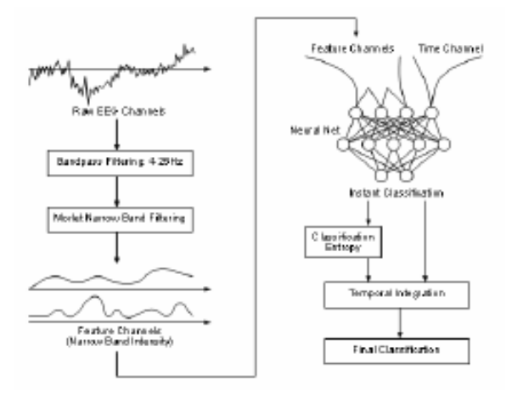
These are the different steps:
- Acquire raw EEG data. Filter the EEG channel using a band pass filter between 4 and 25 Hz.
- Use Morlet Wavelets to extract local frequency information. Compute their absolute value. These are the feature channels.
- Feed a two layer feedforward neural net with the frequency information and an additional time channel (restarts at zero at the begin of every trial). The neural net has two layers: the first weight layer uses the tanh activation function, the second a normal logistic activation. The net is trained using the cross-entropy error as the optimization criterion. The output of the neural net is the estimated instant classification.
- The final classification is obtained after performing a weighted time integration of the instant outputs, where individual weights are higher for low entropy outputs.

CONCLUSION

Brain-Computer Interface (BCI) is a method of communication based on voluntary neural activity generated by the brain and independent of its normal output pathways of peripheral nerves and muscles.
The neural activity used in BCI can be recorded using invasive or noninvasive techniques.
We can say as detection techniques and experimental designs improve, the BCI will improve as well and would provide wealth alternatives for individuals to interact with their environment.

REFERENCES

- 1. http://www.nicolelislab.net/NLnet_Load.html
2. http://www.youtube.com/watch?v=7-cpcoIJbOU
3. http://www.en.wikipedia.com/braincomputerinterface

