**Chapter 3**

**System Architecture**

**3.1 Proposed Model:**

This section provides how Augmented Reality allows us to interact with the real and

virtual worlds at the same time how a computer can be used as a tool so as to make it easier for a human to perform a task. This technology has been applied in many fields such as the following:

Medical

Augmented Reality will be far-reaching in the near future. It is being widely used in the healthcare sector (as shown in figure1) where there is a need of visualizing the medical information and the patient within the same physical space . Augmented Reality can be used to perform surgeries and can help surgeons perform real time surgeries without being physically present near the patient. Some of the real life examples where AR is being used in medical field are:

* EyeDecide : This is a medical app which simulates the impact of specific conditions or medicines on a person’s vision using a camera.
* AccuVein : This app uses a handheld camera which projects over the skin. Thus nurses and doctors get to know where the veins are in the patients’ bodies. 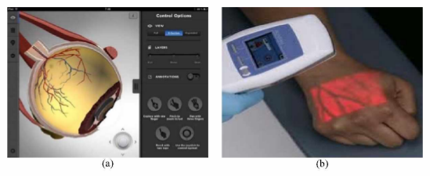

Fig 3.1 Applications of AR in Medical : (a) EyeDecide App, (b) AccuVein App