Solution:  
(MOVE-LEFT-FROM-TO ROBOT1 X0 Y2 X0 Y1)

(MOVE-LEFT-FROM-TO ROBOT1 X0 Y1 X0 Y0)

(MOVE-DOWN-FROM-TO ROBOT1 X0 Y0 X1 Y0)

(MOVE-DOWN-FROM-TO ROBOT1 X1 Y0 X2 Y0)

(MOVE-DOWN-FROM-TO ROBOT1 X2 Y0 X3 Y0)

(MOVE-RIGHT-FROM-TO ROBOT1 X3 Y0 X3 Y1)

(MOVE-RIGHT-FROM-TO ROBOT1 X3 Y1 X3 Y2)

(MOVE-UP-FROM-TO ROBOT1 X3 Y2 X2 Y2)

(MOVE-RIGHT-FROM-TO ROBOT1 X2 Y2 X2 Y3)

Solution:  
(MOVE-DOWN-FROM-TO ROBOT1 X2 Y0 X3 Y0)

(MOVE-RIGHT-FROM-TO ROBOT1 X3 Y0 X3 Y1)

(MOVE-RIGHT-FROM-TO ROBOT1 X3 Y1 X3 Y2)

(MOVE-RIGHT-FROM-TO ROBOT1 X3 Y2 X3 Y3)

Solution:  
(MOVE-UP-FROM-TO ROBOT1 X1 Y2 X0 Y2)

Solution:  
No plan

Solution:  
No plan

Solution:  
(MOVE-DOWN-FROM-TO ROBOT1 X2 Y2 X3 Y2)

(MOVE-RIGHT-FROM-TO ROBOT1 X3 Y2 X3 Y3)

Solution:  
(MOVE-DOWN-FROM-TO ROBOT1 X1 Y1 X2 Y1)

(MOVE-RIGHT-FROM-TO ROBOT1 X2 Y1 X2 Y2)

Solution:

No plan

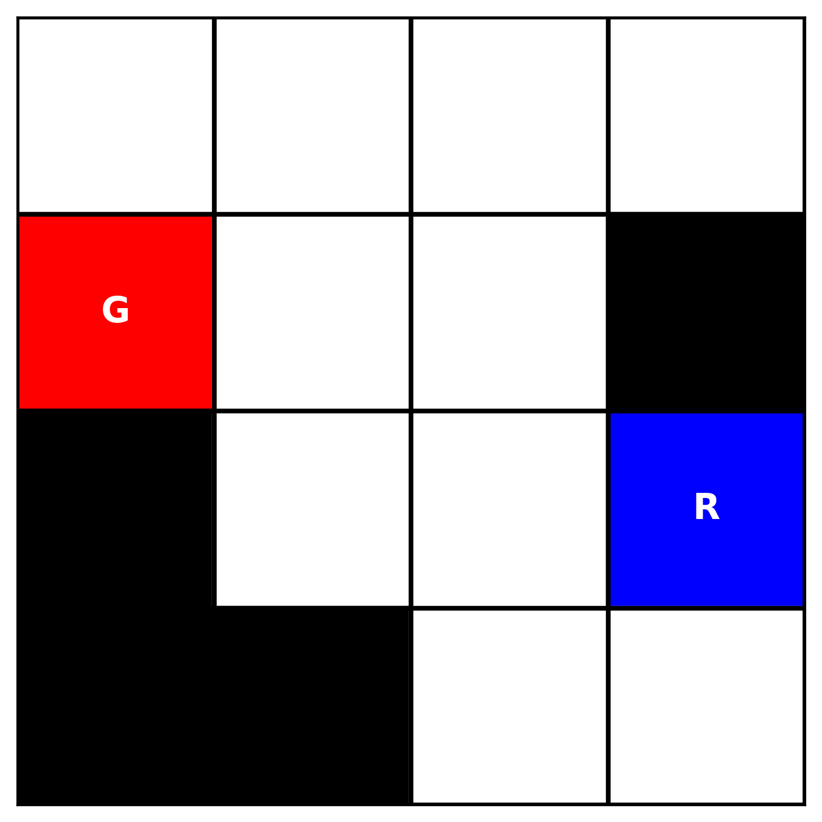

Solution:  
(MOVE-LEFT-FROM-TO ROBOT1 X2 Y3 X2 Y2)

(MOVE-LEFT-FROM-TO ROBOT1 X2 Y2 X2 Y1)

(MOVE-UP-FROM-TO ROBOT1 X2 Y1 X1 Y1)

(MOVE-LEFT-FROM-TO ROBOT1 X1 Y1 X1 Y0)

Solution:  
(MOVE-RIGHT-FROM-TO ROBOT1 X1 Y2 X1 Y3)

(MOVE-UP-FROM-TO ROBOT1 X1 Y3 X0 Y3)