Exercise 2.A
1. Weak prompt - Explain regression
a. improved prompt
Explain linear regression in simple words and give a real-life example. Also explain when it is used in data analysis?
b. Include a screenshot of the AI response
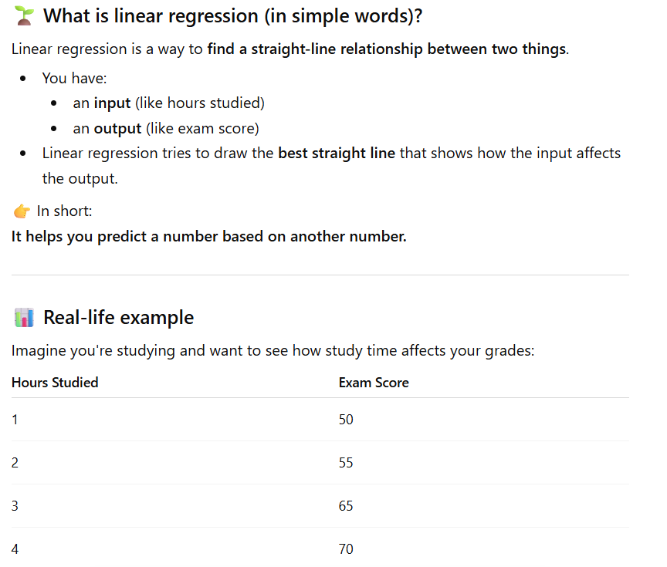

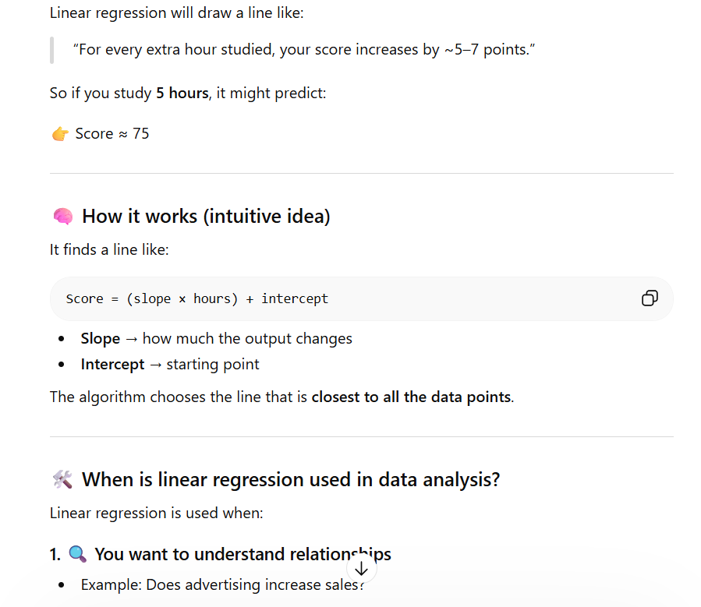

c. Briefly explain why your revised prompt is stronger?
This prompt is better because it gives more details. It asks for simple words and an example, so the answer is easier to understand.
2. Weak Prompt - Help me understand SQL
a. Improved Prompt
Explain SQL basics for beginners and include simple examples of SELECT, WHERE, and JOIN.
b. Include a screenshot of the AI response

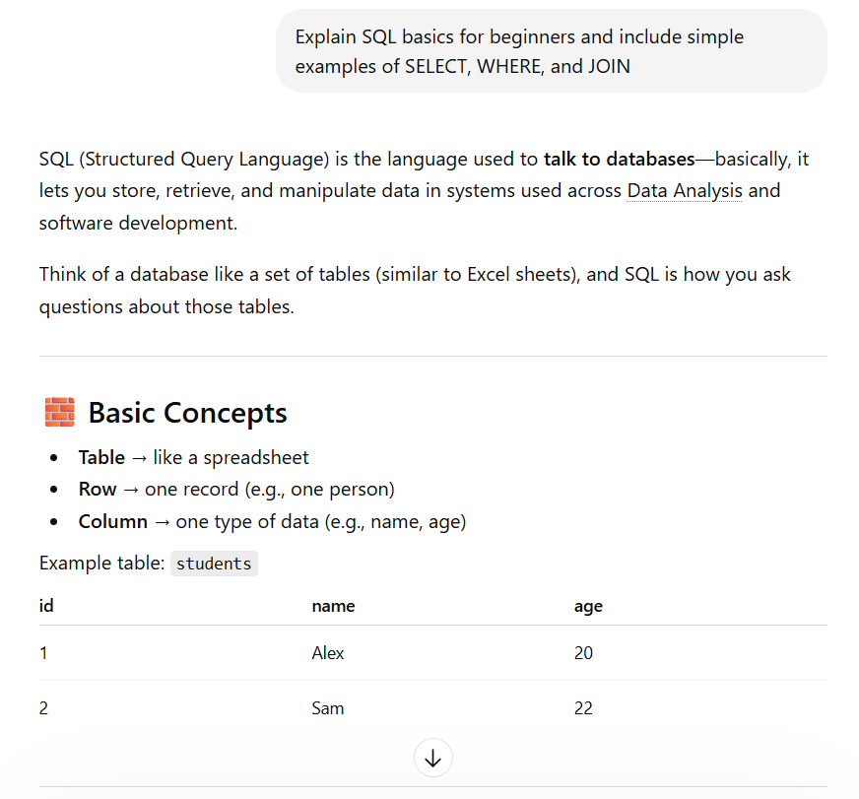
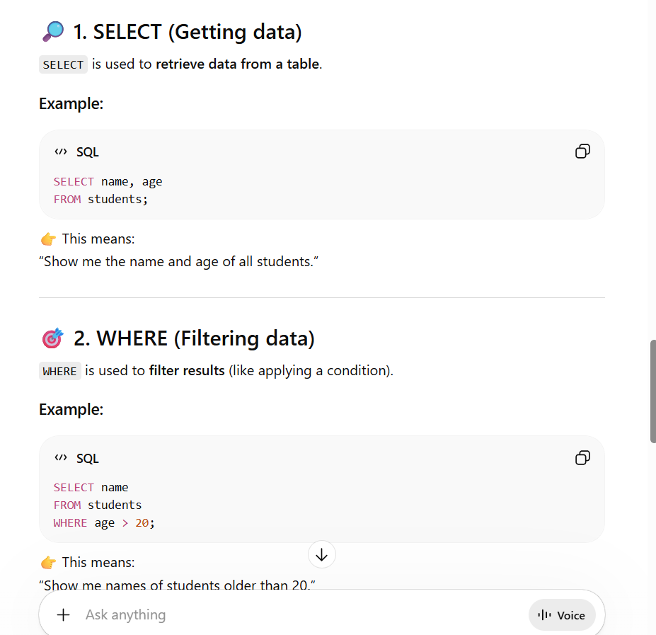

c. Briefly explain why your revised prompt is stronger?
This one is clearer because it says beginner level and asks for specific parts. This helps get a more useful and simple answer.

3. Weak Prompt - Create a dataset
a. Improved Prompt
Create a dataset with 5 rows that includes student names, test scores (0–100), and grades. Show it in a table?
b. Include a screenshot of the AI response
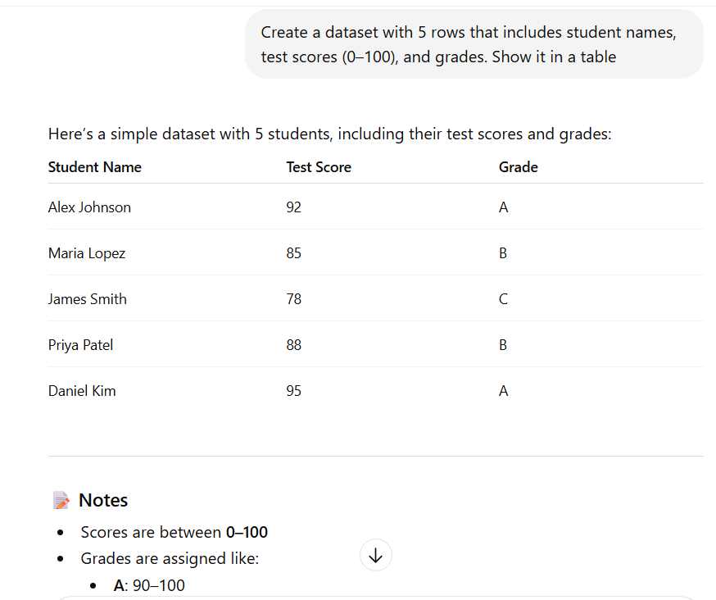

c. Briefly explain why your revised prompt is stronger?
This prompt is stronger because it clearly explains what is needed. It gives details like number of rows and columns, so the result is more accurate.

