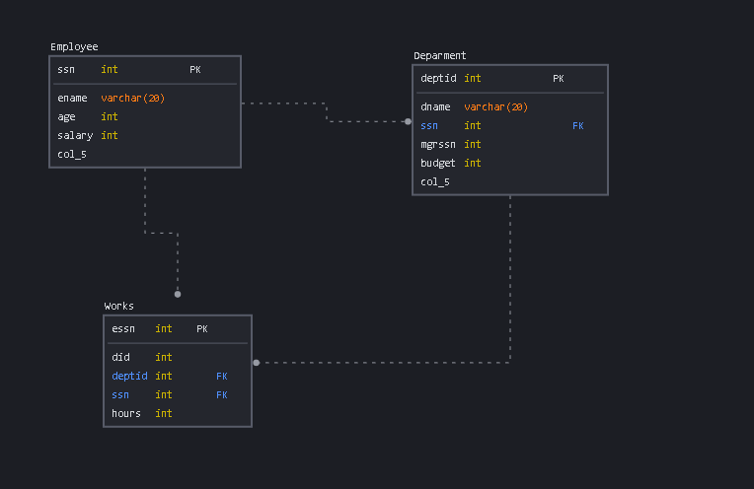
2.
Primary key ,NOT NULL ,FOREIGN KEY
3 .
ALTER TABLE WORKS ADD CONSTRAINT PRIMARY KEY(ESSN)
4.1
ENAME | SALARY
RAY DIAZ | 89000
PHYLLIS BONACCI | 55000
BRYAN DECIMALI | 65 000
4.2
DNAME | ENAME | BUDGET | SALARY
SOFTWARE | PHYLLIS BONNACCI | 678000 | 55000
HARDWARE | RAY DIAZ | 531000 | 89000
FIRMWARE | RAY DIAZ | 420000 | 89000
SLEEPWEAR | HIRAM POTTANOOSE | 88000 | 100000
4.3
DNAME | SUM(SALARY)
HARDWARE | 89000
FIRMWARE | 89000
SOFWARE | 78000

5.A
SELECT E.ENAME,E.AGE FROM EMLOYEE INNER JOIN DEPARTMENT D ON SSSN=MGRSSN WHERE D.DNAME=’FIRMWARE ‘ AND D.DNAME =’SOFTWARE’
5.B
SELECT E.ENAME FROM EPMLOYEE E ,DEPARTMENT D WHERE E.SSN !=D.MGRSSN
5.C
SELECT DNAME FROM DEPARTMENT WHERE BUDGET=(SELECT MAX(BUDGET) FROM DEPARTMENT)
6.SELECT D.DNAME ,SUM(SALARY) FROM DEPARTMENT INNER JOIN WORKS W ON D.DEPTID=W.DID INNER JOIN EMPLOYEE E ON E.SSN =W.ESSSN WHERE W.HOURS>=20
7. RS.ISEMPTY()
SOUT(EMPLOYEE NAME)
SOUT (SALARY)
8.IT IS NOT LOGICAL TO CREATED THIS COLUMN BECAUSE ONE REASON MENAGER TABLE HAVE NOT IN US THEN WHY IS CREATED

