XRAY

Day 1 – XRAY Basics + Setup
Learnt
- What Xray is and why companies use it
- Xray vs TestRail
- Xray architecture inside Jira
- Xray issue types overview
Practical
- Enabled Xray in Jira project
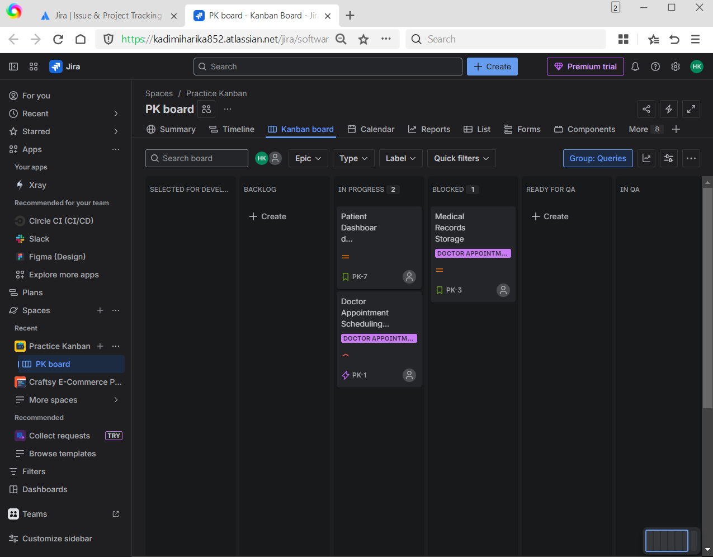
- Identified Xray issue types:
  - Test
  - Test Execution
  - Test Plan
  - Test Set
  - Precondition
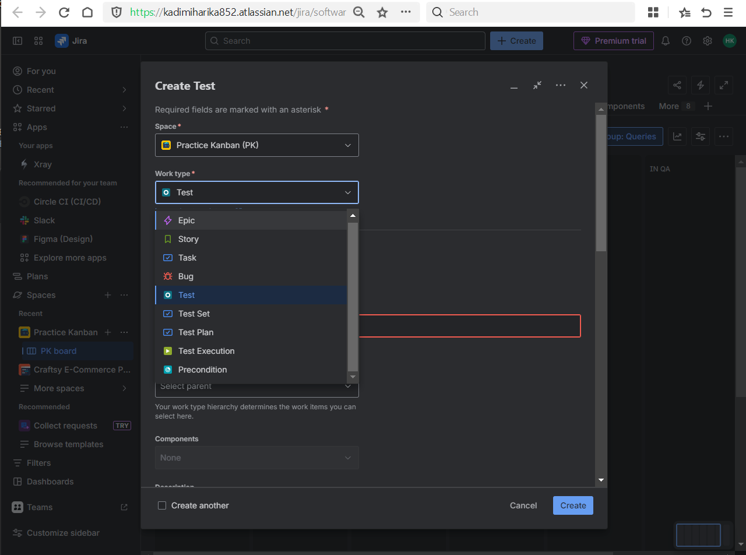
- Navigated Xray menu and reports
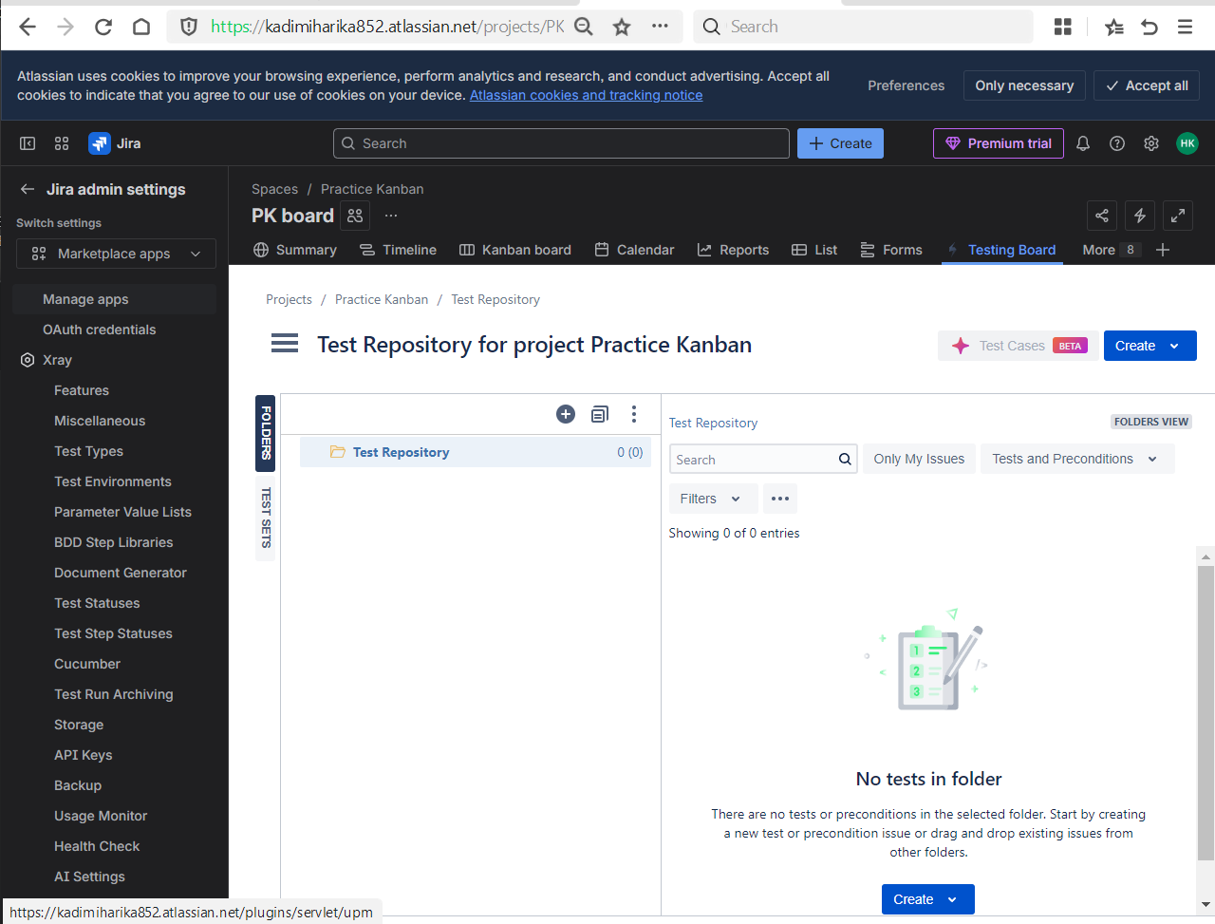
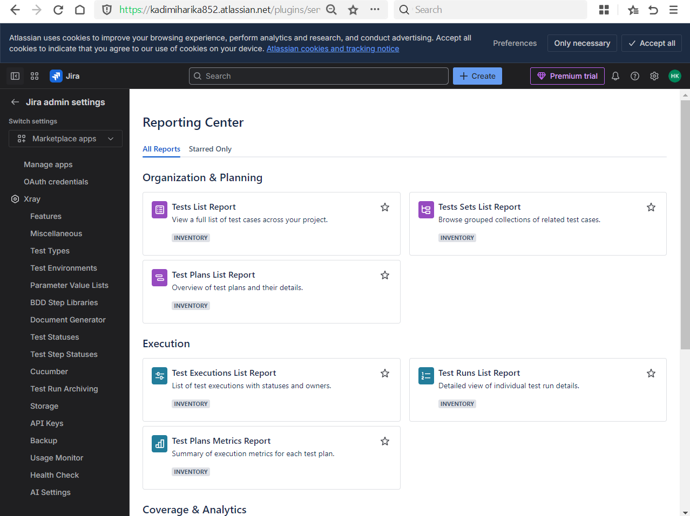

Day 2 – Writing Test Cases in XRAY (Core Skill)
Learnt
- Xray Test issue structure
- Manual test vs Cucumber test
- One test case = one validation
- Test steps vs expected results
Practical
- Created manual Test issues:
  - Login – valid credentials
  - Login – invalid password
  - Login – blank fields
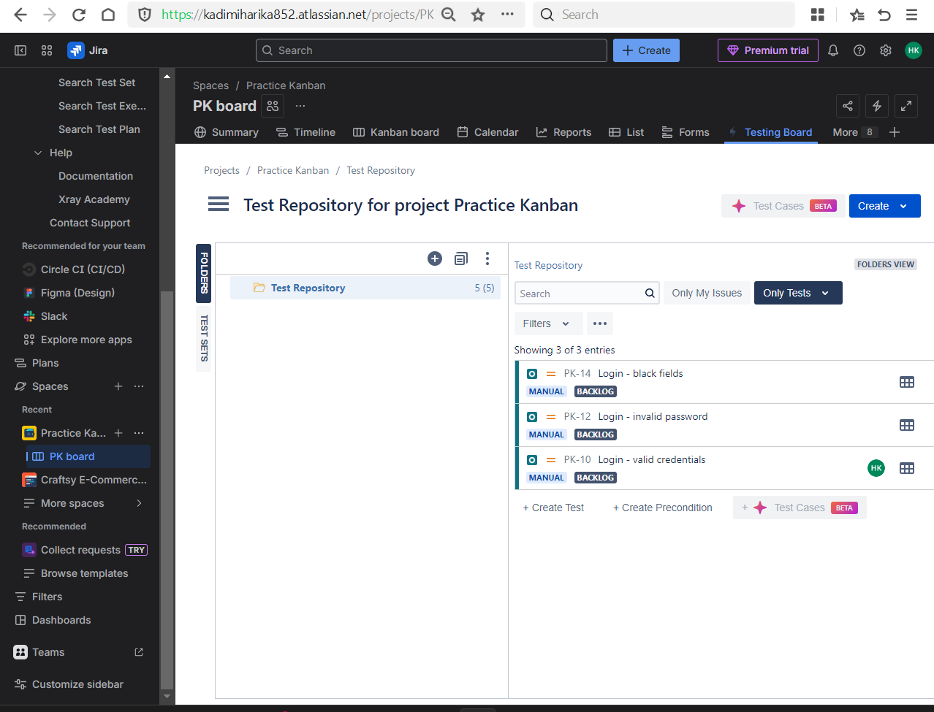
- Added test steps and expected results
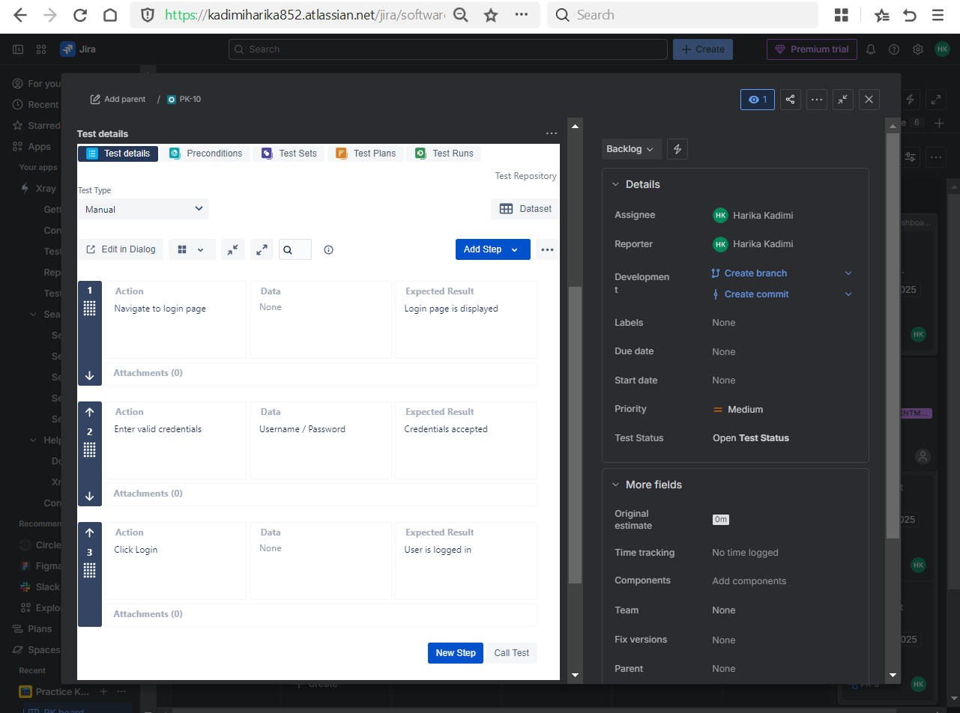
- Edited and cloned test cases
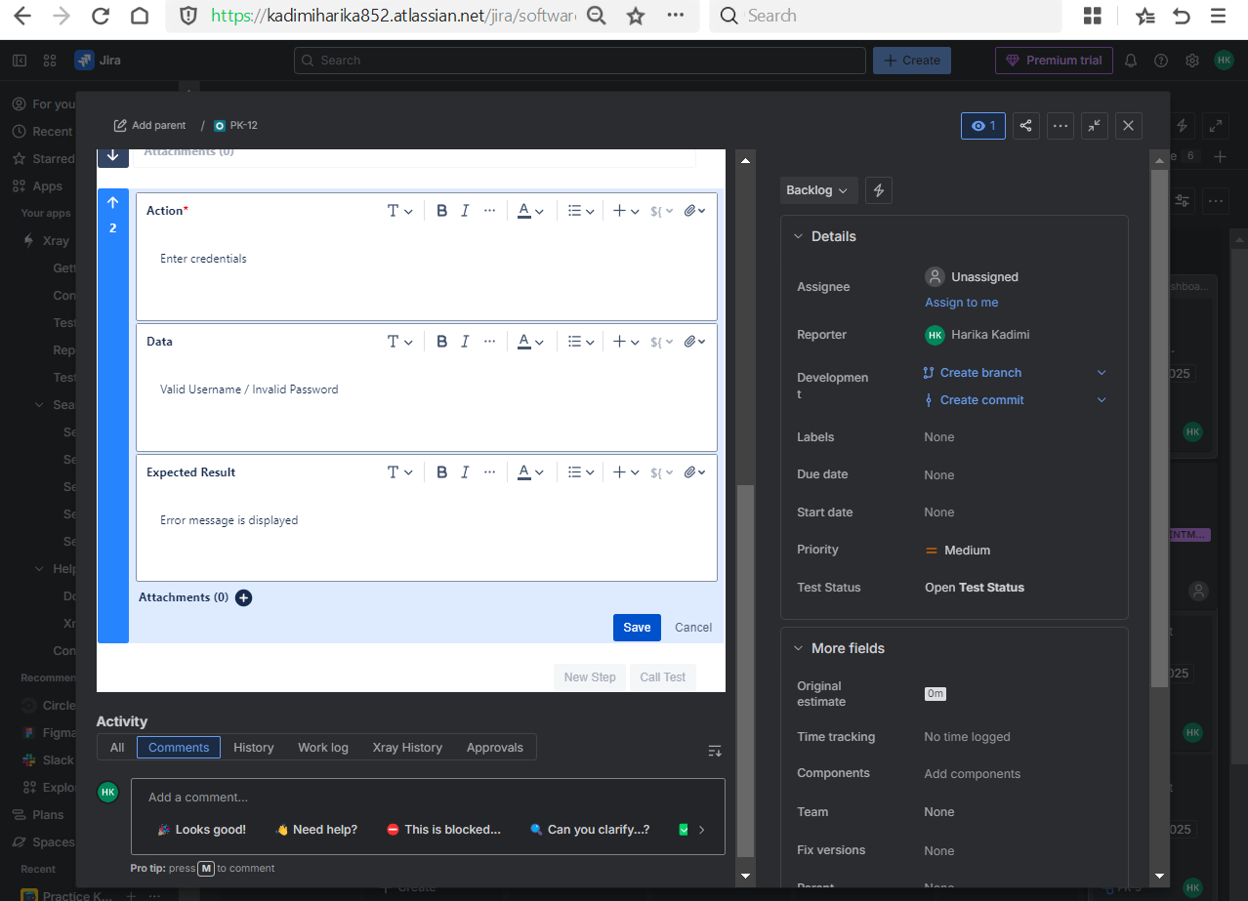
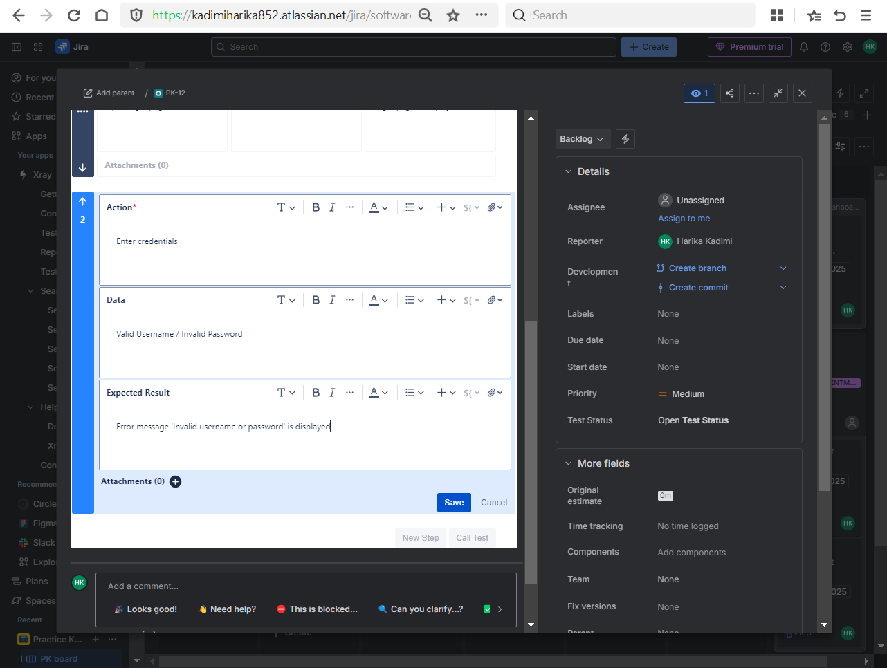
- Cloning
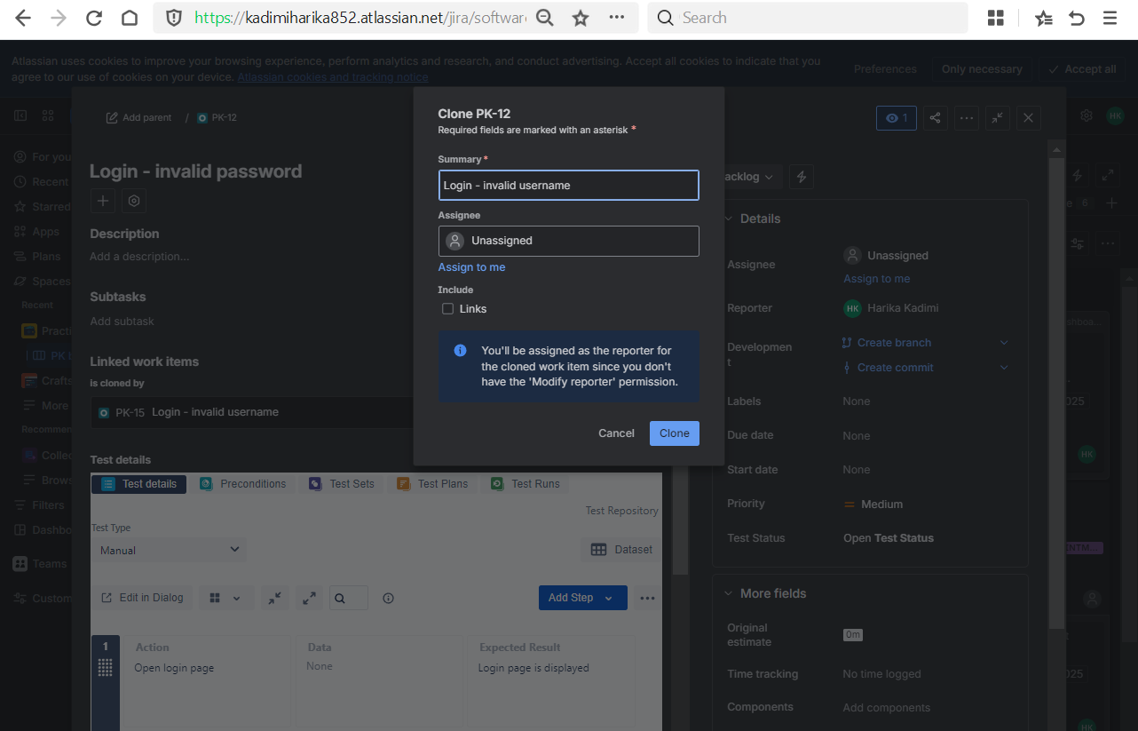
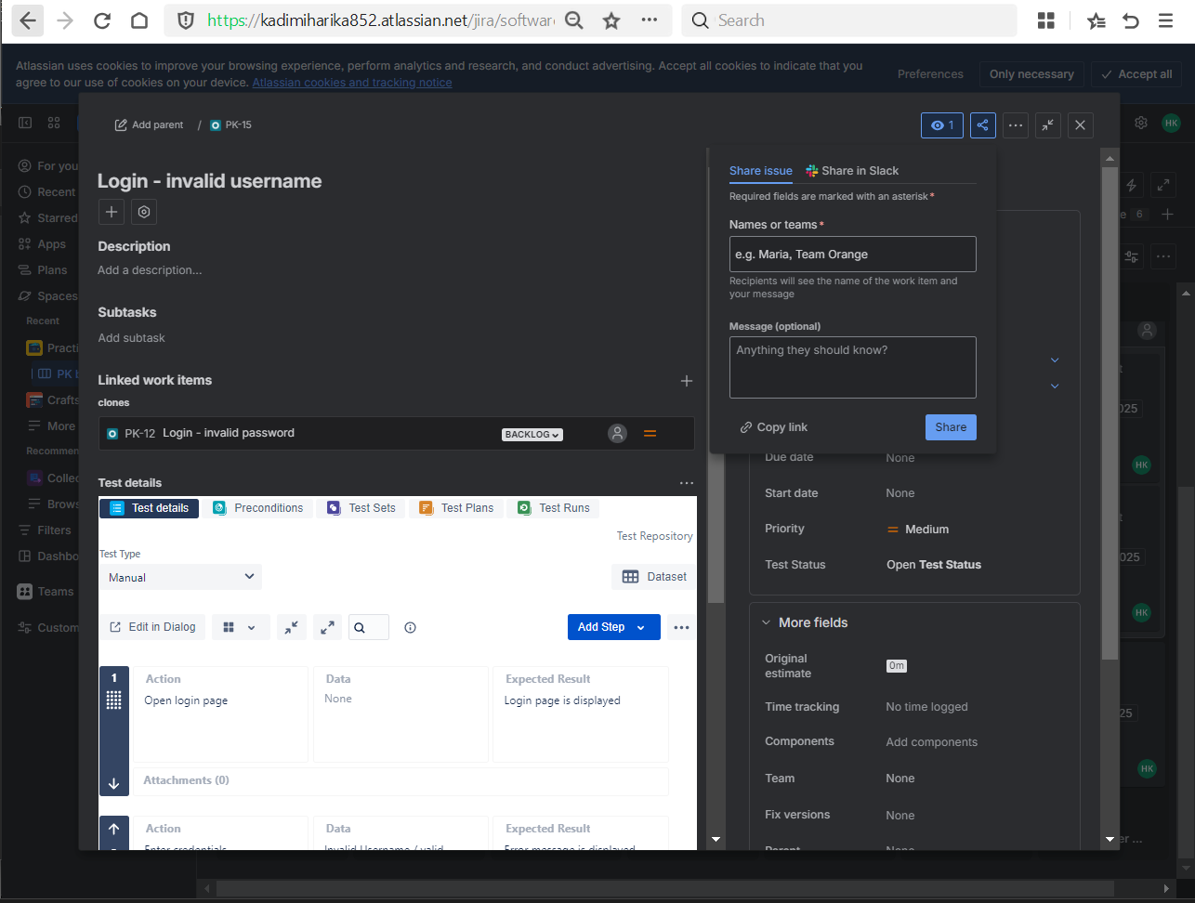

Day 3 – Preconditions + Test Sets
Learnt
- What Preconditions are and why they are used
- Reusability of Preconditions
- Difference between Test Set and Test Plan
Practical
- Created Preconditions:
  - Active user exists in the system
  - User account exists
  - Application is up and running
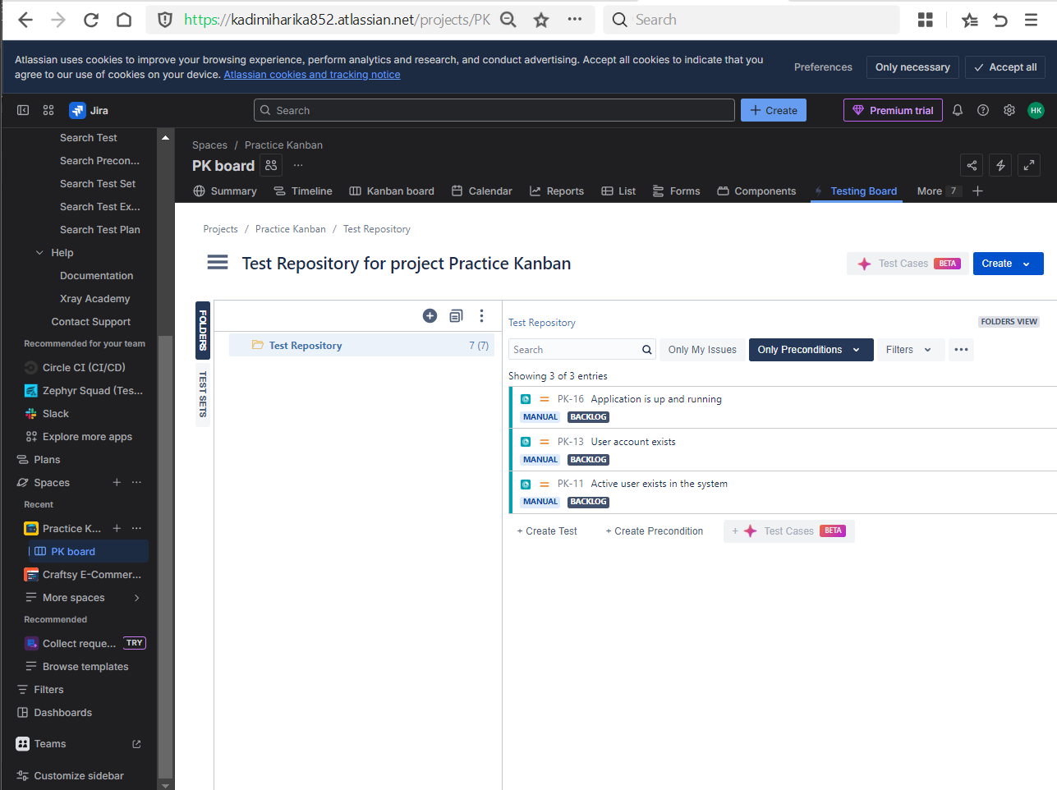
- Linked Preconditions to test cases
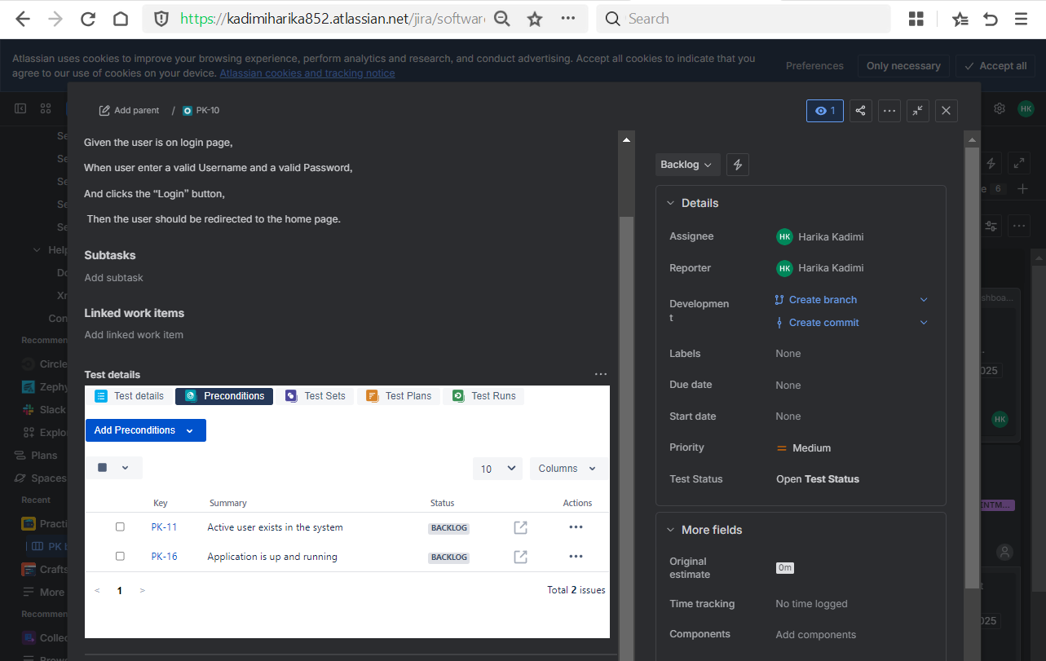
- Created Test Sets:
  - Login test set
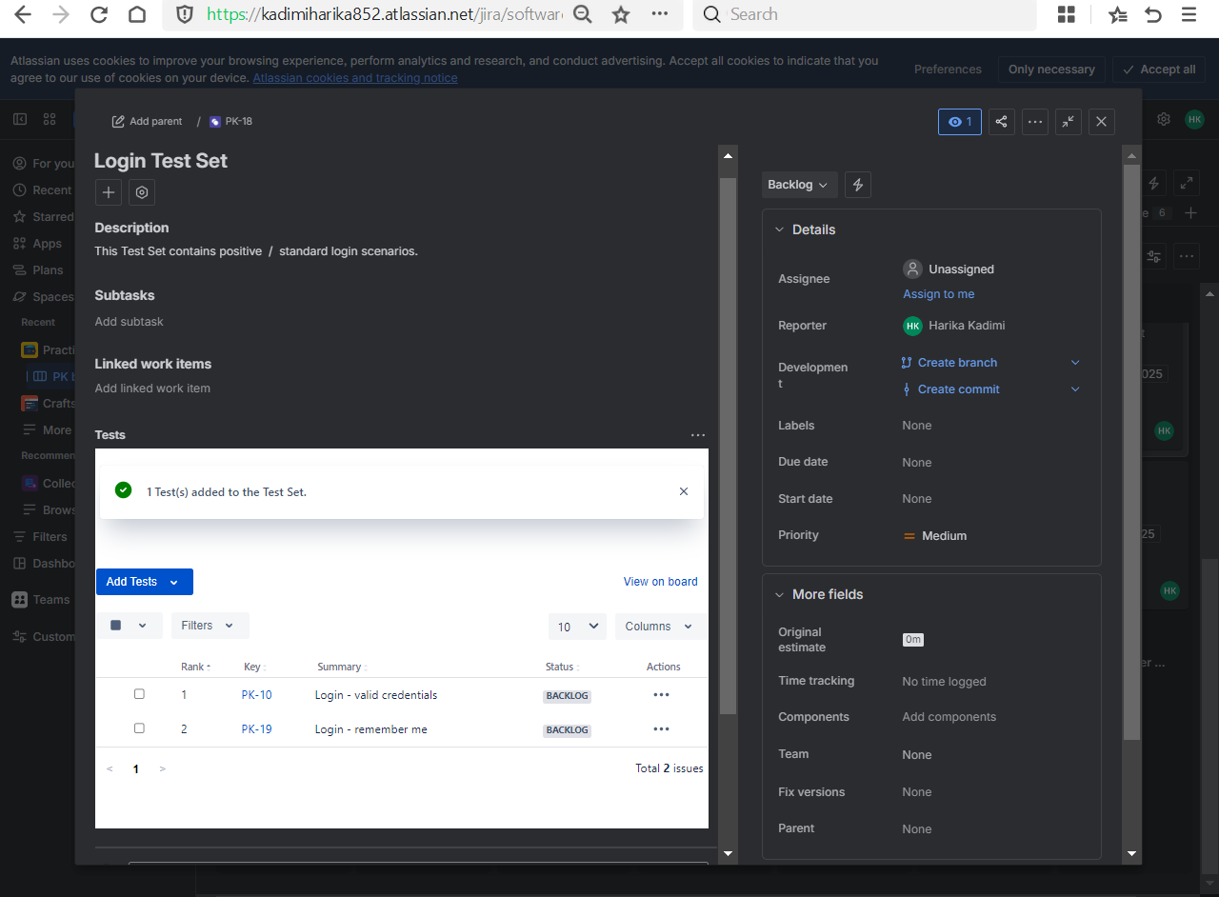
  - Negative login test set
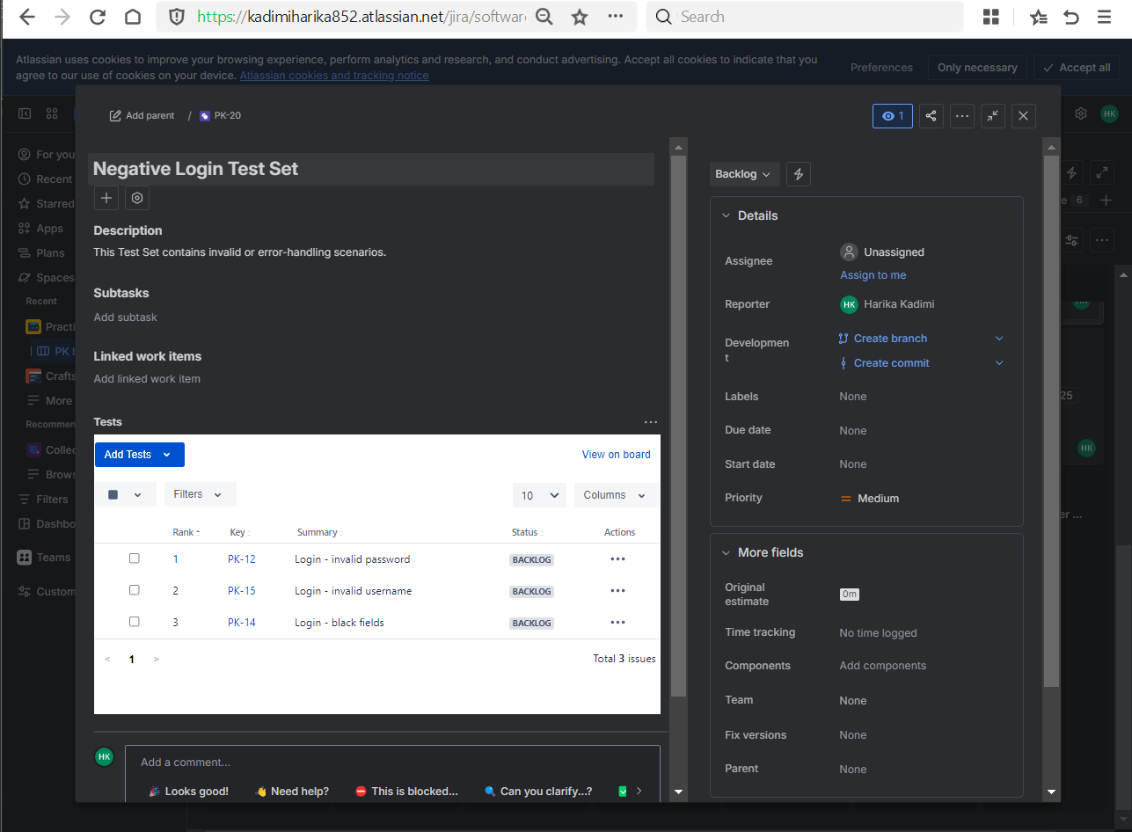

Day 4 – Test Execution + Defect Management (VERY IMPORTANT)
Learnt
- What Test Execution means in real projects
- Execution statuses (Pass / Fail / Blocked)
- Defect linkage from failed tests
Practical
- Created Test Execution issue
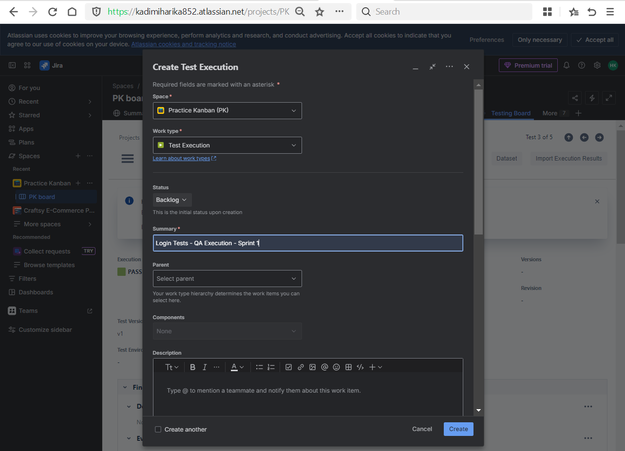
- Added test cases to execution
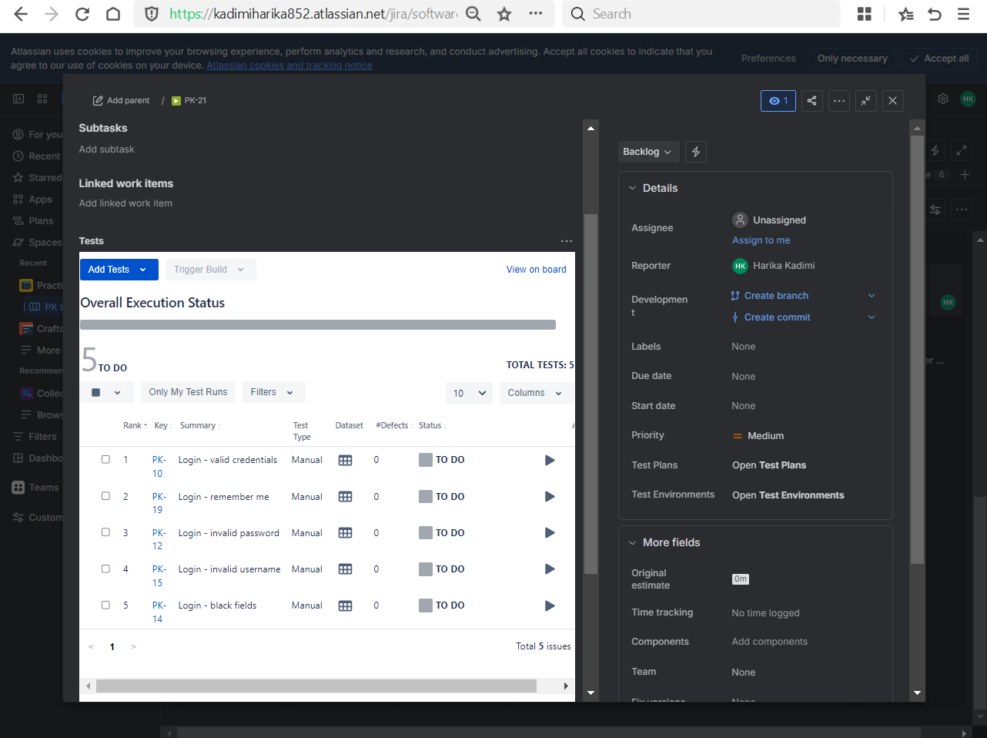
- Executed tests and updated status
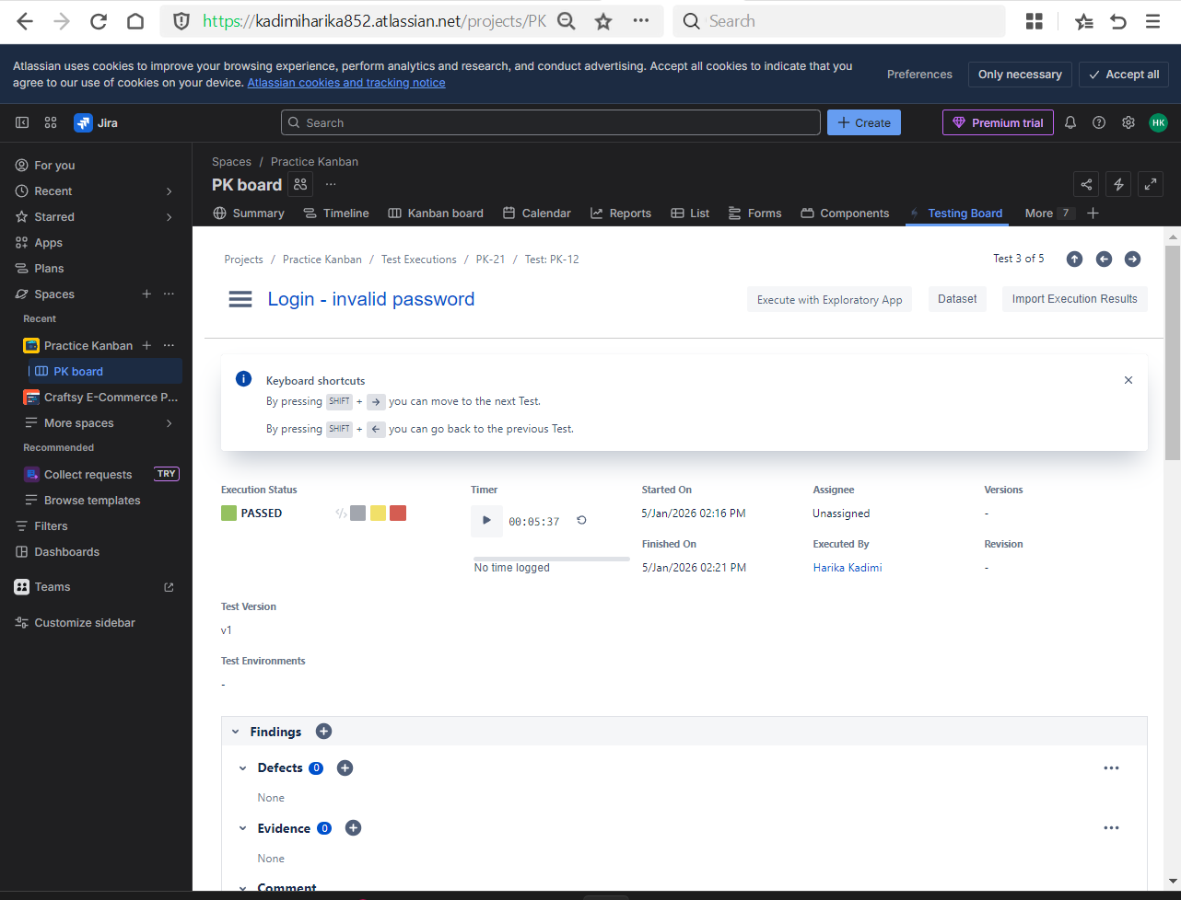
- Created Bug and linked it to failed test
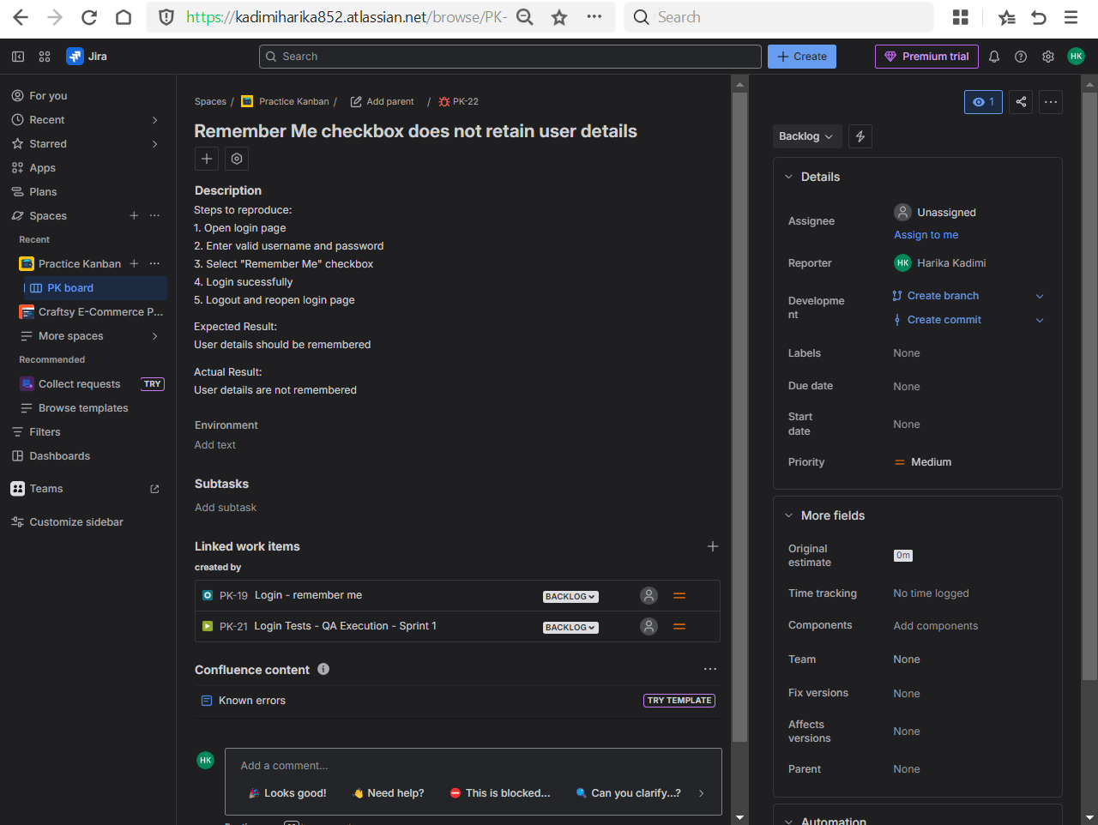

Day 5 – Test Plan + RTM (Veeva Critical)
Learnt
- Purpose of Test Plan in releases
- Requirement Traceability Matrix (RTM)
- Bi-directional traceability
Practical
- Created Test Plan for:
  - Sprint 1 / Release 1
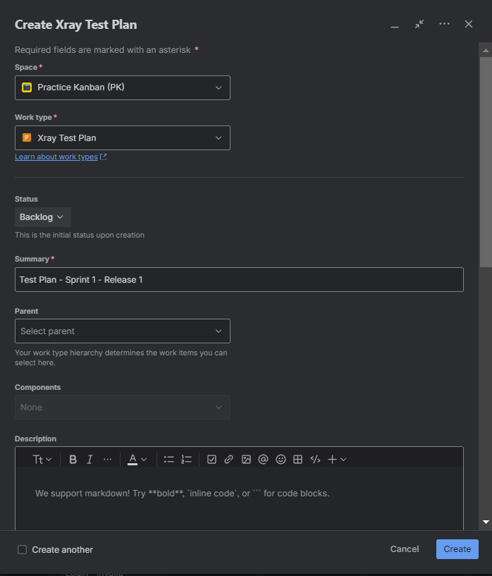
- Linked:
  - User Stories → Tests → Executions → Bugs
- User Story Test (Using is tested by or tests link issue)
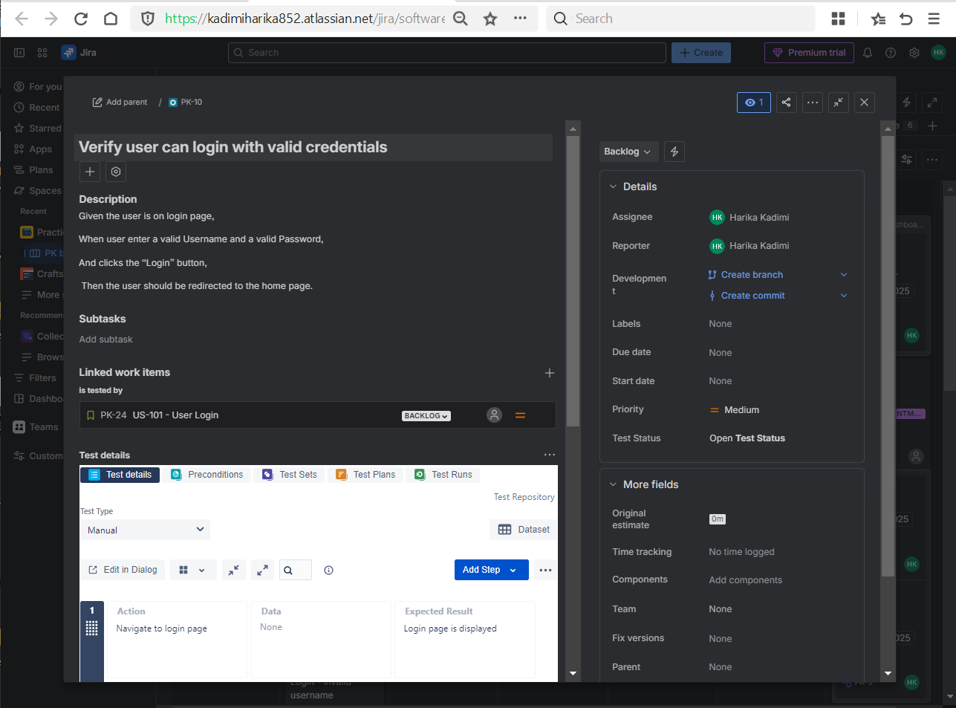
- Test Test Plan
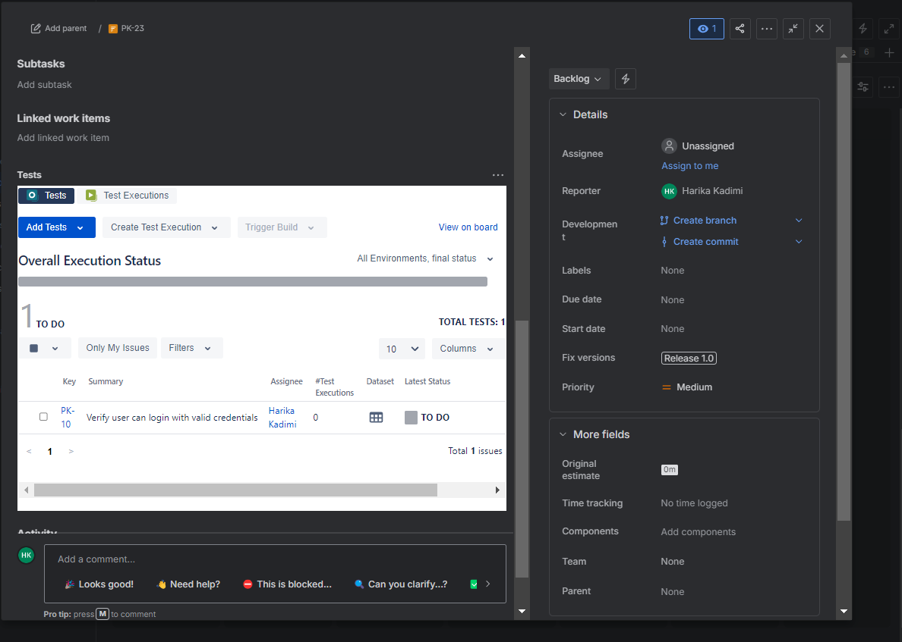
- Test Test Execution
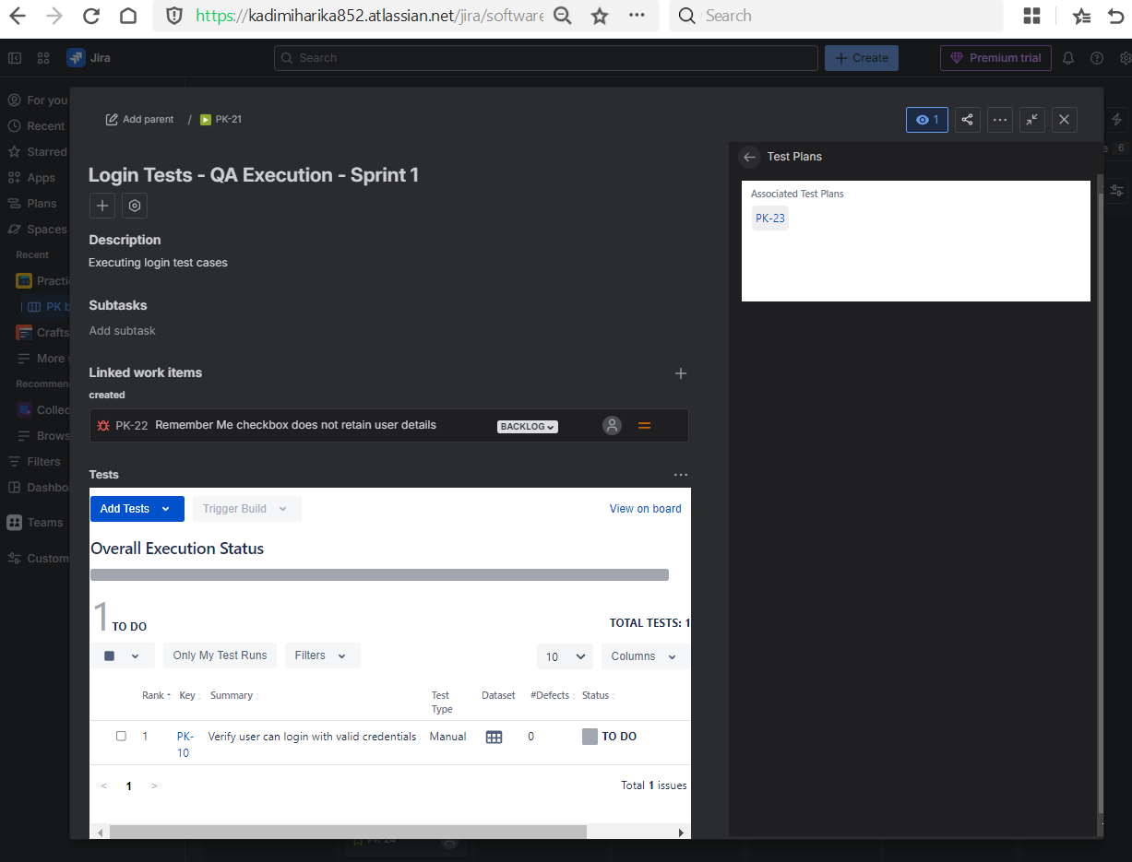
- Test Execution Bug
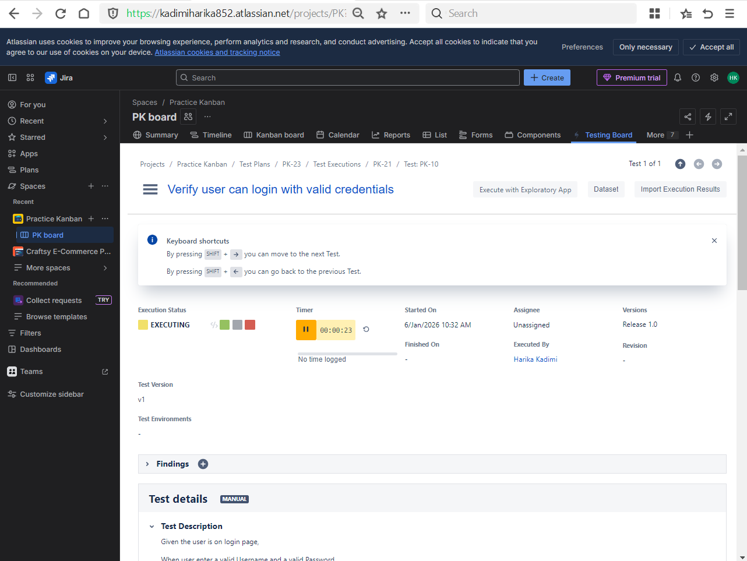
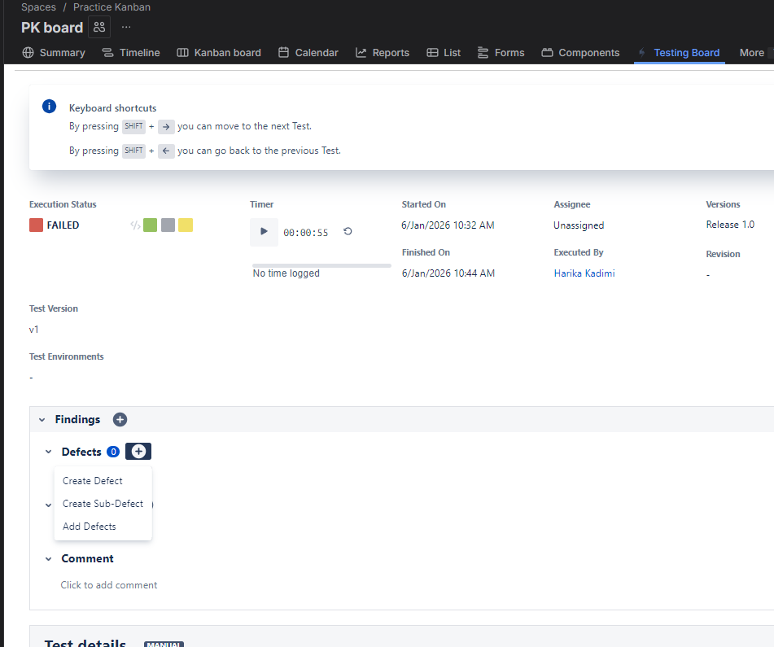
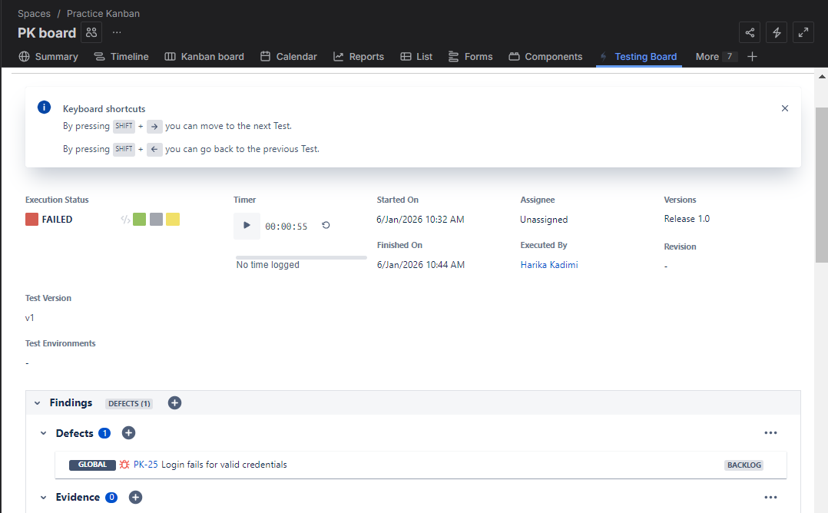
- Viewed coverage and traceability reports
- Go to Xray Reporting Centre
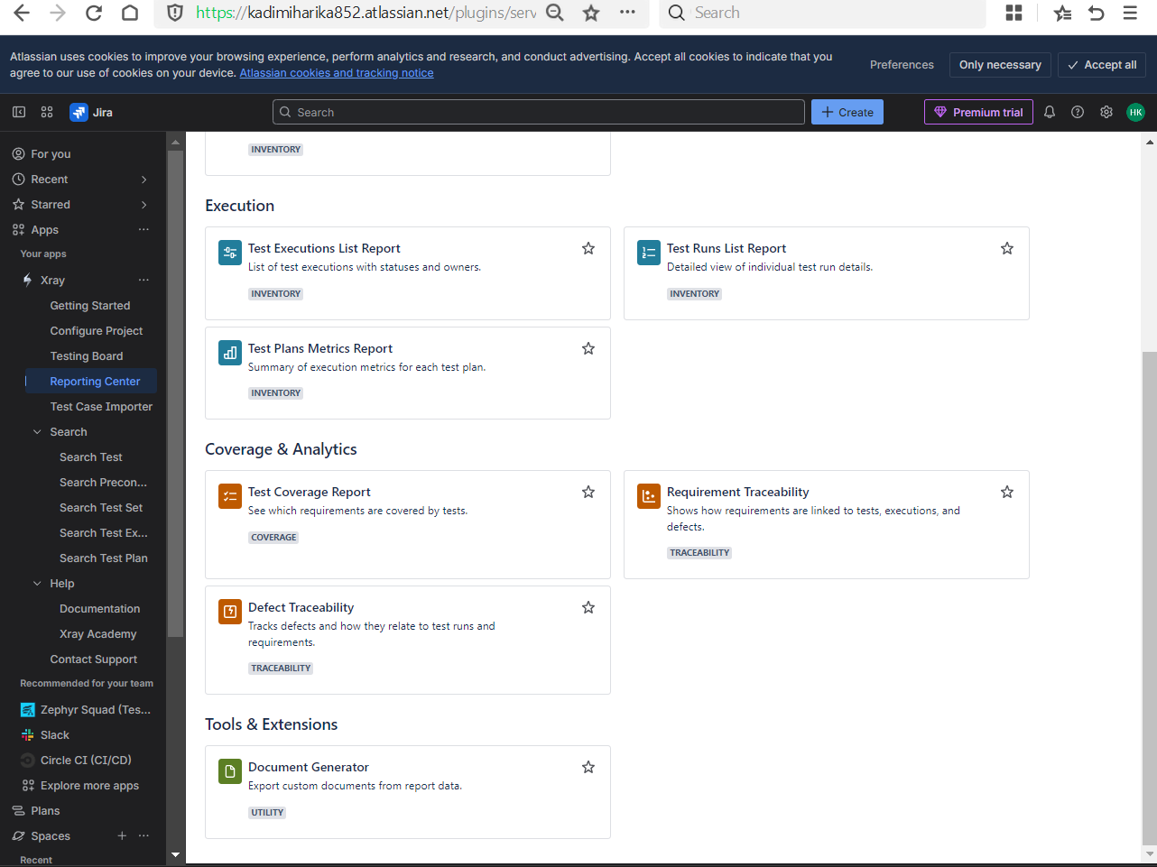
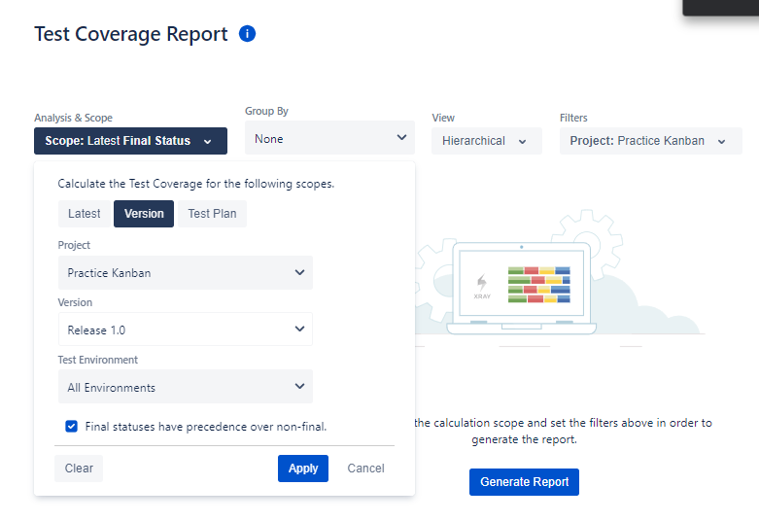

Day 6 – Reports + Interview Preparation
Learnt
- Xray reports overview
- Coverage report
- Execution report
- Audit & compliance relevance (Veeva)
Practical
- Viewed:
  - Requirement coverage report
  - Test execution status report
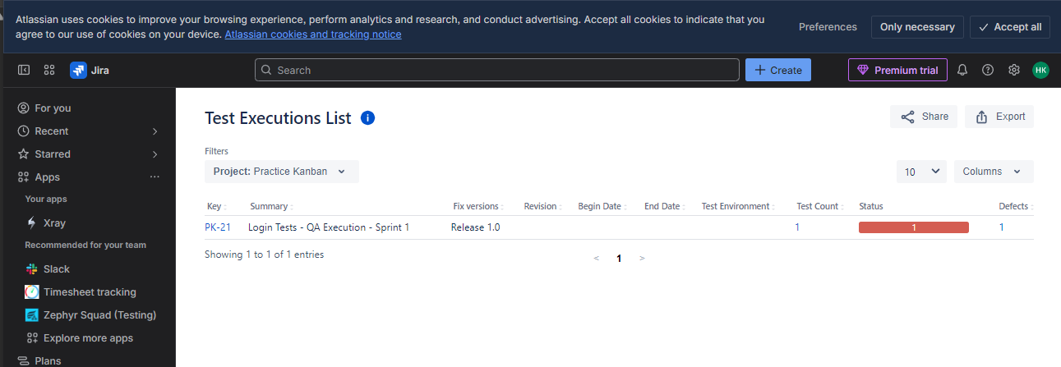
- Prepared answers for:
  - “How do you use Xray in Agile?”
  - “How is RTM maintained in Xray?”

.

