PRECISION API BDD AUTOMATION FRAMEWORK
Using Java, REST Assured & Cucumber (BDD)

Project Title: Automation of Swagger Petstore API
Technologies Used: Java | REST Assured | Cucumber | Maven | Postman | Git
Organization: Veeva Systems
Duration: 10-03-2026 to 10-04-2026
EXECUTIVE SUMMARY
This project presents the design and implementation of a robust API Test Automation Framework developed using Java, REST Assured, and Cucumber following Behavior-Driven Development (BDD) principles. The framework is designed to automate and validate RESTful web services using the Swagger Petstore API as the test application.
The primary objective of this project is to simulate real-world automation practices by building a scalable, maintainable, and reusable framework. It includes implementation of core testing concepts such as CRUD operations, API chaining, cross-endpoint validation, and negative testing.
The framework follows a modular architecture with clear separation of concerns, including feature files for test scenarios, step definitions for execution logic, and a client layer for handling API requests. Maven is used for dependency management and execution, enabling test execution through a single command.
Additionally, Postman was used to validate API behavior, perform request testing, and understand status codes and environment configurations. Execution reports are generated to provide visibility into test results.
This project demonstrates strong understanding of API automation, framework design, and real-time testing strategies aligned with industry standards.
INTRODUCTION
In modern software development, APIs play a critical role in enabling communication between systems. Ensuring the reliability, performance, and correctness of APIs is essential for overall application stability. Manual testing of APIs can be time-consuming and error-prone, which makes automation a crucial part of the testing process.
API automation enables faster execution, better test coverage, and improved accuracy. It also allows continuous integration and delivery practices to be implemented effectively.
This project focuses on building a scalable API automation framework using industry-standard tools and practices. The framework is designed to simulate real-time testing scenarios and provide a structured approach to API validation.
OBJECTIVE
The primary objective of this project is to design and implement a robust, scalable, and maintainable API Test Automation Framework using industry-standard tools and practices.
The key goals of this project include:
- To automate REST API testing using REST Assured
- To implement Behavior-Driven Development (BDD) using Cucumber
- To perform end-to-end CRUD operations with API chaining
- To validate cross-endpoint data consistency and complex response parsing
- To implement negative testing scenarios for error handling
- To design a modular framework with clear separation of concerns
- To enable execution using Maven with the command "mvn clean test"
- To generate execution reports for test analysis
- To utilize Postman for API validation and understanding request-response behavior
This project aims to simulate real-world automation framework development and strengthen practical testing skills aligned with industry requirements.
TECHNOLOGY STACK
The following technologies and tools were used to design and implement the API automation framework:
- Java 21: Core programming language used to develop the automation framework and implement test logic.
- REST Assured: A Java-based library used for testing RESTful APIs. It simplifies HTTP request creation, response validation, and JSON parsing.
- Cucumber (BDD Framework): Used to implement Behavior-Driven Development. It allows writing test scenarios in a readable Gherkin format using Given-When-Then structure.
- Maven: Build automation and dependency management tool. It helps in managing project dependencies and executing tests using the command "mvn clean test".
- Postman: Used for manual API testing, request validation, and understanding API behavior including status codes and environment variables.
- IntelliJ IDEA: Integrated Development Environment (IDE) used for writing, debugging, and executing the project.
- Git: Version control system used to track changes and manage project versions.
- Swagger Petstore API: Public API used as the test application for performing automation testing.
These tools collectively help in building a scalable, maintainable, and efficient automation framework aligned with industry practices.
FRAMEWORK ARCHITECTURE
The API automation framework is designed using a layered architecture approach to ensure modularity, reusability, and maintainability. Each layer has a specific responsibility, enabling clear separation of concerns.
The framework consists of the following components:
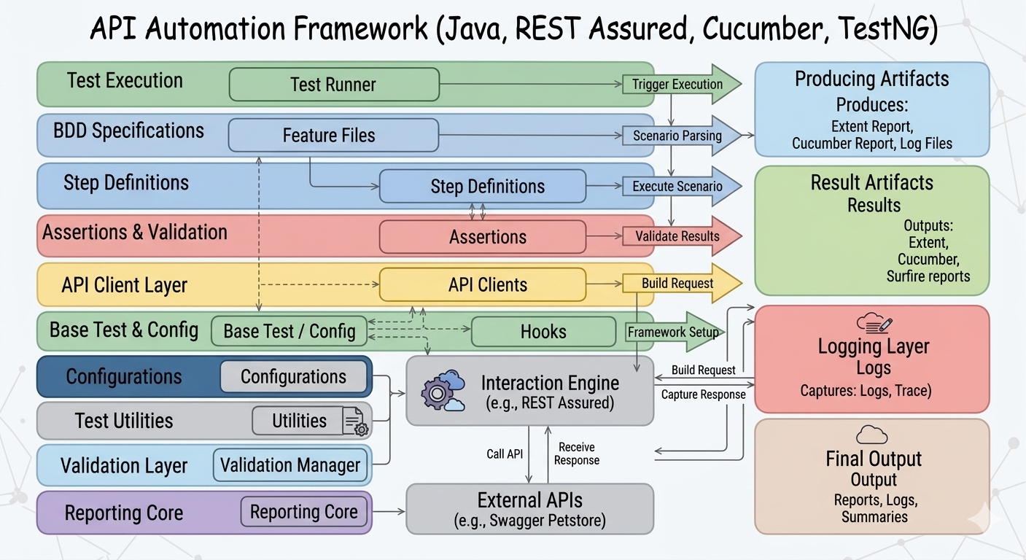
Fig. No. 1: System Architecture

This diagram represents a layered architecture for our API BDD automation framework. Test execution starts from the TestNG runner, which triggers the Cucumber feature files written in Gherkin. These feature steps are mapped to step definitions that interact with reusable API client methods. The API client layer encapsulates all REST calls using REST Assured, ensuring separation between test logic and API interaction. Core framework components like BaseTest and Hooks manage configuration, setup, and environment properties. The framework validates responses using TestNG assertions, while logging is handled through Log4j. Finally, execution results are captured in Extent and Cucumber reports, providing clear test artifacts for analysis.

TEST CASE IMPLEMENTATION
The framework includes multiple test scenarios designed to validate the functionality, reliability, and consistency of the Swagger Petstore API. These test cases simulate real-world API testing practices.

Test Case 1: Pet Lifecycle (CRUD Operations & API Chaining)
This test case validates the complete lifecycle of a pet using API chaining.
- A new pet is created using a POST request with a unique name and status "available".
- The generated pet ID is extracted dynamically from the response.
- The pet is retrieved using a GET request with the extracted ID.
- The response is validated to ensure the name and status match the original request.
- The pet status is updated to "sold" using a PUT request.
- The pet is deleted using a DELETE request.
- A final GET request is performed to confirm deletion, expecting a 404 response.
This scenario demonstrates API chaining and end-to-end validation.

Test Case 2: Inventory Analysis (Complex Data Parsing)
This test case focuses on validating data consistency across endpoints.
- The inventory is fetched using the GET /store/inventory API.
- The response is parsed to extract the count of pets with status "available".
- A second API call is made to fetch pets by status "available".
- The number of pets returned is compared with the inventory count.
This scenario demonstrates complex response parsing and cross-endpoint validation.

Test Case 3: User Security & Negative Testing
This test case validates error handling and system robustness.
- A user is created with an invalid email format.
- An attempt is made to fetch a non-existing user, expecting a 404 response.
- A login attempt is performed using incorrect credentials.
- The response is validated to ensure that authentication fails.
This scenario ensures proper handling of invalid inputs and error responses.

Test Case 4: Cross-Endpoint Data Consistency
This test case validates consistency of data across multiple API endpoints.
- A new pet is created with a specific status.
- The pet status is updated from "available" to "sold".
- The list of all sold pets is retrieved.
- The created pet ID is searched within the sold pets list using a loop.
This scenario demonstrates cross-endpoint validation and dynamic data verification.

POSTMAN IMPLEMENTATION
Postman was used to perform manual API testing and to understand request-response behavior before implementing automation. It helped in validating API endpoints, status codes, and request structures.
The following tasks were completed using Postman:

Assignment 1: Simple Request and Query Parameters
- A GET request was created for the endpoint /pet/findByStatus.
- A query parameter status=available was added.
- A test script was implemented to validate that the response status code is 200.

Assignment 2: Working with Request Body
- A POST request was created to add a new pet.
- A JSON body was provided with fields such as id, name, and status.
- A test script was written to validate that the response contains the correct pet name.

Assignment 3: Status Code Validation
- A valid GET request was executed to verify a 200 OK response.
- A GET request with a non-existing pet ID was tested to validate a 404 Not Found response.
- A POST request with an empty body was tested to validate 400/405 error responses.

Assignment 4: Environment Variables
- A Postman environment was created with a variable url set to the base API URL.
- All requests were updated to use {{url}} instead of hardcoding the base URL.
- This improved reusability and maintainability of API requests.
Postman helped in building a strong understanding of API testing concepts, which were later implemented in the automation framework.

PROJECT EXECUTION (HOW TO RUN)
The framework is designed to support execution through Maven, enabling easy and consistent test execution.

Prerequisites
Ensure the following tools are installed:
- Java (JDK 21)
- Maven
- IntelliJ IDEA (or any Java IDE)

Steps to Execute
- Open the project in IntelliJ IDEA.
- Install dependencies using Maven:
mvn clean install
- Execute the test suite using:
mvn clean test

Execution Flow
- The TestRunner class triggers execution of all feature files.
- Feature files define the test scenarios.
- Step definitions execute the logic.
- API calls are made using REST Assured.
- Responses are validated using assertions.

Reports
- Test execution reports are generated in:
target/surefire-reports
This setup ensures easy execution and integration with continuous integration pipelines.
REPORTING AND LOGGING
The automation framework generates execution reports to provide detailed insights into test results. Maven Surefire is used to generate reports that include information about test execution status, passed and failed scenarios, and execution time.

Reporting
- Reports are generated automatically after test execution.
- The reports can be accessed in the following location:
target/surefire-reports
- These reports help in analyzing test outcomes and identifying failures.

Logging
- Console logs are used to display execution flow and step-level details.
- Important information such as request execution, response validation, and status codes are printed during test execution.
- Clear assertion messages are provided to improve readability and debugging.
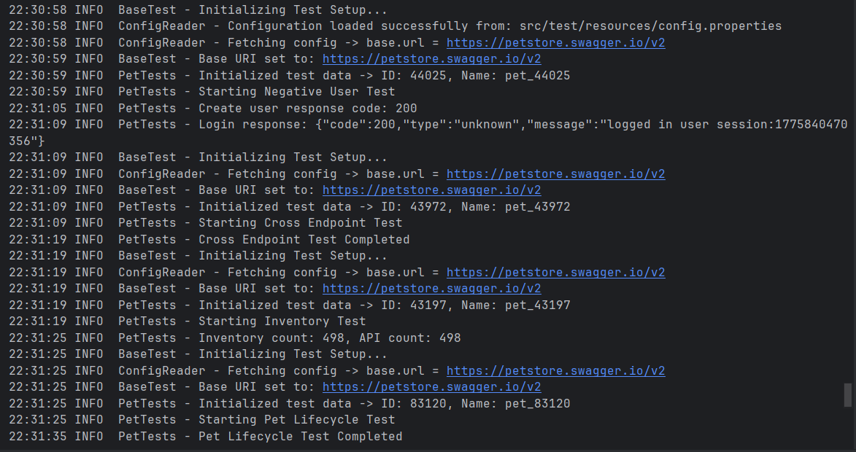
Fig. No. 2: Logging Info

VERSION CONTROL (GITHUB)
Git was used as a version control system to manage the project and track changes throughout development. The project was maintained in a structured repository to ensure proper version tracking and collaboration.

Key Practices Followed
- The project was initialized using Git.
- Code changes were committed regularly with meaningful commit messages.
- Incremental progress was maintained to reflect step-by-step development of the framework.
- The repository includes all essential project files such as source code, feature files, configuration files, and documentation.

Repository
- The complete project is hosted on GitHub for easy access and review.
- It provides visibility into the development process and project structure.
Using Git ensures better collaboration, version tracking, and maintainability of the project.
MY ROLE IN THIS PROJECT:
I was primarily responsible for the design, implementation, and validation of the API automation framework. My key contributions include:
- Designed and developed the framework architecture using Client Pattern, Base classes, and proper package structure.
- Implemented API automation scripts using Java and REST Assured.
- Developed reusable components such as:
- Base test setup
- API client classes
- Utility/helper methods
- Created and executed CRUD test scenarios ensuring proper validation and assertions.
- Integrated BDD (Cucumber) for writing readable and maintainable test scenarios.
- Implemented logging and reporting for better traceability of test execution.
- Handled test data management and dynamic request handling.
- Debugged issues, fixed test failures, and ensured stable execution via Maven.

Collaboration
- Worked collaboratively with the team member on:
  - Requirement understanding
  - Test scenario discussions
  - Review and validation of test cases

CONCLUSION
This project successfully demonstrates the design and implementation of a robust API Test Automation Framework using Java, REST Assured, and Cucumber. The framework is capable of handling real-world testing scenarios including CRUD operations, API chaining, cross-endpoint validation, and negative testing.
The modular architecture ensures scalability, reusability, and maintainability, making it suitable for enterprise-level applications. The use of Maven for execution, Postman for validation, and Git for version control further enhances the overall quality of the project.
Through this project, valuable knowledge was gained in API automation, framework design, and industry-standard testing practices. It also strengthened problem-solving skills and the ability to implement structured and efficient automation solutions.
This framework serves as a strong foundation for future enhancements such as data-driven testing, CI/CD integration, and advanced reporting mechanisms.
REFERENCES AND PROJECT EVIDENCE

GitHub Repository
The complete source code for the project is available at: view
The repository includes:
- Source code (Java, REST Assured, Cucumber)
- Feature files and step definitions
- Maven configuration (pom.xml)
- Documentation and project structure

Execution Screenshots
The following screenshots provide evidence of successful test execution:
- Maven Execution (mvn clean test output)
- Cucumber Test Execution Results
- Surefire Report Output
- Postman Request and Response Validation
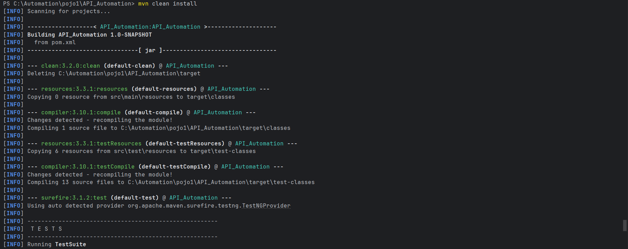
Fig. No. 3: Execution of the project
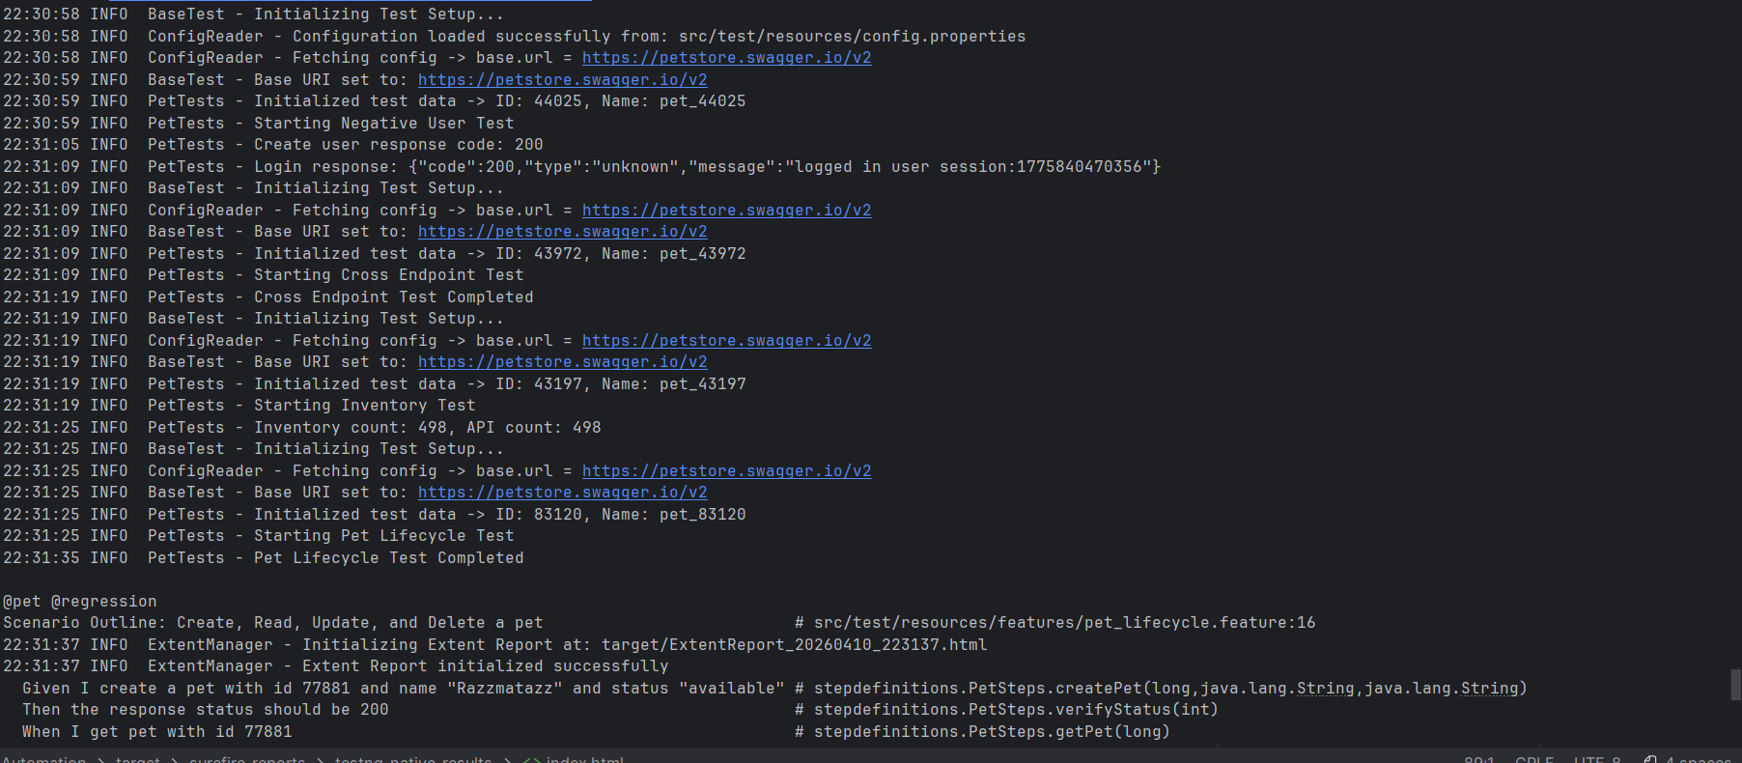
Fig. No. 4: Execution of the project
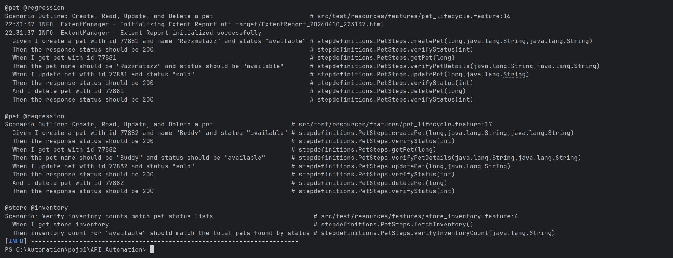
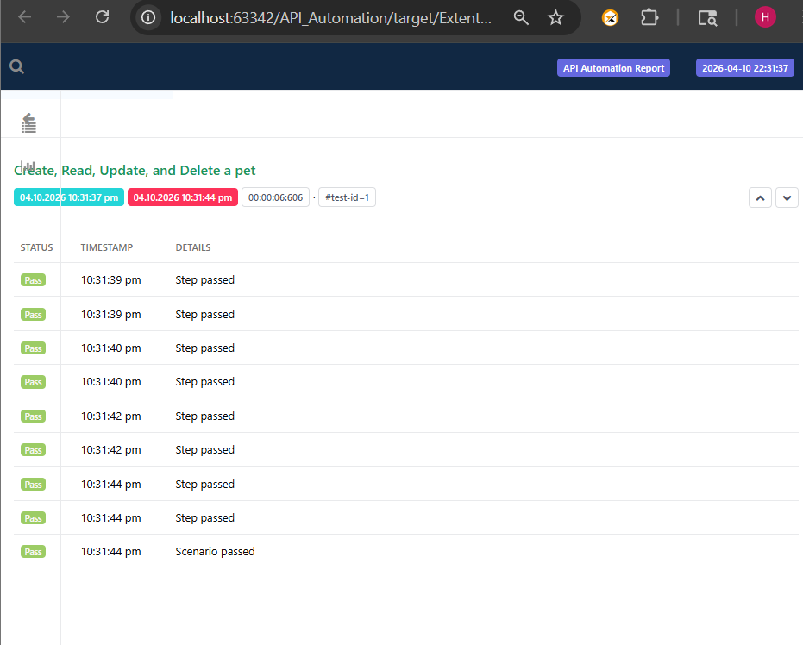
Fig. No. 5: Execution of the project
Fig. No. 6: ExtentReport.html
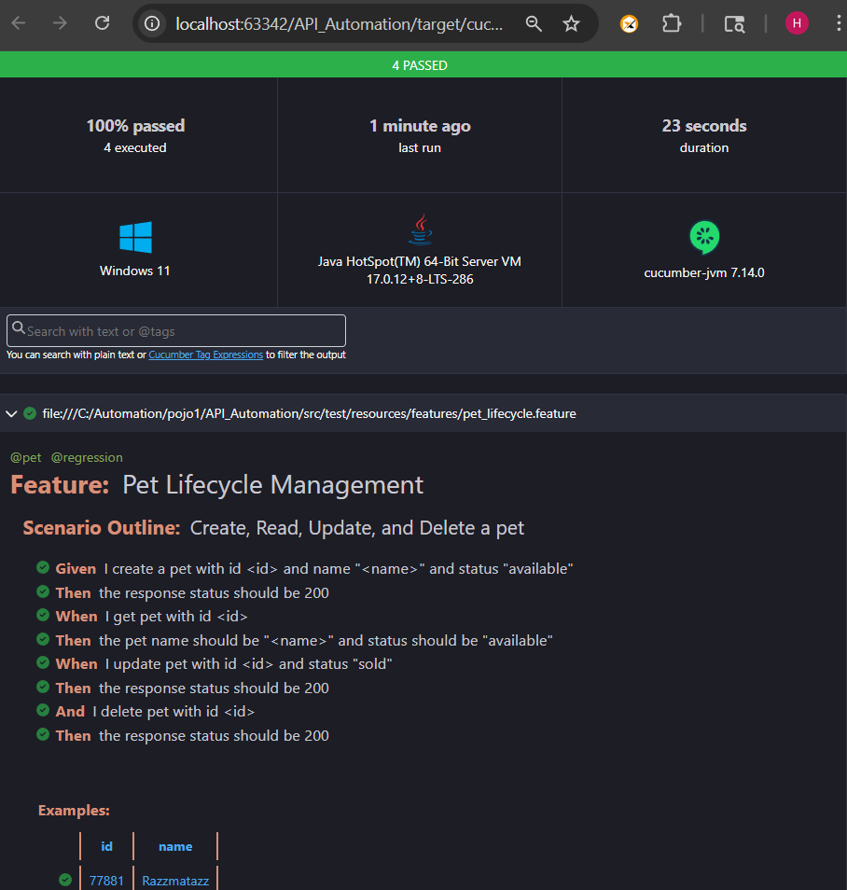
Fig. No. 7: Cucumber Reports
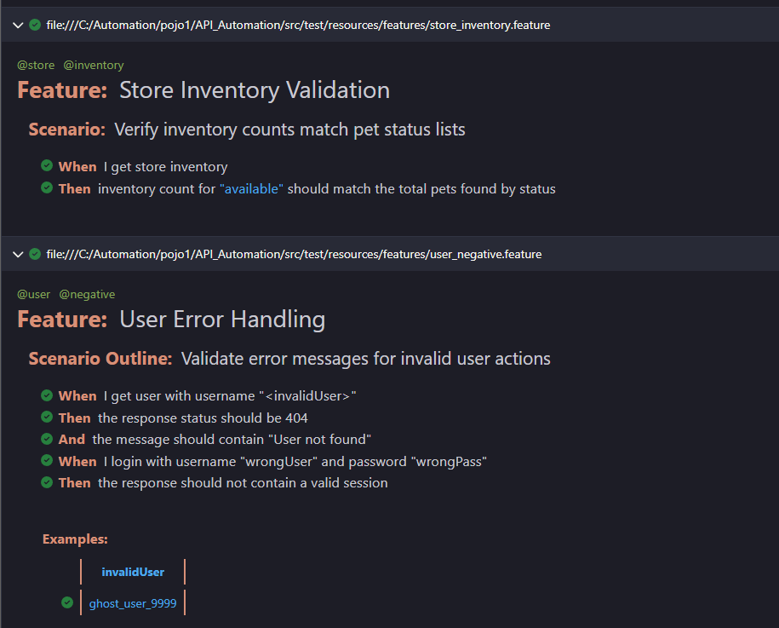
Fig. No. 8: Cucumber Reports
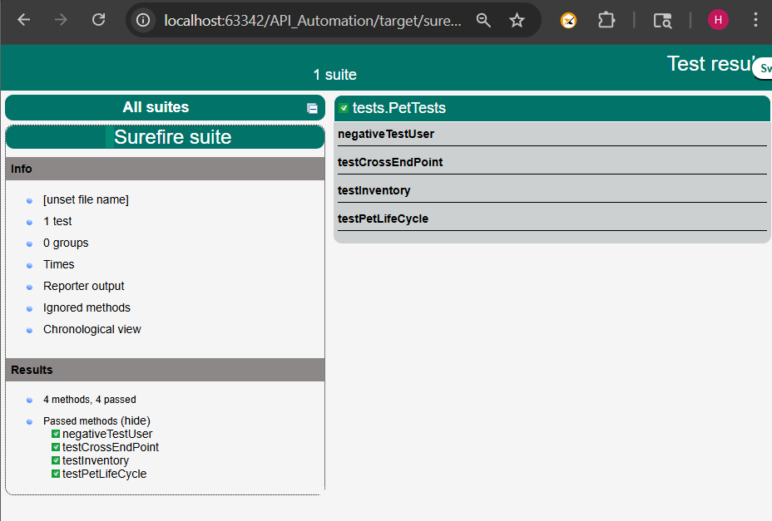
Fig. No. 9: Surefire suite/index.html
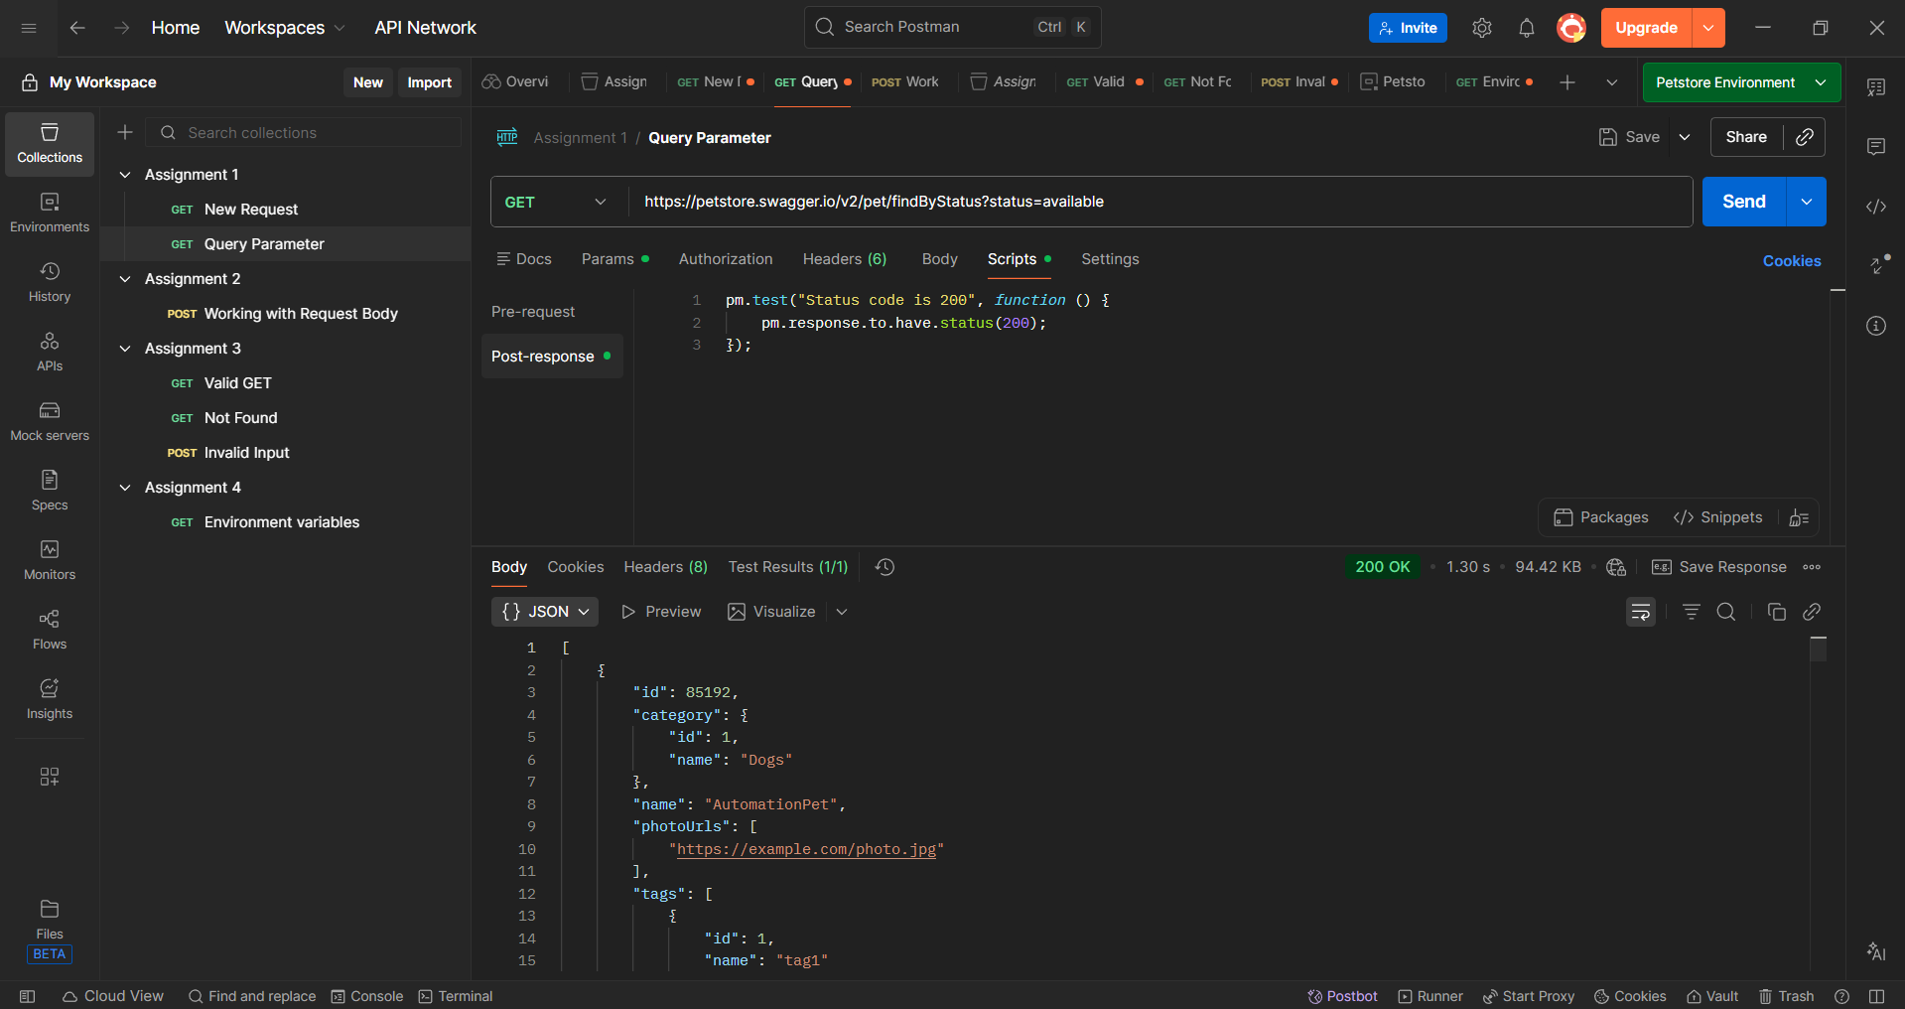
Fig. No. 10: Postman – Query Params
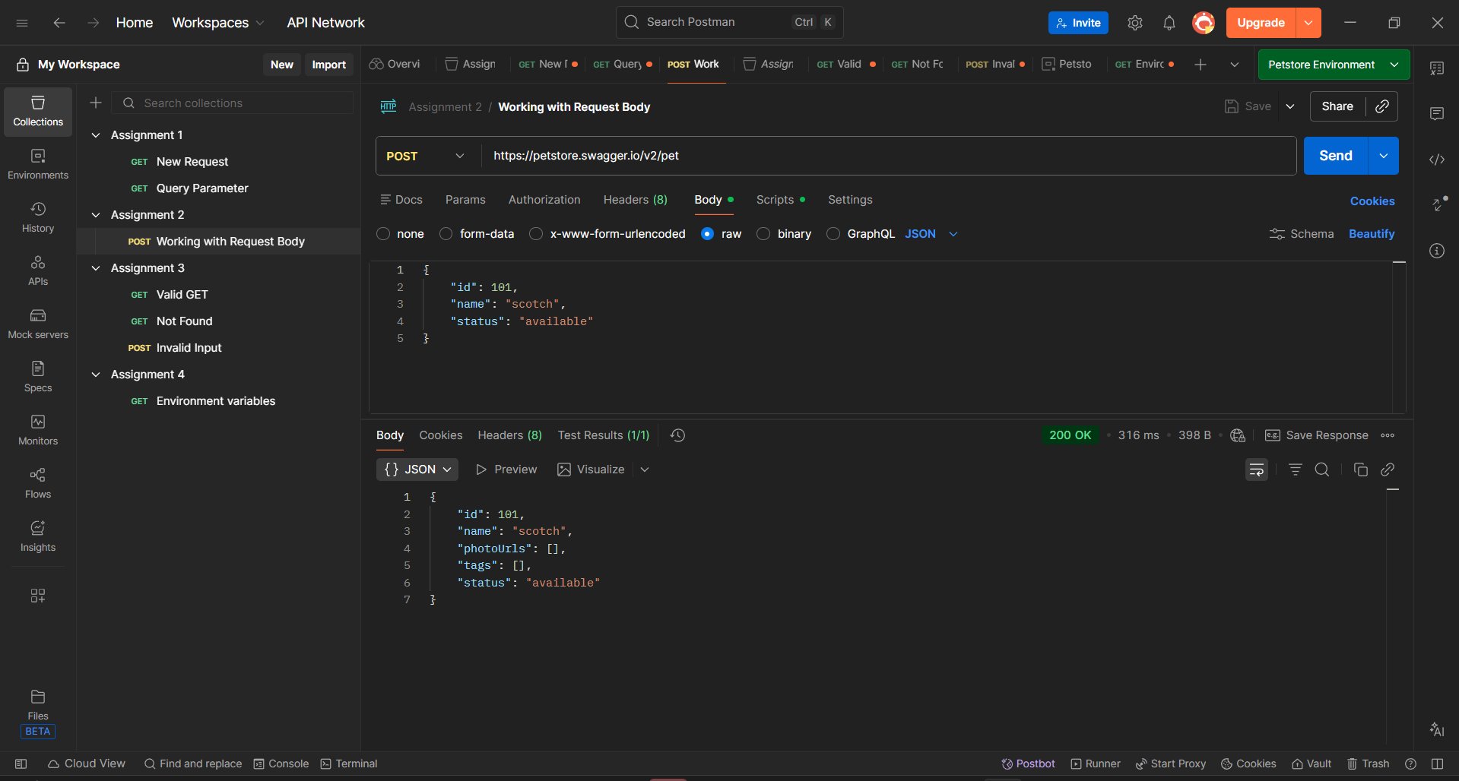
Fig. No. 11: Postman – Working with Response Body
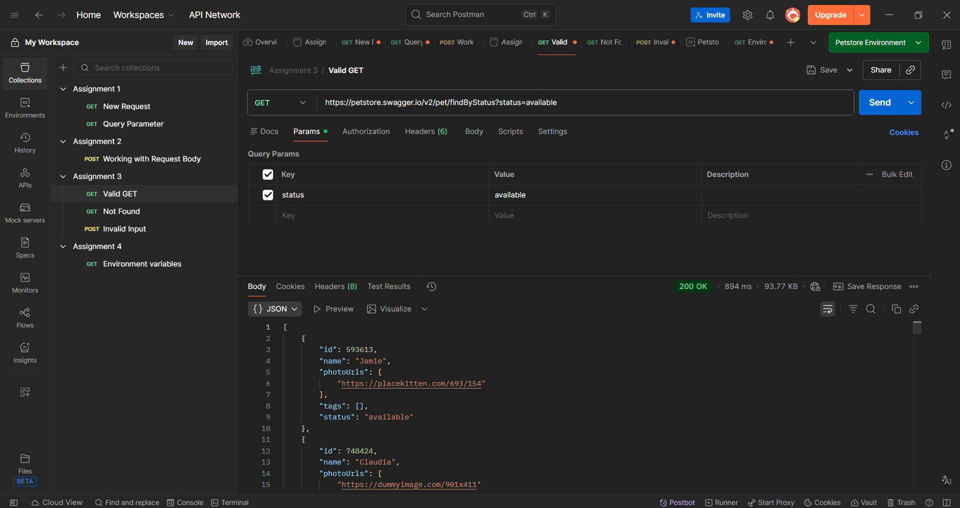
Fig. No. 12: Postman – Valid GET
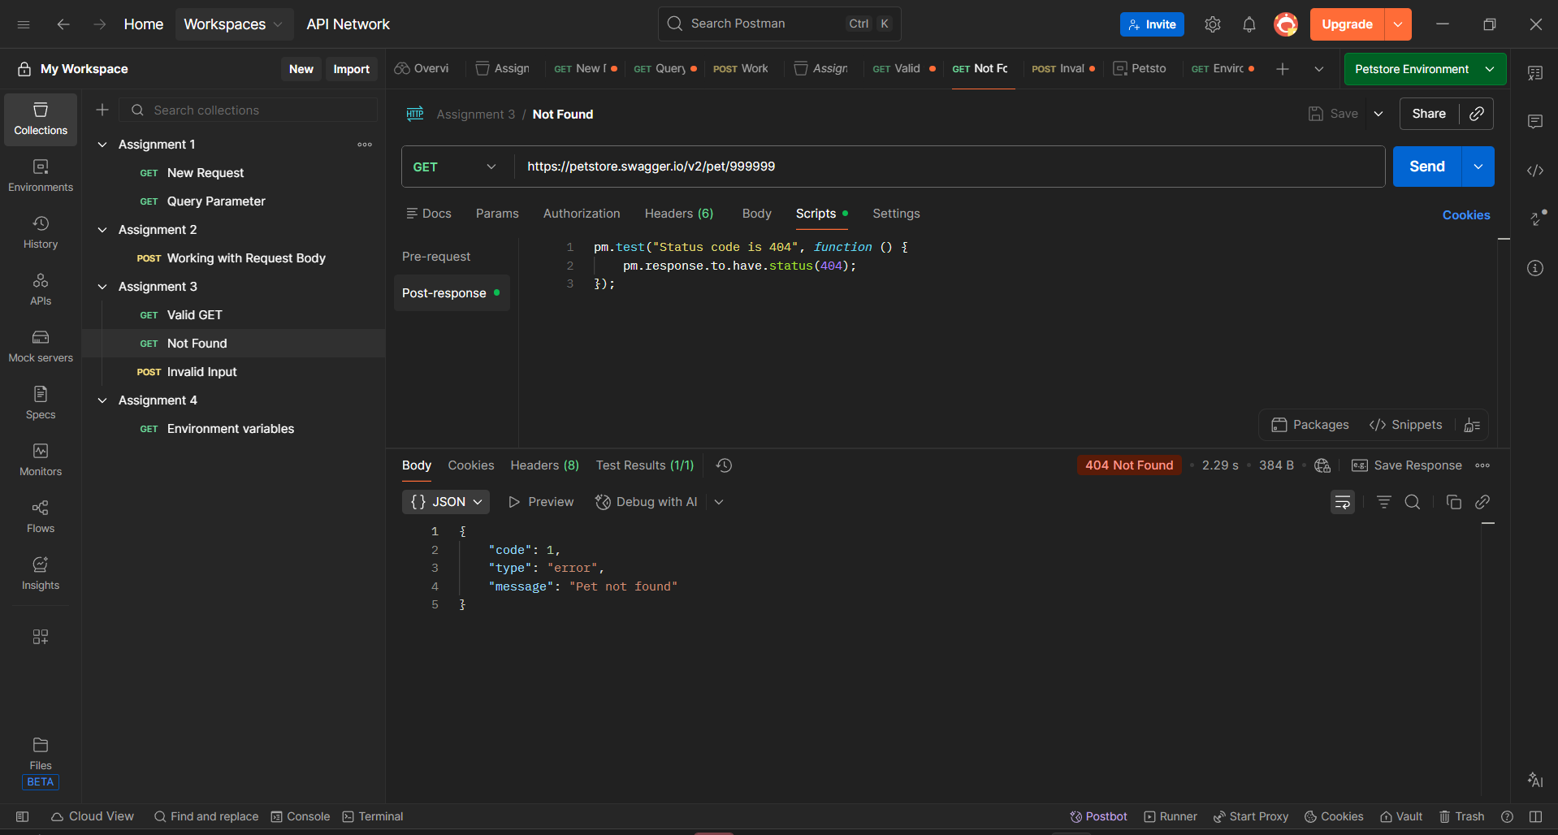
Fig. No. 13: Postman – Not found
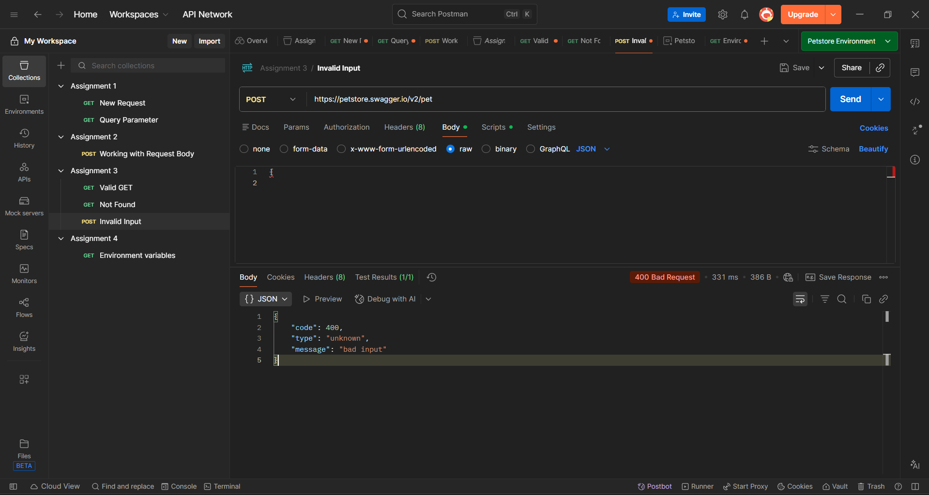
Fig. No. 14: Postman – Invalid Input
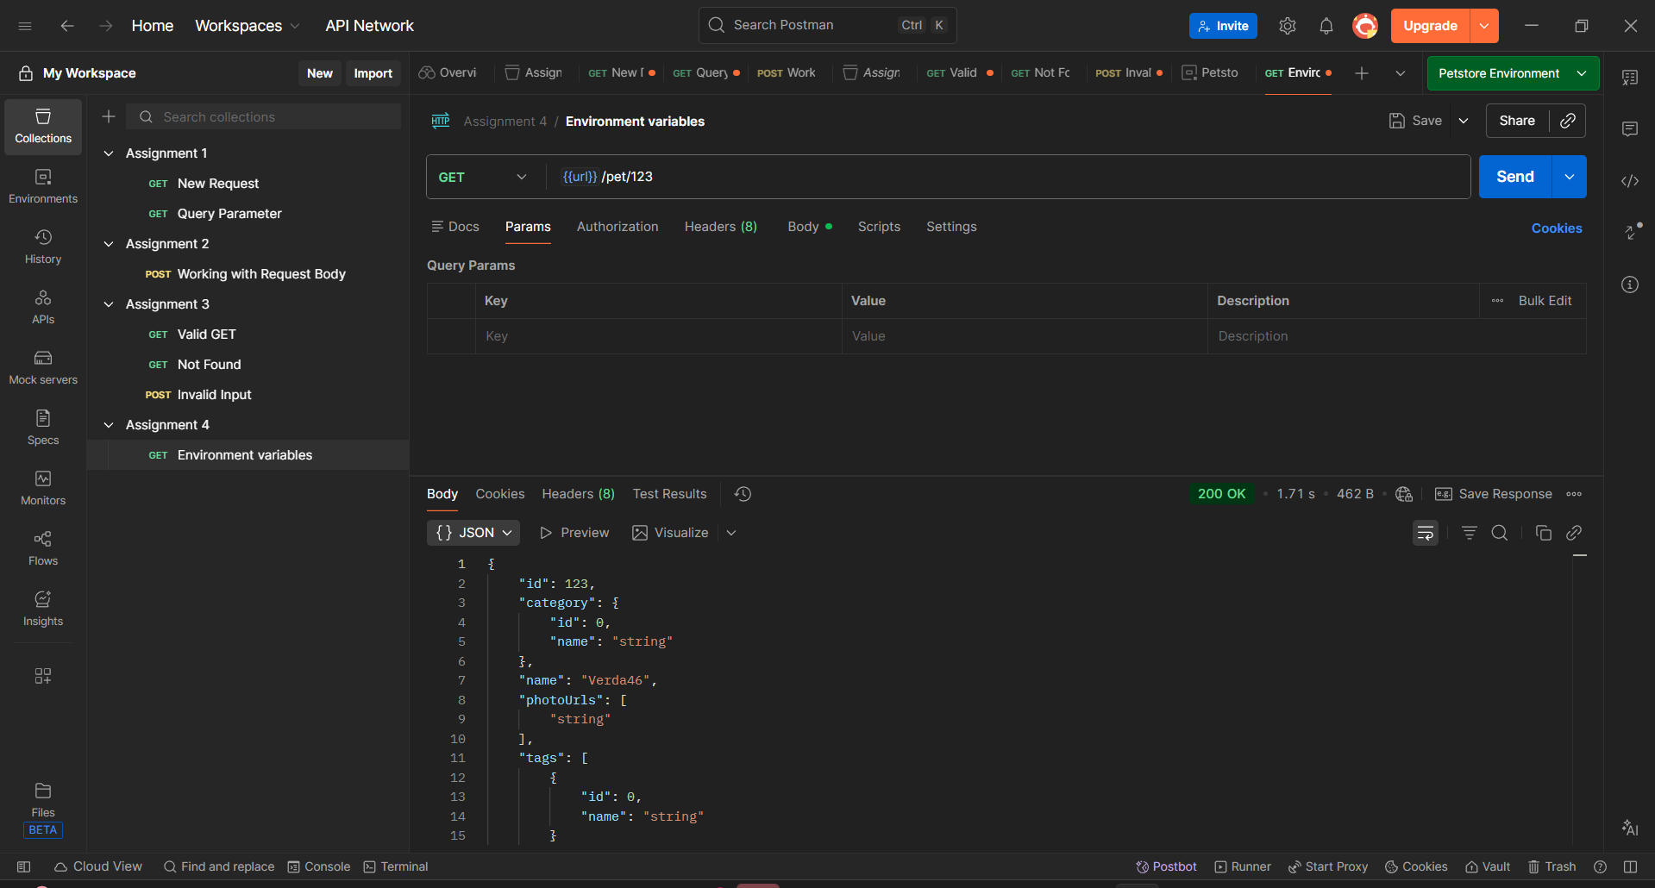
Fig. No. 15: Postman – Environment variables
GitHub link: GitHub - Nihakadiyam1/Veeva-Systems-Curriculum-Courses-: This Curriculum is given by the company Veeva Systems. · GitHub

Swagger Documentation
API reference used for testing:
https://petstore.swagger.io/

