Question.5
- Create a testcase for exploratory testing
Perform exploratory testing on the Login module to identify defects, usability issues, and unexpected behaviors without predefined test steps.
Preconditions for this:
Application is accessible
User is on Login Page
Valid and invalid credentials are available
Test Steps (Exploratory Charter):
- Enter valid username and password → verify successful login
- Enter invalid credentials → verify error message
- Leave fields empty → check validation messages
- Enter special characters and long inputs
- Test password visibility toggle
- Refresh page after entering data
- Try multiple failed login attempts
- Test login with slow internet (if possible)
- Navigate using browser back/forward buttons
- Check UI alignment and responsiveness
Steps to create:
1.Go to project
2.Click the create issue
3.Select Issue Type(Test)
4.Chose test type is Exploratory
5.Give the required steps and description
6.Save the test
7.Execute via TestExecution issue

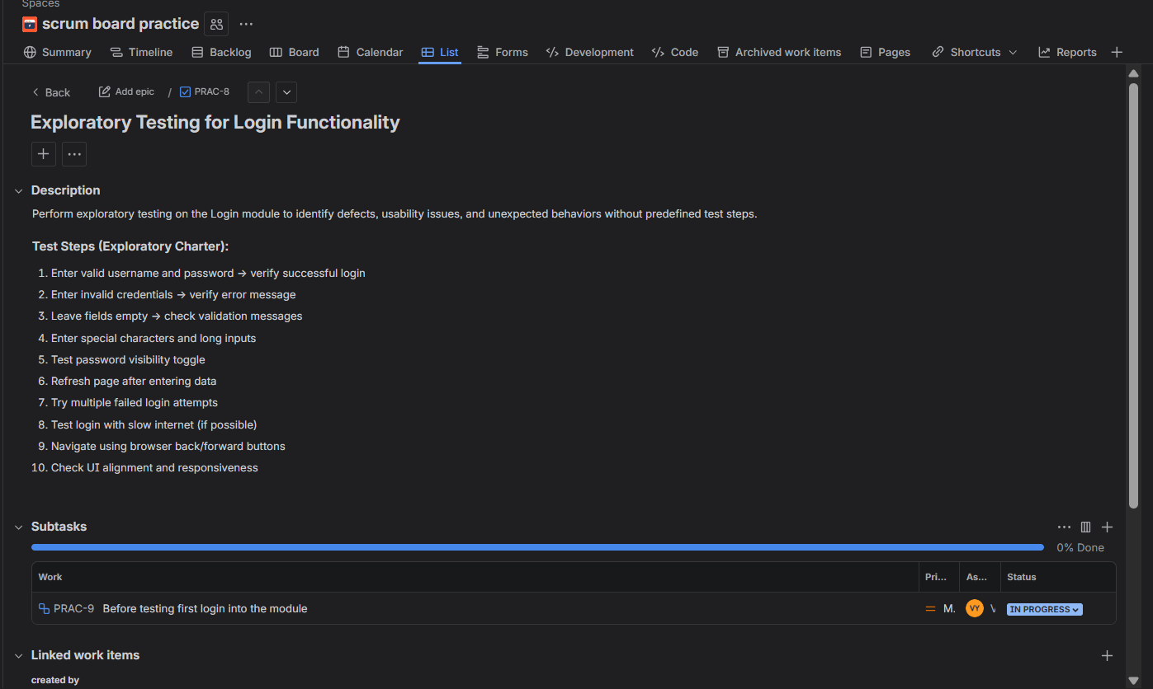

- Track the progress of a specific release or sprint
Steps to track the progress of the sprint
- Got to the project
- Open the active sprint
- Click on the board
- Now click on Reports and select burndown chart
- It shows the work remaining and time
- After select Sprint Report
- It shows the completed tasks, Incomplete tasks
- Select Cumulative flow diagram
- It shows track of todo, in progress, done tasks

