Question.4
- Create a rule to automatically assign a bug to a developer when the priority is set to highest give in Jira
Steps to Execute this:
- Go to your Jira project
- Click Project Settings and click Automation
- Click Create Rule
- Add Trigger i.e, Select Issue Created (or) Field Value Changed
- Choose Field Value Changed and select priority
- Add another condition IssueType=Bug
- Now Add Condition --> Click New Condition and
Set:
- Field → Priority
- Condition → equals
- Value → Highest
- Click New Action and Assign Issue
- Now set Assignee is to a team member in the team
- Save and Enable
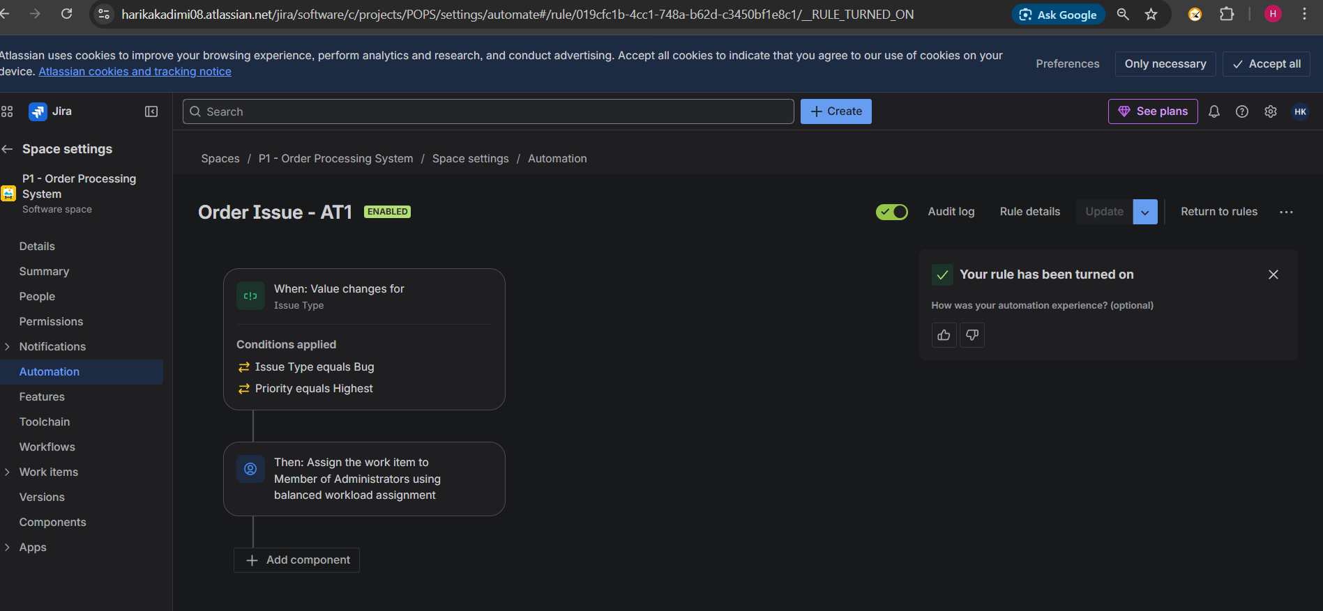

- Write a Query to find all unresolved bugs in a specific project assigned to a specific user example: Project=P1 and Issue Type=Bug and Status !=Done and Assignee=Current User
After execution this query will show:
All open bugs in selected project that was assigned to current user
Steps to execute this query:
1.Open jql in jira
2.After write the required query i.e,
- project="P1 – Order Processing System": Filters for that specific project
- issuetype=Bug: Only shows items marked as bugs.
- Status !=Done: Excludes any issues that are already completed.
- assignee = currentuser(): Returns issues assigned to current user.
