

Customer Retention Project

Submitted by:

NIHAL SINGH

This Project includes the details about the e-retails factor of customers.it is having data related to customers activation and retention.it includes the various factors like gender, age range, location types and other multiple factors which effect to achieve the customer satisfaction for E-commence websites.

**INTRODUCTION**

* Business Problem Framing

It is basically related to end user experience depend upon the multiple criteria which effect the e-commerce business and increases the customer experience.

* Conceptual Background of the Domain Problem

Conceptually it is related to the e-commerce domain having the details related to the factors affecting the e-commerce business and activation and retention of the customers.

* Motivation for the Problem Undertaken

The excel data provides having the multiple factors that affecting the e-commerce business and problem faced by the customer’s and experience on purchase at e-commerce websites.

**Analytical Problem Framing**

* Mathematical/ Analytical Modeling of the Problem

The Dataset is in excel format which consist of the data code and code sheet. Different plot methods has been used like count plot, heatmap, distplot and strip plot to analyse the data. Different encoding method is also used to encode the data like label encoding, encoder method and replace method to encode the data and understand the data.

* Data Sources and their formats

Data is in the excel format.the data has been imported into the data frame using the python library.

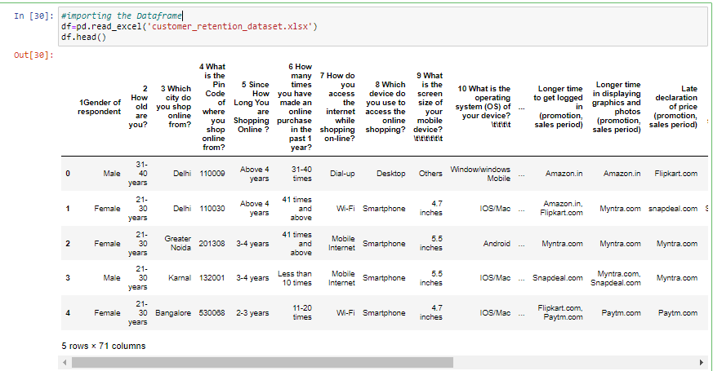

The columns of the data is having some unwanted values so used strip method to clean the column.

The data having the different datatypes i.e. int, and object.

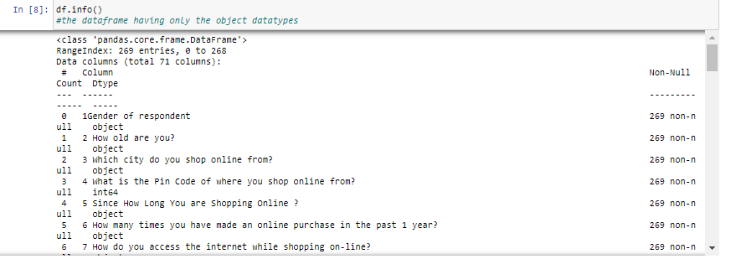

* Data Preprocessing Done

The Data Preprocessing consist of cleaning importing the data and then cleaning of data. Graphical representation of multiple features using multiple graphs. Checking the null values.

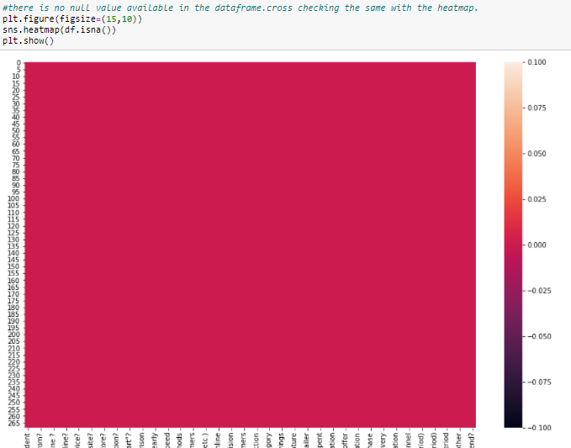

Using the count plot check the features details:

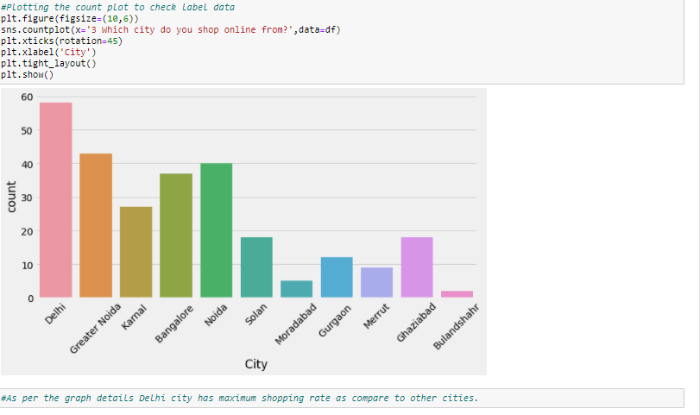

* State the set of assumptions (if any) related to the problem under consideration

From looking at the feature you can describe the features means are relevant features and which are irrelevant.

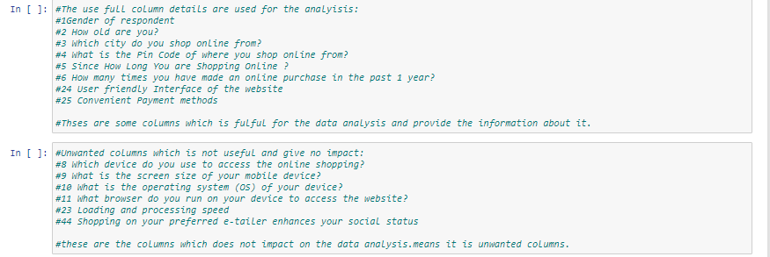

**Model/s Development and Evaluation**

* Visualizations

Used different plots to check the details of the feature.

The plot has been used as follows:

Count plot

Heat map

Dist plot

Strip plot

This plots are used to visualize and analyse the data from the data.

Basically to do the analysis in the on given data and check the data I is useful.

* Interpretation of the Results

From visualization, we can check the different types of opinion of the users. The factors affecting the e-commerce business like which city you belong, pin code, gender, age criteria, platform, mobile type, user satisfaction and other features, which effects the E-commerce users experience.

**CONCLUSION**

* Learning Outcomes of the Study in respect of Data Science

From the provided data we are able to learn the different factors on which e-commerce depends upon. Try to visualize those factors using the plots and do some analysis on the data. Which is useful for the model.