One-Click Day Planner: AI-Powered Daily Planning and Schedule Management with Seamless Calendar & Notion Integration

Project Description:
One-Click Day Planner is an AI-powered web application designed to help users organize their daily tasks and automatically create a practical schedule based on their priorities, deadlines, working hours, breaks, and fixed commitments. Instead of manually deciding what to work on and when, the user provides the required tasks and preferences, and the application uses Google Gemini AI to generate a structured plan for the day.
The application is built with a React.js and Vite frontend and a Python Flask backend. The frontend provides a simple interface for entering tasks, setting priorities and deadlines, defining working hours, and adding fixed commitments. The backend processes this information and communicates with the Gemini API to generate a schedule while considering time availability and avoiding conflicts.
The generated schedule is presented as clear time-based blocks so that users can easily understand how their day is planned. The application also allows the generated schedule to be exported to Google Calendar and Notion, making it easier for users to continue using the plan with the tools they already work with.
The main aim of One-Click Day Planner is to reduce the time and effort involved in planning a day while providing a structured schedule based on the user's actual requirements and available time.
Scenarios:
Scenario 1: Daily Schedule Generation
A user enters the tasks they need to complete during the day along with their priorities, deadlines, and available working hours. The system processes the information and generates a structured schedule that assigns suitable time slots to each task.
Scenario 2: Managing Priorities and Deadlines
A user has several tasks with different levels of importance and different deadlines. The planner considers these factors while arranging the tasks so that important and time-sensitive work is given appropriate attention.
Scenario 3: Working Around Fixed Commitments
A user already has activities such as classes, meetings, or appointments at specific times. These commitments can be entered into the planner, and the generated schedule avoids placing other tasks during those periods.
Scenario 4: Exporting the Schedule to Google Calendar
After reviewing the generated plan, the user can export the scheduled tasks to Google Calendar. This allows the user to view the planned activities alongside their existing calendar events.
Scenario 5: Exporting the Schedule to Notion
A user can also send the generated schedule to the connected Notion workspace. The planned activities are added to the configured Notion page, allowing the user to keep a record of their daily schedule in one place.
Technical Architecture:
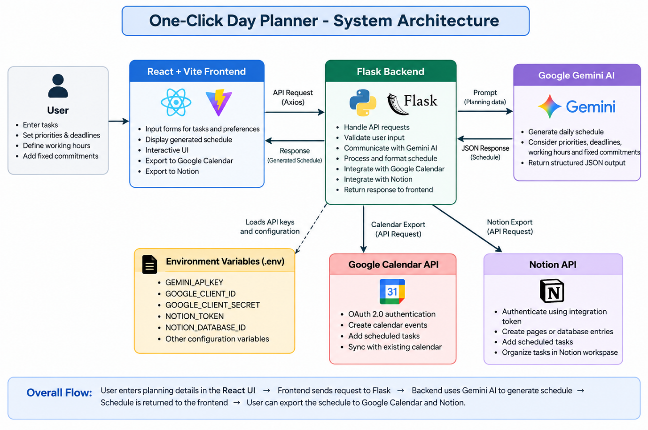
Description:
- The React + Vite frontend collects tasks, priorities, deadlines, working hours, and fixed commitments from the user.
The Flask backend receives and validates this information before processing it.
- Google Gemini AI generates a structured daily schedule based on the user's planning requirements.
The generated schedule is returned to the frontend and displayed as organized time blocks.
- Google Calendar and Notion integrations allow users to export their generated schedules.
Environment variables are used to securely manage API credentials and configuration.
Prerequisites:
- React.js & Vite: Basic understanding of React components, JSX, and frontend development.
- Python & Flask: Familiarity with Python, Flask routes, APIs, and backend development.
- JavaScript: Basic knowledge of JavaScript, asynchronous operations, and API requests.
- Google Gemini AI: Understanding of AI APIs and basic prompt-based integration.
- Google Calendar & Notion APIs: Basic knowledge of API integration and authentication.
- HTML & CSS: Understanding of webpage structure, styling, and responsive design.
- Git & GitHub: Basic knowledge of version control, repositories, commits, and project management.
- Environment Variables: Understanding of .env files and keeping API credentials secure.
`Project Workflow
Milestone 1: Requirement Analysis and Project Planning
Activity 1.1:
The first activity focused on identifying the main problem faced by users when planning their daily activities. Manually arranging tasks according to priorities, deadlines, available time, and existing commitments can be time-consuming and difficult to manage.
Activity 1.2:
The major problems identified were:
- Difficulty deciding which tasks should be completed first.
- Time wasted manually creating daily schedules.
- Overlapping tasks and fixed commitments.
- Difficulty balancing deadlines with available working hours.
- Lack of a simple way to convert a task list into a structured schedule.
- Need to manage the generated plan across different productivity platforms.
Activity 1.3:
The major functional requirements identified were:
1. Adding daily tasks.
2. Assigning priorities to tasks.
3. Setting task deadlines.
4. Defining working hours.
5. Adding fixed commitments.
6. Generating an AI-based daily schedule.
7. Avoiding conflicts between scheduled tasks and fixed commitments.
8. Displaying the generated schedule in organized time blocks.
9. Exporting the schedule to Google Calendar.
10. Exporting the schedule to Notion.
Activity 1.4:
The system was primarily designed for users who need help organizing their daily activities, including:
- College students
- Working professionals
- Interns
- Freelancers
- Users managing multiple daily responsibilities
- Anyone who wants to structure their day more efficiently
Activity 1.5:
The planned workflow was:
User Input → Task and Constraint Collection → AI Processing → Schedule Generation → Schedule Display → Calendar/Notion Export
Activity 1.6:
The project requirements, core features, user inputs, external integrations, and overall workflow were finalized before development began. The scope was defined around generating practical daily schedules while considering priorities, deadlines, working hours, and fixed commitments.
Status: COMPLETED

Milestone 2: System Design and Technology Selection
Activity 2.1:
The second milestone focused on planning the technical structure of One-Click Day Planner. The frontend, backend, AI service, external integrations, and communication between these components were defined before implementation.
Activity 2.2:
The following technologies were selected:
Component | Technology
Frontend | React.js
Build Tool | Vite
Backend | Python Flask
AI Service | Google Gemini API
API Communication | Axios
External Services | Google Calendar API and Notion API
Programming Languages | JavaScript and Python
Package Manager | npm
Version Control | Git
Repository | GitHub
Development Environment | Antigravity
Activity 2.3:
The system was designed using a client-server architecture.
Architecture Flow
User
↓
React + Vite Frontend
↓
Axios API Request
↓
Flask Backend
↓
Google Gemini AI
↓
Generated Schedule
↓
React Frontend
↓
Google Calendar / Notion
Activity 2.4:
A clean and modern interface was planned to make daily planning simple and easy to understand. The design uses organized cards, clear time blocks, visual priority indicators, and a glass morphism-inspired layout to present the generated schedule.
Activity 2.5:
The technology stack, application architecture, user interface structure, AI workflow, and external integrations were finalized before moving into development.
Status: COMPLETED

Milestone 3: Backend Development and AI Integration
Activity 3.1:
The backend was developed using Python and Flask to handle requests from the frontend. API routes were created for schedule generation, health checking, Google Calendar, and Notion integration.
Activity 3.2:
Google Gemini AI was connected to the backend to generate personalized daily schedules. The API credentials were kept in environment variables instead of being placed directly in the source code.
Activity 3.3:
The schedule generation module was implemented to process tasks and user preferences and return a structured schedule. The generated response was formatted so that it could be displayed directly by the frontend.
Activity 3.4:
Task priorities and deadlines were included in the scheduling process. These details help the AI determine how tasks should be arranged within the available time.
Activity 3.5:
Working hours, breaks, and available time were considered while creating the schedule. This prevents the planner from assigning tasks outside the user's selected working period.
Activity 3.6:
A fixed commitment system was implemented for activities that already occupy specific time slots. Generated tasks are arranged around these commitments to reduce scheduling conflicts.
Activity 3.7:
Validation and error handling were added to the backend to handle invalid requests, unavailable AI services, and other API-related issues. The backend returns appropriate responses so that the frontend can display relevant status or error messages.
Status: COMPLETED
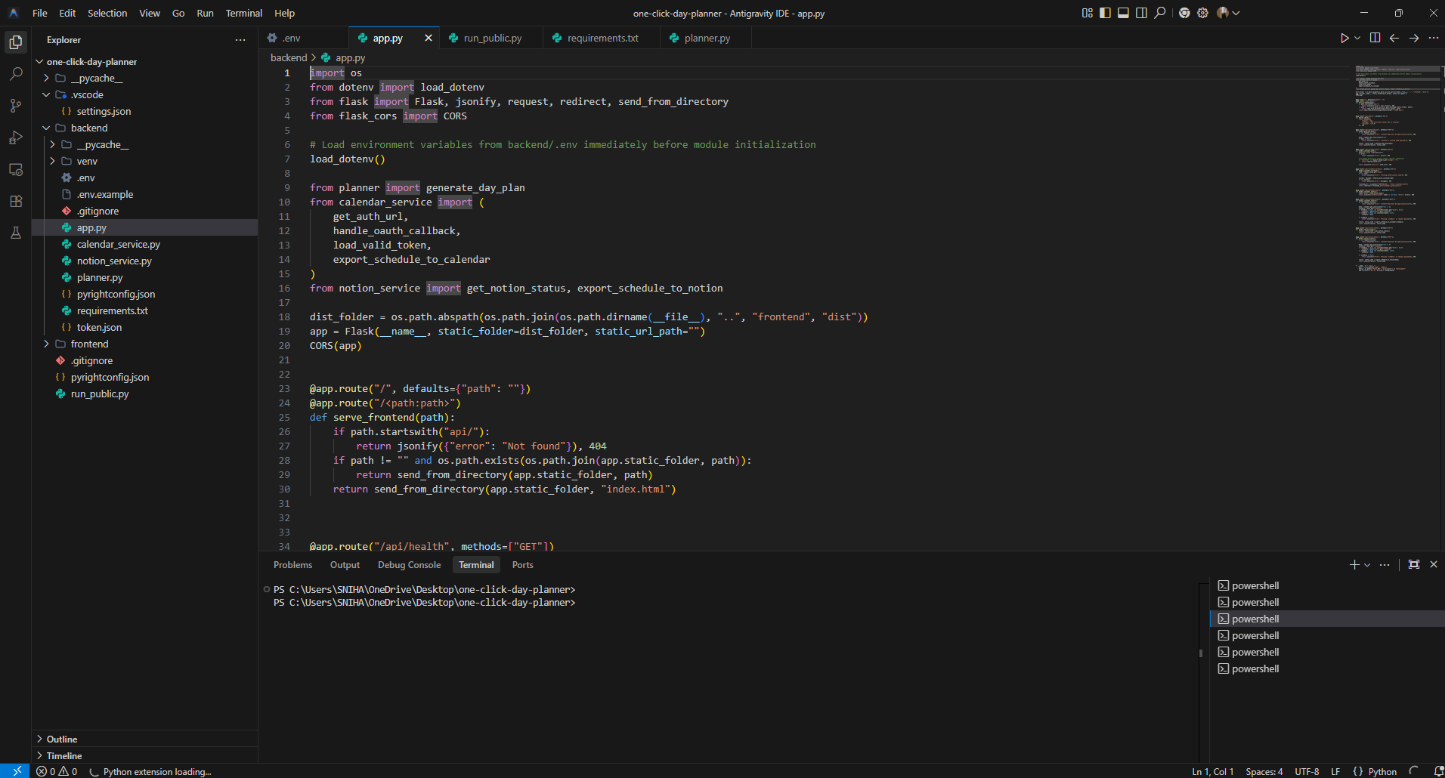

Milestone 4: Frontend Development and User Interface
Activity 4.1:
The frontend was developed using React.js and Vite. The main application structure was created to provide a simple interface for entering planning information and viewing the generated schedule.
Activity 4.2:
A task input module was implemented where users can add their daily tasks along with relevant details such as priority and deadline. The entered information is maintained through the application's state.
Activity 4.3:
A working hours module was added to allow users to define when they are available during the day. This information is passed to the backend during schedule generation.
Activity 4.4:
A fixed commitments module was developed for entering activities that already occupy specific time periods. These commitments are considered while generating the final schedule.
Activity 4.5:
A schedule display component was created to present the generated plan as organized time blocks. Priority information and task details are displayed clearly so that users can quickly understand their planned day.
Activity 4.6:
Axios was used to connect the React frontend with the Flask backend. Application state is used to manage tasks, user inputs, generated schedules, loading states, and error messages.
Activity 4.7:
The interface was refined using a clean, modern design with glassmorphism-inspired elements, organized cards, and responsive layouts. Export options for Google Calendar and Notion were also incorporated into the frontend.
Status: COMPLETED
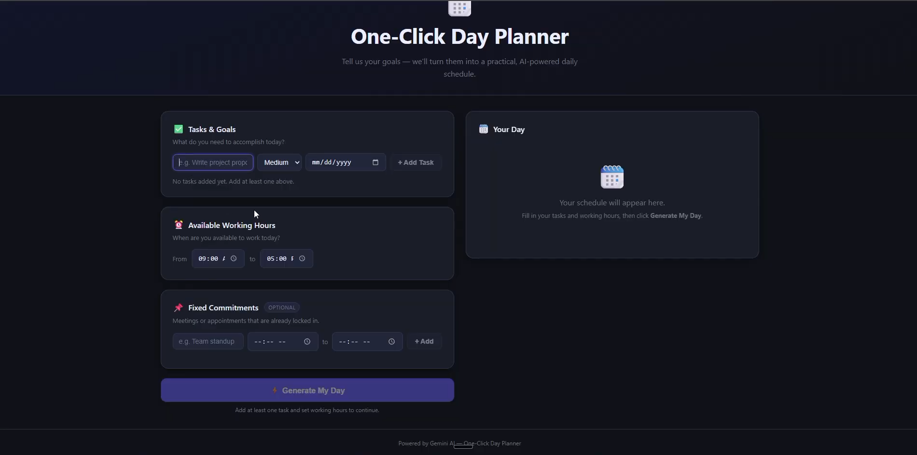
Milestone 5: External Service Integration
The Google Calendar and Notion integrations were completed to allow users to export their generated schedules to external productivity platforms. The Google Calendar integration supports authentication and creation of calendar events, while the Notion integration stores the generated schedule in the configured Notion database. The interface was also refined to provide clear export options and feedback messages for successful or unsuccessful operations.
Status: COMPLETED
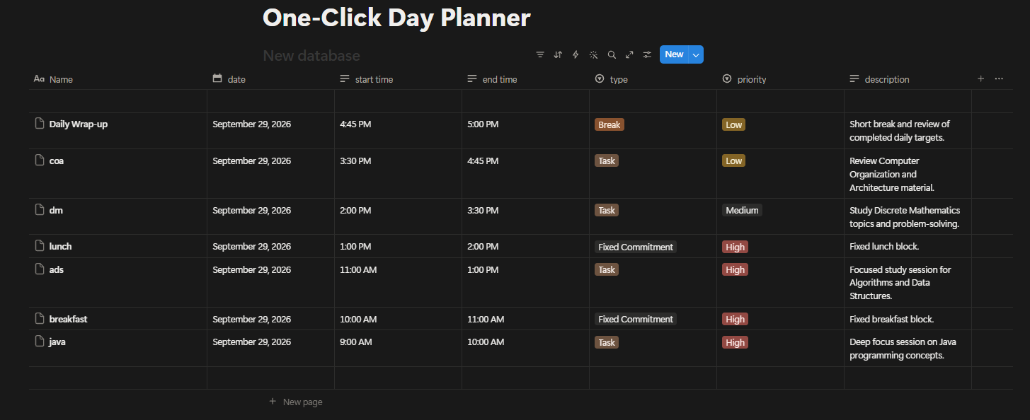
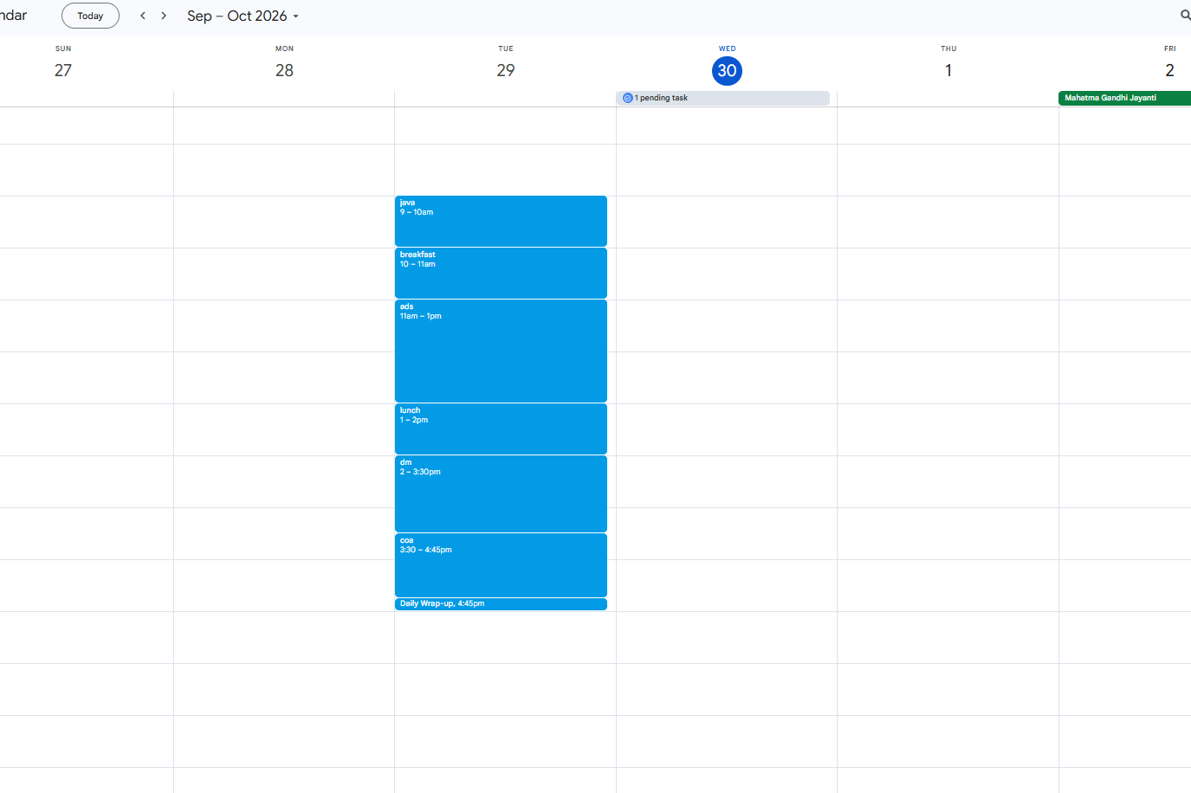
Milestone 6 : Testing & Version Control
The complete application was tested to verify the main features, including task input, AI-based schedule generation, priority and deadline handling, working hours, fixed commitments, Google Calendar export, and Notion export. API communication between the frontend, Flask backend, Gemini AI, and external services was also checked, and necessary issues were resolved. Git was used for version control, and the completed project was uploaded to the GitHub repository.
Status: COMPLETED
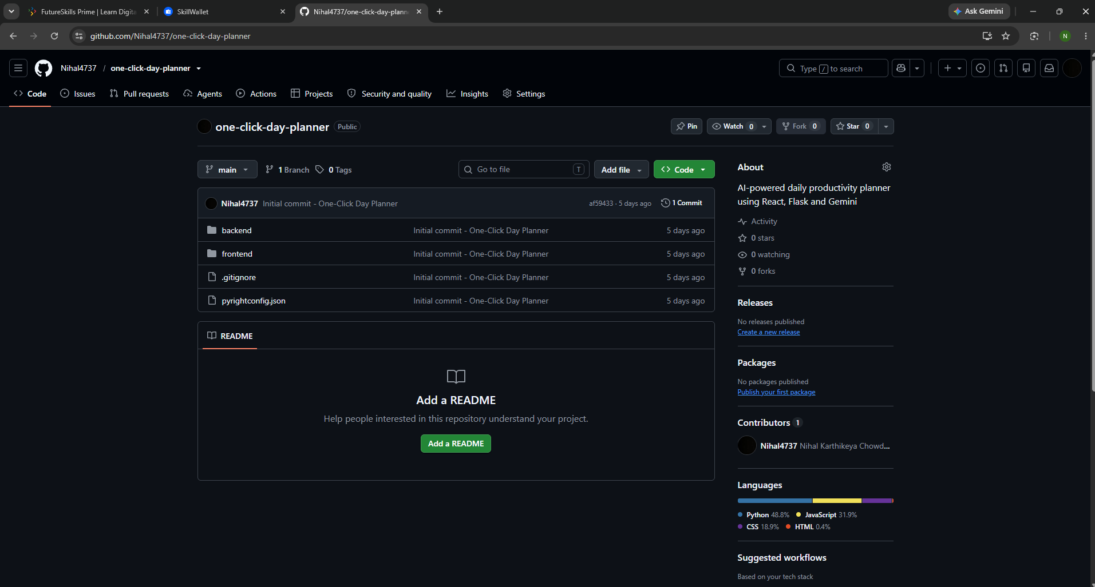

Milestone 7 – Final Validation
The complete One-Click Day Planner application was tested as an integrated system to verify that the major features work together correctly. The schedule generation process, task management, fixed commitments, Google Calendar export, and Notion export were checked during final validation. The final GitHub repository was also reviewed to ensure that the project files were properly organized and sensitive credentials were not included.
Status: COMPLETED
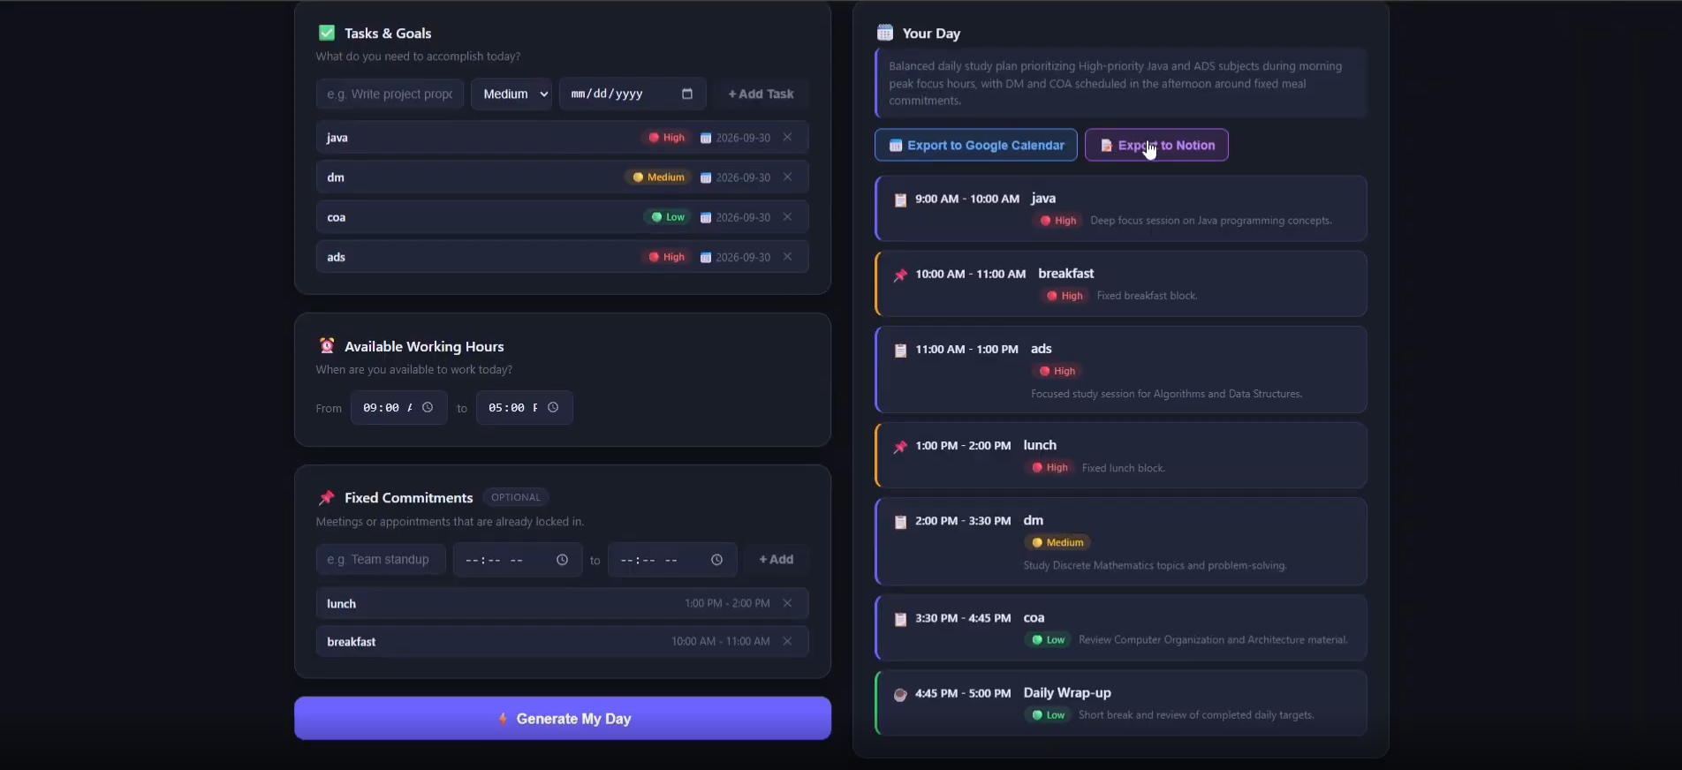
Final Project Status
One-Click Day Planner was successfully completed with the planned features implemented and tested. The application was integrated with Google Gemini AI, Google Calendar, and Notion, and the final project was uploaded to the GitHub repository with the required documentation and demo materials.
Conclusion:
One-Click Day Planner was successfully developed as an AI-powered daily planning application that simplifies the process of organizing tasks and managing available time. The system combines task priorities, deadlines, working hours, and fixed commitments to generate a structured daily schedule using Google Gemini AI. Google Calendar and Notion integration further extend the usefulness of the application by allowing users to export their generated plans. The major features were implemented, tested, and documented, and the completed project was uploaded to GitHub.

