Memory Profiling for ./streamer` Application

This document outlines the steps to determine the memory usage of the `./streamer` application, running on a Raspberry Pi or similar system. It includes detailed instructions on checking both **virtual memory** and **physical memory** consumption.

# 1. Checking Virtual and Physical Memory Usage

### Tools Used:  
- `htop` (interactive process viewer)  
- `ps` (process status)  
- `pmap` (process memory map)

## 2.1. Virtual Memory (VIRT)

To view **virtual memory** usage (the total address space used by the process), use the `htop` tool or the following command:  
```bash  
htop  
```  
In the `htop` output, **VIRT** shows the **total allocated virtual memory**, which can include shared libraries, mmap regions, and more. For example, an application may show **300 MB of VIRT**, but not all of it is actively used by physical memory.

## 2.2. Physical Memory (RSS)

To check the **physical memory** usage (RAM in use), look at the **RSS (Resident Set Size)** field. The **RSS** shows the actual physical memory consumed by the process. In the `ps` output, you can check:  
```bash  
ps -p <PID> -o pid,vsz,rss,comm  
```  
For example:  
```  
 PID VSZ RSS COMMAND  
13134 310000 10496 streamer  
```  
Here, **RSS** = **10.5 MB** represents the actual physical memory used by `./streamer`.

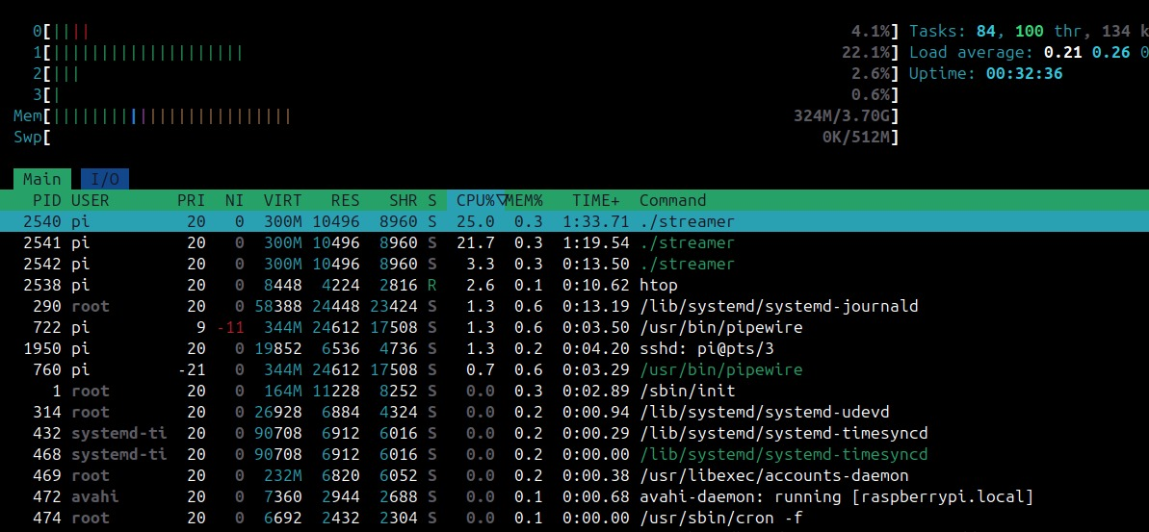

## 2.3. Thread Information

If the application uses multiple threads, use `ps -T` to show all threads within the process:  
```bash  
ps -T -p <PID>  
```  
This will show all threads of `./streamer` with their individual Thread IDs (TIDs), ensuring you know the complete memory consumption of the application.

# 3. Memory Usage Breakdown for `./streamer` Process

Based on the `ps -T -p <PID>` command, we identified the following:  
- **One process** with **multiple threads**:  
 - `videoStreaming` thread  
 - `audioStreaming` thread  
 - PipeWire audio helpers (`module-rt`, `pw-data-loop`, `alsa-pipewire`)  
- **Physical Memory (RSS)**: ~10.5 MB (shows the actual memory being used)  
- **Virtual Memory (VIRT)**: ~300 MB (total allocated address space, including memory-mapped files, shared libraries, and buffers)

# 4. Conclusion

The application `./streamer` is consuming **10.5 MB of physical RAM** while running, with a larger **virtual memory space of ~300 MB**. Most of the virtual memory is allocated but not necessarily using physical memory.