Report
Problem Statement:
To analyze numerous resumes using the Python ML library. To address this problem, we will clean and count words of the resume file, generate bigrams and trigrams, extract topics and make a word network from the file. We will use Python script and ML/AI libraries to achieve this.

Comparison of My resume with my instructor’s resume using statistical analysis:
Our instructor at Stevens gave us his resume to analyze, the basic statistical analysis of the resume is as follows. The instructor’s resume has a total of 747 words without removing any words whereas my resume has 360 words almost double. This is kind of obvious considering his long career, but we can see in the word selection my instructor has used fewer unique words as compared to me. The ratio of unique words to total words in my resume is 1.66 which is less than 2.37 for my instructor.

Bia-grams and tri-grams comparison:
The top 10 bia-grams and trigrams of my and my instructor’s resumes are as follows.
Since I am trying to get the job of Data Analyst, my resume will reflect diagrams and trigrams related to data analysis whereas my instructor is a data science professional his resume will reflect diagrams and trigrams related to data analysis.

Entropy comparison:
Here the entropy means the information rate of the resume. In the entropy comparison, my instructor’s resume contains slightly more information than mine because entropy rate of his resume is 0.37 which is more than 0.34 which is the entropy of my resume.

Topic Extractions:

LDAViz of both resumes is attached the right image is of my instructor’s resume and the left is my resume. As per the image, the frequency of a word in a topic is less in my resume as compared to my instructor’s.

Word Cloud of the instructor’s resume:
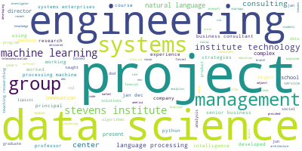

Word Cloud of my resume:
