Q.3.

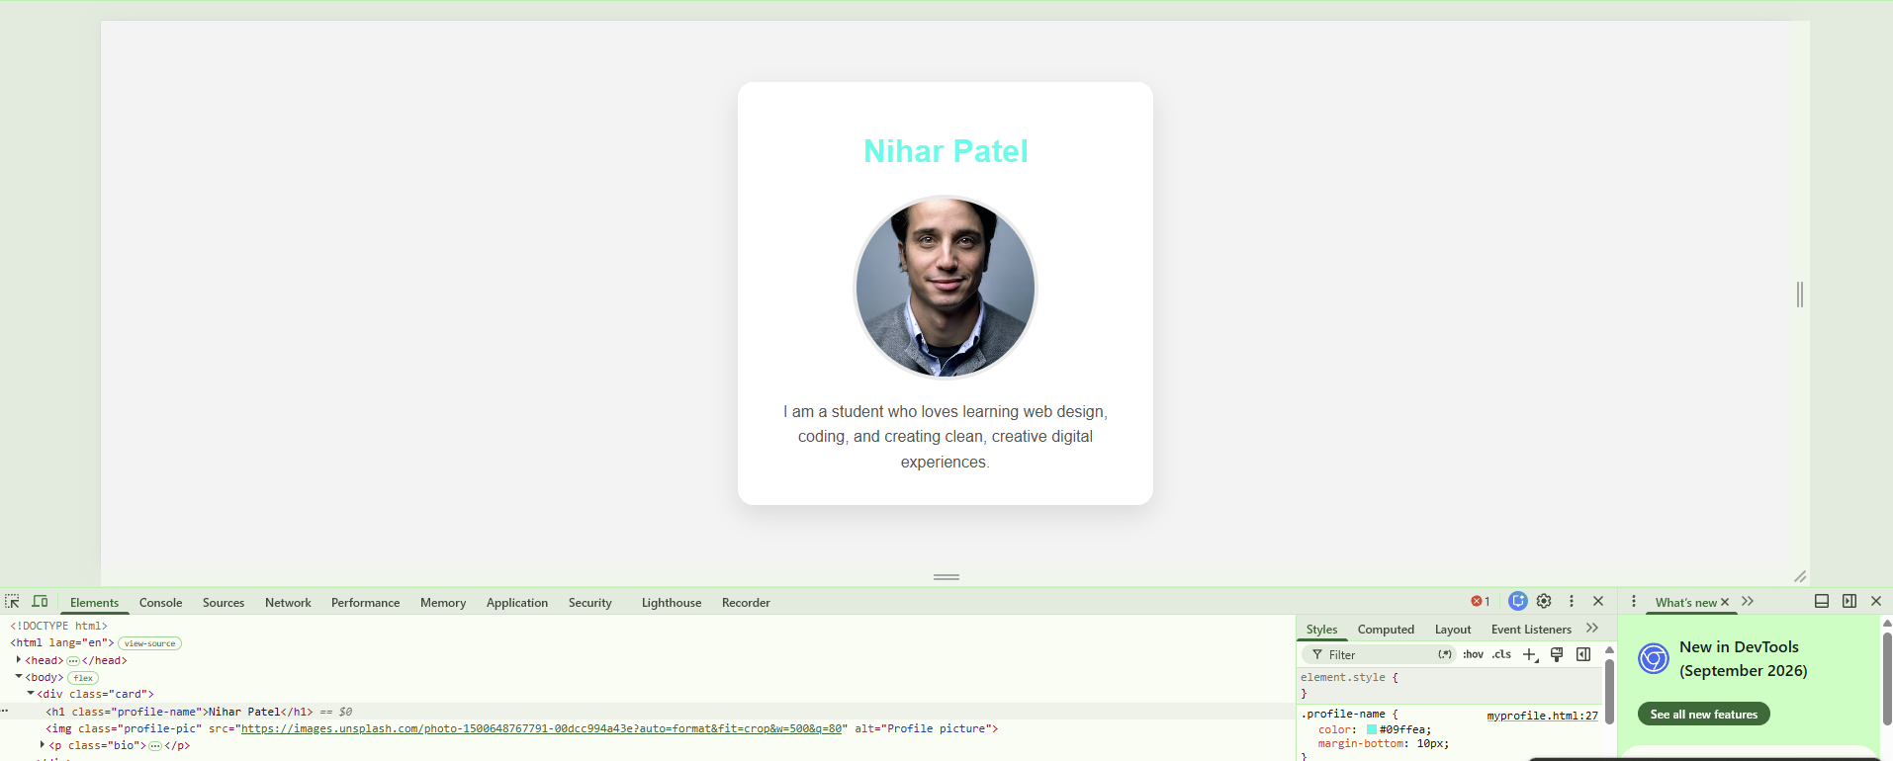

Q.4.
Draw a diagram or write a list showing the DOM structure (parent-child relationships) of your myprofile.html page. Include at least 3 levels (html > body > your content).
Ans:
Document
└── <html> (Root Element)
│
├── <head> (Child of html)
│ ├── <meta charset="UTF-8"> (Child of head)
│ ├── <meta name="viewport"> (Child of head)
│ └── <title> (Child of head)
│
└── <body> (Child of html)
├── <h1> (Child of body)
├── <p> (Child of body)
└── <img> (Child of body)

