Destructuring Objects and Arrays

Variable names must be similar to the name defined in the list of objects to access.

const data = [

  {

    id: 1,

    title: "The Lord of the Rings",

    publicationDate: "1954-07-29",

    author: "J. R. R. Tolkien",

    genres: [

      "fantasy",

      "high-fantasy",

      "adventure",

      "fiction",

      "novels",

      "literature",

    ],

    hasMovieAdaptation: true,

    pages: 1216,

    translations: {

      spanish: "El señor de los anillos",

      chinese: "魔戒",

      french: "Le Seigneur des anneaux",

    },

    reviews: {

      goodreads: {

        rating: 4.52,

        ratingsCount: 630994,

        reviewsCount: 13417,

      },

      librarything: {

        rating: 4.53,

        ratingsCount: 47166,

        reviewsCount: 452,

      },

    },

  },

  {

    id: 2,

    title: "The Cyberiad",

    publicationDate: "1965-01-01",

    author: "Stanislaw Lem",

    genres: [

      "science fiction",

      "humor",

      "speculative fiction",

      "short stories",

      "fantasy",

    ],

    hasMovieAdaptation: false,

    pages: 295,

    translations: {},

    reviews: {

      goodreads: {

        rating: 4.16,

        ratingsCount: 11663,

        reviewsCount: 812,

      },

      librarything: {

        rating: 4.13,

        ratingsCount: 2434,

        reviewsCount: 0,

      },

    },

  },

  {

    id: 3,

    title: "Dune",

    publicationDate: "1965-01-01",

    author: "Frank Herbert",

    genres: ["science fiction", "novel", "adventure"],

    hasMovieAdaptation: true,

    pages: 658,

    translations: {

      spanish: "",

    },

    reviews: {

      goodreads: {

        rating: 4.25,

        ratingsCount: 1142893,

        reviewsCount: 49701,

      },

    },

  },

  {

    id: 4,

    title: "Harry Potter and the Philosopher's Stone",

    publicationDate: "1997-06-26",

    author: "J. K. Rowling",

    genres: ["fantasy", "adventure"],

    hasMovieAdaptation: true,

    pages: 223,

    translations: {

      spanish: "Harry Potter y la piedra filosofal",

      korean: "해리 포터와 마법사의 돌",

      bengali: "হ্যারি পটার এন্ড দ্য ফিলোসফার্স স্টোন",

      portuguese: "Harry Potter e a Pedra Filosofal",

    },

    reviews: {

      goodreads: {

        rating: 4.47,

        ratingsCount: 8910059,

        reviewsCount: 140625,

      },

      librarything: {

        rating: 4.29,

        ratingsCount: 120941,

        reviewsCount: 1960,

      },

    },

  },

  {

    id: 5,

    title: "A Game of Thrones",

    publicationDate: "1996-08-01",

    author: "George R. R. Martin",

    genres: ["fantasy", "high-fantasy", "novel", "fantasy fiction"],

    hasMovieAdaptation: true,

    pages: 835,

    translations: {

      korean: "왕좌의 게임",

      polish: "Gra o tron",

      portuguese: "A Guerra dos Tronos",

      spanish: "Juego de tronos",

    },

    reviews: {

      goodreads: {

        rating: 4.44,

        ratingsCount: 2295233,

        reviewsCount: 59058,

      },

      librarything: {

        rating: 4.36,

        ratingsCount: 38358,

        reviewsCount: 1095,

      },

    },

  },

];

function getBooks() {

  return data;

}

function getBook(*id*) {

  return data.find((*d*) => d.id === id);

}

//Destructuring Data

//General way

const books = getBooks();

const book = getBook(2);

// const author = book.author;

// const title = book.title;

// console.log(author, title);

// Destructiring way of Objects

const { title, author, pages, publicationDate, genres } = book;

console.log(author, title, pages, publicationDate, genres);

//General way for array

// const primaryGenres= genres[0];

// const secondaryGenres= genres[1];

// console.log(primaryGenres,secondaryGenres);

// Destructuring of arrays

const [primaryGenres, secondaryGenres] = genres;

console.log(primaryGenres, secondaryGenres);

Output:



Rest and Spread Operator

//Rest Operator

const [primaryGenres, secondaryGenres, ...otherGenres] = genres;

console.log(primaryGenres, secondaryGenres, otherGenres);

//Spread Operator

const newGenres= [...genres, "epic fantasy"];

console.log(newGenres);

Output: 

//Example-2

const updatedBook = {

  ...book,

  //Adding a new property

  moviePublicationDate: "19-12-2001",

  //Overiding the property

  pages: 230,

};

Template Literal

//Template Literals//Template Literals

const summary = ` ${title}, a ${pages}-page long book which is written by ${author} and published on ${

  publicationDate.split("-")[0]

}`;

Output:



Ternary Operator:

//Ternary Operator

const pagesRanges = pages > 1000 ? "over a thousand" : "less than 1000";

console.log(pagesRanges);

console.log(`the book has ${pagesRanges} pages`);

Output:



Arrow Functions:

// Arrow functions

//old way

function getYear(*str*) {

  return str.split("-")[0];

}

console.log(getYear(publicationDate));

//Arrow function way

const getYear_1 = (*str*) => str.split("-")[0];

console.log(getYear_1(publicationDate));

Short Circuiting and logical operations

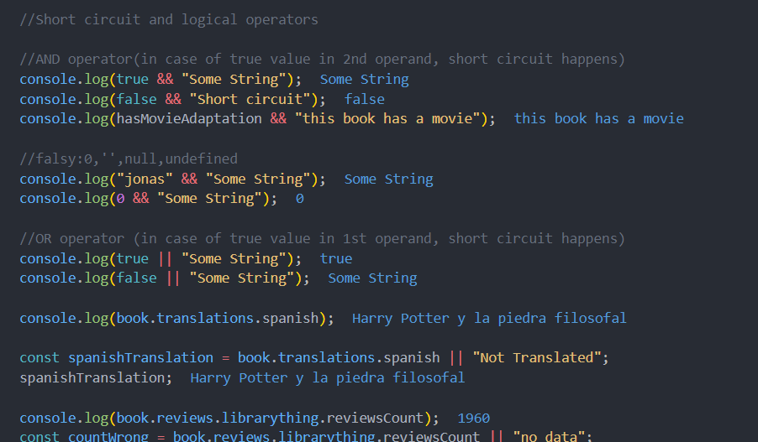

Optional Chaining

Without optional Chaining

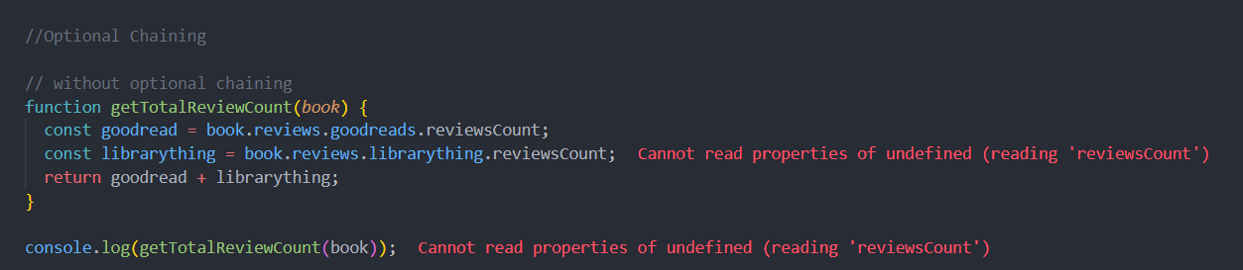

With Optional Chaining

The Array Map Method

The Array Filter Method

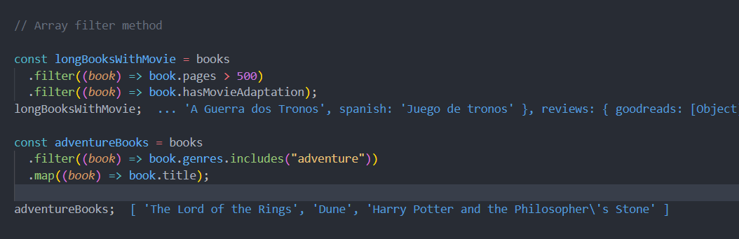

The Array Reduce Method

The Array Sort Method

Unlike map, reduce and filter method, sort method is a mutable method where the original gets modified. (Explore slice()).

Working with Immutable arrays

JavaScript Promises

JavaScript Aync and Await

