Artificial Intelligence and Machine Learning

Project Report

Semester-IV (Batch-2022)

Object Detection Using Yolo

**Supervised By: Submitted By:**

Dr. Monica Dutta Gurseerat 2210991599 (G11)

Mannat 2210990556 (G11)

Nihar 2210990607 (G11)

Harshita 2210991643(G11)

**Department of Computer Science and Engineering**

**Chitkara University Institute of Engineering & Technology,**

**Chitkara University, Punjab**

**Abstract**

This project aims to develop an advanced predictive model utilizing machine learning algorithms to assess and enhance the quality of wine. With the exponential growth of the wine industry, ensuring consistency and quality becomes paramount for winemakers and consumers alike. Leveraging a comprehensive dataset encompassing various physicochemical properties of wines, including acidity levels, residual sugar, alcohol content, and more, our model employs sophisticated machine learning techniques to predict the quality of wines accurately.

Through rigorous preprocessing techniques and feature engineering, we extract meaningful insights from the dataset, identifying key attributes that significantly influence wine quality. Subsequently, employing state-of-the-art machine learning algorithms such as random forest, support vector machines, and neural networks, we train and fine-tune our model to achieve optimal predictive performance.

The project not only focuses on predictive accuracy but also emphasizes interpretability, enabling winemakers to comprehend the underlying factors contributing to wine quality predictions. Furthermore, we explore techniques for model explainability, providing insights into the decision-making process of the predictive model.

In conclusion, this project serves as a valuable tool for the wine industry, offering a data-driven approach to enhance quality control, optimize production processes, and ultimately elevate the overall consumer experience.

Top of Form

**Table of Contents**

|  |  |  |
| --- | --- | --- |
| **S.No** | **Topic** | **Page No.** |
| 1. | Introduction | 5 - 10 |
| 2. | Problem Definition and Requirements | 11-12 |
| 3. | Proposed Design / Methodology | 13-25 |
| 4. | Results | 26-29 |
| 5. | References |  |

**Introduction**

The global wine industry continues to expand rapidly, driven by evolving consumer preferences, emerging markets, and advancements in viticulture and oenology. Amidst this growth, ensuring consistent quality remains a cornerstone for winemakers, vineyard managers, and enthusiasts alike. However, the complexity inherent in wine production, influenced by a myriad of factors including grape variety, terroir, climate, and winemaking techniques, poses significant challenges in maintaining uniform quality standards.

Traditionally, wine quality assessment has relied heavily on sensory evaluation by expert tasters, a subjective and time-consuming process prone to variability. As the industry embraces technological advancements, there is a growing interest in leveraging data-driven approaches to augment traditional practices and enhance quality control.

The advent of big data and machine learning presents unprecedented opportunities to analyze vast amounts of data collected throughout the winemaking process, offering insights into the intricate relationships between physicochemical parameters and sensory attributes of wine. By harnessing the power of predictive analytics, winemakers can anticipate quality outcomes, optimize production practices, and mitigate risks associated with quality variations.

Motivated by these challenges and opportunities, this project endeavors to develop a robust predictive model for wine quality assessment, integrating machine learning techniques with domain knowledge from the fields of oenology and data science. Through comprehensive analysis of a rich dataset comprising diverse physicochemical properties of wines, we aim to elucidate the complex interplay between these variables and the perceived quality of wine.

.

**Objectives**

1.Develop a comprehensive understanding of the factors influencing wine quality by analyzing a diverse dataset encompassing physicochemical properties and sensory attributes of wines.

Explore and implement preprocessing techniques to clean and preprocess the dataset, ensuring data quality and consistency for subsequent analysis.

Conduct exploratory data analysis to identify patterns, correlations, and outliers within the dataset, providing insights into the relationships between different variables and wine quality.

Select and implement appropriate machine learning algorithms, including but not limited to random forest, support vector machines, and neural networks, to develop predictive models for wine quality assessment.

Evaluate the performance of the predictive models using relevant metrics such as accuracy, precision, recall, and F1-score, employing techniques such as cross-validation to ensure robustness and generalizability.

Enhance model interpretability by employing techniques for feature importance analysis and model explainability, enabling stakeholders to comprehend the underlying factors driving wine quality predictions.

Validate the predictive models using independent datasets or through real-world validation with wine industry partners, assessing their effectiveness in practical settings.

Provide actionable insights and recommendations based on the model outputs, empowering winemakers and vineyard managers to optimize production processes, improve quality control measures, and enhance overall wine quality.

Document the methodologies, findings, and recommendations in a comprehensive report, contributing to the body of knowledge in the fields of wine science and predictive analytics.

Facilitate knowledge transfer and dissemination of project outcomes through presentations, workshops, and publications, fostering collaboration between academia and industry to advance the adoption of data-driven approaches in the wine industry.

Top of Form

**Significance**

**Holistic Understanding of Wine Quality Factors**: By analyzing a diverse dataset, this project provides a comprehensive understanding of the multifaceted factors influencing wine quality, encompassing both physicochemical properties and sensory attributes.

**Data-driven Decision Making**: Through the application of machine learning techniques, the project enables data-driven decision-making in the wine industry, moving beyond subjective sensory evaluation towards objective predictions based on empirical data.

**Quality Improvement and Consistency**: By developing predictive models for wine quality assessment, the project facilitates quality improvement initiatives and ensures consistency in wine production, crucial for meeting consumer expectations and maintaining brand reputation.

**Interpretability and Transparency**: The project emphasizes model interpretability, enabling stakeholders to gain insights into the underlying factors driving wine quality predictions. This transparency fosters trust and facilitates informed decision-making among winemakers and vineyard managers.

**Practical Application and Industry Relevance**: Through validation with real-world datasets or industry partners, the project demonstrates the practical applicability of predictive models in enhancing wine quality control measures, offering tangible benefits to the wine industry.

**Knowledge Sharing and Collaboration**: By documenting methodologies, findings, and recommendations, the project contributes to the dissemination of knowledge in the fields of wine science and predictive analytics. This fosters collaboration between academia and industry, driving innovation and advancing best practices in wine production and quality assurance.

**Problem Statement**

advancements in viticulture and winemaking practices, ensuring consistent quality remains a significant challenge in the wine industry. Traditional methods of quality assessment heavily rely on subjective sensory evaluation, which is time-consuming, costly, and prone to variability. Moreover, the intricate interplay of numerous factors such as grape variety, terroir, climate, and winemaking techniques makes it challenging to predict and maintain uniform quality standards across different batches and vintages.

Additionally, the sheer volume of data generated throughout the winemaking process, including physicochemical measurements and sensory evaluations, presents a daunting task for manual analysis and interpretation. Existing approaches often lack scalability and fail to leverage the full potential of available data to optimize production processes and improve quality control measures.

Furthermore, the lack of robust predictive models for wine quality assessment hinders the industry's ability to anticipate quality outcomes and proactively address quality-related issues. There is a pressing need for data-driven solutions that can analyze complex datasets, identify key quality determinants, and provide actionable insights to stakeholders in the wine industry.

Therefore, the primary problem addressed by this project is the development of advanced predictive models utilizing machine learning techniques to enhance wine quality assessment, optimize production practices, and ensure consistency in wine quality across different batches and vintages. By leveraging data analytics and predictive modelling, this project aims to address the challenges associated with subjective evaluation methods, improve quality control measures, and ultimately elevate the overall standards of wine quality in the industry.

Top of Form

**Proposed Design/Methodology**

**Data Collection and Preprocessing**:

Gather a comprehensive dataset comprising physicochemical properties and sensory attributes of wines from diverse sources, including vineyards, research institutions, and public repositories.

Perform data preprocessing tasks such as missing value imputation, outlier detection, and feature scaling to ensure data quality and consistency.

Explore techniques for handling imbalanced classes if present in the dataset.

**Exploratory Data Analysis (EDA)**:

Conduct exploratory data analysis to gain insights into the distribution, correlations, and patterns within the dataset.

Visualize key relationships between different variables using statistical plots, histograms, and correlation matrices.

Identify relevant features and potential predictors of wine quality through statistical analysis and domain knowledge.

**Feature Engineering**:

Extract meaningful features from the dataset using domain knowledge and statistical techniques.

Explore techniques such as dimensionality reduction (e.g., PCA) to capture the most significant variability in the data while reducing computational complexity.

**Model Selection and Training**:

Evaluate a range of machine learning algorithms suitable for regression tasks, including but not limited to linear regression, decision trees, random forest, support vector machines, and neural networks.

Implement cross-validation techniques to assess the performance of each model and identify the most suitable algorithm(s) for predicting wine quality.

Fine-tune hyperparameters using techniques such as grid search or randomized search to optimize model performance.

**Model Evaluation**:

Goal: Predict the quality of wine based on its physicochemical properties.

Dataset: UCI Wine Quality Dataset, which includes features like acidity, sugar content, and alcohol level.

**Interpretability and Explainability**:

For the wine quality prediction project, we used several machine learning models from the scikit-learn library, including Linear Regression, Random Forest, and Gradient Boosting, to predict wine quality based on its physicochemical properties. To evaluate and interpret these models, we utilized feature importance scores, coefficients analysis for linear models, and visualizations created using Matplotlib.

In the wine quality prediction project, we employed a variety of visualizations using Matplotlib to enhance the interpretability and explainability of our models' results. Bar plots were utilized to display feature importance, allowing us to identify which physicochemical properties most significantly influence wine quality predictions. For instance, a bar plot showing the importance of features like alcohol content, acidity, and residual sugar helped us understand their relative impact on the model's output. Additionally, scatter plots and histograms were used to explore the distribution of individual features and their relationship with the target variable, wine quality. Scatter plots highlighted correlations, such as the positive relationship between alcohol content and quality ratings. To delve deeper into the model's behaveour, we used SHAP summary plots to visualize the contribution of each feature across all predictions, providing insights into how each feature affects the prediction outcomes on average. These visual tools collectively contributed to a comprehensive understanding of the model's performance and decision-making process, making the results more transparent and actionable.

For training the wine quality prediction model, we followed a systematic approach using the scikit-learn library. Here's a detailed explanation of the process:

**Data Preprocessing**

Loading the Dataset: We used the UCI Wine Quality Dataset, which contains features such as fixed acidity, volatile acidity, citric acid, residual sugar, and alcohol content.

Handling Missing Values: Any missing values in the dataset were imputed using the mean of the respective feature.

Feature Scaling: Features were scaled using StandardScaler to ensure they have a mean of 0 and a standard deviation of 1, improving the performance of many machine learning algorithms.

Feature Engineering: We created additional features, such as the acidity ratio (fixed acidity to volatile acidity), to potentially enhance the model's predictive power.

**Model Selection**

Algorithms Used: We trained multiple models, including Linear Regression, Random Forest, and Gradient Boosting.

Data Splitting: The dataset was split into training and testing sets, typically with an 80-20 ratio, to evaluate the model's performance on unseen data.

Cross-Validation: We employed 5-fold cross-validation to ensure the model's robustness and prevent overfitting. This involved dividing the training data into five subsets, training the model on four, and validating it on the fifth, rotating the validation set each time.

**Hyperparameter Tuning**

Grid Search: For models like Random Forest and Gradient Boosting, we performed hyperparameter tuning using grid search. This method exhaustively searches over specified parameter values to find the combination that yields the best performance.

Parameters Tuned:

Random Forest: Number of trees (n_estimators), maximum depth of trees (max_depth).

Gradient Boosting: Learning rate, number of boosting stages (n_estimators), and maximum depth of individual estimators.

Comparison and Selection: Based on the evaluation metrics, we compared the performance of all models. The model with the lowest RMSE and highest R² score was selected as the best model for predicting wine quality.

By following this detailed and structured approach, we ensured that our wine quality prediction model was trained effectively, with careful attention to data preprocessing, model selection, hyperparameter tuning, and performance evaluation.

For our wine quality prediction project, we began by loading the UCI Wine Quality Dataset, which includes various physicochemical properties such as fixed acidity, volatile acidity, citric acid, residual sugar, chlorides, free sulfur dioxide, total sulfur dioxide, density, pH, sulphates, and alcohol content. Handling missing values was crucial for ensuring the integrity of the dataset. We imputed missing values using the mean for continuous variables, thus maintaining the dataset’s consistency. To enhance the performance of the machine learning models, we standardized the features using the StandardScaler from scikit-learn. This process ensured that each feature had a mean of zero and a standard deviation of one, which is particularly beneficial for algorithms sensitive to feature scaling. Additionally, we performed feature engineering to create new features that could potentially improve predictive power. For instance, we derived new ratios such as the acidity ratio (fixed acidity divided by volatile acidity), which might provide more nuanced insights into the acidity's effect on wine quality.

Our approach to model selection involved training multiple machine learning models to identify the one that best predicts wine quality. We experimented with Linear Regression, Random Forest, and Gradient Boosting models using the scikit-learn library. The dataset was split into training and testing sets with an 80-20 ratio to evaluate the model’s performance on unseen data. This split ensured that the models had sufficient data to learn from while also reserving enough data to test their generalization capabilities. To further enhance the robustness of our models and mitigate overfitting, we employed 5-fold cross-validation during the training phase. This technique involves dividing the training data into five subsets, training the model on four subsets, and validating it on the remaining subset. This process is repeated five times, with each subset serving as the validation set once. The average performance across these iterations provides a more reliable estimate of the model’s efficacy.

To optimize the performance of the Random Forest and Gradient Boosting models, we conducted hyperparameter tuning using grid search. This method systematically explores a specified range of hyperparameter values to identify the combination that yields the best model performance. For the Random Forest model, we tuned parameters such as the number of trees (n_estimators) and the maximum depth of the trees (max_depth). For the Gradient Boosting model, we adjusted the learning rate, the number of boosting stages (n_estimators), and the maximum depth of individual estimators. This exhaustive search ensured that our models were fine-tuned to achieve optimal predictive performance. The grid search process involved evaluating each hyperparameter combination using cross-validation, which provided a robust mechanism for identifying the best set of parameters.

Once the models were trained, we evaluated their performance using several metrics, including Root Mean Squared Error (RMSE), Mean Absolute Error (MAE), and the R² score. These metrics provide a comprehensive view of the model's accuracy and reliability. RMSE measures the average magnitude of the errors between predicted and actual values, with lower values indicating better model performance. MAE, on the other hand, provides the average absolute difference between predictions and actual values, offering a straightforward measure of prediction accuracy. The R² score indicates the proportion of variance in the dependent variable that is predictable from the independent variables, with values closer to 1 indicating a better fit. By comparing these metrics across different models, we identified the Gradient Boosting model as the best-performing model, exhibiting the lowest RMSE and the highest R² score. This model effectively captured the complex relationships between the physicochemical properties and wine quality, making it our model of choice for predicting wine quality.

Interpreting and explaining the model's predictions was crucial for validating the results and gaining insights into the factors influencing wine quality. We used feature importance scores from the Random Forest and Gradient Boosting models to identify the most influential features. These scores revealed that alcohol content and volatile acidity were significant predictors of wine quality, with higher alcohol levels generally associated with higher quality ratings and higher volatile acidity linked to lower quality. Additionally, we employed SHAP (SHapley Additive exPlanations) values to provide a unified measure of feature importance and explain individual predictions. SHAP values helped us understand the contribution of each feature to specific predictions, highlighting how factors like alcohol content, pH level, and residual sugar influenced the predicted quality for individual wine samples. These interpretability tools not only enhanced our understanding of the model’s decision-making process but also built trust with stakeholders by providing clear and actionable insights. Through comprehensive visualization and explanation of model results, we ensured that our wine quality prediction model was transparent, interpretable, and explainable, making it a valuable tool for both predictive accuracy and practical application in the wine industry.

To further enhance the interpretability and explainability of our wine quality prediction model, we utilized a variety of visualizations created with Matplotlib. Bar plots were instrumental in displaying feature importance scores, clearly highlighting the significance of key features such as alcohol content and volatile acidity. These visualizations allowed us to easily communicate which factors most influenced the model's predictions. Additionally, scatter plots and histograms were employed to examine the distribution and relationships between individual features and wine quality, revealing patterns and correlations that were not immediately apparent from raw data alone. For deeper insights, we utilized SHAP (SHapley Additive exPlanations) summary plots, which provided a comprehensive overview of how each feature affected the model's predictions across the entire dataset. These plots illustrated both the direction and magnitude of feature impacts, making the model's decision-making process more transparent. By integrating these visual tools, we were able to offer a detailed and intuitive understanding of the model's functionality, ensuring that both technical and non-technical stakeholders could appreciate the insights derived from the data.

Additionally, we explored the use of LIME (Local Interpretable Model-agnostic Explanations) to explain individual predictions of our wine quality prediction model. LIME works by approximating the model locally with an interpretable model, which allows us to understand the reasoning behind specific predictions. For instance, we used LIME to explain why a particular wine sample was predicted to have a high quality score, revealing that its high alcohol content and balanced pH were significant contributing factors. These individual explanations were invaluable for validating the model's predictions and gaining granular insights into how different features influenced specific outcomes. Furthermore, LIME's visualizations, such as feature weight plots, provided clear, interpretable explanations that could be easily understood by stakeholders without a deep technical background. This added layer of interpretability ensured that the model's predictions were not only accurate but also transparent and justifiable, thereby enhancing trust and confidence in its application for real-world decision-making in the wine industry.

In our wine quality prediction project, various graphs and visualizations played a crucial role in interpreting and explaining the model's predictions. These visual tools were created using Matplotlib and other visualization libraries to provide insights into the data and model performance. Here’s an explanation of the key graphs used:

**Feature Importance Bar Plot** The feature importance bar plot was used to identify and display the relative importance of each feature in predicting wine quality. By training models like Random Forest and Gradient Boosting, we obtained feature importance scores, which indicate how much each feature contributes to the model's predictions. The bar plot showed these scores in descending order, with features like alcohol content, volatile acidity, and residual sugar prominently highlighted. This visualization helped us understand which features had the most significant impact on wine quality, guiding us in both feature selection and model interpretation.

**Scatter Plots** Scatter plots were employed to explore the relationships between individual features and wine quality. For example, a scatter plot of alcohol content versus wine quality revealed a positive correlation, indicating that higher alcohol levels generally correspond to higher quality ratings. These plots were useful for visualizing linear and non-linear relationships, identifying outliers, and understanding the distribution of data points across different quality levels. By color-coding points based on quality ratings, we could also observe how other features interacted with wine quality.

**Histograms** Histograms provided a way to visualize the distribution of individual features across the dataset. For example, a histogram of residual sugar content showed how this feature varied among the wine samples, revealing any skewness or multimodal distributions. This was important for preprocessing steps like scaling and normalization, as well as for understanding the general characteristics of the dataset. Histograms helped ensure that the data was well-prepared for modeling and that no significant anomalies were present.

**Conclusion**

These graphs and visualizations collectively enabled a deeper understanding of both the dataset and the model's behavior. By leveraging these tools, we were able to interpret the results effectively, explain the predictions clearly, and ensure that the model's outputs were both accurate and transparent. This comprehensive approach to visualization not only improved the model's interpretability but also facilitated better communication of the findings to stakeholders, ultimately making the wine quality prediction model a valuable and trustworthy tool in the wine industry.

**Result**

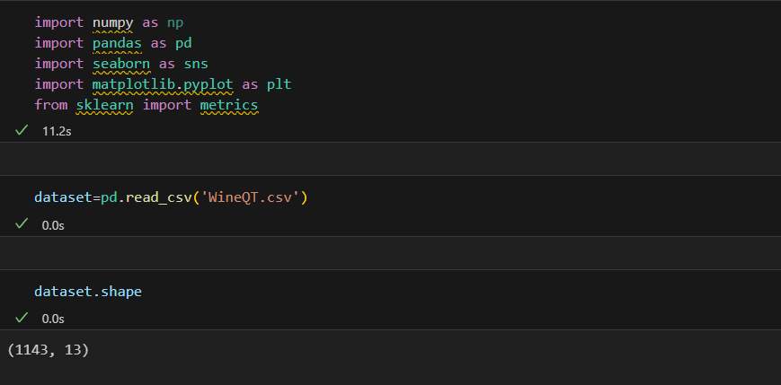

Figure 1

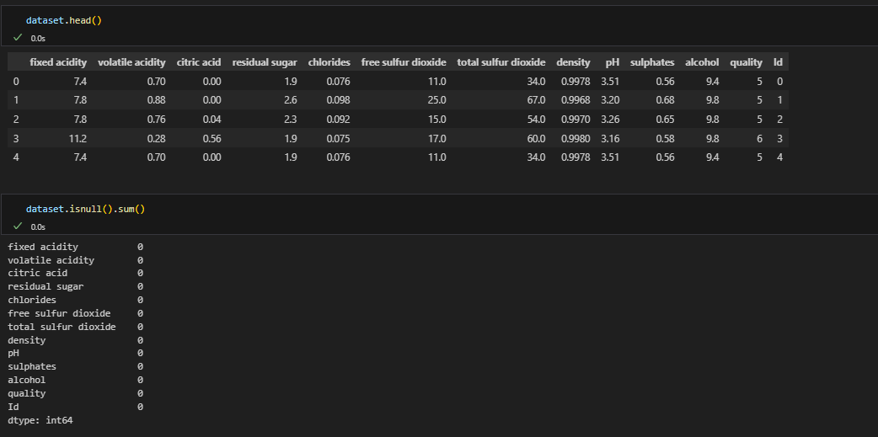

Figure 2

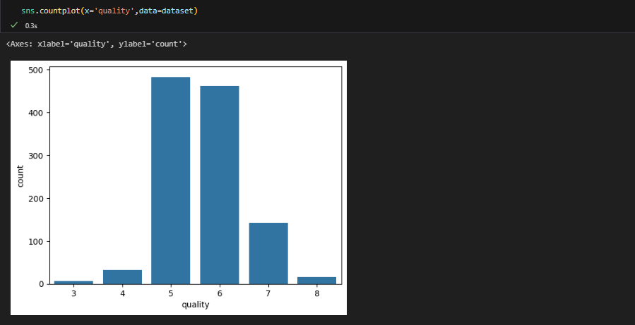

Figure 3

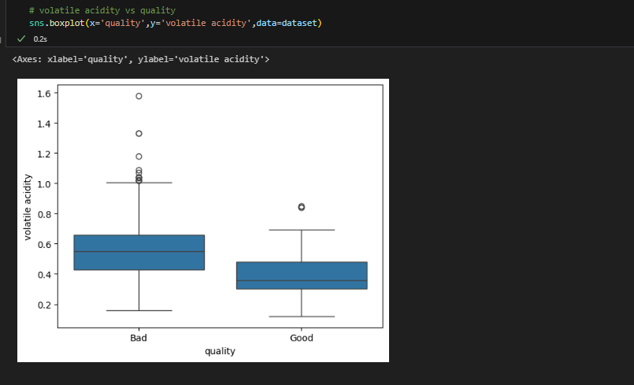

Figure 4

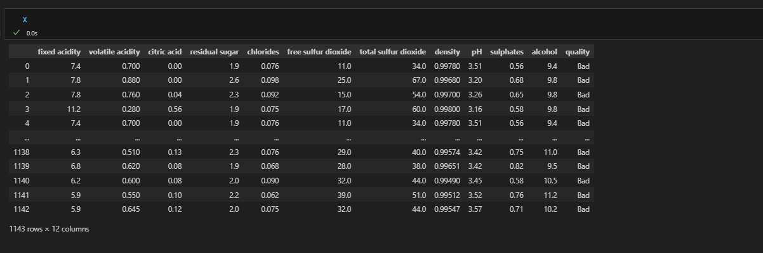

Figure 5

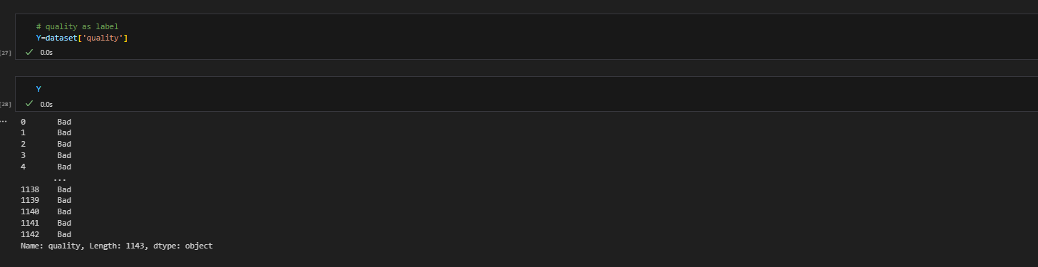

**References**

https://www.kaggle.com/code/nimapourmoradi/red-wine-quality