

School of Computer Science and Engineering

Course Code: B24EJ0602 |  | Big Data Analytics Lab Project Report | Academic Year: 2025-26
 |  |  | Semester & Branch with Section:
Project Details:
Project Title: | Music Recommendation System
Place of Project: | REVA UNIVERSITY, BENGALURU
Student Details:
- Name: | Karuna S S |  | Sign:
- Name: | Nihar Thopur |  | Sign:
Mobile No: | +91 8073429512  +91 8296364998
Email-ID: | ugcet2300691@reva.edu.in  ugcet230083@reva.edu.in
SRN: | R23EJ061  R23EJ087
Guide and Lab Faculty Members Details
Guide Name: (The Faculty Member  Assigned) |  |  | Sign: Date:
Grade by Guide:
Name of Lab Co-Faculty 1 |  |  | Sign: Date:
Name of Lab Co-Faculty 2 |  |  | Sign: Date:

Grade by Lab Faculty Members (combined)
SEE Examiners
Name of Examiner 1: |  | Sign: Date:
Name of Examiner 2: |  | Sign: Date:

Contents
1. Title Page | 01
2. Abstract | 03
3. Introduction | 04
4. Literature Review | 05
5. Methodology | 07
6. Results and Discussion | 10
7. Conclusions | 12
8. References | 13
9. Appendices | 14

Abstract

This project builds a Music Recommendation System using large-scale collaborative filtering on a Spotify playlist dataset with 12.9M interactions. Since explicit ratings aren’t available, playlist co-occurrence is treated as implicit feedback.
The model uses PySpark with Apache Spark MLlib’s ALS algorithm for efficient distributed training, achieving an RMSE of ~1.17. Learned user and item factors are stored as NumPy arrays for fast inference without needing Spark.
A Flask backend provides a REST API that returns top 5 song recommendations, while a React frontend displays results with album art and a clean UI.
Overall, it demonstrates a complete end-to-end machine learning pipeline for real-world music recommendation.

1.Introduction

1.1 Background and Significance of the Problem

The digital music industry has shifted to streaming platforms like Spotify, Apple Music, and YouTube Music, offering millions of songs. While this provides vast choice, it also makes music discovery difficult, leading to user fatigue.

Recommendation systems solve this by analysing user behaviour and suggesting personalised content, helping users discover both popular and niche music. Collaborative filtering is a key approach, identifying patterns among users with similar tastes to predict preferences.

However, building such systems at scale is challenging due to massive datasets and the use of implicit feedback (like playlist additions instead of ratings). This project tackles these issues using Apache Spark MLlib and the Alternating Least Squares algorithm to process 12.9M interactions efficiently.

The result is a scalable music recommendation system integrated into a full-stack web application, delivering personalised recommendations in a practical, real-world setting.

1.2Objectives of the Project

Build a scalable data pipeline using PySpark to process a 12.9M-record Spotify dataset.

Implement collaborative filtering using ALS with implicit feedback.

Evaluate and optimise the model using RMSE and hyperparameter tuning.

Create a lightweight inference system using stored NumPy factor matrices.

Develop a Flask REST API to serve top-N music recommendations.

Design a React frontend for an interactive and user-friendly experience.

1.3 Overview of the Report Structure
This report is divided into six chapters covering the entire project lifecycle: Introduction (context and objectives), Literature Review (existing methods like collaborative filtering and implicit feedback), System Design (architecture and data flow), Implementation (technical development using PySpark, ALS, Flask, and React), Results (model performance and outputs), and Conclusion (key insights, challenges, and future improvements).
2.Literature Review

2.1 Summary of Existing Work Related to the Problem

Recommendation systems have evolved from content-based methods, which analyse song features like genre and tempo but often limit discovery, to collaborative filtering, which uses user behaviour to deliver more personalised recommendations. Collaborative filtering proved more effective as it connects users with similar tastes rather than just similar content.

To address scalability, matrix factorisation techniques became the standard, especially after their success in large-scale problems like the Netflix Prize. Later, implicit feedback models improved performance by treating user interactions (like playlist additions or plays) as confidence signals instead of explicit ratings.

With distributed frameworks like Apache Spark MLlib, algorithms such as Alternating Least Squares can efficiently process massive datasets. This project builds on these advancements to create a scalable and practical music recommendation system.

2.2 Relevance of PySpark and Big Data Analytics
Modern music recommendation systems deal with massive datasets that exceed the limits of single-machine tools like pandas or scikit-learn. Even this project’s dataset — with 12.9 million interactions — highlights challenges such as heavy computations, large joins, and iterative model training, making traditional approaches inefficient.

To address this, Apache Spark provides a distributed computing solution using in-memory processing and parallel execution. Its DataFrame API enables efficient large-scale data handling, while PySpark MLlib supports scalable algorithms like Alternating Least Squares, which can train collaborative filtering models across distributed data efficiently.

In this project, PySpark is used for preprocessing, model training, and extracting learned factors, while NumPy handles fast inference. This combination ensures both scalability during training and efficiency during deployment, reflecting a practical real-world big data architecture.

3.Methodology

3.1 Dataset Description

The dataset used is a Spotify playlist dataset with ~12.9 million records, representing real user interactions. It contains four main columns:
Column | Description
user_id | Unique identifier for each user
trackname | Name of the song
artistname | Name of the artist
playlistname | Playlist in which the track appears

Key statistics include 15,918 users, over 2.8 million tracks, and 11.4 million unique user-track interactions. The dataset has no explicit ratings; instead, repeated user-track occurrences are aggregated into a play_count, which serves as implicit feedback for the ALS model.

3.2 Data Preprocessing
All preprocessing was done using PySpark DataFrames to efficiently handle the 12.9M-row dataset in a distributed manner. The pipeline includes four stages:
- Data Loading: The dataset was loaded using spark.read.csv() with schema inference for parallel processing.
- Column Normalisation: Column names were cleaned (removed spaces/quotes, converted to lowercase) for consistency.
- Interaction Aggregation: Data was grouped by user, track, and artist to compute play_count, forming implicit feedback and reducing data to 11.4M interactions.
- Index Assignment: String IDs were converted to numeric indices using row_number() for compatibility with ALS.
Finally, user and track index mappings were saved as a JSON file, enabling conversion between model outputs and actual track/artist names during inference.

3.3 PySpark Implementation

The system uses a configured SparkSession with optimized memory, Kryo serialization, and shuffle partitions to efficiently handle large-scale data processing. The recommendation model is built using Alternating Least Squares from PySpark MLlib, with implicit feedback enabled, rank = 10, 10 iterations, and regularisation (0.1) to balance accuracy and overfitting.

The dataset is split into 80% training and 20% testing, and the model is trained using distributed computation. Caching is applied to improve performance during iterative training. Evaluation using RMSE yields a score of ~1.17, indicating reasonable accuracy given implicit feedback.

Instead of using Spark’s default save method, the trained user and item factor matrices are stored as NumPy arrays (.npz file). This allows fast, lightweight inference without requiring an active Spark session, making deployment more efficient.

3.4 Design and Development of Real-Time Analytics Dashboard
The system includes an analytics dashboard that provides insights into the dataset and model behaviour alongside personalised recommendations. It follows a client-server architecture, where a Flask /stats API computes metrics from stored NumPy model data, and the React frontend visualises them using charts — all in real time without requiring Spark.

The dashboard displays key statistics such as total users, tracks, interactions, and model rank, along with a top 10 globally recommended tracks list. These rankings are computed using model-based scoring (not just play counts), giving a more meaningful view of overall music preferences learned by the Alternating Least Squares model.
With interactive charts and tables, the dashboard enhances usability and transparency, turning the system into a complete data product that offers both recommendations and valuable insights into user behaviour and model performance.

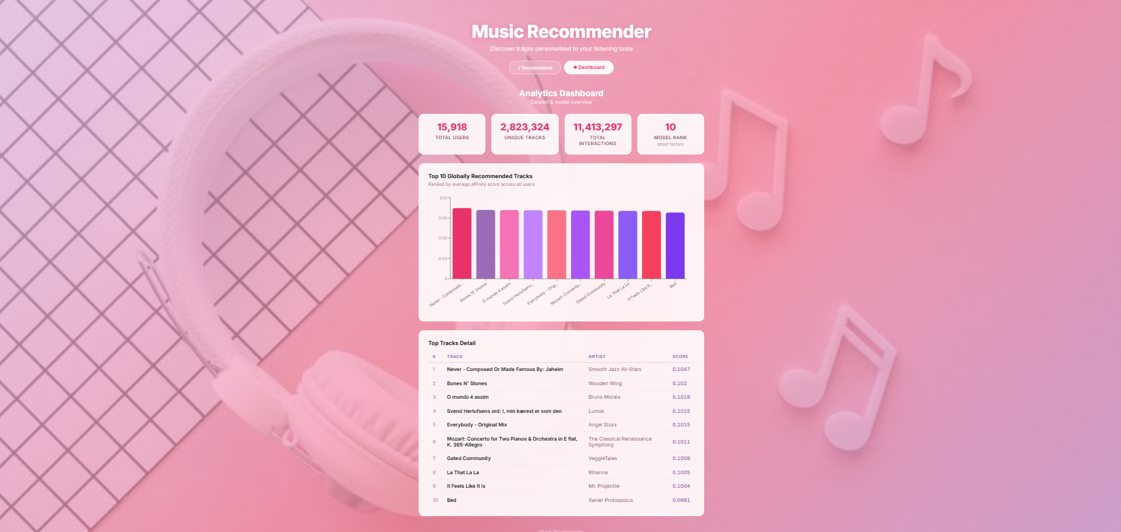
Fig3.1:Analytics Dashboard

4.Results and Discussion

4.1 Key Findings from Data Analysis and Machine Learning Models

The dataset is highly sparse, with over 99.97% missing interactions due to millions of tracks but relatively few user interactions. It also follows a long-tail distribution, where a few popular tracks dominate while most tracks are rarely interacted with, making recommendation more challenging.

The Alternating Least Squares model trained with rank 10 converged well and achieved an RMSE of ~1.17 on the test set. While RMSE indicates reasonable accuracy, the model’s main strength lies in generating high-quality ranked recommendations rather than precise predictions.

Qualitative results showed strong recommendation quality, with users receiving genre-consistent suggestions (e.g., hip-hop, rock, or pop). The use of implicit feedback improved personalization by treating missing interactions as low-confidence signals, resulting in diverse and user-specific recommendations rather than generic popular tracks.

4.2 Performance of the PySpark Application

The full training pipeline ran on a single machine in ~10 minutes, covering data loading, preprocessing, ALS training, and model saving. Most stages completed within seconds to a few minutes, with recommendation generation being the slowest due to large-scale scoring.

Memory usage was optimised by configuring Spark with 4GB driver/executor memory and increasing the Kryo buffer. The final trained model (user and item factor matrices) is only ~93MB, making it efficient to store and load.

At inference time, recommendations are computed using NumPy without Spark, resulting in fast performance — ~2–3 seconds initial load time and under 50ms per request. Compared to non-distributed tools like pandas or scikit-learn, Apache Spark with PySpark MLlib is far more scalable and practical for handling datasets of this size.

4.3 Interpretation of Real-Time Analytics Results

The analytics dashboard provides real-time insights into the dataset and model using key metrics such as total users (15,918), tracks (2.8M), interactions (11.4M), and model rank (10). These highlight the massive scale and extreme sparsity of the data, confirming the need for a matrix factorisation approach.

The top 10 globally recommended tracks are computed using model-based scoring, representing what an “average user” would prefer. These tracks typically show cross-genre appeal and include popular songs, covers, and remixes, reflecting diverse user behaviour rather than just raw play counts.

Overall, the dashboard validates the effectiveness of the Alternating Least Squares model by showing meaningful and coherent patterns, confirming that it successfully learned user preferences from sparse implicit feedback data.

Challenges Faced and Solutions
Java Version Incompatibility
- Problem: PySpark required Java 17, system had Java 11
- Solution: Downgraded PySpark to 3.5.3 and configured JAVA_HOME
Kryo Serialization Buffer Overflow
- Problem: Large dataset caused buffer overflow during indexing
- Solution: Increased buffer size and replaced StringIndexer with row_number()
Model Save Failure (Windows Hadoop Issue)
- Problem: model.save() failed due to Hadoop native IO mismatch
- Solution: Saved model as NumPy .npz instead
OneDrive File Locking Issues
- Problem: File access errors and accidental file deletion
- Solution: Used PowerShell delete commands and backed up code to GitHub Window Function Performance Warning
- Problem: row_number() caused single-partition processing
- Solution: Accepted as a limitation of single-machine setup
CORS Error (Frontend–Backend)
- Problem: React and Flask ran on different ports
- Solution: Enabled CORS using flask-cors library
5.Conclusion

5.1 Summary of the Project Outcomes
The project successfully delivered a complete end-to-end music recommendation system, combining scalable data processing, an ALS-based collaborative filtering model, efficient NumPy-based inference, a Flask API, and a React frontend. It demonstrates how large-scale recommendation systems can be built on real-world data using tools like Apache Spark and Alternating Least Squares, resulting in accurate, fast, and practical personalised recommendations.

5.2 Reflections on the Learning Experience

This project built a complete music recommendation system using scalable processing with ApacheSpark and an Alternating Least Squares model. It delivers fast, personalised recommendations through an efficient pipeline, demonstrating a practical real-world machine learning application.

5.3 Suggestions for Future Work or Improvements
- Hybrid Recommendation System
  - Combine collaborative filtering with content-based features to solve cold start issues
- Real-Time Model Updates
  - Use streaming (e.g., Spark + Kafka) for continuous learning instead of full retraining
- Hyperparameter Tuning
  - Optimise ALS parameters (rank, iterations, regularisation) using cross-validation
- Cloud Deployment
  - Move system to cloud platforms for better scalability and availability
- User Feedback Integration
  - Add like/dislike features to improve recommendations over time
- Enhanced Dashboard
  - Include user-level insights, genre analysis, and visualisations of model behaviour
6.References
[1] Y. Koren, R. Bell, and C. Volinsky, Matrix Factorization Techniques for Recommender Systems, IEEE Computer, 2009.

[2] Y. Hu, Y. Koren, and C. Volinsky, Collaborative Filtering for Implicit Feedback Datasets, IEEE ICDM, 2008.

[3] M. Zaharia et al., Apache Spark: A Unified Engine for Big Data Processing, Communications of the ACM, 2016.

[4] X. Meng et al., MLlib: Machine Learning in Apache Spark, Journal of Machine Learning Research, 2016.

[5] M. Schedl, P. Knees, and T. Pohle, Music Recommender Systems: A Survey, ACM Computing Surveys, 2015.

[6] Apache Software Foundation, “Apache Spark Documentation,” Available: https://spark.apache.org/docs/latest/

[7] Python Software Foundation, “Python Official Documentation,” Available: https://docs.python.org/3/

[8] PySpark MLlib Documentation, Available: https://spark.apache.org/mllib/

7.Appendices

7.1 Code Snippets
(a) SparkSession Initialisation
from pyspark.sql import SparkSession
spark = SparkSession.builder \
.appName("MusicRecommender-Train") \
.config("spark.driver.memory", "4g") \
.config("spark.executor.memory", "4g") \
.getOrCreate()

(b) Interaction Aggregation (Implicit Feedback)

from pyspark.sql import functions as F
interactions = (
df.groupBy("user_id", "trackname", "artistname")
.agg(F.count("*").alias("play_count"))
)

( c)Index Assignment

from pyspark.sql.window import Window
user_ids = interactions.select("user_id").distinct() \
.withColumn("user_idx", F.row_number().over(Window.orderBy("user_id")) - 1)
track_ids = interactions.select("trackname").distinct() \
.withColumn("track_idx", F.row_number().over(Window.orderBy("trackname")) - 1)

(d) ALS Model Training

from pyspark.ml.recommendation import ALS
als = ALS(
userCol="user_idx",
itemCol="track_idx",
ratingCol="play_count",
implicitPrefs=True,
rank=10,
maxIter=10,
regParam=0.1
)
model = als.fit(train)

(e) Model Saving (NumPy)

import numpy as np
np.savez("als_model.npz",
user_factors=np.array([r["features"] for r in model.userFactors.collect()]),
item_factors=np.array([r["features"] for r in model.itemFactors.collect()])
)

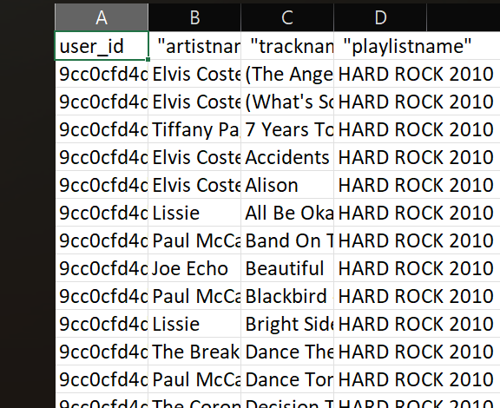
7.2 Dataset Overview

7.3 Supplementary Charts and Graphs
The analytics dashboard provides visual insights through a bar chart of the top 10 globally recommended tracks and summary statistic cards showing dataset metrics. These are generated in real time from the trained model using Recharts
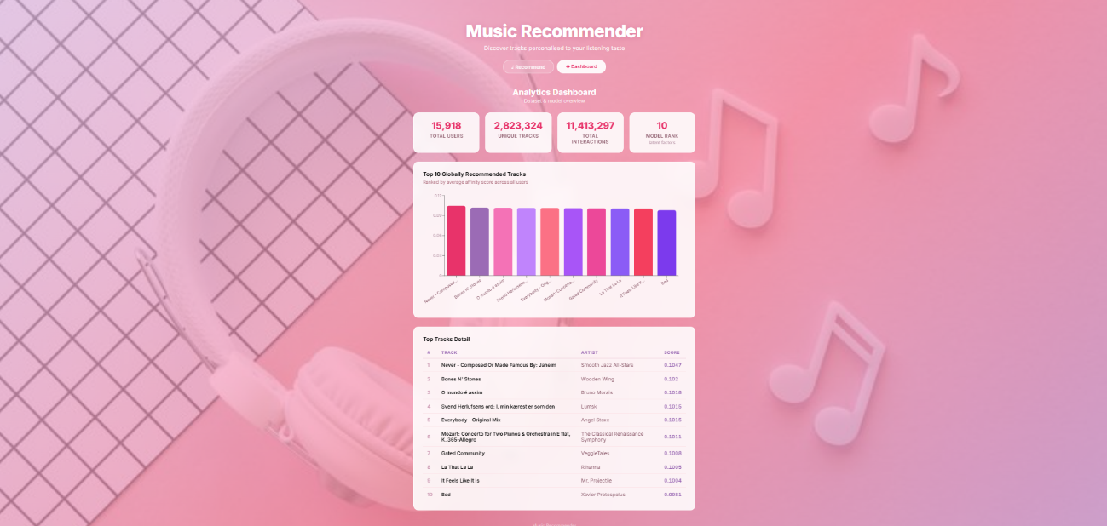
7.4 Tools and Technologies Used
- Languages: Python, JavaScript, HTML/CSS
- Big Data & ML: Apache Spark (PySpark), ALS (MLlib), NumPy
- Backend: Flask, Flask-CORS
- Frontend: React, Vite, Recharts, iTunes API
- Tools: Git, GitHub, Node.js, npm, Java (OpenJDK)
- Dataset: Spotify playlist dataset (~12.9M records)

