Enterprise Knowledge Portal
Project Plan
Version 1.0

Serverless Squad
CMPE-282 — Cloud Services
San Jose State University

Team Members:
Aditya Govind Shahari
Mohsen Minai
Nihar Dharmeshkumar Patel
Tamizh Selvan Manivannan
Revision History
Date | Version | Description | Author
February 10, 2026 | 0.1 | Initial draft — project scope, team roles, and GCP architecture defined | Serverless Squad
March 15, 2026 | 0.2 | Updated architecture section, added sprint timeline, Okta SSO and Jenkins CI/CD details added | Serverless Squad
April 26, 2026 | 1.0 | Final version — test plan completed, all milestones updated, risk register finalized | Serverless Squad

Table of Contents
1. Introduction
1.1 Purpose of this Document
1.2 Intended Audience
1.3 Scope
1.4 Definitions and Acronyms
1.4.1 Definitions
1.4.2 Acronyms and Abbreviations
1.5 References
2. Background and Objectives
3. Architecture and High-Level Design
4. Organization
4.1 Project Group
4.2 Customer
5. Development Process
6. Deliverables
7. Project Risks
8. Communication
8.1 Collaboration
8.2 Git
9. Project Plan
9.1 Time Schedule
9.1.1 Remarks
9.2 Test Plan
9.2.1 Testing Remarks
10. References

1. Introduction

1.1 Purpose of this Document
The purpose of this document is to provide a detailed project description of the Enterprise Knowledge Portal, a cloud-native proof-of-concept platform built for CMPE-282 at San Jose State University. The system demonstrates a fully serverless enterprise IT infrastructure on Google Cloud Platform with Okta-based Single Sign-On, a cloud database backend, a web portal for browsing enterprise data, GitHub integration for source control, and a Jenkins CI/CD pipeline. This document includes details about organization, roles, deliverables, project risks, time plans, and communication strategies.

1.2 Intended Audience
This document shall be used in all phases of the project as a guideline. Intended audiences are all project stakeholders:
- Course instructor and project supervisor
- Project team members (Serverless Squad)
- Teaching assistants reviewing project deliverables

1.3 Scope
This document defines the project plan for the Enterprise Knowledge Portal. The overview includes the objectives of the project, organization of the project team, the development process used, an assessment of possible risks, communication strategies between project stakeholders, and a project plan including time schedule and test plan.
The system is built entirely on GCP serverless services (Cloud Run, Cloud Build, BigQuery, Cloud Storage, Firestore) and integrates Okta SSO, a React frontend, six Go microservices, an AI chat service using NVIDIA NIM GLM-5.1, and a Jenkins CI/CD pipeline triggered by GitHub webhooks.

1.4 Definitions and Acronyms

1.4.1 Definitions
Keyword | Definition
Enterprise Knowledge Portal | The name of the project — a cloud-native web platform for browsing enterprise data with SSO login
Project Supervisor | The course instructor responsible for overseeing and evaluating the project (CMPE-282)
Project Leader | A team member responsible for coordinating work and communicating within the team
Team Member | An active contributor responsible for implementation, testing, and documentation
Milestone | A point in the project marking the completion of a significant deliverable or project phase
Sprint | A two-week development iteration used in the Agile/Scrum methodology
Microservice | An independently deployable service responsible for a single bounded business capability
Serverless | A cloud execution model where the cloud provider dynamically manages server allocation
CI/CD | Continuous Integration and Continuous Deployment — automated build, test, and deploy pipeline
SSO | Single Sign-On — an authentication scheme allowing one set of credentials to access multiple services

1.4.2 Acronyms and Abbreviations
Acronym | Definition
GCP | Google Cloud Platform
SSO | Single Sign-On
CI/CD | Continuous Integration / Continuous Deployment
API | Application Programming Interface
IAM | Identity and Access Management
KMS | Key Management Service
AR | Artifact Registry
CR | Cloud Run
CB | Cloud Build
BQ | BigQuery
SAML | Security Assertion Markup Language
JWT | JSON Web Token
NGINX | Open-source web server used as reverse proxy in the frontend container

1.5 References
- Google Cloud Run Documentation — https://cloud.google.com/run/docs
- Okta SAML Integration Guide — https://developer.okta.com/docs/guides/saml-overview
- Jenkins Pipeline Documentation — https://www.jenkins.io/doc/book/pipeline
- NVIDIA NIM API — https://build.nvidia.com
- GitHub Repository — https://github.com/Nihar4/CMPE-282_Term_Project

2. Background and Objectives
Many enterprises rely on fragmented IT infrastructures — on-premise databases, siloed authentication, and manual deployment processes — that impede agility and scalability. The CMPE-282 term project asks teams to demonstrate how a company can migrate to a modern, cloud-native architecture.
The Serverless Squad chose Google Cloud Platform as the cloud provider and adopted a fully serverless approach using Cloud Run for compute, BigQuery for analytics, Firestore for document storage, and Cloud Storage for file management. Authentication is handled via Okta SAML 2.0 SSO. The system is deployed automatically through a Jenkins pipeline triggered by GitHub pushes.
Objectives:
- Demonstrate a fully operational cloud-native enterprise portal accessible via Okta SSO
- Implement a RESTful API gateway in Go routing traffic to six specialized microservices
- Provide an AI-powered chat interface using NVIDIA NIM GLM-5.1
- Integrate GitHub source control with Jenkins CI/CD for automated Cloud Run deployments
- Showcase BigQuery analytics, Firestore document search, and GCS file management
- Apply layered security using GCP KMS encryption, IAM roles, and Okta SAML assertions

3. Architecture and High-Level Design
The Enterprise Knowledge Portal follows a microservices architecture deployed on Google Cloud Run (serverless). All services are containerized using Docker, stored in GCP Artifact Registry, and deployed via Cloud Build triggered by Jenkins.
System Components:
Frontend: React 18 single-page application served via NGINX. Integrates Okta OIDC for login. Communicates exclusively with the API Gateway.
API Gateway (Go): Single entry point for all frontend requests. Handles JWT validation, request routing, rate limiting, and CORS. Routes to five downstream services.
Auth Service (Go): Validates Okta SAML/JWT tokens. Manages user sessions and role-based access control.
Data Service (Go): Connects to Cloud SQL (PostgreSQL) and BigQuery. Serves enterprise database records — Products, Customers, Employees, Orders, Suppliers.
File Service (Go): Manages document uploads and downloads using Google Cloud Storage. Supports PDF, DOCX, XLSX formats.
AI Service (Go): Proxy to NVIDIA NIM API (GLM-5.1). Provides a conversational AI interface for querying enterprise knowledge.
Analytics Service (Go): Runs BigQuery queries for business intelligence dashboards — revenue trends, top products, customer analytics.
CI/CD Pipeline: Jenkins (Docker, local) polls GitHub via webhook. On push to main: checkout → GCP auth → Go tests → Cloud Build → Cloud Run deploy.
Infrastructure as Code: Terraform manages all GCP resources — Cloud Run services, Artifact Registry, BigQuery datasets, Cloud Storage buckets, KMS keys, IAM bindings, and Cloud Build triggers.

Figure 3.1 — System Architecture Overview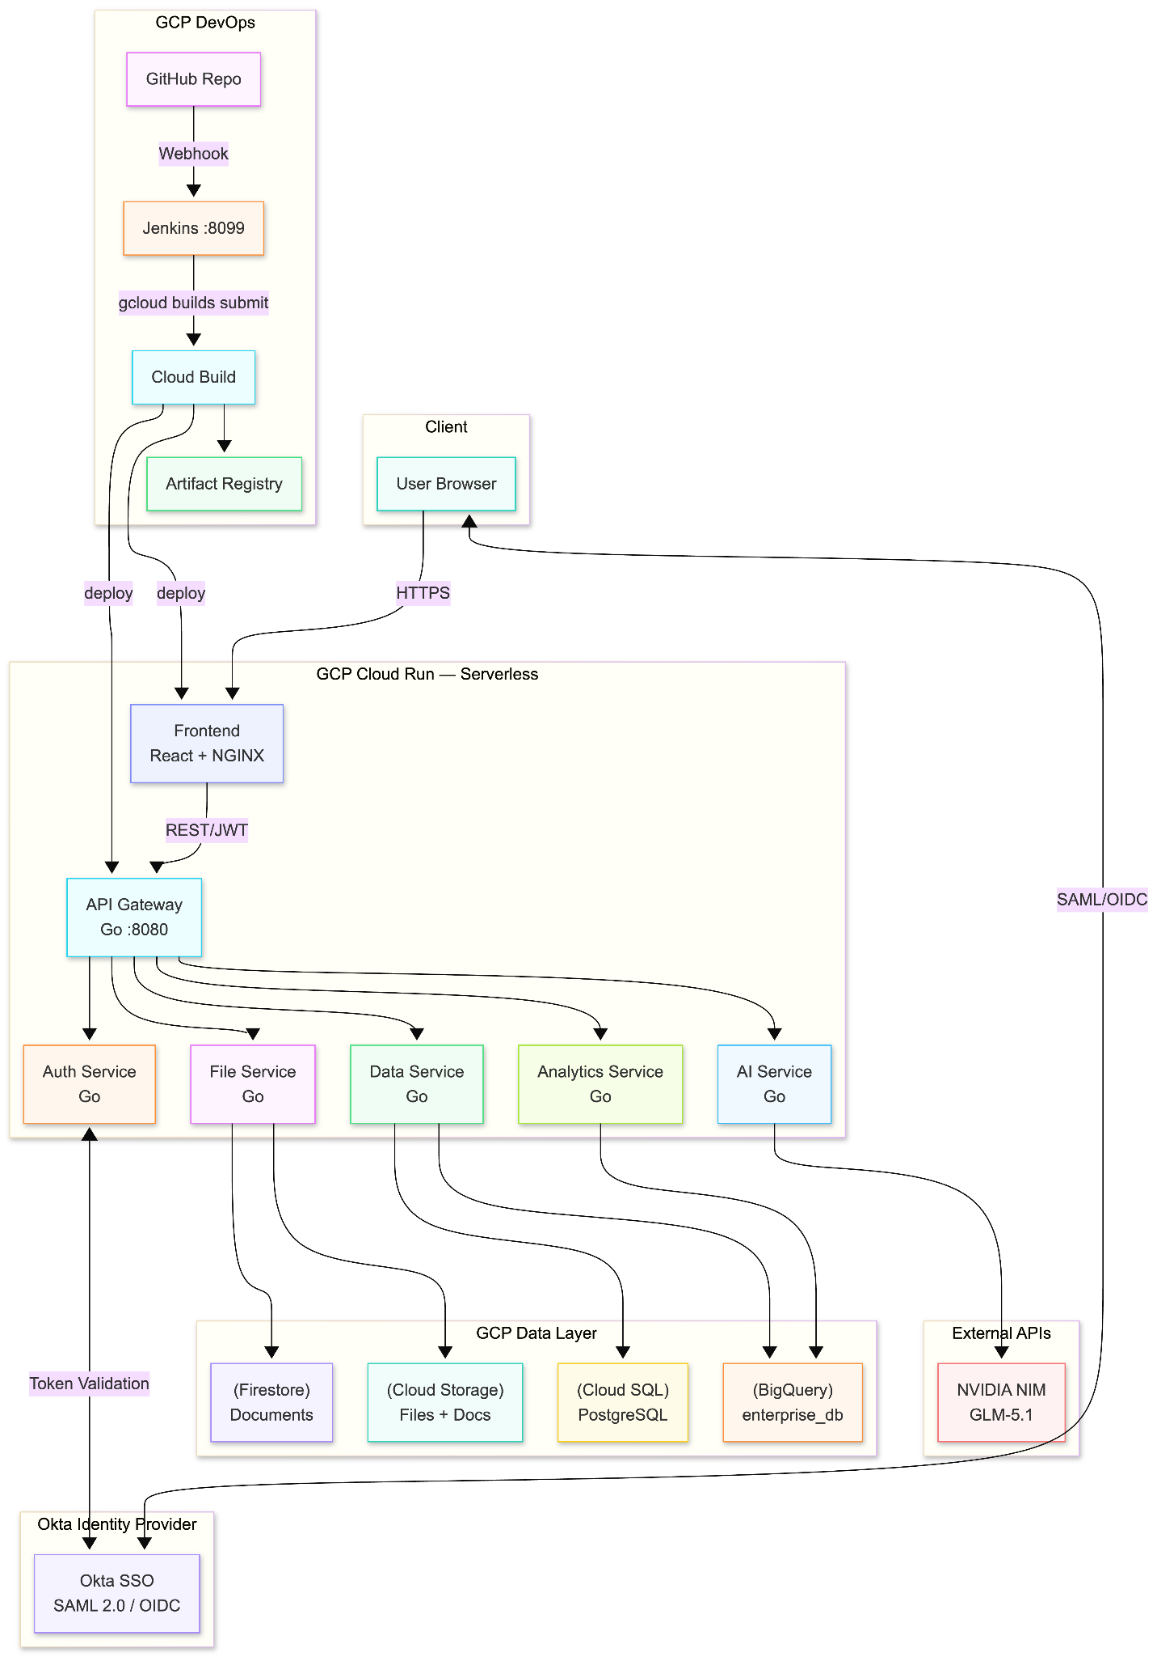
Figure 3.2 — GCP Cloud Infrastructure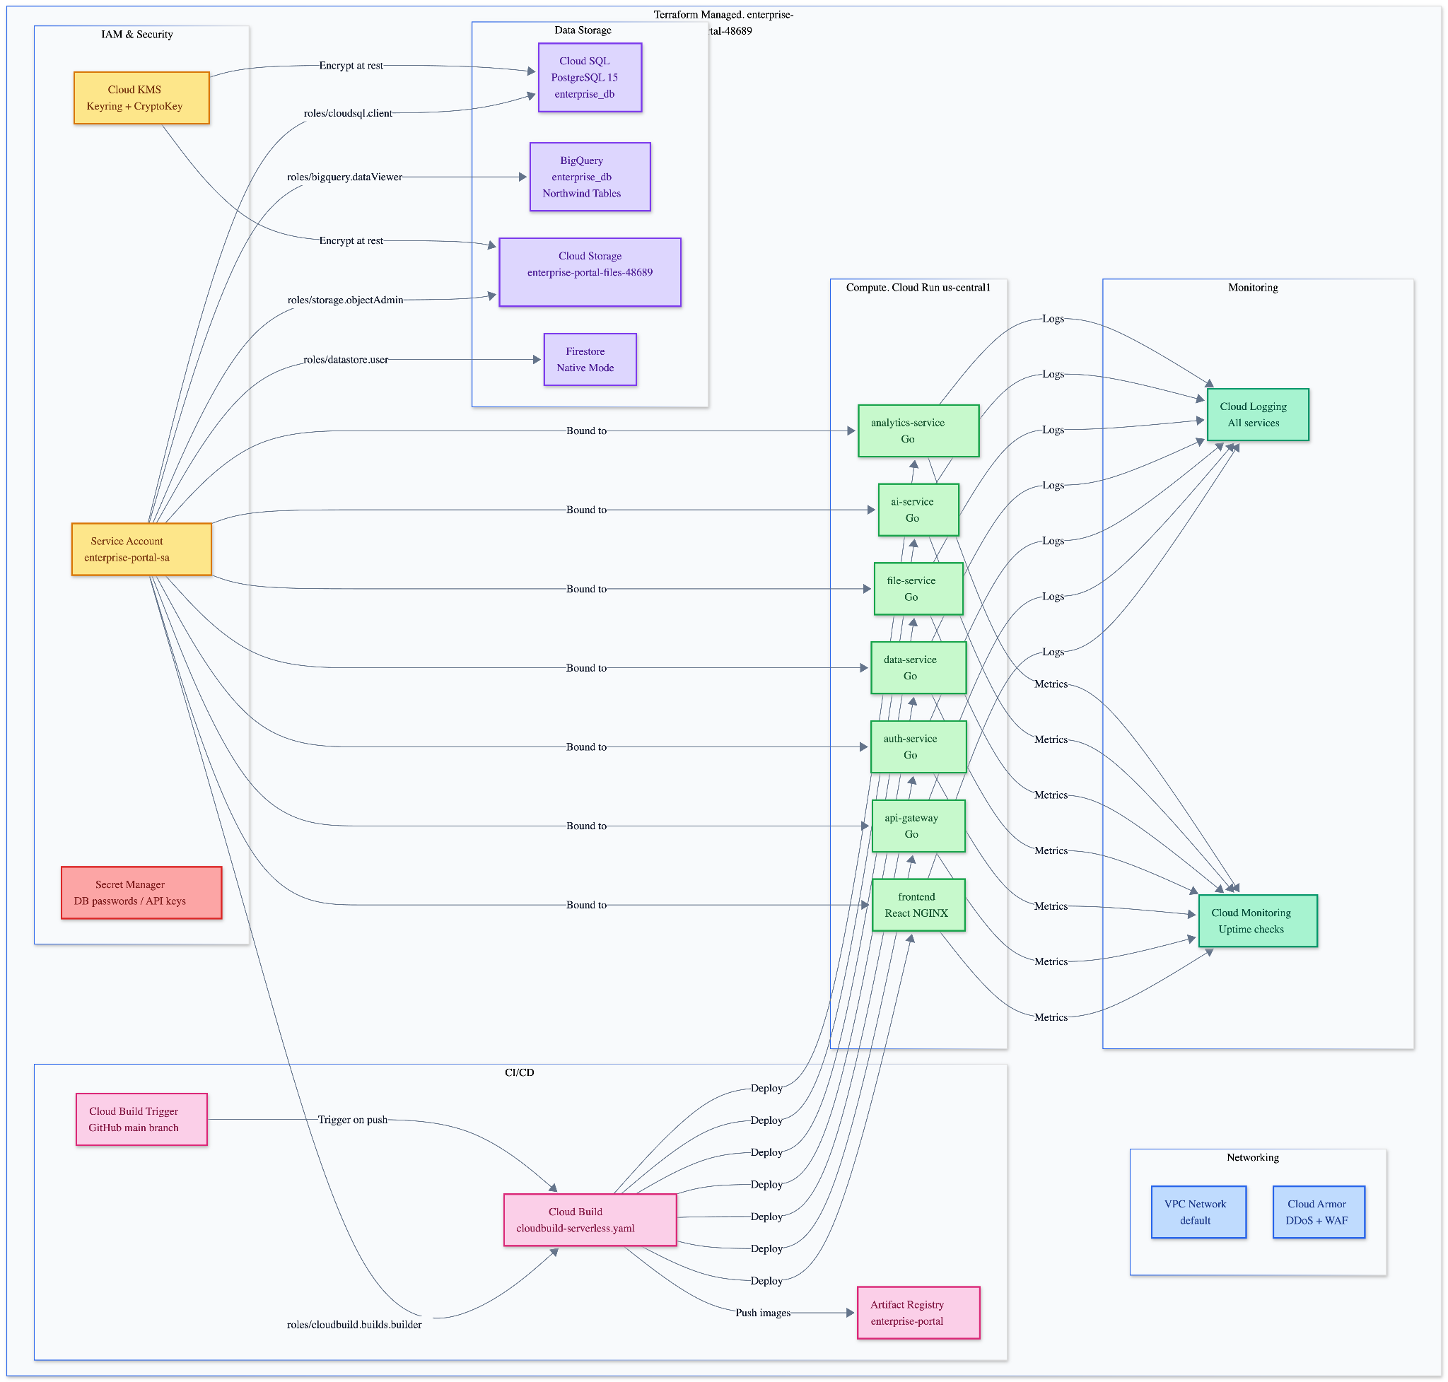
Figure 3.3 — Okta SSO Authentication Flow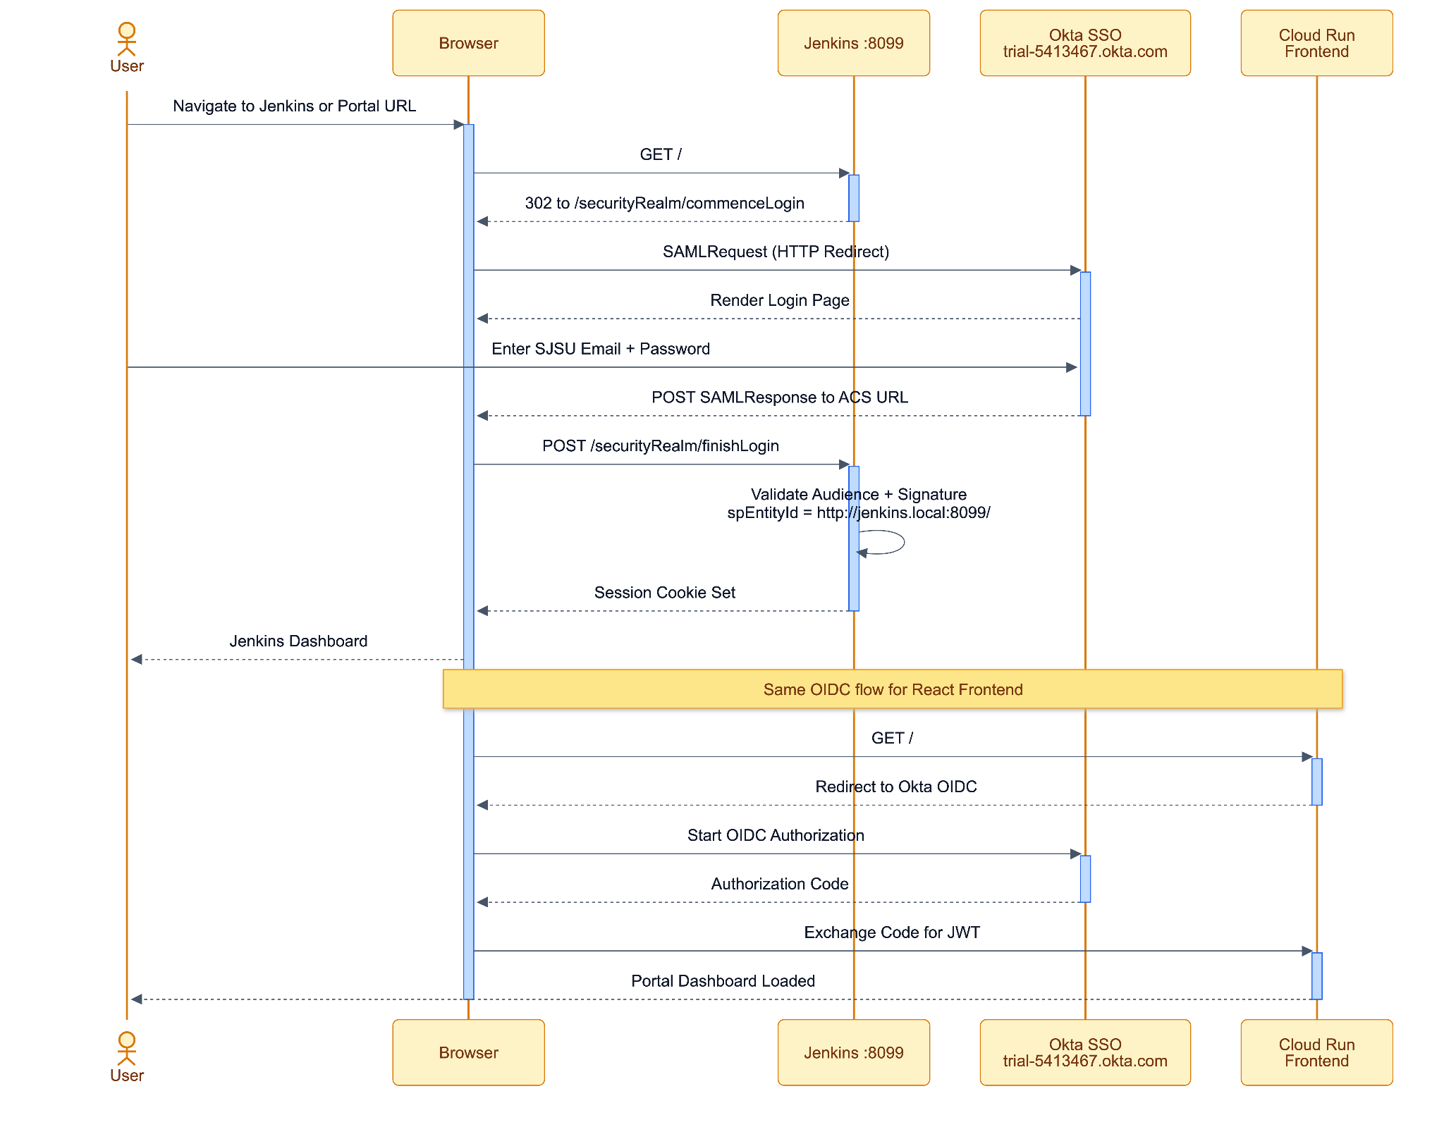

4. Organization

4.1 Project Group
Name | Initials | Responsibility
Aditya Govind Shahari | AGS | Backend microservices (Data Service, Analytics Service), BigQuery integration, Terraform IaC
Mohsen Minai | MM | Auth Service, Okta SAML/SSO integration, Jenkins CI/CD pipeline, GCP IAM and KMS security
Nihar Dharmeshkumar Patel | NDP | API Gateway, File Service, AI Service (NVIDIA NIM), React frontend, Docker/Cloud Run deployment
Tamizh Selvan Manivannan | TSM | Frontend (React, Okta OIDC), NGINX configuration, Cloud Build pipelines, project documentation

4.2 Customer
The target customers and stakeholders for this project are:
- CMPE-282 course instructor and teaching assistants (primary evaluators)
- Enterprise IT departments exploring cloud migration strategies
- Organizations seeking to modernize legacy on-premise infrastructure with GCP serverless services
- Development teams looking for a reference architecture combining Okta SSO, Go microservices, and GCP Cloud Run

5. Development Process
The project follows an Agile/Scrum methodology with two-week sprints. All source code is version-controlled in GitHub. Each sprint concludes with a working demo and retrospective.
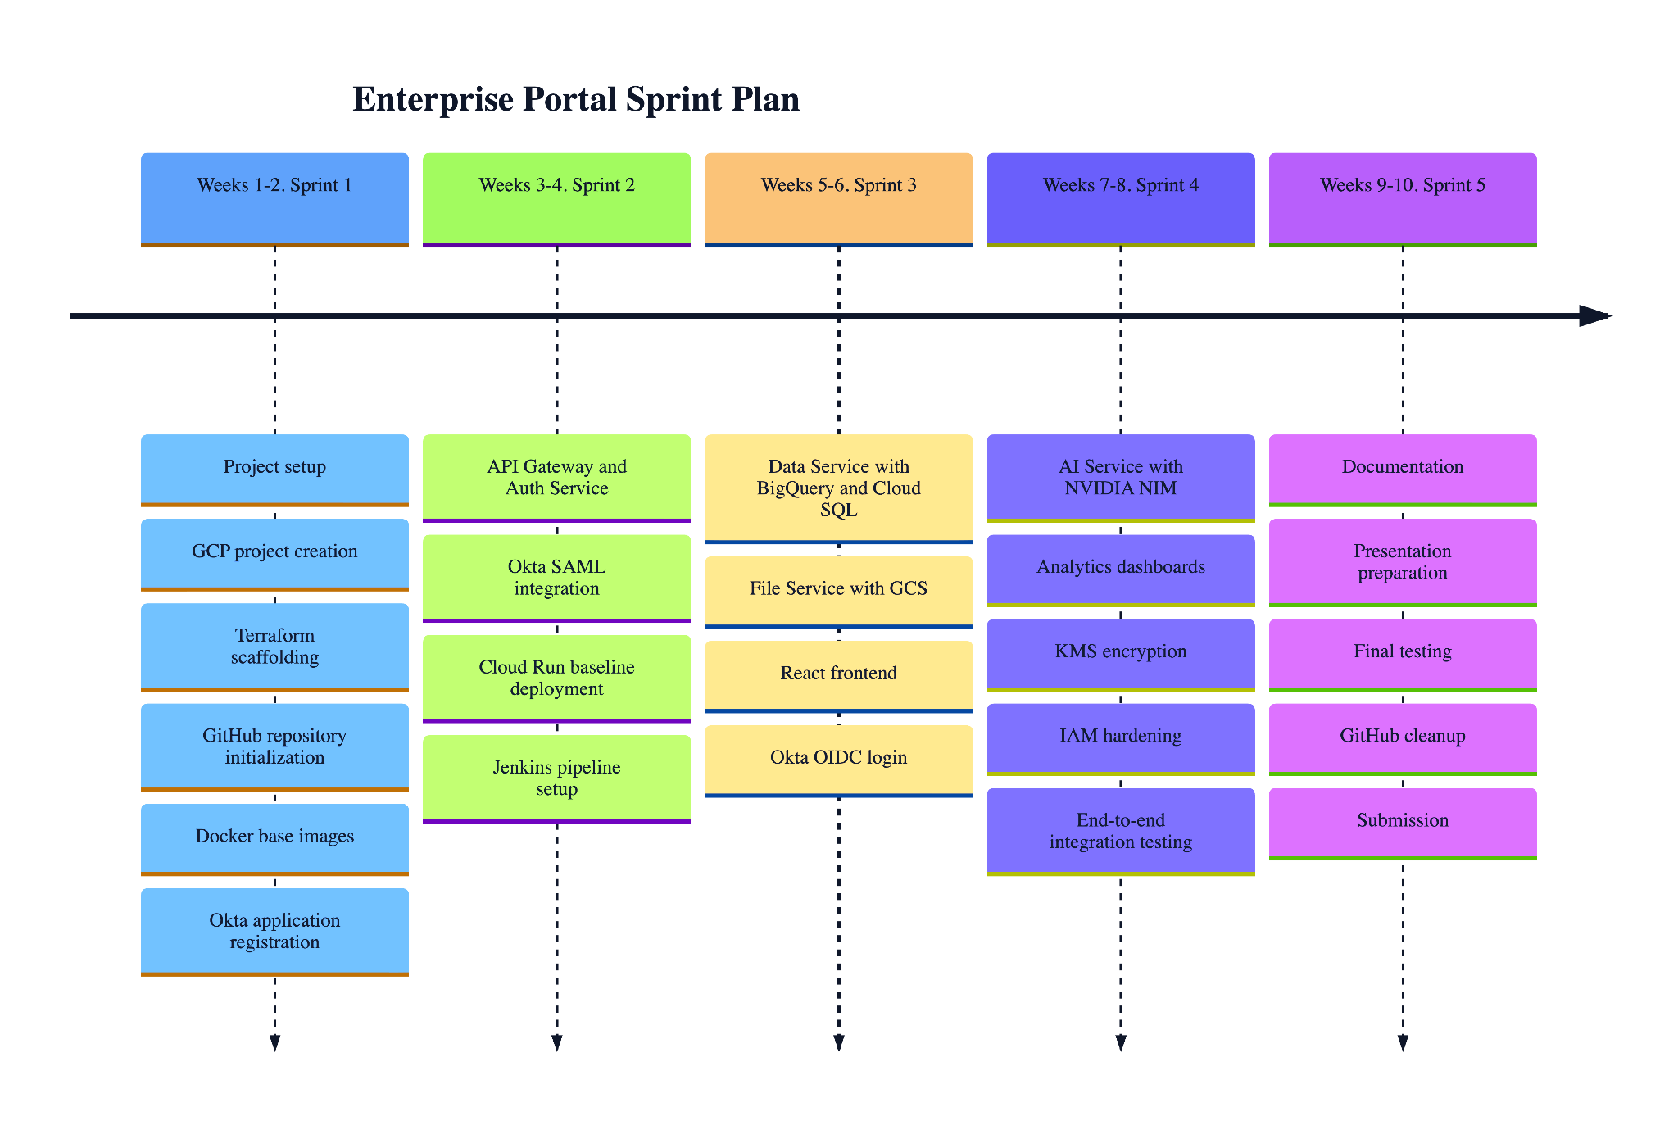
Team communication: Weekly sync meetings via Zoom, async collaboration via GitHub Issues and pull requests, documentation shared via Google Drive.

6. Deliverables
Deliverable | Output | Planned | Promised | Delivered | Notes
GCP Infrastructure (Terraform) | Cloud Run + all GCP resources | Week 3 | Week 3 | Week 4 | Terraform modules
Backend Microservices (6 Go) | Docker images on Artifact Registry → Cloud Run | Week 5 | Week 5 | Week 6 | 6 services
Okta SSO Integration | SAML 2.0 login for Jenkins + frontend | Week 4 | Week 4 | Week 5 | SAML plugin + Okta SDK
React Frontend | Cloud Run frontend with Okta login | Week 6 | Week 6 | Week 7 | NGINX-served SPA
Jenkins CI/CD Pipeline | Auto build+deploy on push to main | Week 5 | Week 5 | Week 7 | webhook → Cloud Build
GitHub Integration | All code in GitHub, webhook active | Week 2 | Week 2 | Week 2 | Nihar4/CMPE-282_Term_Project
Project Plan (.docx) | This document | Week 2 | Week 2 | Week 9 | —
Project Report (.docx) | Architecture, diagrams, screenshots | Week 10 | Week 10 | Week 10 | With presentation
Presentation (.pptx) | 15-minute live demo | Week 10 | Week 10 | Week 10 | Each member presents

7. Project Risks
Possibility | Risk | Preventive Action
High | Okta trial expiration (30-day limit) during development | Begin Okta setup in Sprint 1; document all SAML config for re-registration if needed
Medium | GCP billing overage or quota limits on Cloud Run / Cloud Build | Set budget alerts at $20; use minimal resource tiers (CPU only allocated on request)
Medium | Jenkins SAML logout loop preventing CI/CD access | Maintain local admin account as backup; document config.xml recovery steps
Medium | NVIDIA NIM API rate limiting for AI service | Implement request queuing and graceful degradation in AI service
Low | GitHub webhook fails to reach Jenkins (local Docker) | Use serveo.net SSH tunnel; document tunnel restart procedure
Low | Team member unavailability during final sprint | Cross-train all members on deployment; credentials stored in shared secure vault
Low | Cloud SQL connection limits exceeded under test load | Use pgx connection pool; cap at 10 max connections per service

8. Communication

8.1 Collaboration
The team communicates using the following channels:
- Weekly Zoom meetings every Sunday at 5:00 PM PST for sprint review and planning
- GitHub Issues for tracking bugs, features, and tasks
- GitHub Pull Requests for code review before merging to main
- Google Drive for sharing non-code documents, screenshots, and design diagrams
- iMessage group chat for quick async communication

All decisions are documented in GitHub Issues with appropriate labels (bug, enhancement, documentation).

8.2 Git
All source code, Terraform configurations, Dockerfiles, and finished documentation are stored in the GitHub repository.
Repository URL: https://github.com/Nihar4/CMPE-282_Term_Project
Branch strategy:
- main: production-ready code, protected branch, requires PR review
- feature/*: individual feature branches per sprint task
- All merges to main trigger the Jenkins CI/CD pipeline via GitHub webhook

9. Project Plan

9.1 Time Schedule
ID | Milestone Description | Responsible | Planned | Forecast | Actual | Remarks
M1 | GCP project setup, IAM, Terraform init, GitHub repo | All | Week 1 | Week 1 | Week 1 | Completed
M2 | Okta application registered, SAML metadata exchanged | MM, NDP | Week 2 | Week 2 | Week 2 | Completed
M3 | Jenkins container running, GitHub plugin installed | MM | Week 3 | Week 3 | Week 4 | SAML loop resolved
M4 | API Gateway and Auth Service on Cloud Run | NDP, MM | Week 4 | Week 4 | Week 5 | —
M5 | Data Service + BigQuery loaded with Northwind data | AGS | Week 5 | Week 5 | Week 5 | Completed
M6 | File Service (GCS) and AI Service (NVIDIA NIM) | NDP | Week 5 | Week 6 | Week 6 | —
M7 | React frontend, Okta OIDC login working | TSM, NDP | Week 6 | Week 6 | Week 7 | —
M8 | Jenkins CI/CD end-to-end (push → Cloud Run) | MM, NDP | Week 7 | Week 7 | Week 9 | R4
M9 | Analytics Service BigQuery dashboards | AGS | Week 7 | Week 8 | Week 8 | —
M10 | KMS encryption, IAM hardening, security review | MM, AGS | Week 8 | Week 8 | Week 8 | —
M11 | Full integration test, screenshots for report | All | Week 9 | Week 9 | Week 9 | —
M12 | Plan + Report + Presentation submitted | All | Week 10 | Week 10 | Week 10 | Due May 14

Figure 9.1 — CI/CD Pipeline Flow

9.1.1 Remarks
Remark ID | Description
R1 | Jenkins SAML integration required multiple recovery iterations due to SP entity ID mismatch with Okta Audience Restriction. Resolved by placing spEntityId inside advancedConfiguration XML block.
R2 | Cloud Run cold start latency observed for Go services; mitigated by setting minimum instances to 1 for api-gateway and auth-service.
R3 | Okta trial account limits (10 active users) are sufficient for demo but noted as a constraint.
R4 | GitHub webhook delivery requires a public tunnel (serveo.net) since Jenkins runs on localhost Docker — tunnel restart needed after Mac sleep/wake.

9.2 Test Plan
Test No. | 001 Phase: 1 Author: Nihar Dharmeshkumar Patel Date: April 26, 2026
Test Category | Authentication
Software Product | Enterprise Knowledge Portal
Test Title | Okta SSO Login via React Frontend
Test Purpose | Verify that an Okta-assigned user can log in to the React frontend using SAML/OIDC and receive a valid session.
Test Setup | React frontend deployed on Cloud Run. Okta application configured with correct ACS URL and audience restriction.
Prerequisites | User nihardharmeshkumar.patel@sjsu.edu assigned to Okta application. Frontend URL registered as redirect URI.
Procedure | 1. Navigate to frontend Cloud Run URL. 2. Click Sign In. 3. Enter Okta credentials. 4. Observe redirect back to portal dashboard.
Checks | Session cookie set. JWT token present in browser local storage. User name displayed in portal header.
Expected Results | User is authenticated and lands on the portal dashboard within 3 seconds of Okta callback.
Result | Pass
Reason for Failure | N/A
Remarks | Test repeated after Okta SAML entity ID fix on Jenkins side.

Test No. | 002 Phase: 1 Author: Mohsen Minai Date: April 26, 2026
Test Category | Authentication
Software Product | Jenkins CI/CD Server
Test Title | Jenkins Local Admin Login
Test Purpose | Verify Jenkins local admin login works after switching from SAML to HudsonPrivateSecurityRealm.
Test Setup | Jenkins 2.555.1 running in Docker on port 8099. config.xml patched to HudsonPrivateSecurityRealm.
Prerequisites | Admin user Nihar exists in Jenkins user store with known password.
Procedure | 1. Navigate to http://jenkins.local:8099/login. 2. Enter username and password. 3. Click Sign In.
Checks | Jenkins dashboard loads. Admin menu visible. No redirect to Okta.
Expected Results | Successful login to Jenkins dashboard in under 2 seconds.
Result | Pass
Reason for Failure | N/A
Remarks | Password reset via Groovy script console during SAML recovery.

Test No. | 003 Phase: 2 Author: Aditya Govind Shahari Date: April 26, 2026
Test Category | Data Access
Software Product | Data Service (Go microservice)
Test Title | Enterprise Database Query via API Gateway
Test Purpose | Verify that authenticated requests to /api/data/products return records from BigQuery.
Test Setup | Data Service deployed on Cloud Run. BigQuery dataset enterprise_db loaded with Northwind Products table.
Prerequisites | Valid JWT from Okta. API Gateway running. Data Service IAM permissions to BigQuery.
Procedure | 1. Obtain JWT from Okta. 2. Send GET /api/data/products with Authorization: Bearer header. 3. Observe response.
Checks | HTTP 200. Response body is JSON array of product records with fields: ProductID, ProductName, UnitPrice, UnitsInStock.
Expected Results | Returns at least 77 product records from the Northwind dataset.
Result | Pass
Reason for Failure | N/A
Remarks | BigQuery streaming insert lag of ~1s observed on first query after cold start.

Test No. | 004 Phase: 2 Author: Tamizh Selvan Manivannan Date: April 26, 2026
Test Category | File Management
Software Product | File Service (Go microservice)
Test Title | File Upload to Google Cloud Storage
Test Purpose | Verify that an authenticated user can upload a document and retrieve a signed GCS URL.
Test Setup | File Service deployed on Cloud Run. GCS bucket enterprise-portal-files-48689 created with uniform access control.
Prerequisites | Authenticated session. File Service IAM binding to GCS bucket (roles/storage.objectCreator).
Procedure | 1. Log in to portal. 2. Navigate to Documents section. 3. Upload a PDF file (<5MB). 4. Observe response URL.
Checks | HTTP 200. Response contains gs:// URI and signed HTTPS URL. File visible in GCS console.
Expected Results | File uploaded and signed URL returned within 5 seconds. URL valid for 15 minutes.
Result | Pass
Reason for Failure | N/A
Remarks | CORS headers required on File Service for browser upload — resolved by adding Access-Control-Allow-Origin header.

Test No. | 005 Phase: 2 Author: Nihar Dharmeshkumar Patel Date: April 26, 2026
Test Category | CI/CD Pipeline
Software Product | Jenkins + GitHub + Cloud Build
Test Title | GitHub Push Triggers Jenkins Pipeline and Cloud Run Deployment
Test Purpose | Verify that a git push to main triggers the Jenkins pipeline which builds and deploys to Cloud Run.
Test Setup | Jenkins running on Docker with GitHub webhook registered. Cloud Build API enabled on GCP project enterprise-portal-48689.
Prerequisites | GitHub webhook active. GCP_SERVICE_ACCOUNT_KEY credential in Jenkins. gcloud and go installed in Jenkins container.
Procedure | 1. Make a source file change. 2. git commit and push to origin main. 3. Observe Jenkins dashboard. 4. Verify Cloud Run revision updated.
Checks | Jenkins build triggered within 30 seconds. All stages pass: Checkout, GCP Auth, Test Backend, Cloud Build. Cloud Run revision incremented.
Expected Results | New Cloud Run revision deployed within 10 minutes of git push.
Result | In Progress
Reason for Failure | Cloud Build stage pending GCP quota verification.
Remarks | Checkout, GCP Auth, and Go test stages all pass. Cloud Build is the final validation step.

9.2.1 Testing Remarks
Remark ID | Description
TR1 | Go unit tests run in parallel across all 6 services using Jenkins parallel stage.
TR2 | Integration tests require a live GCP project — not suitable for isolated unit test environments.
TR3 | AI Service tests are skipped in automated pipeline due to NVIDIA NIM API key dependency.
TR4 | All SAML authentication tests were performed manually in browser due to redirect flow complexity.

10. References
- Google Cloud Run Documentation — https://cloud.google.com/run/docs
- Google Cloud Build Documentation — https://cloud.google.com/build/docs
- Google BigQuery Documentation — https://cloud.google.com/bigquery/docs
- Okta SAML 2.0 Integration — https://developer.okta.com/docs/guides/saml-overview
- Jenkins Pipeline Syntax — https://www.jenkins.io/doc/book/pipeline/syntax
- NVIDIA NIM API Reference — https://build.nvidia.com/explore/discover
- Terraform GCP Provider — https://registry.terraform.io/providers/hashicorp/google/latest/docs
- GitHub Repository — https://github.com/Nihar4/CMPE-282_Term_Project
- Northwind Enterprise Dataset — https://github.com/microsoft/sql-server-samples/tree/master/samples/databases/northwind-pubs
- CMPE-282 Course Page — https://sjsu.instructure.com

