TITLE:

HOTEL REGISTRATION
SYSTEM

DONE BY:

NIHAR.N.NAYAK (ROLL.NO 42)
ASHUTOSH SARDESAI(ROLL.NO 54)

PROBLEM STATEMENT
All one needs for a memorable vacation is a stay which suits their needs, which is in their desired location and is also light on their pocket. Quite often one ends up finding a hotel without checking other better options,
reviews/ratings of all the nearby hotels, thus compromising. Finding a proper contact easily for a hotel is also a tough ask.

ABSTRACT

- A hotel reservation system that compares all the hotels in the given locality and shows the best results according to the needs of the user.
- The user can decide their priorities and this GUI lists all the hotels suitable for the user by comparing the prices/availability/amenities etc of nearby hotels thus providing the best stay experience at affordable cost. Price amenities and hotels are stored in the database.
- The GUI has a seperate interface for admin where the admin can input/delete data that is accessed by the user.
- This hotel reservation system also lists all the reviews and ratings of the hotel selected by the user, given by all the customers who previously visited that particular hotel.
- User can give reviews which will be updated in the database with the user ID.

DDL COMMANDS USED

create table family(
family_head_ssn INT PRIMARY KEY,
family_head_fullname VARCHAR(20),
address VARCHAR(20),
ph_no INT,
no_of_adults INT,
no_of_children INT)

create table hotel(
hotel_id INT PRIMARY KEY,
location VARCHAR(20),
hotel_name VARCHAR(20),
avg_rating INT,
tot_ratings INT);

create table room(
room_no INT,
type VARCHAR(20),
rate INT,
status VARCHAR(20),
f_ssn INT,
h_id INT,
PRIMARY KEY(room_no,h_id),
FOREIGN KEY(h_id) references hotel(hotel_id) on delete cascade);

create table facility(
h_id INT,
rate INT,
facility_name VARCHAR(20),
PRIMARY KEY(h_id,facility_name),
FOREIGN KEY(h_id) REFERENCES hotel(hotel_id) on delete cascade);

create table food(f_id INT,
rate INT,
h_id INT,
type VARCHAR(20),
PRIMARY KEY (f_id,h_id),
FOREIGN KEY (h_id) references hotel (hotel_id) on delete cascade);

create table ratings(
h_id INT,
f_ssn INT,
cust_rating INT,
PRIMARY KEY(h_id,f_ssn),
FOREIGN KEY (h_id) references hotel (hotel_id) on delete cascade,
FOREIGN KEY (f_ssn) REFERENCES family(family_head_ssn));

create table facilitybooked
(f_ssn int,
fname varchar(20),
h_id int,
primary key(f_ssn,fname,h_id),
foreign key(f_ssn) references family,
foreign key(h_id,fname) references facility(h_id,facility_name) on delete cascade);

create table family_log
(f_ssn int,
pn_no int);

create table hotel_log(
hotel_id int,
name varchar(20));

ER DIAGRAM/RELATIONAL SCHEMA MODIFICATIONS

- MEMBERS TABLE REMOVED.
- ORDERS TABLE REMOVED.
- A NEW TABLE CALLED facility_booked ADDED WHICH KEEPS A TRACK OF FACILITIES BOOKED BY USER.
- A NEW TABLE family_log created in which newly inserted values in family table by firing a trigger.
- New table called hotel_log added which keeps a track all hotel data which is deleted by the admin.
- Assumption: A hotel can have upto 3 facilities.

PROCEDURES TRIGGERS/QUERIES USED

PROCEDURE FOR UPDATING RATINGS:

create or replace procedure ratings_update(ho_id ratings.h_id%type,fssn ratings.f_ssn%type,c_rating ratings.cust_rating%type) as
avg_r ratings.cust_rating%type;
begin
insert into ratings values(ho_id,fssn,c_rating);
select avg(cust_rating) into avg_r from ratings where h_id=ho_id group by h_id;
dbms_output.put_line(avg_r);
update hotel set avg_rating=avg_r where hotel_id=ho_id;
update hotel set tot_ratings=tot_ratings+1 where hotel_id=ho_id;
end;
/

TRIGGER FOR SAVING ALL NEW INSERTS TO family TABLE:

create or replace trigger save_info
after insert on family
for each row
begin
insert into family_log values(:new.family_head_ssn,:new.ph_no);
end;
/

TRIGGER FOR SAVING HOTEL DATA FOR ALL DELETIONS DONE BY ADMIN:

create or replace trigger admin_trigger
after delete on hotel
for each row
begin
insert into hotel_log values(:old.hotel_id,:old.hotel_name);
end;
/

QUERIES:

- select hotel_id,hotel_name from hotel where location=loc order by avg_rating desc;
- select room_no,type from room where h_id=ho_id and status =’Vacant’ group by room_no,type;
- update room set status=’Booked’ where room_no=r_no and h_id=ho_id;
- select facility_name from facility where h_id=ho_id;
- select h_id,f_ssn from room where status=’Booked’;

UI DESIGN

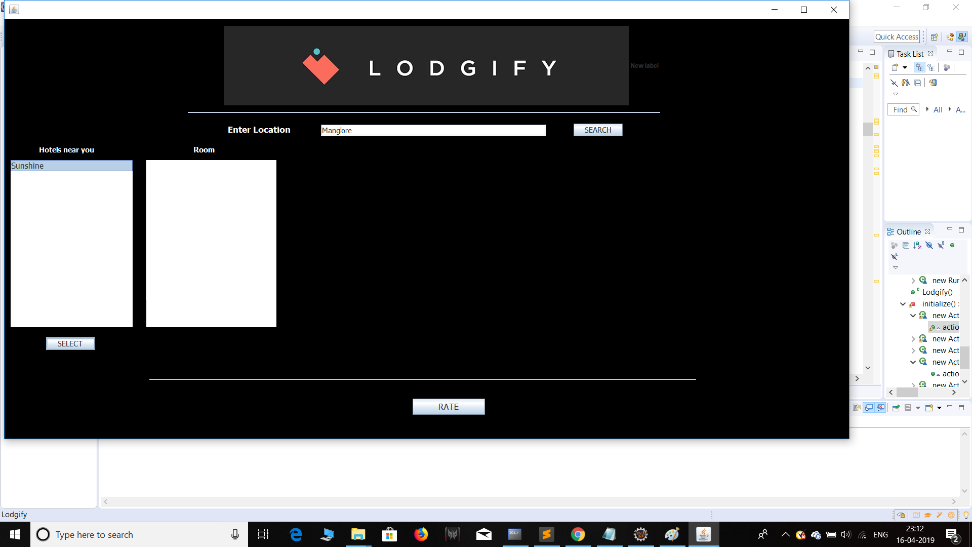
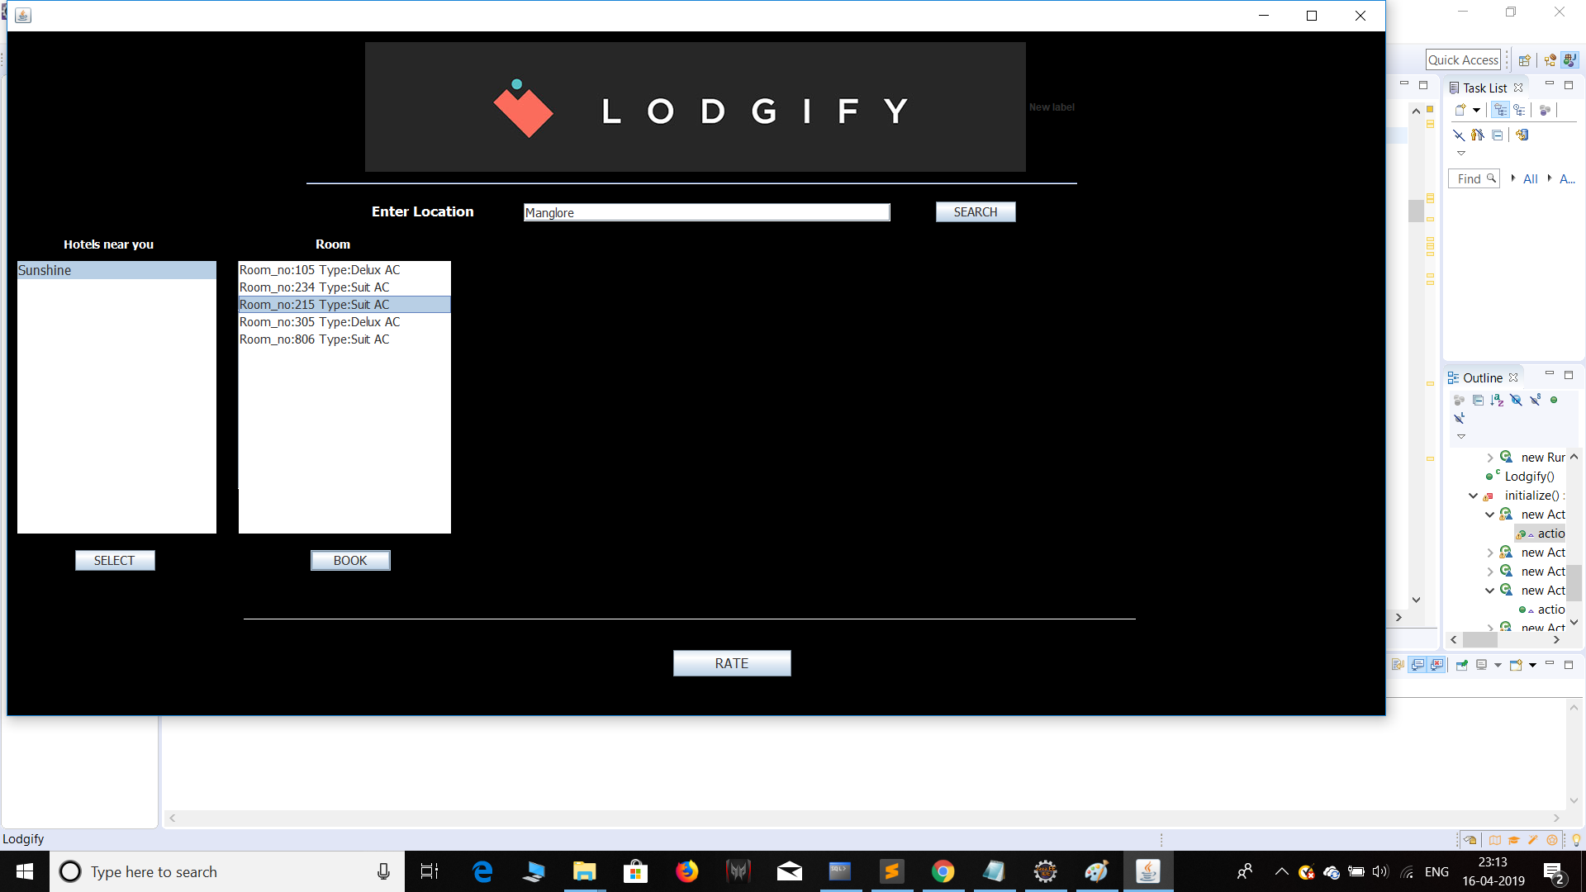

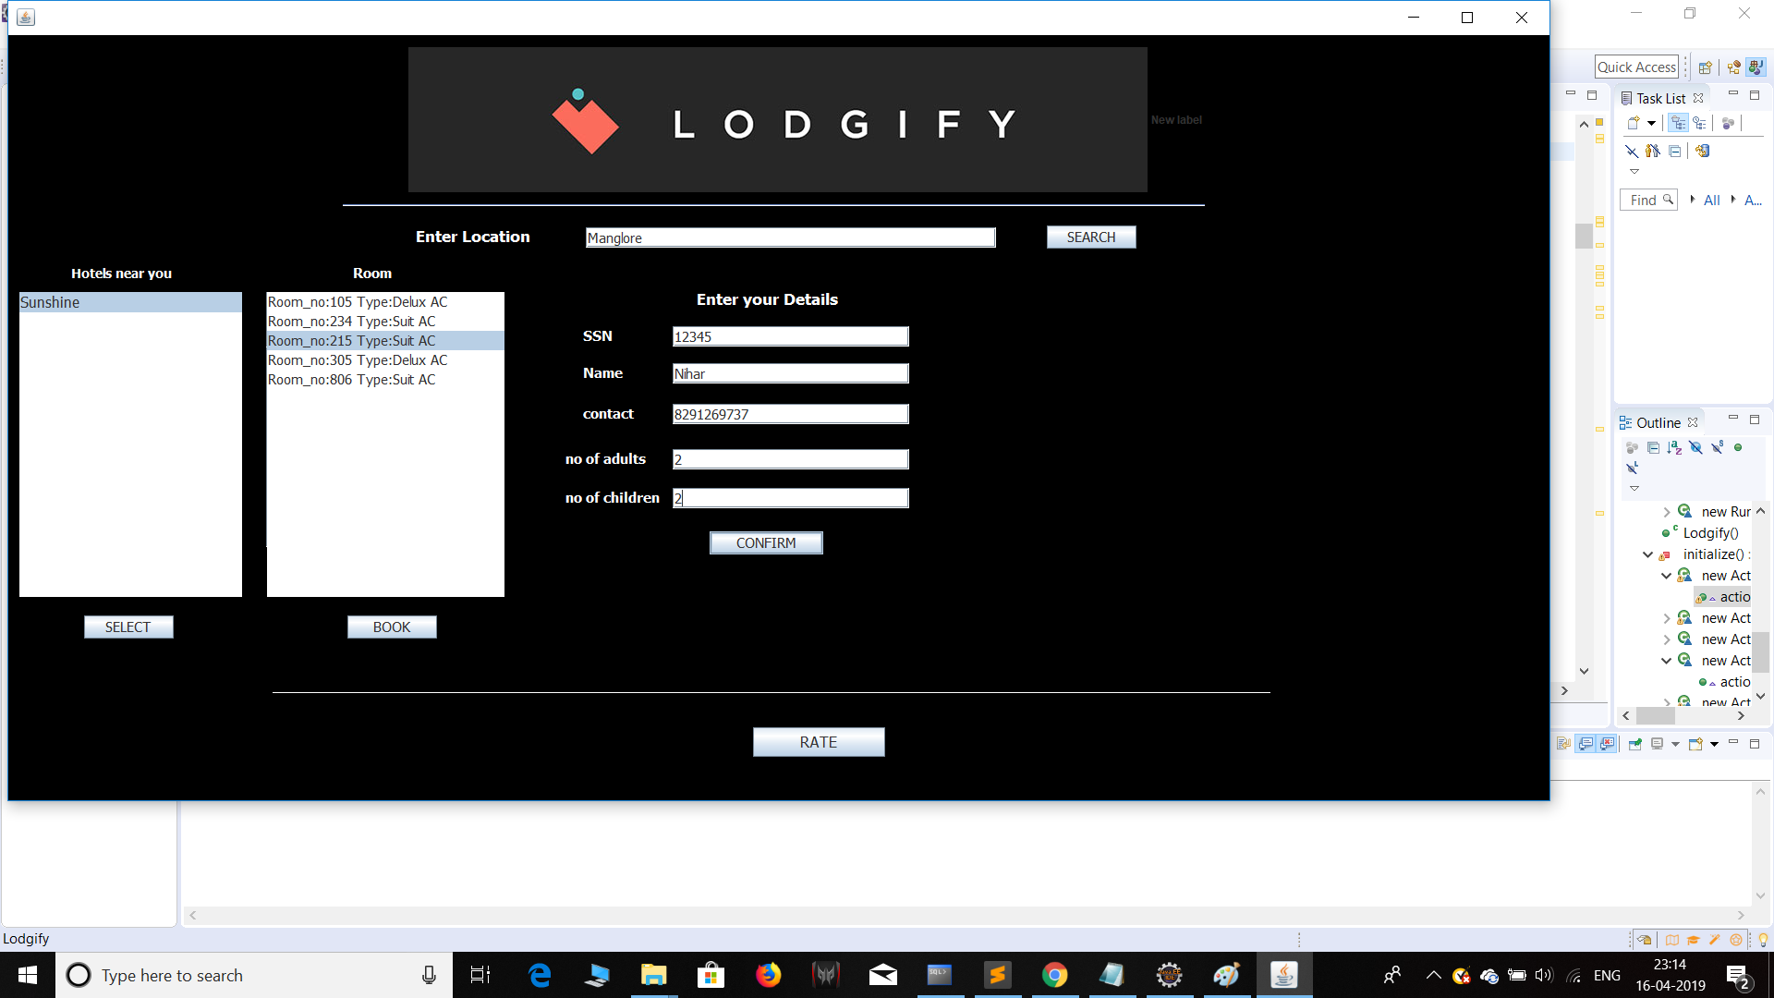
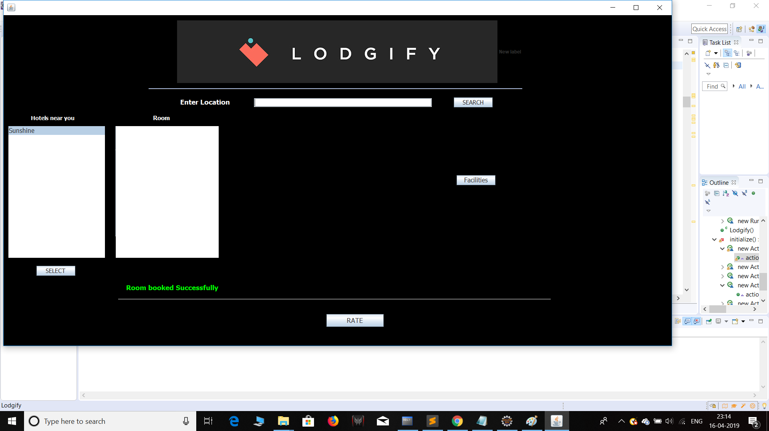

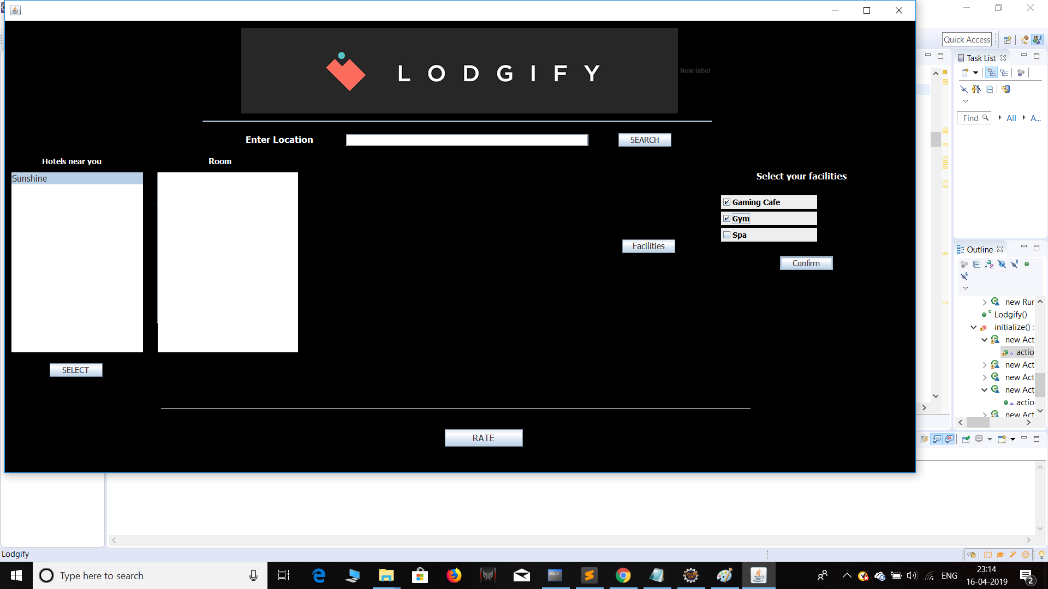
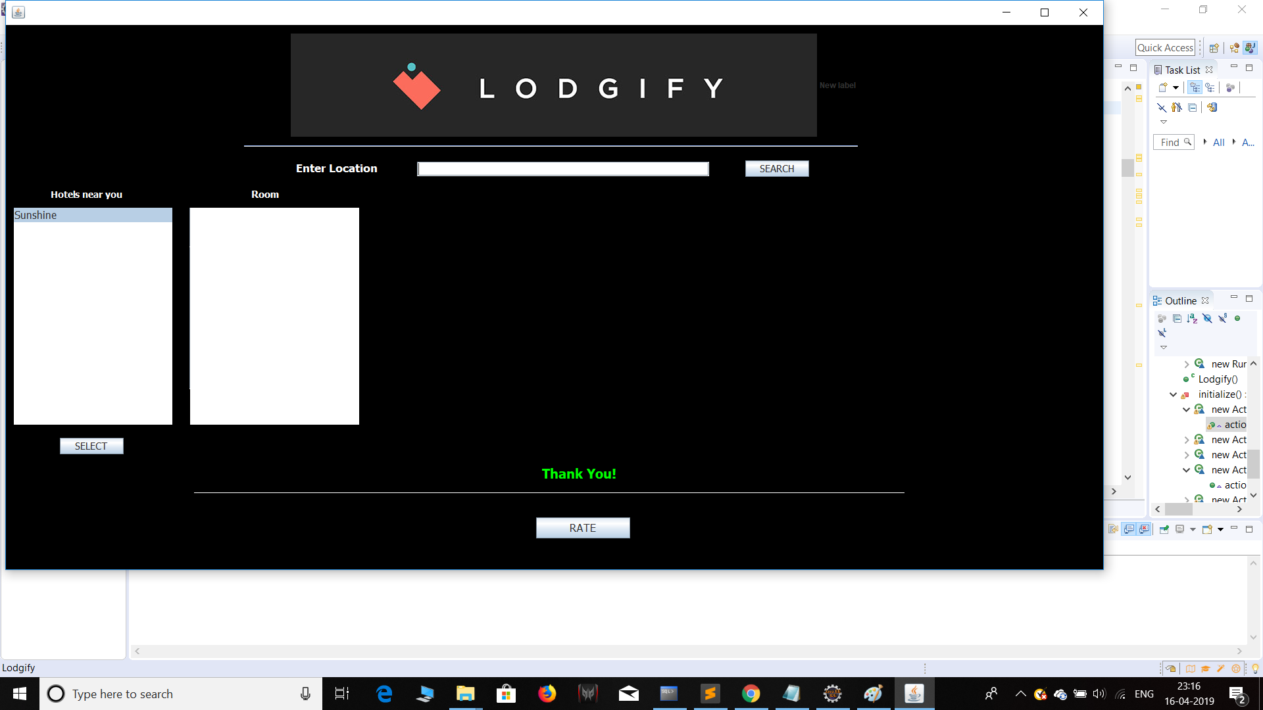

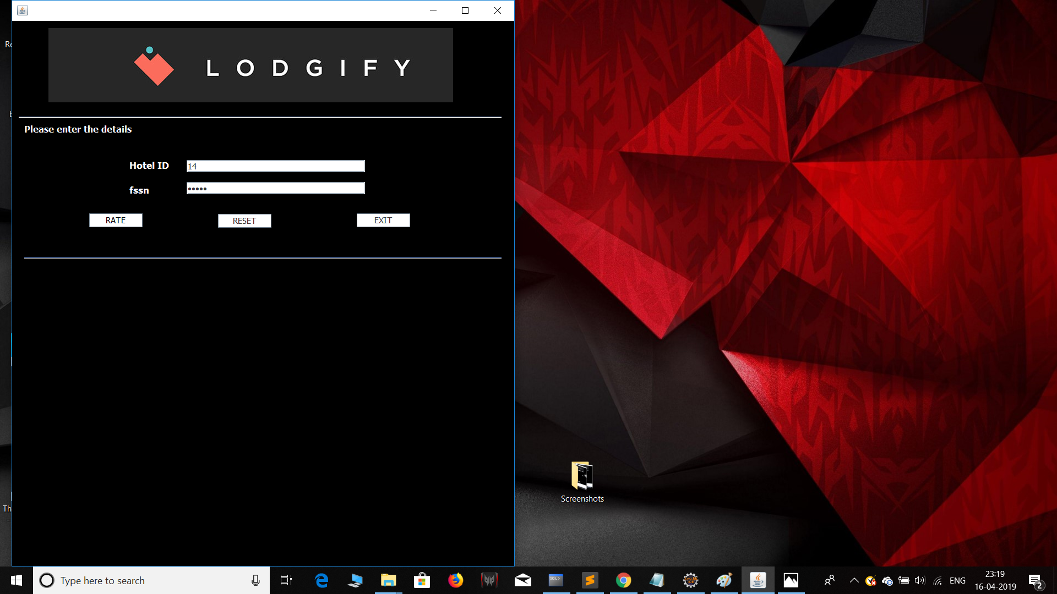

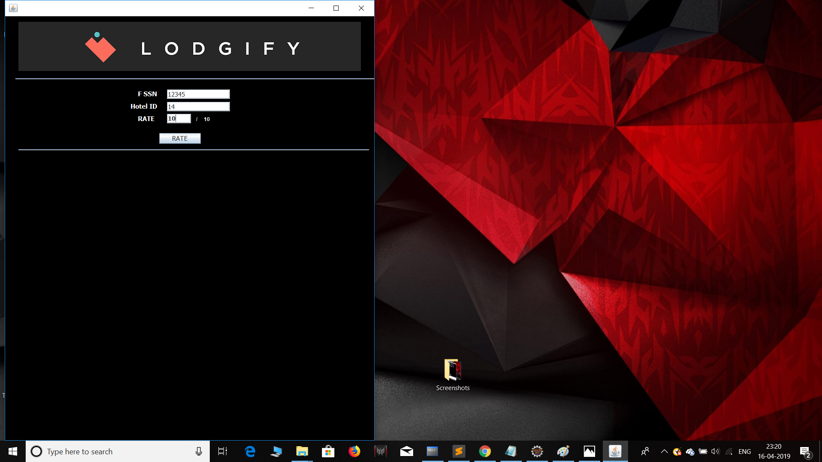

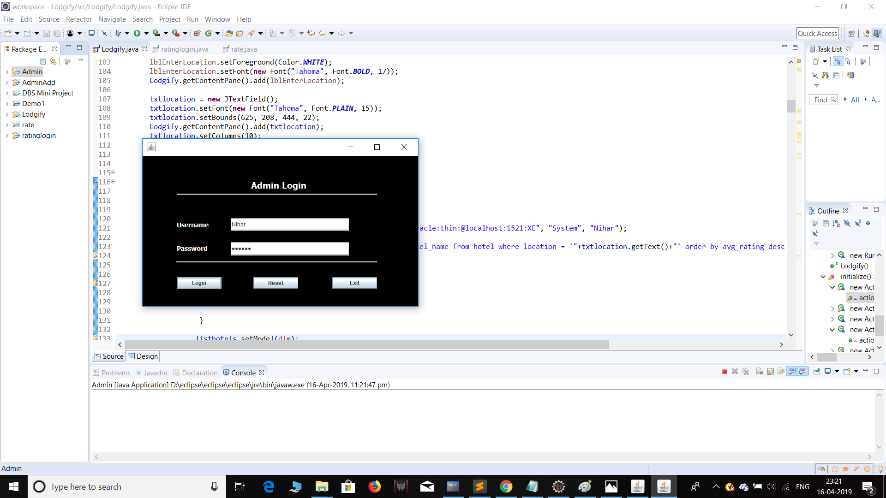

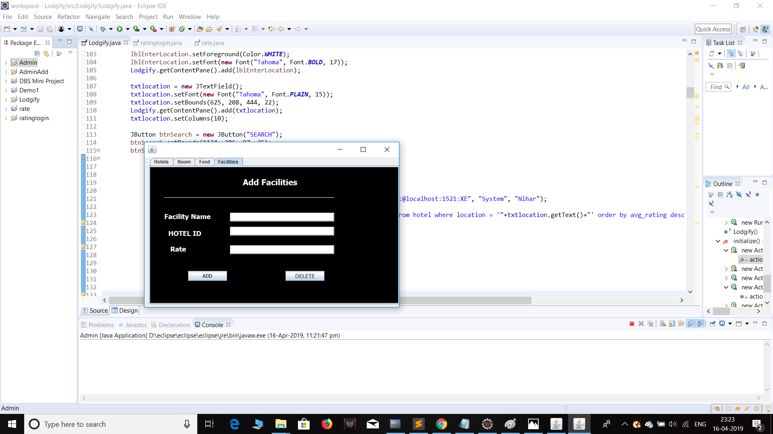

DB Connectivity:

Class.forName("oracle.jdbc.driver.OracleDriver");
Connection con = DriverManager.getConnection("jdbc:oracle:thin:@localhost:1521:XE", "System", "Nihar");
Statement stmt = con.createStatement();
----------------------------------------------------------

