NSSA-102 Computer system Concepts (Fall 2023)

Qusai Hasan

Homework 2

Student Name: ________________________________________________

1. Fill-in the truth table for the below function. [1 pt]

$F\left(X,Y\right)=(X\overline{Y}) Y⨁{X}$

|  |  |  |
| --- | --- | --- |
| **X** | **Y** | **F** |
| 0 | 0 |  |
| 0 | 1 |  |
| 1 | 0 |  |
| 1 | 1 |  |

1. Determine the SoM expression for the Boolean function F in below. Show your work.

$F\left(X, Y, Z\right)=\left( Z \overline{Y}+X \right) ( X+ \overline{Y} Z )$ [1pt]

1. Determine the PoM expression for the Boolean function F in below. Show your work.

$F\left(A, B, C\right)=B ⨀ ( A \overline{C} )$ [1 pt]

1. Given the below circuit, write a **simplified** expression of F ? [1 pt]

$F\left(X, Y\right)= ______________________$

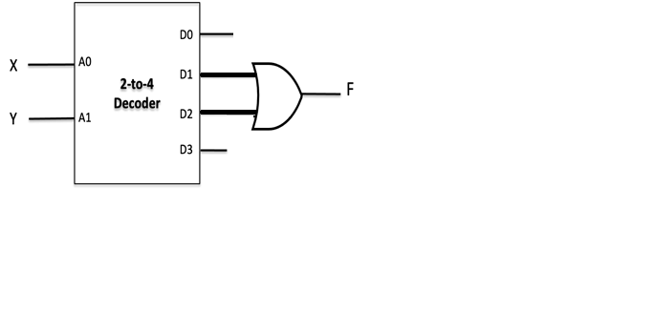

1. Fill-in the truth table for the below circuit. [1 pt]

|  |  |  |
| --- | --- | --- |
| A | B | **F** |
| 0 | 0 |  |
| 0 | 1 |  |
| 1 | 0 |  |
| 1 | 1 |  |

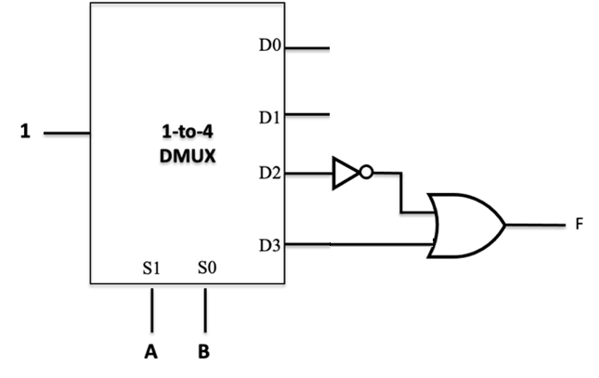

1. Fill-in the truth table for the below circuit. [2 pts]

|  |  |  |  |
| --- | --- | --- | --- |
| X | Y | **F1** | **F0** |
| 0 | 0 |  |  |
| 0 | 1 |  |  |
| 1 | 0 |  |  |
| 1 | 1 |  |  |

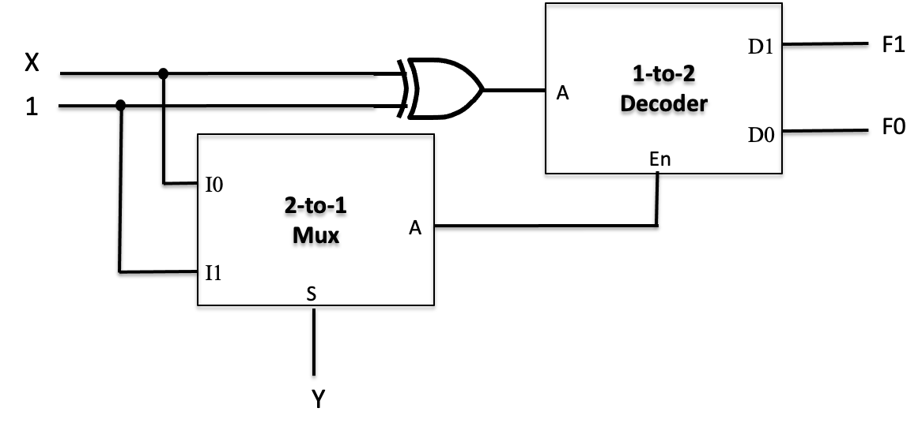

1. Write down the equations of A1 and A0 in the below encoder circuit. [1 pt]

$A1= ____________________________$

$A0= ____________________________$

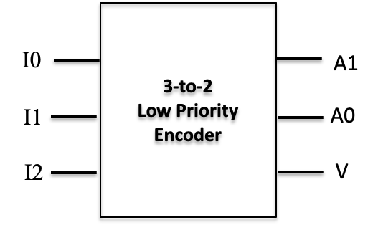

1. If N = 10101 in binary, then what is N in decimal, assuming we have signed-magnitude representation? [0.5 pts]

N = ________________

1. If N = 11100 in binary, then what is N in decimal, assuming we have signed 2s complement representation? [0.5 pts]

N = ________________

1. If N = +88 in decimal, then what is N in binary, assuming we have 8-bit signed 2s complement representation? [0.5 pts]

N = ________________

1. If N = -88 in decimal, then what is N in binary, assuming we have 8-bit signed-magnitude representation? [0.5 pts]

N = ________________