NSSA-102 Computer System Concepts Fall 2023/2024

Instructor: Qusai Hasan

Lab 1: Linux Basics

Student Name 1:

Student Name 2:

Use Linux operating system to answer the below questions.

1. Write down a single command that shows the number of cores on your machine? [0.5 pt]

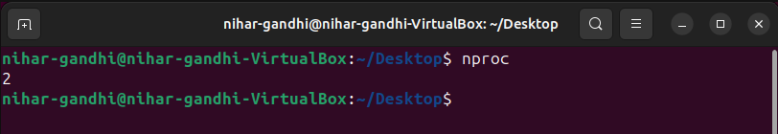

1. Write down a single command that shows the used and free disk space (in gigabytes) available on mounted file systems? [0.5 pt]

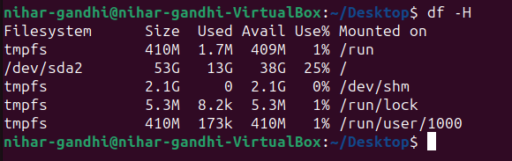

1. Write down a single command that shows the name of the user who is currently logged-in? [0.5 pt]

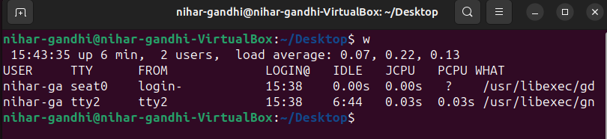

1. Write down a single command that lists all files in the current directory, including hidden files? [0.5 pt]

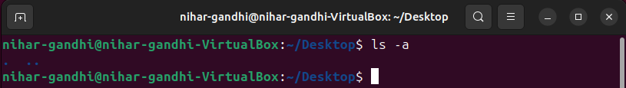

1. Write down a single command that compares two files, i.e., file1.txt and file2.txt line by line while ignoring all white spaces? [0.5 pt]
2. Assume you have a text file called file1.txt, write down a single command that compresses this file and create a new file called file1.zip [0.5 pt]
3. Use vi to create a file text called fruits.txt and insert the following text:

Mango

Apple

Orange

Banana

Kiwi

Peach

Fig

Strawberry

Now, using pipes and redirection, write down a pipe command needed to find all words inside fruits.txt that has the letter ‘n’ and store them in to a file called fruits2.txt in an alphabetically sorted order. [1 pt]

1. Going back to fruits.txt file in the previous question, write down a pipe command needed to replace every occurrence of the letter ‘n’ with the letter ‘N’. [1 pt]