NSSA-102 Computer system Concepts (Fall 2023) Instructor: Qusai Hasan

Homework 1 Student Name:

1. If N = 615.301 in octal, what is N in hexadecimal?

[1 pt]

Show your work in below.



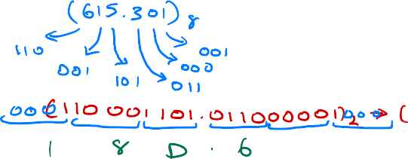



1. If N = 365.125 in decimal, what is the value of N in base r

= 4 ?

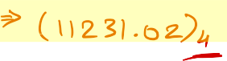Show your work in below.

[1 pt]



   

   

     



1. If N = 100000 in binary, and N = 112 in base r, then what is the value of r ? Show your work in below. [1 pt]

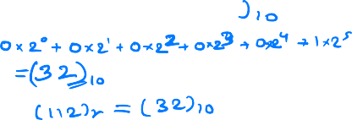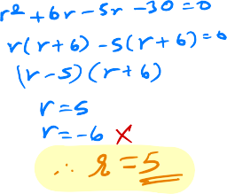

1. 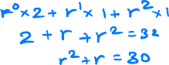If N = 547 in decimal, what is N in BCD?

 [0.5 pt]

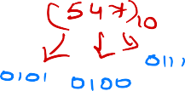

1. What is the minimal number of bits needed to assign binary codes to 48 colors? [0.5 pt]
2. Fill-in the below truth table for the following circuit. [1 pt]

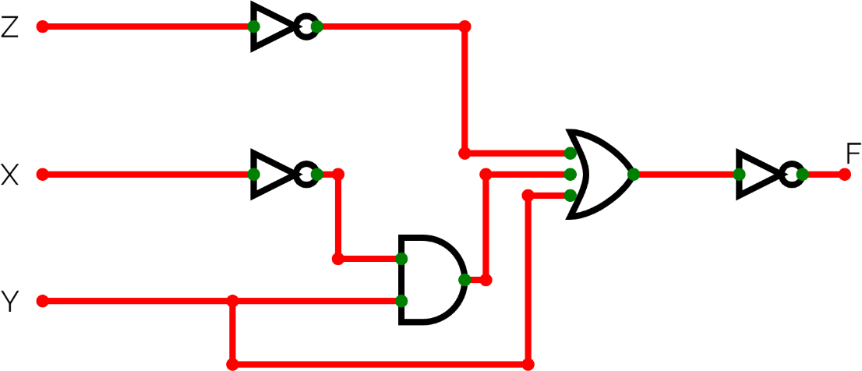

**X Y Z F**

0 0 0

0 0 1

0 1 0

0 1 1

1 0 0

1 0 1

1 1 0

1 1 1

1. Fill-in the below truth table for the following equation. [1 pt]

)

**A B F G**

0 0

0 1

1 0

1 1

1. Using Boolean algebra, prove that [1 pt]