NSSA-102 Computer system Concepts (Fall 2023)

Instructor: Qusai Hasan

Homework 1

Student Name: ________________________________________________

1. If N = 615.301 in octal, what is N in hexadecimal? ________________ [1 pt]

Show your work in below.

1. If N = 365.125 in decimal, what is the value of N in base r = 4 ? ______________ [1 pt]

Show your work in below.

1. If N = 100000 in binary, and N = 112 in base r, then what is the value of r ? ___________ Show your work in below. [1 pt]
2. If N = 547 in decimal, what is N in BCD? ____________________ [0.5 pt]
3. What is the minimal number of bits needed to assign binary codes to 48 colors? ______ [0.5 pt]
4. Fill-in the below truth table for the following circuit. [1 pt]

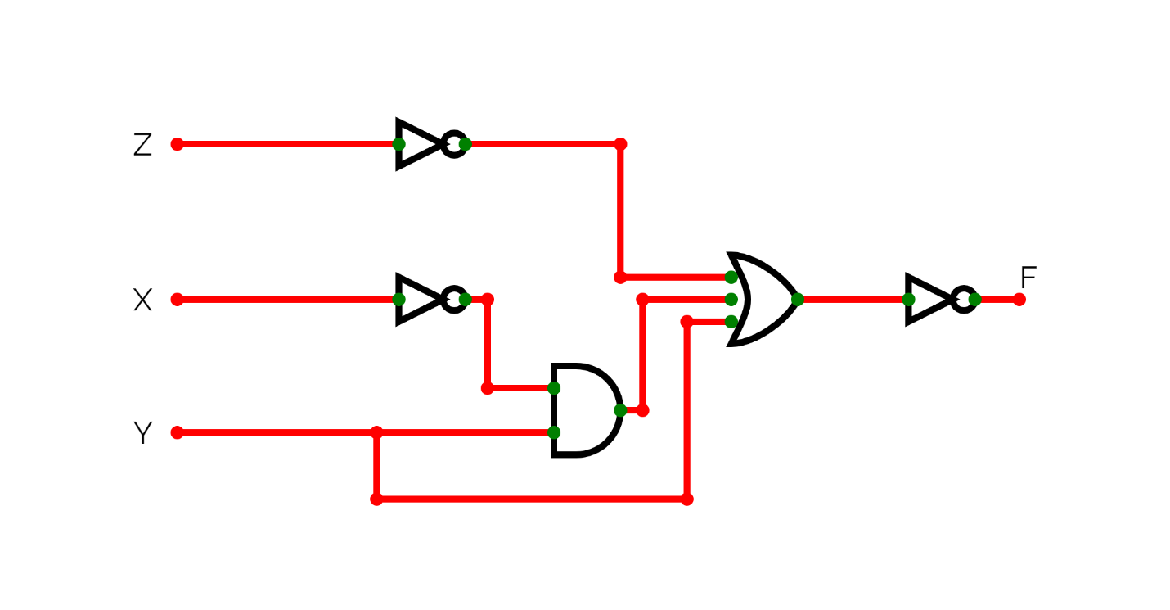

|  |  |  |  |
| --- | --- | --- | --- |
| **X** | **Y** | **Z** | **F** |
| 0 | 0 | 0 |  |
| 0 | 0 | 1 |  |
| 0 | 1 | 0 |  |
| 0 | 1 | 1 |  |
| 1 | 0 | 0 |  |
| 1 | 0 | 1 |  |
| 1 | 1 | 0 |  |
| 1 | 1 | 1 |  |

1. Fill-in the below truth table for the following equation. [1 pt]

$$F\left(A, B\right)= \overline{A B}+A \overline{B}$$

$G\left(A,B\right)= \overline{A} ( \overline{B}+A B$)

|  |  |  |  |
| --- | --- | --- | --- |
| **A** | **B** | **F** | **G** |
| 0 | 0 |  |  |
| 0 | 1 |  |  |
| 1 | 0 |  |  |
| 1 | 1 |  |  |

1. Using Boolean algebra, prove that [1 pt]

$A + A’ B’ + A’ B C’ = A + B’ + C’$