TASKS DONE :

We read the U-Net research paper and understood it.

KEY TAKEAWAYS :

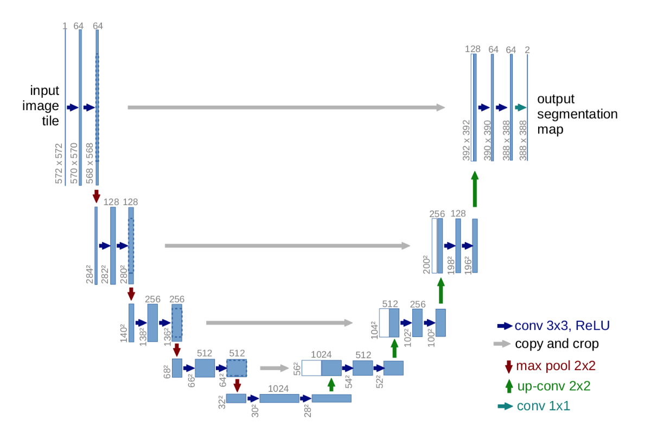

This paper describes a novel approach to training deep neural networks for image segmentation tasks. The approach uses a combination of data augmentation techniques and an innovative network architecture, which consists of a contracting path and an expanding path, to make the most efficient use of limited annotated training data. The results of the experiments show that the proposed method outperforms the prior best method (a sliding-window convolutional network) on the ISBI challenge for segmentation of neuronal structures in electron microscopic stacks. Additionally, the network trained on transmitted light microscopy images achieved the highest performance in the ISBI cell tracking challenge 2015, demonstrating its versatility and effectiveness in a range of imaging modalities. The network is also computationally efficient, with a fast inference time of less than a second for a 512x512 image.

REFERENCES :

<https://paperswithcode.com/paper/u-net-convolutional-networks-for-biomedical>

GROUP MEMBERS :

Aadya Chinubhai

Abhishu Oza

Razin Karimi

Nihar Jani