**Lab Assignment – 2**

1. **Check firewall settings in your linux machine.**

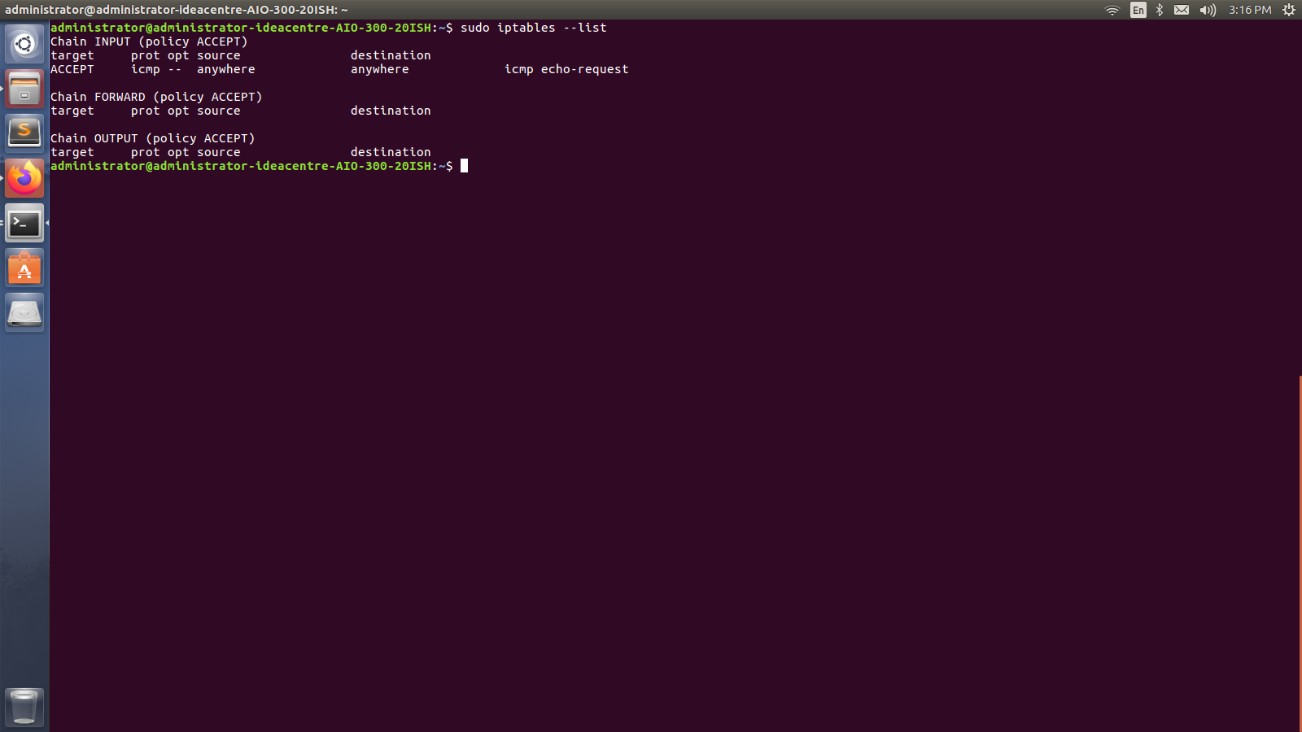

Overview of Firewall home screen

1. **Block ping command using iptables in your linux machine, also pair up with another student to verify the same.**

Here two systems are connected with same network.

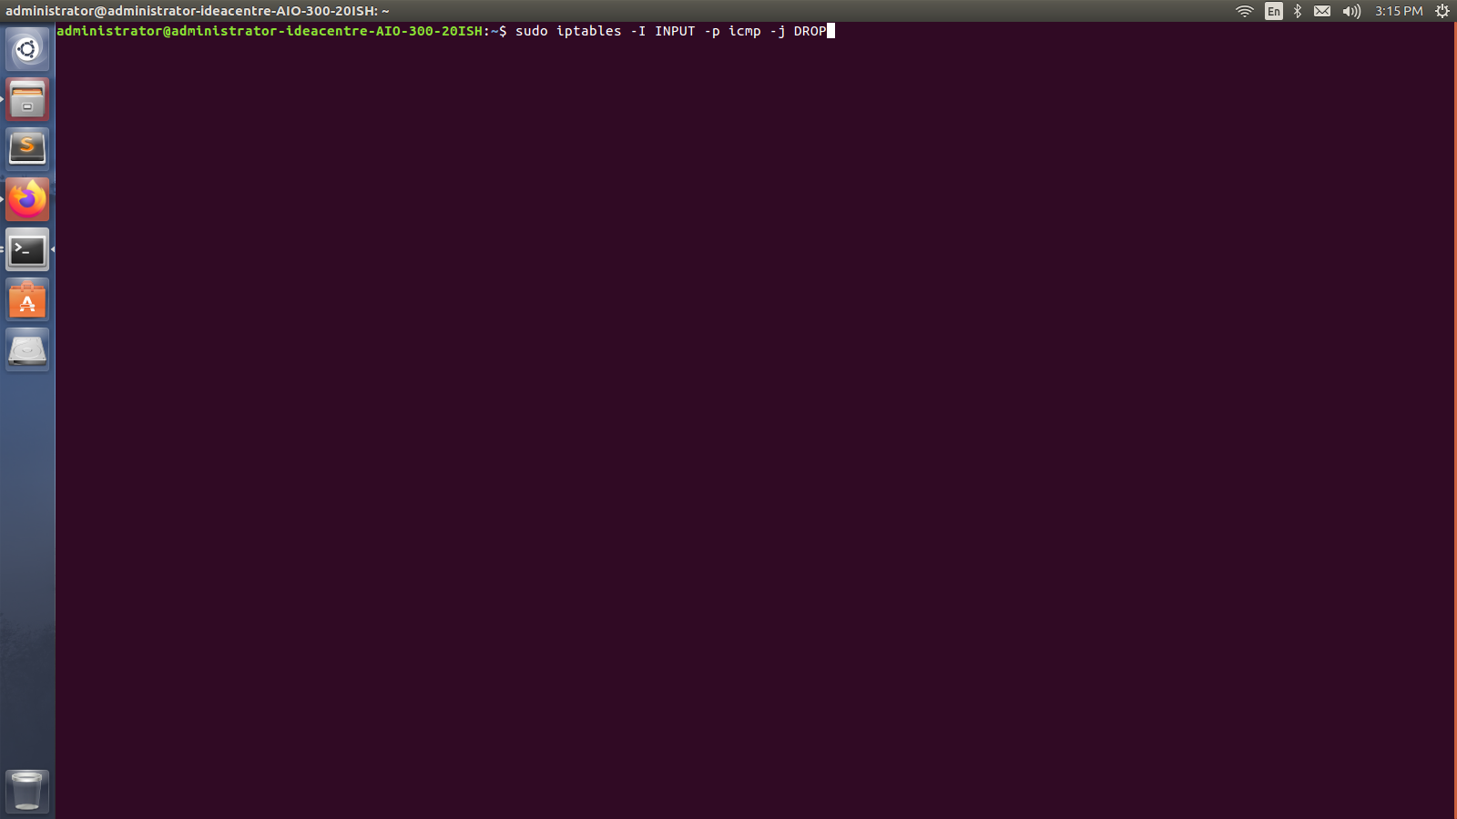

Block rule for icmp

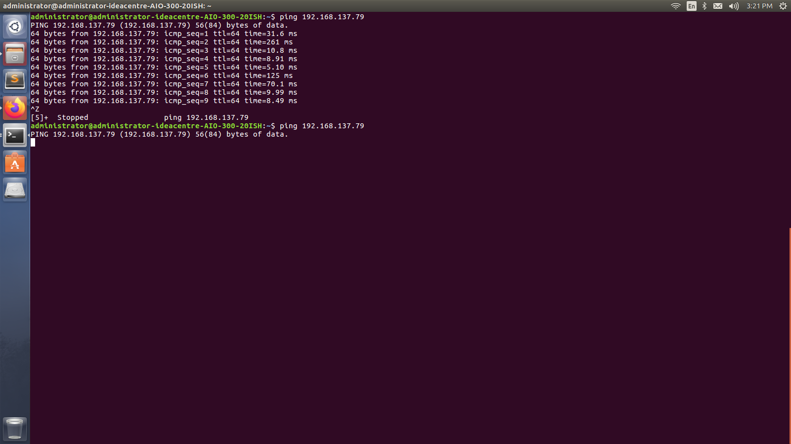

Output of ping command

In another system icmp is disabled.

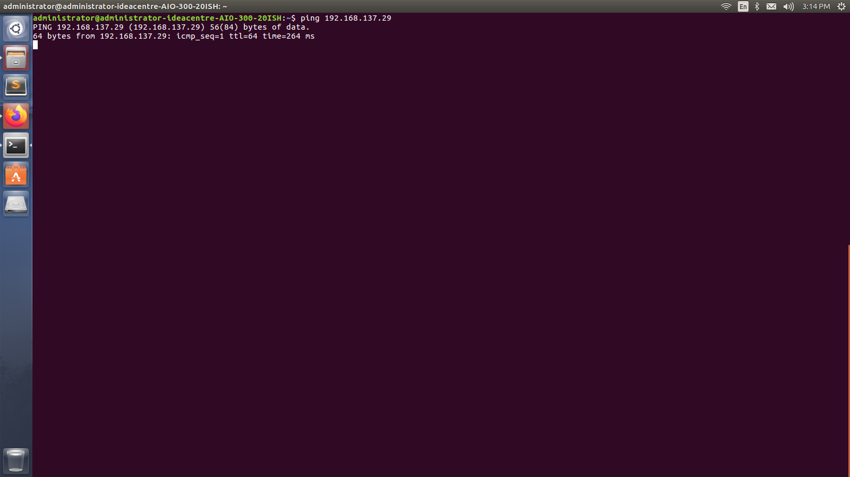

Output of ping command when inbound rule is disabled

1. **Whether a iptables is able to block some specific pages in a web application? If yes then demonstrate the same using linux iptables.**

Yes, iptables is able to block some specific pages in a web application.



Web page of DDU website

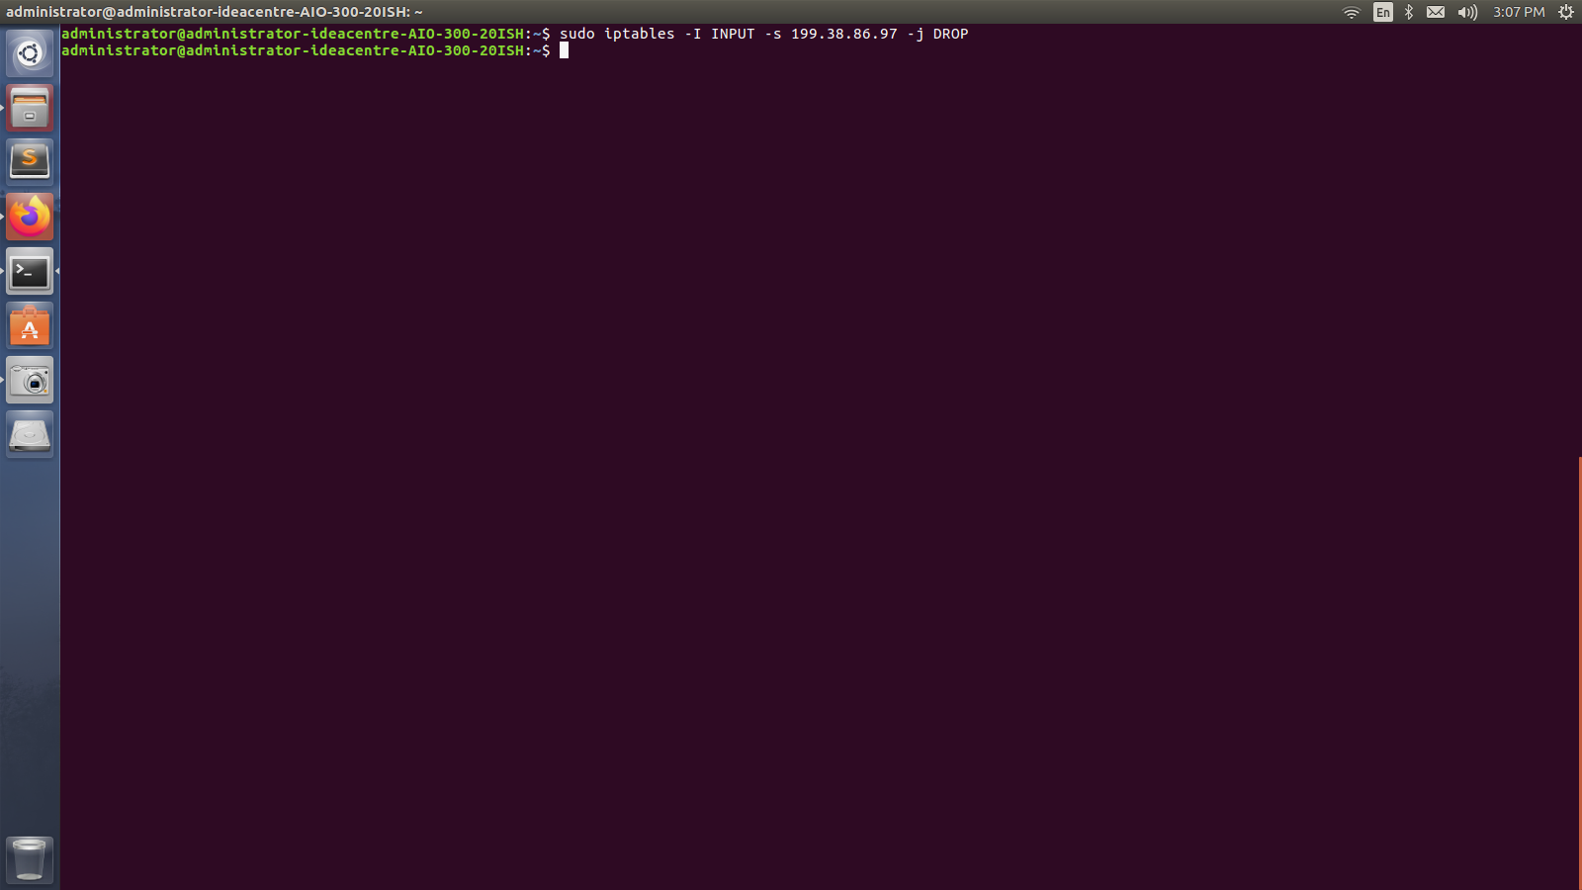

Blocked rule of DDU website

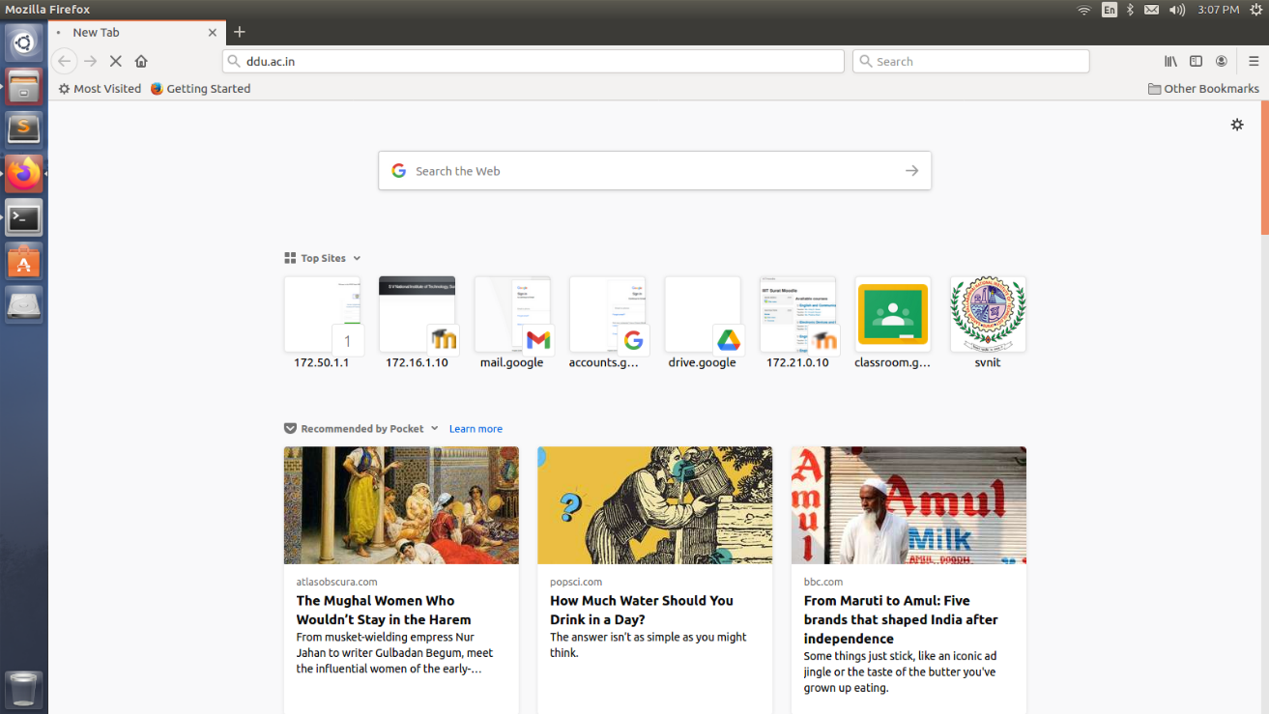

Output of blocked web page