1. Answers to the following questions:

i. What times did the smoker need attention? Make sure to list ALL the times!

A. I am guessing atleast 2285 times. From 5/22/2021 13:46 to 5/22/2021 22:27.

iii. What time did the food on channel 1 hit its stall?

1. It did happen atleast 6 times on channel 1.

iv. What time did the food on channel 2 hit its stall?

A. It happened at least 4 times and overall 10 times.

v. Do you think other windowing approaches or considering the entire temperature history would be more appropriate for the questions we are trying to answer? Why or why not?

A. I can say that there are other approaches to find the better result. We have to use other tool to do so because this is not the better tool I’ve ever tried so far. Windowing does help to manipulate data and do data streaming so it does work but it’s not the best option.

2. Screenshots of your code running on your computer showing the output that you generated. Your screenshots must have some kind of indication that it is you running the code.

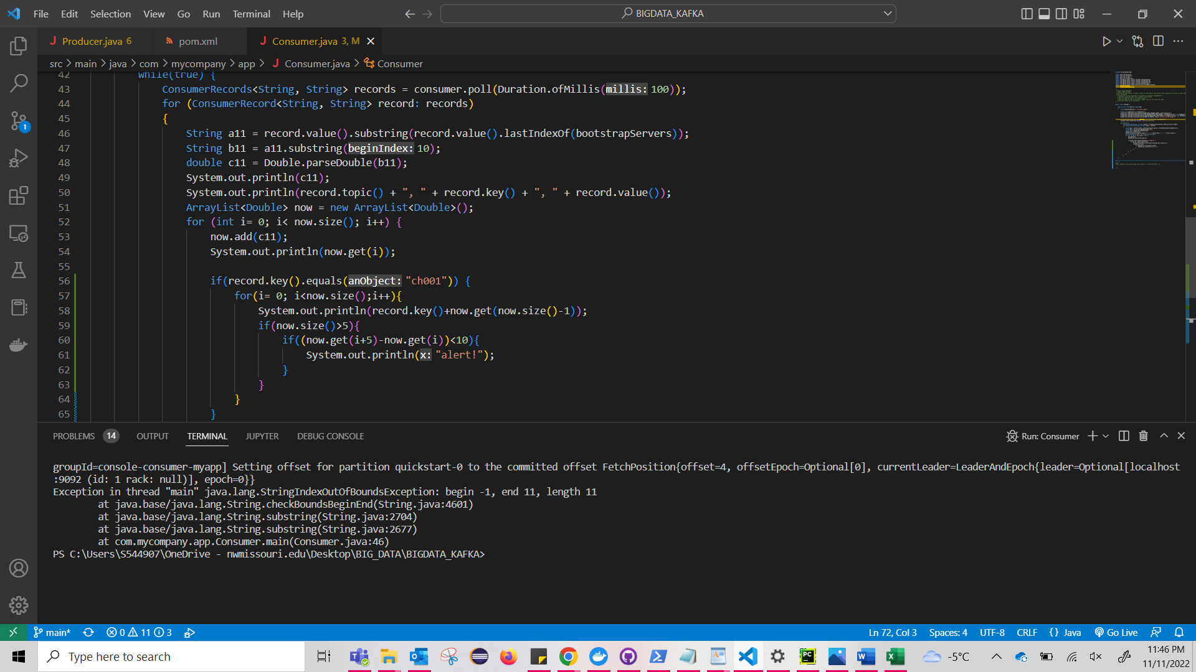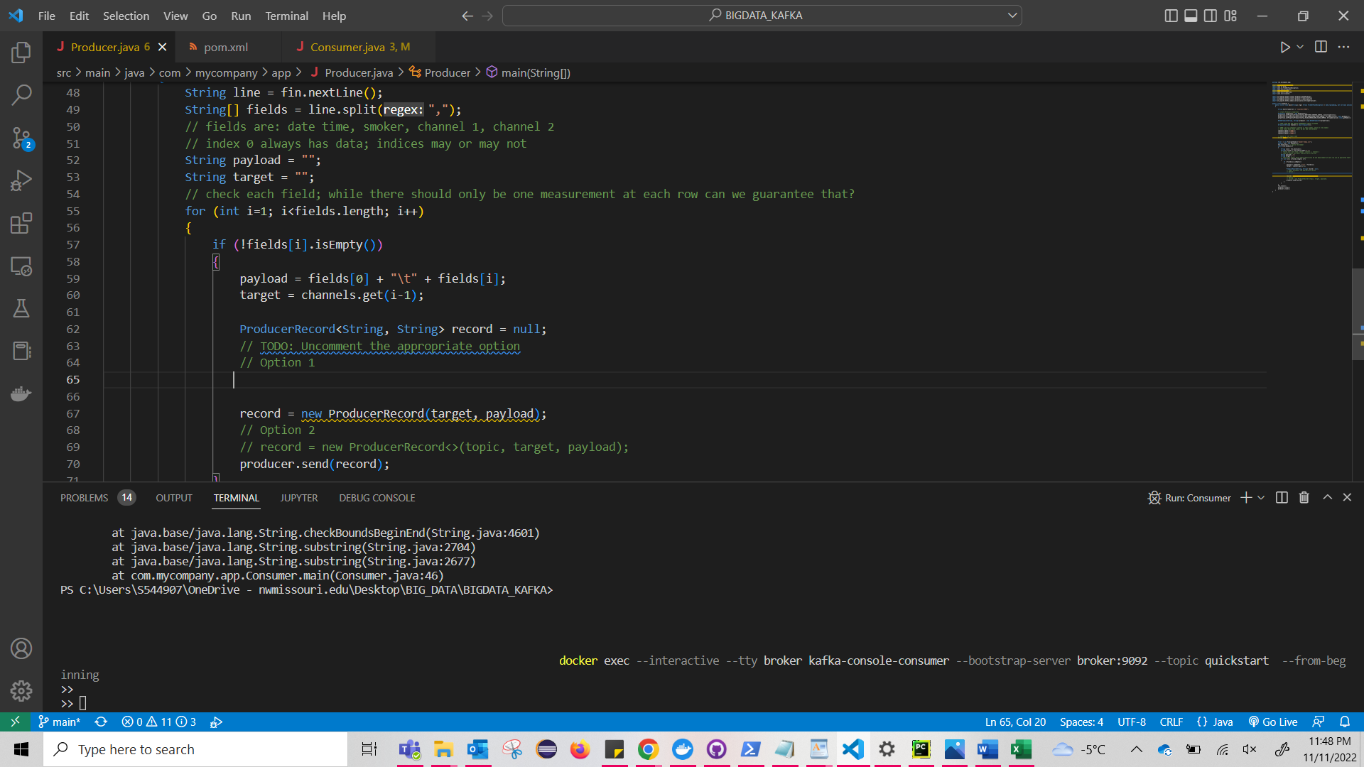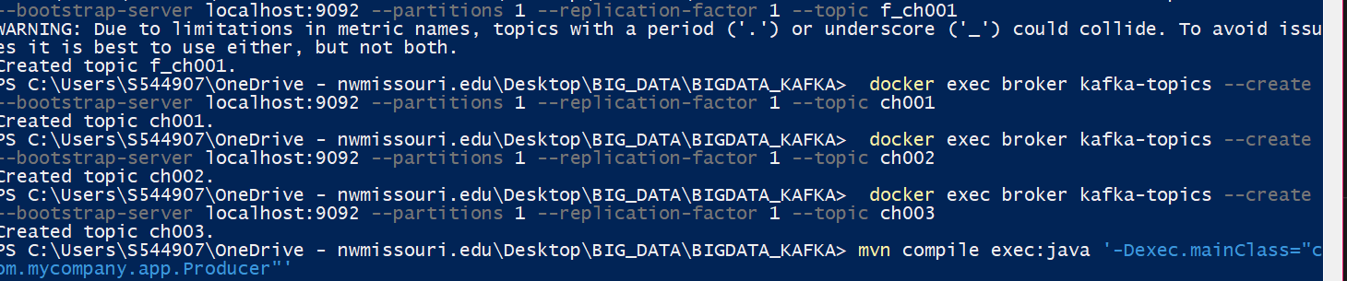

The below image is just to show you that I can send message and the consumer can receive the message!

Note: I manually guessed the output for the above questions. I did not copy or took anyone’s help during the assignment which is why I haven’t done full assignment.