# **Mobile and Autonomous Robots - MEE6044 :**

**Summer Semester 2021 , VIT Vellore**

# **J – Component Project Implementation :-**

**Implementation of Forward Kinematics Model of Differential Wheel Mobile Robot on MATLAB SIMULINK :** (**PATTERN : TRIANGLE** )

**Implemented By : 20MAI0001 - NIHARIKA MAITRA**

**Git Repo Link (for the Implemented Forward Kinematics Model of Differential Wheel Mobile Robot in MATLAB SIMULINK) :**

The following Equations hold true for the Forward Kinematics Model of Differential Wheel Mobile Robot :

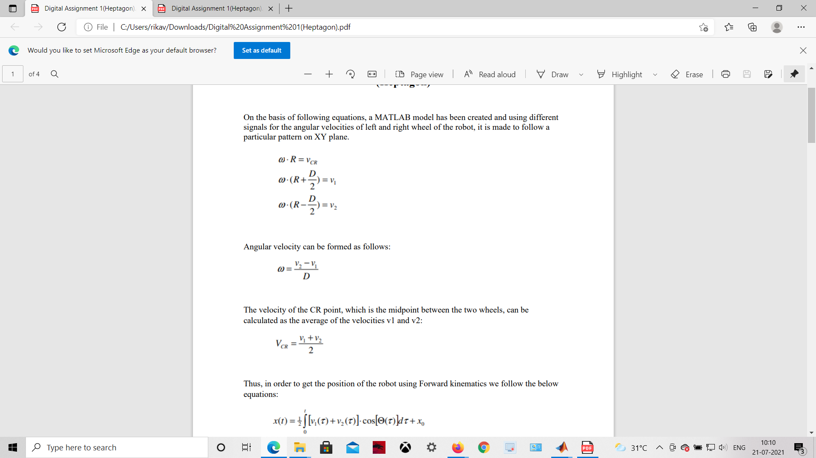

Angular Velocity (Omega) can be formulated as follows:



The Velocity of the CR point, which is the midpoint between the two Wheels (the Left and the Right Wheels ) of the Differential Wheel Mobile Robot , can be calculated as the Average of the Velocities v1 and v2 :



Therefore , in order to obtain the Position (( x, y ) -coordinates) of the Differential Wheel Mobile Robot using Forward Kinematics we rely on the following mentioned Equations:

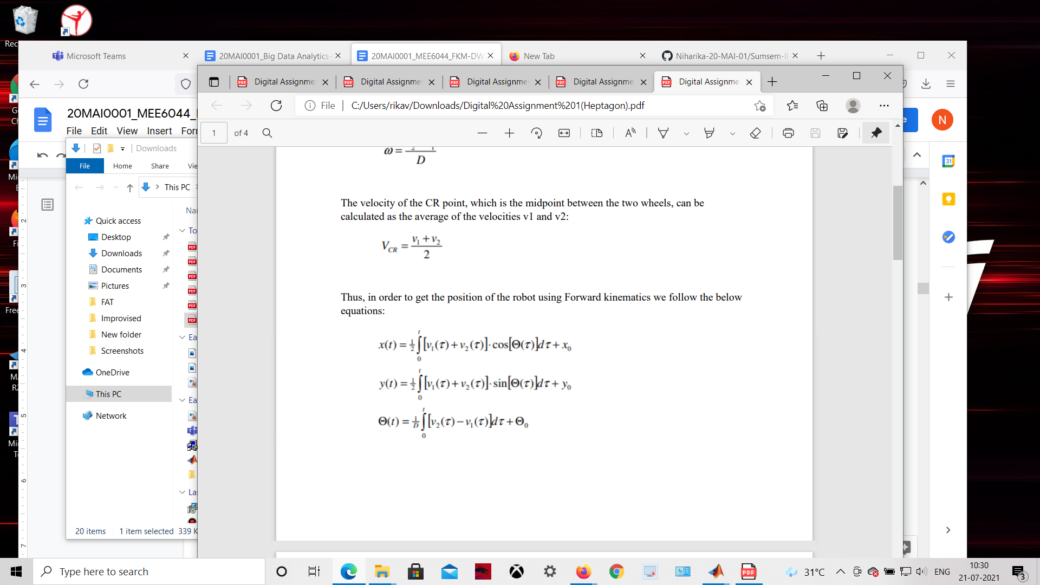

**In this implementation we build and Implement a MATLAB SIMULINK Model for a Differential Wheel Mobile Robot :**

using Different (varied ) Signals for the Angular Velocities of the Left (OmegaL) and Right (OmegaR) Wheels of the Mobile Robot, in order to make the

Differential Wheel Mobile Robot to, follow a Particular Pattern / Path of Motion on the X-Y Plane : the PATTERN made to follow by the Differential Wheel Mobile

Robot is : **TRIANGLE**

**Screenshot of the Base MATLAB SIMULINK Model for the Forward Kinematics of Differential Wheel Mobile Robot :**

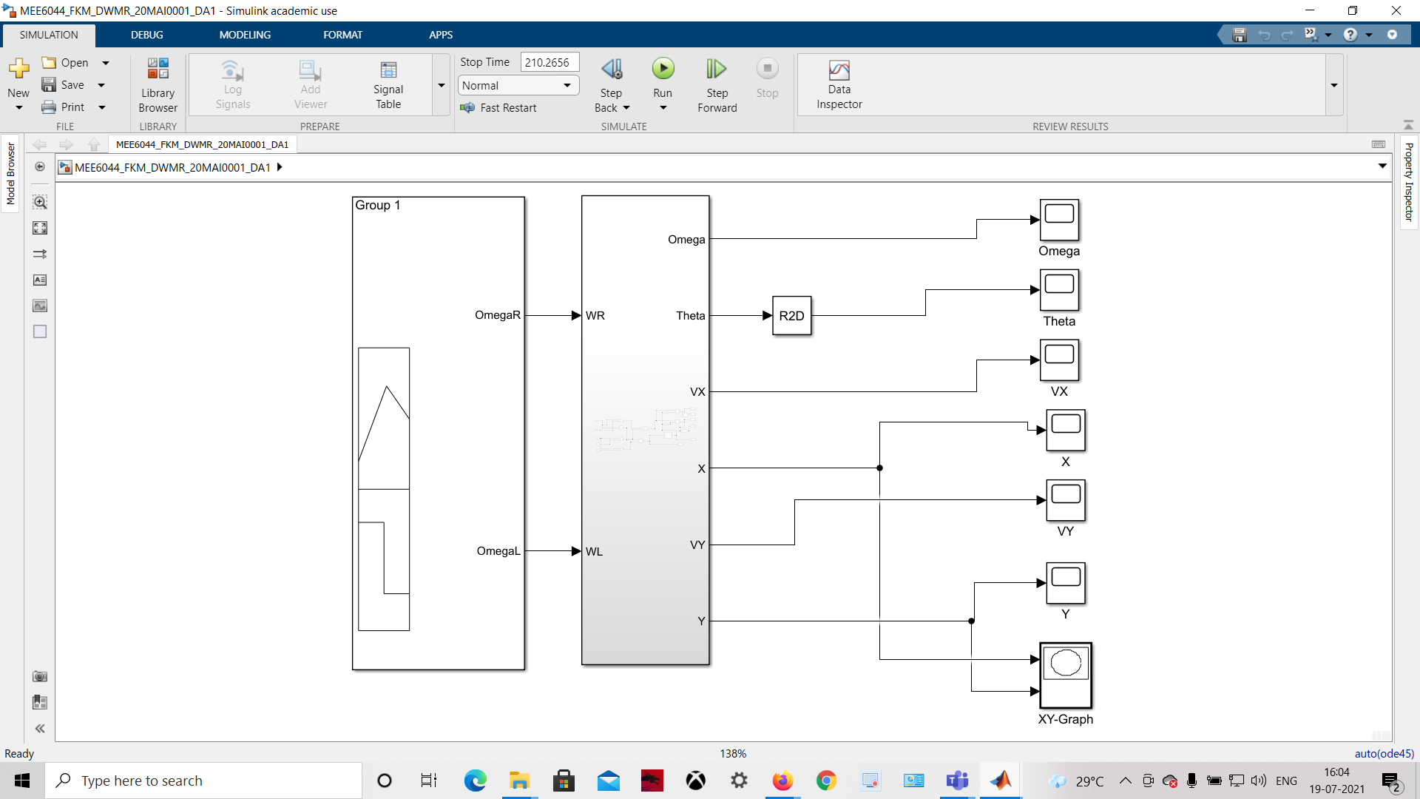

**D = 120 , R = 80 , Pattern / Path of Motion = TRIANGLE**

**Screenshot of the SUBSYSTEM ( Equation ) for the Forward Kinematics Model :**

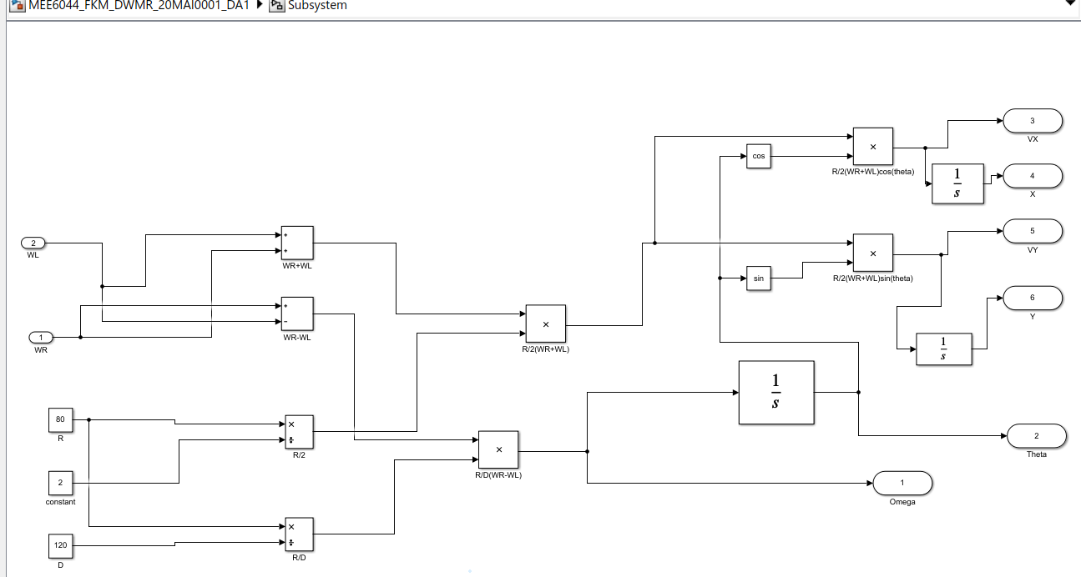

**Details about the values of different parameters in the Signal Builder Block for the Forward Kinematics Model :**

**Signal Builder :- Total Timeline : 210.2656 (5 cycles of 13.1416 secs each) ,**

**Square Signals**

**Travel Time = 10 sec (for each cycle); Turning Time = 3.1416 sec (for each cycle)**

**Y-axis Limit: 0.5 to 1 (Omega R) ; -0.5 to 1 (Omega L)**

**Screenshots of the Signal Builder Block for the Forward Kinematics Model of Differential Wheel Mobile Robot:**

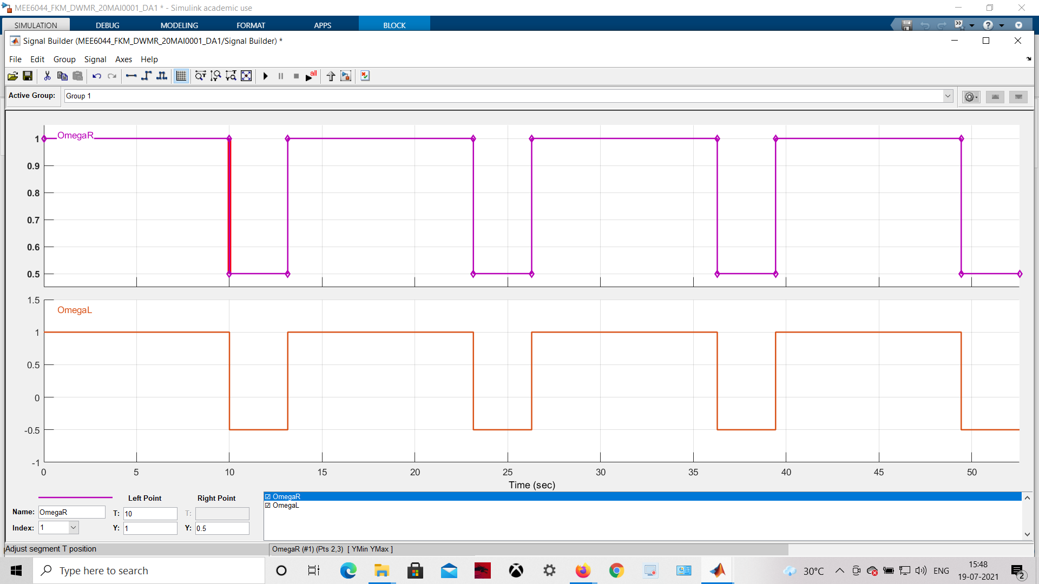

**Screenshot of the Plot for Omega (in rad / sec) : (Angular Velocity) for the Forward Kinematics Model :**

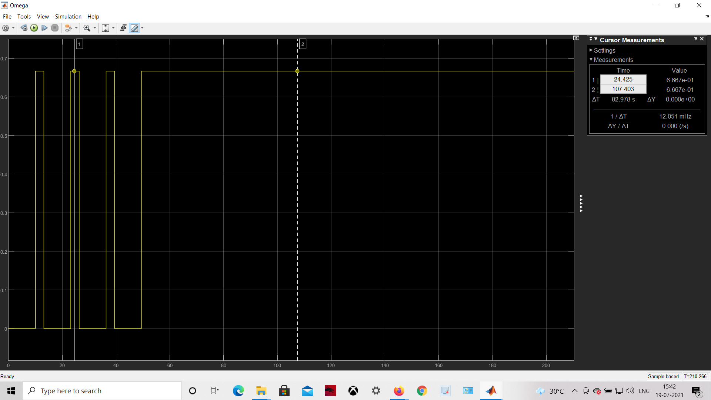

**Screenshot of the Plot for Theta ( in degrees) : ( Angle ) for the Forward Kinematics Model :**

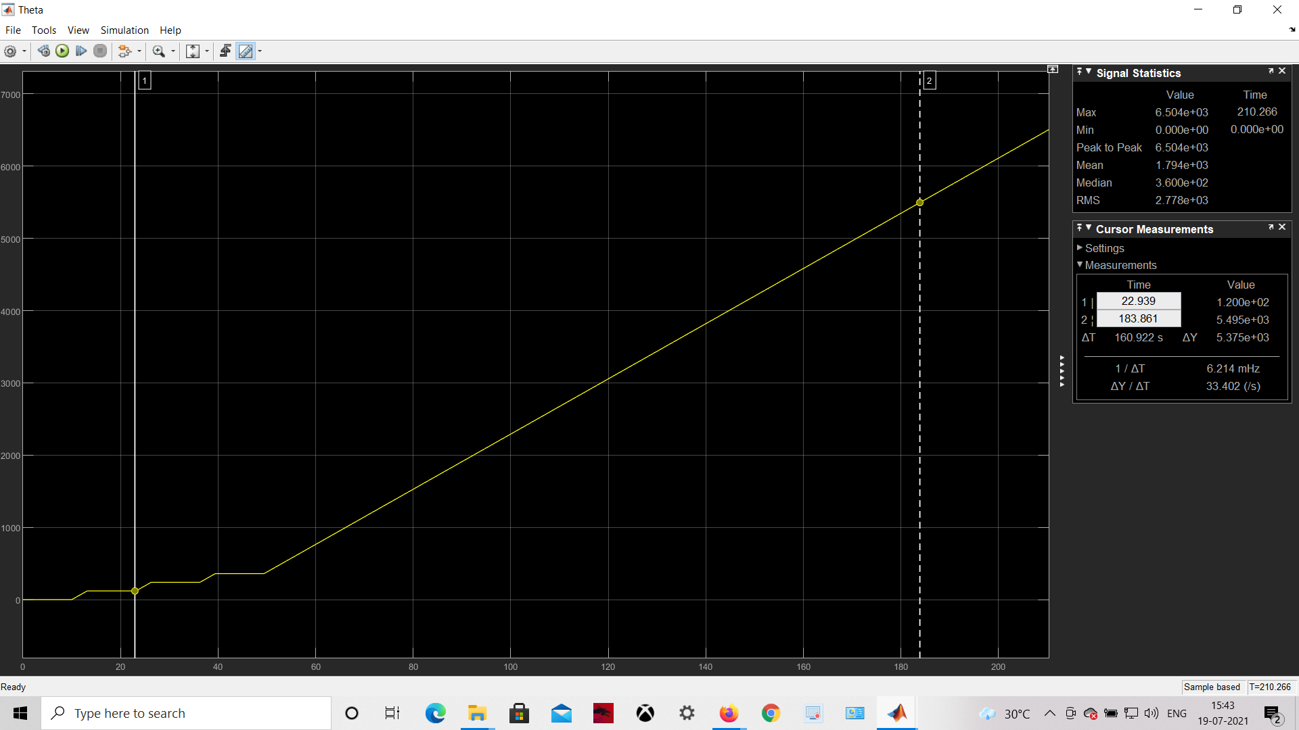

**Screenshot of the Plot for VX : ( Velocity in X- direction ) for the Forward Kinematics Model :**

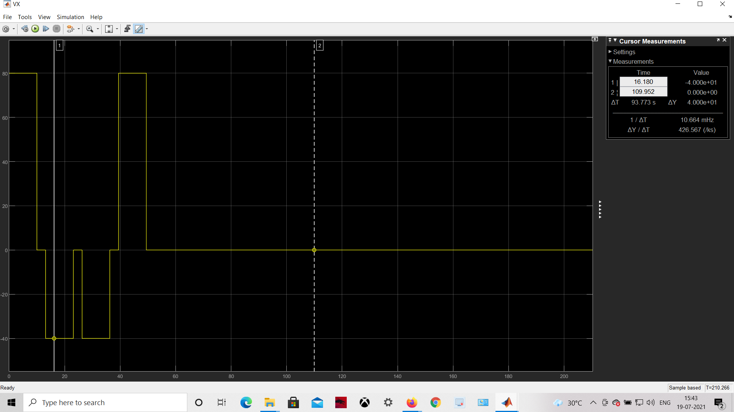

**Screenshot of the Plot for the Position : X ( Co-ordinate ) for the Forward Kinematics Model :**

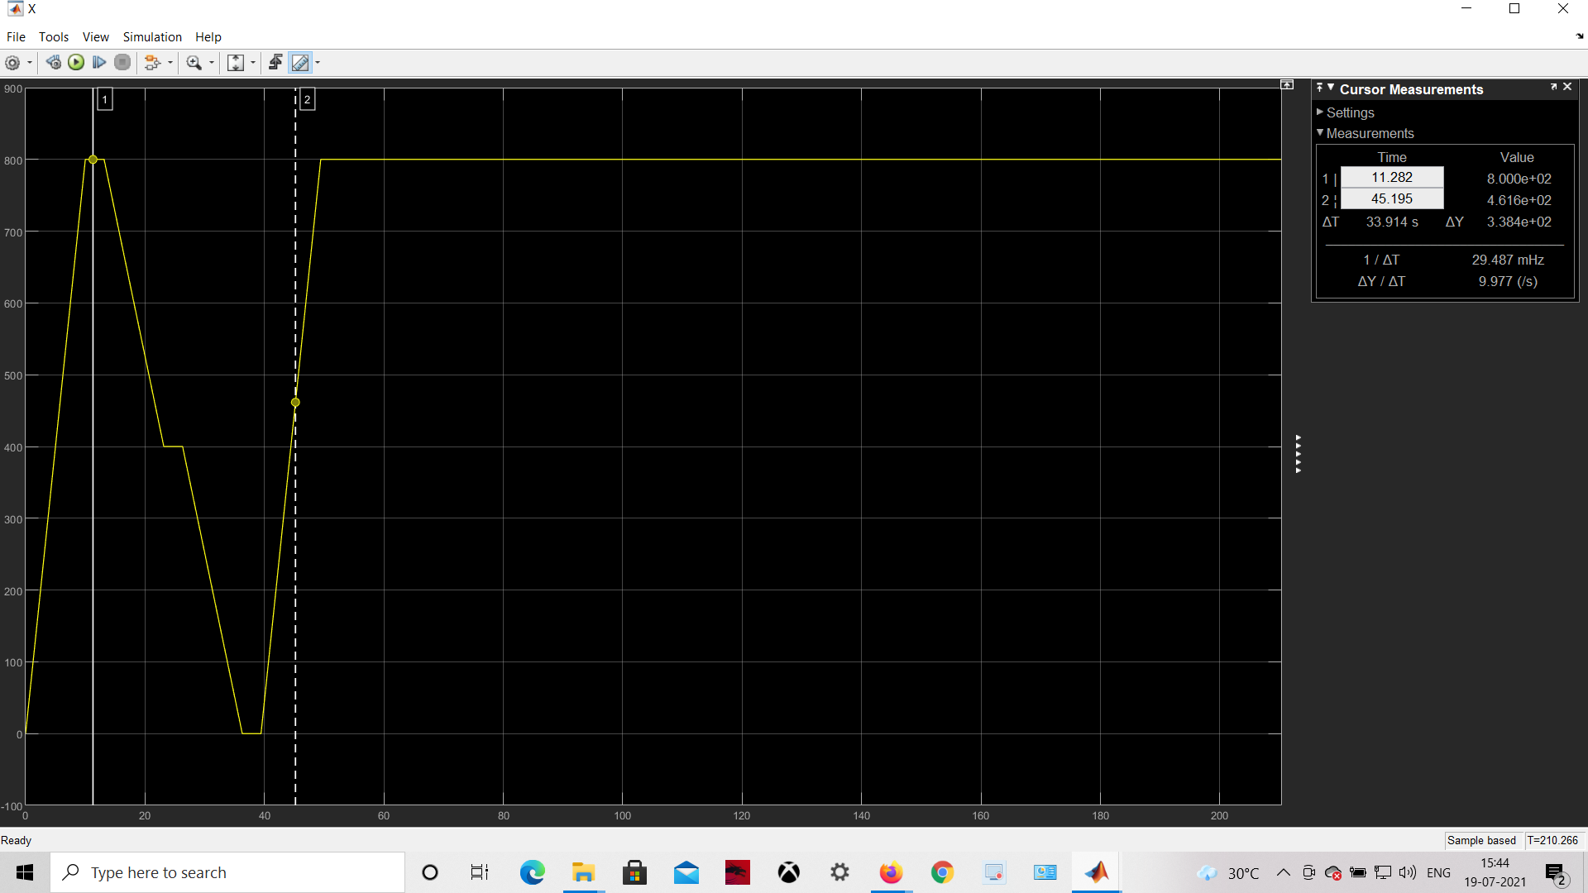

**Screenshot of the Plot for VY : ( Velocity in Y-direction ) for the Forward Kinematics Model :**

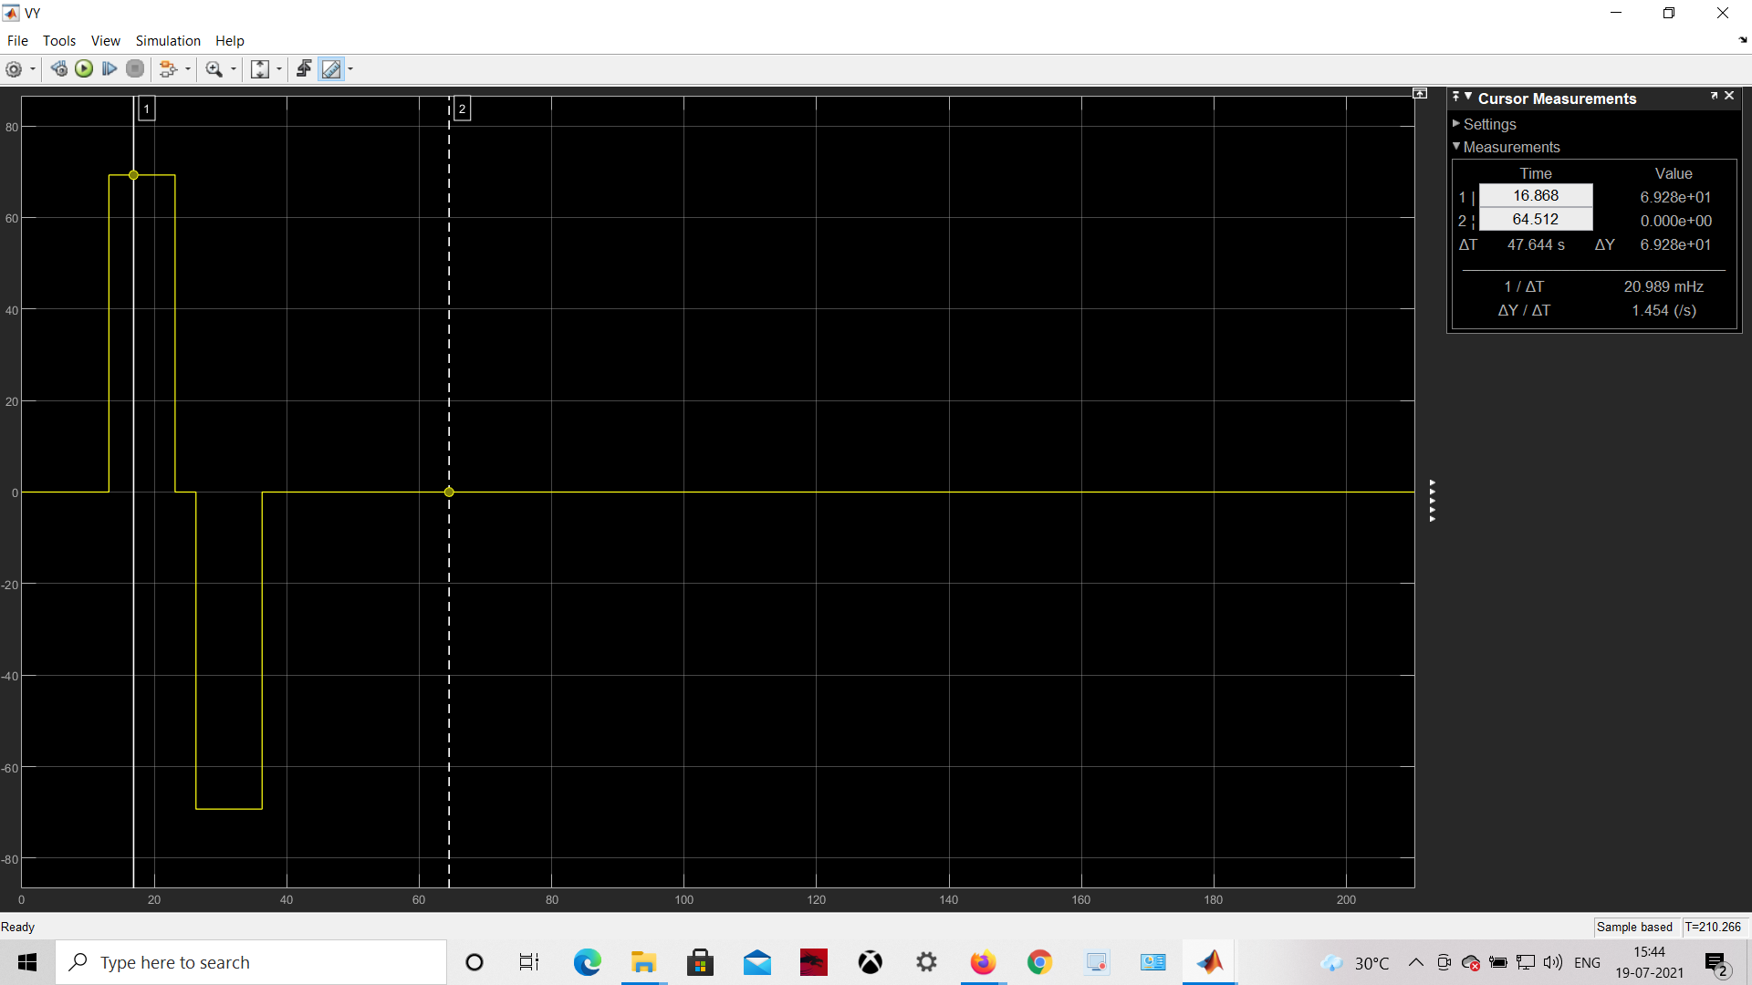

**Screenshot of the Plot for the Position : Y ( Co-ordinate ) for the Forward Kinematics Model :**

**Screenshots of the Plot for the X-Y Graph : ( Tracing the Path / Pattern of Movement made to follow by the Differential Wheel Mobile Robot MATLAB Simulated Model,**

**is a Particular Pattern on the X-Y Plane : TRIANGLE for the Forward Kinematics Model of Differential Wheel Mobile Robot:**



