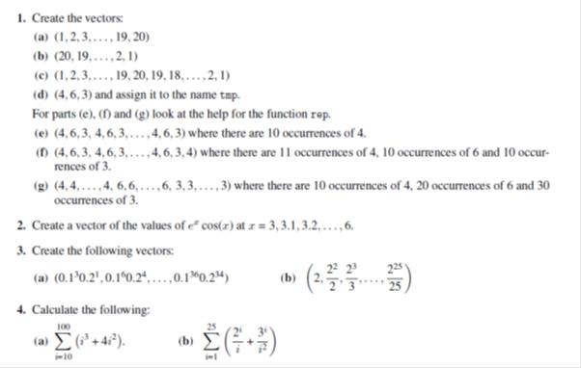

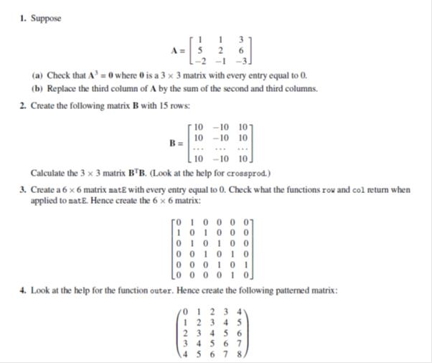

Write a R program to create an array of two 3x3 matrices each with 3 rows and 3 columns from two given two vectors. Print the second row of the second matrix of the array and the element in the 3rd row and 3rd column of the 1st matrix

Write a function to print square of each number in the sequence

Create a for loop that, given a numeric vector, prints out one number per line, with its square

and cube alongside.



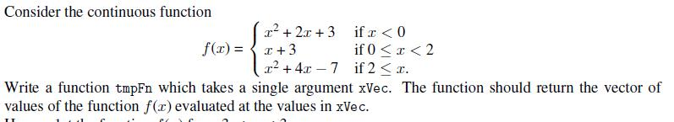

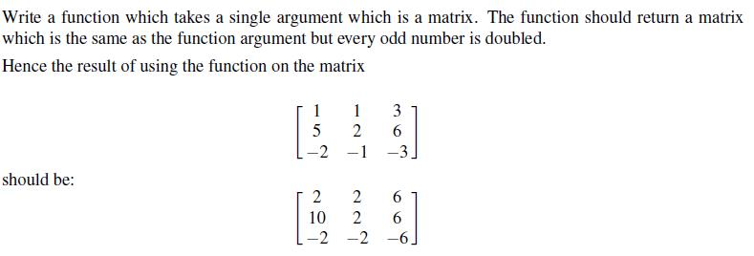

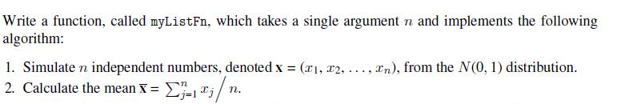

Use the functions mean() and range() to find the mean and range of:

(a) the numbers 1, 2, . . . , 21

(b) the sample of 50 random normal values, that can be generated from a normaL distribution

with mean 0 and variance 1 using the assignment y

y<- rnorm(50)

(c) the columns height and weight in the data frame women.

[The datasets package that has this data frame is by default attached when R is started.]

mean(c(1,3,5,6,NA,7,9))

mean(c(1,2,NA),na.rm = TRUE)

1.Write correct function to plot a scatter plot in R for the given data

x = c(112,95,101,85,90,117,120,125,80,70), y = c(35,25,31,28,30,40,35,36,25,29) z = c(70,60,70,65,60,80,75,50,52,78) ?

2.The paired data on height (x) in centimeters and weight (y) in kilograms of 10 children is obtained. Use correct command to obtain the scatter plot in R for the given data x = c(112,95,101,85,90,117,120,125,80,70), y = c(35,25,31,28,30,40,35,36,25,29) ?

3.In the R package MASS there is a dataset called cats. The variables Bwt and Hwt contain the weight of the body (kg) and the heart (g), respec[1]tively. There are both male and female cats. Try the following commands and explain what happens:

attach(cats)

hist(Hwt[Sex=="M"])

hist(Hwt[Sex=="M"], prob=T)

hist(Hwt[Sex=="M"],

breaks=c(5,10,15,20,25))

Use the xlab and main arguments to change the x-label and the title to something more appropriate.