**Design and implement a stack using array and demonstrate its working with necessary inputs**.

#include<stdio.h>

int stack[100],choice,n,top,x,i;

void push(void);

void pop(void);

void display(void);

int main()

{

//clrscr();

top=-1;

printf("\n Enter the size of STACK[MAX=100]:");

scanf("%d",&n);

printf("\n\t STACK OPERATIONS USING ARRAY");

printf("\n\t--------------------------------");

printf("\n\t 1.PUSH\n\t 2.POP\n\t 3.DISPLAY\n\t 4.EXIT");

do

{

printf("\n Enter the Choice:");

scanf("%d",&choice);

switch(choice)

{

case 1:

{

push();

break;

}

case 2:

{

pop();

break;

}

case 3:

{

display();

break;

}

case 4:

{

printf("\n\t EXIT POINT ");

break;

}

default:

{

printf ("\n\t Please Enter a Valid Choice(1/2/3/4)");

}

}

}

while(choice!=4);

return 0;

}

void push()

{

if(top>=n-1)

{

printf("\n\tSTACK is over flow");

}

else

{

printf(" Enter a value to be pushed:");

scanf("%d",&x);

top++;

stack[top]=x;

}

}

void pop()

{

if(top<=-1)

{

printf("\n\t Stack is under flow");

}

else

{

printf("\n\t The popped elements is %d",stack[top]);

top--;

}

}

void display()

{

if(top>=0)

{

printf("\n The elements in STACK \n");

for(i=top; i>=0; i--)

printf("\n%d",stack[i]);

printf("\n Press Next Choice");

}

else

{

printf("\n The STACK is empty");

}

}#include<stdio.h>

int stack[100],choice,n,top,x,i;

void push(void);

void pop(void);

void display(void);

int main()

{

//clrscr();

top=-1;

printf("\n Enter the size of STACK[MAX=100]:");

scanf("%d",&n);

printf("\n\t STACK OPERATIONS USING ARRAY");

printf("\n\t--------------------------------");

printf("\n\t 1.PUSH\n\t 2.POP\n\t 3.DISPLAY\n\t 4.EXIT");

do

{

printf("\n Enter the Choice:");

scanf("%d",&choice);

switch(choice)

{

case 1:

{

push();

break;

}

case 2:

{

pop();

break;

}

case 3:

{

display();

break;

}

case 4:

{

printf("\n\t EXIT POINT ");

break;

}

default:

{

printf ("\n\t Please Enter a Valid Choice(1/2/3/4)");

}

}

}

while(choice!=4);

return 0;

}

void push()

{

if(top>=n-1)

{

printf("\n\tSTACK is over flow");

}

else

{

printf(" Enter a value to be pushed:");

scanf("%d",&x);

top++;

stack[top]=x;

}

}

void pop()

{

if(top<=-1)

{

printf("\n\t Stack is under flow");

}

else

{

printf("\n\t The popped elements is %d",stack[top]);

top--;

}

}

void display()

{

if(top>=0)

{

printf("\n The elements in STACK \n");

for(i=top; i>=0; i--)

printf("\n%d",stack[i]);

printf("\n Press Next Choice");

}

else

{

printf("\n The STACK is empty");

}

}

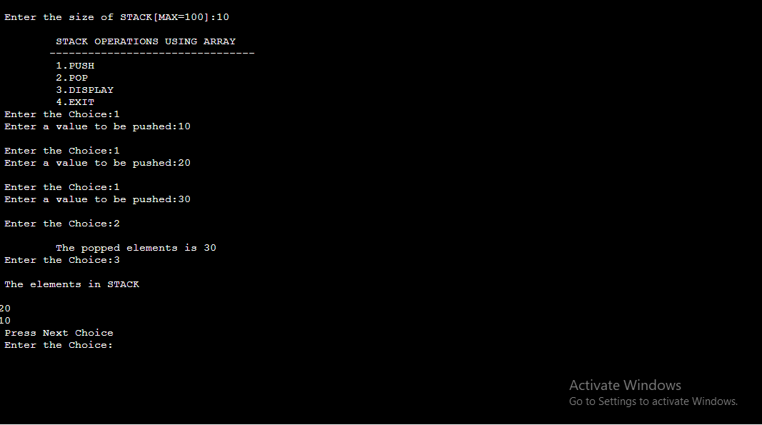

**Algorithm:**

Step 1:Include all the header files which are used in the program and define a constant ‘size’ with specific value

Step 2:Declare all the functions used in stack implementation

Step 3:Create a 1-D array with fixed size

Step 4:Define an integer variable ‘top’ and initialize it with ‘-1’

Step 5:In main function,display more with list of operations and make a suitable function call to perform operation selected by the user on the stack

To push:

Step 1:check whether stack is FULL

Step 2:If it is full,then display stack is full

Step 3:If it is not full,then increment top value by one and set stack(top) to value (stack(top)=value)

To pop()

Step 1:Check whether the stack is empty ,if its not empty delete stack[top]and decrement top by one

To display:

Step 1:Check whether the stack is empty

Step 2:If empty display”Stack is empty”

Step 3:If not empty,display stack[1]value and decrement i value by one