DATE-1/12/2022
USN-1NT21IS102
Q.DESIGN AND IMPLEMENT STACK(LINKED LIST IMPLEMENTATION) AND DEMONSTRATE ITS WORKING WITH NECESSARY INPUTS.DISPLAY THE APPROPRIATE MESSAGES IN CASE OF EXCEPTION
#include<stdio.h>/*input output functions
#include<stdlib.h>/*for memory allocation
void push();
void pop();
void display();
struct node{/*we use a structure because there are values of different data types
int val;
struct node *next;
};
struct node *head;/*with the help of head we can access node
void push()/*we are pushing the elements to the node
{
int val;
struct node *ptr=(struct node *)malloc(sizeof(struct node));/*here malloc is helping us create a node
if(ptr==NULL)
{
printf("not able to push element");
}
else
{
printf("enter value");
scanf("%d",&val);
if(head==NULL)
{
ptr->val=val;
ptr->next=NULL;
head=ptr;
}
else{
ptr->val=val;
ptr->next=head;
head=ptr;
}
printf("item pushed");
}
}
void pop()/* to pop the elements out of the node
{
int item;
struct node *ptr;
if(head==NULL)
{
printf("underflow");
}
else
{
item=head->val;
ptr=head;
head=head->next;
free(ptr);
printf("item popped");
}
}
void display()
{
int i;
struct node *ptr;
ptr=head;
if(ptr==NULL)
{
printf("stack is empty");
}
else
{
printf("printing stack ele");
while(ptr!=NULL)
{
printf("%d\n",ptr->val);
ptr=ptr->next;
}
}
}
int main()
{
int choice;
while(1)
{
printf("op performed by stack");
printf("\n1.push\n 2.pop\n 3.display\n 4.exit\n");
printf("enter the choice");
scanf("%d",&choice);
switch(choice)
{
case 1:push();
break;
case 2:pop();
break;
case 3:display();
break;
case 4:exit(0);
default:printf("invalid choice");
}
}
}

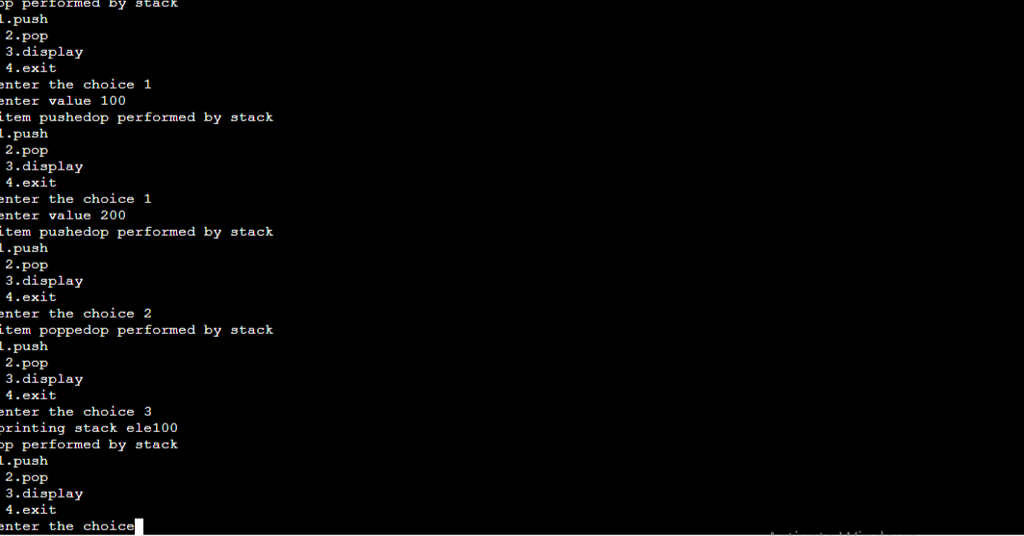

Algorithm:
Step 1:Define a node structure
Step 2:Define a Node pointer top and set it to NULL
Step 3:Implement the main method by displaying Menu with list of operations and make suitable function calls in the main method.
Push()
Step1:Create a newnode with given value
Step 2:Check whether stack is empty
Step 3:If it is empty ,then set newnode to NULL
Step 4:If it is not empty ,then set newnode to top.
Display()
Step 1:

