Receipt and Invoice Digitizer

Introduction
In today's fast-paced business environment, efficient management of financial documents such as receipts and invoices is paramount for accurate accounting, timely expense reporting, and informed decision-making. Historically, this process has been heavily reliant on manual data entry, leading to significant time consumption, increased potential for human error, and a lack of real-time visibility into financial transactions. These challenges are amplified in organizations dealing with a high volume of such documents.
The Receipt and Invoice Digitizer emerges as a critical solution to these pervasive issues. By automating the conversion of physical and digital financial records into structured, usable data, it promises to revolutionize how businesses handle their financial paperwork. This system is not merely about scanning documents; it encompasses a sophisticated workflow that includes intelligent data extraction, validation, categorization, and integration with existing financial systems. Our goal is to provide a robust, scalable, and user-friendly platform that enhances operational efficiency, improves data integrity, and offers a competitive edge through superior financial data management.
•Automated Receipt & Invoice Processing
•Using OCR & Image Processing
•Developed using Streamlit & Python

Problem Statement
Organizations across various sectors face substantial challenges in managing the sheer volume and diversity of receipts and invoices. The current manual processes are fraught with inefficiencies and vulnerabilities:

High Manual Effort
Employees spend considerable time manually entering data from receipts and invoices into accounting systems, diverting valuable resources from core business activities. This often leads to backlogs and delays in financial reporting.

Increased Error Rates
Human error during manual data entry is inevitable, leading to discrepancies, incorrect financial records, and potential compliance issues. Correcting these errors is costly and time-consuming.

Lack of Real-time Visibility
Paper-based or unstructured digital documents hinder immediate access to financial data, making it difficult for stakeholders to track expenses, manage budgets, and make timely financial decisions.

Storage and Retrieval Issues
Physical storage of documents is cumbersome and expensive, while searching for specific information within a vast archive of unstructured documents is often a protracted and inefficient process.

Compliance Risks
Failure to maintain accurate and easily retrievable financial records can expose organizations to regulatory non-compliance fines and audit complications.
• Manual receipt handling is time-consuming
• Data loss and errors
• Difficult expense tracking
• No centralized storage

Requirements - Functional
The Receipt and Invoice Digitizer must fulfill a set of critical functional requirements to address the identified problems and deliver value to its users. These requirements dictate what the system must do.

Document Upload and Ingestion
Support for various input formats including image files (JPEG, PNG, TIFF) and PDF documents. The system shall provide an intuitive interface for single and batch uploads.

Optical Character Recognition (OCR)
Accurate extraction of text from scanned and image-based documents, including handwritten text where feasible. The OCR engine must be optimized for diverse invoice and receipt layouts.

Intelligent Data Extraction
Automatic identification and extraction of key data fields such as vendor name, date, total amount, line items, tax amounts, and currency. The system should learn and adapt to new document formats over time.

Data Validation and Correction
Mechanisms to validate extracted data against predefined rules and external databases (e.g., vendor lists, GL codes). Users must be able to easily review and correct any extracted data that is flagged as potentially inaccurate.

Data Categorization and Tagging
Automatic categorization of expenses and revenue based on extracted data and user-defined rules. Support for custom tags and metadata to enhance search and reporting capabilities.

Export and Integration
Ability to export processed data in various formats (e.g., CSV, XML, JSON) and integrate with popular accounting software (e.g., QuickBooks, SAP) via APIs or file transfers.

Search and Reporting
Robust search functionality allowing users to quickly find documents based on any extracted or tagged data. Customizable reporting features for expenditure analysis and financial audits.

Requirements - Non-Functional
Beyond what the system does, non-functional requirements define how well the system performs its functions. These are crucial for the overall user experience and the system's reliability.

Performance
The system shall process a standard invoice within 5 seconds and maintain responsiveness under peak load conditions (e.g., 100 concurrent users).

Security
All data, both at rest and in transit, must be encrypted. The system shall adhere to industry-standard security protocols (e.g., GDPR, CCPA) and include role-based access control.

Scalability
The architecture must be designed to scale horizontally to accommodate increasing volumes of documents and users without significant performance degradation.

Usability
The user interface shall be intuitive, easy to navigate, and require minimal training for new users. Error messages should be clear and actionable.

Reliability
The system must demonstrate 99.9% uptime, with robust error handling and recovery mechanisms to ensure data integrity even in the event of system failures.

Maintainability
The codebase should be well-documented, modular, and easy to update or extend. Future enhancements and bug fixes should be implementable with minimal effort.

Proposed Solution
• Digital receipt & invoice processing
• OCR-based text extraction
• Image preprocessing
• Centralized data storage

System Features
• Upload receipts/invoices
• Image processing comparison
• OCR text extraction
• Persistent storage

Technology Stack
•• Python
•• Streamlit
•• OpenCV
•• Tesseract OCR
•• Pandas & Matplotlib

Workflow
•1. Upload receipt image
•2. Image preprocessing
•3. OCR text extraction
•4. Data storage
•5. Analytics visualization

Image Processing Comparison
•• Original Image
•• Grayscale Conversion
•• Thresholding
•• OCR-ready image

Benefits
•• Saves time
•• Reduces manual errors
•• Easy expense tracking
•• Digital record keeping

Architecture Overview
The Receipt and Invoice Digitizer is built upon a modular, microservices-based architecture to ensure scalability, resilience, and ease of maintenance. This design allows for independent development, deployment, and scaling of individual components, facilitating agility and flexibility in evolving the system.
At its core, the architecture comprises several key layers: the User Interface, API Gateway, various Microservices (for Document Ingestion, OCR & Extraction, Data Validation, etc.), a Data Storage layer, and an Integration layer. Each component plays a specific role in the overall workflow, communicating primarily through RESTful APIs and message queues.

Architecture Details
The system's architecture is segmented into distinct, interconnected modules. This modularity ensures high cohesion within each service and loose coupling between services, promoting independent development and deployment cycles.

User Interface (UI)
A web-based application providing the primary interaction point for users to upload documents, review extracted data, manage categories, and generate reports. It communicates with the backend via the API Gateway.

API Gateway
Serves as a single entry point for all client requests, routing them to the appropriate microservices. It handles authentication, authorization, and load balancing, protecting the backend services from direct exposure.

Document Ingestion Service
Responsible for receiving and storing raw document files, managing file metadata, and initiating the OCR and extraction pipeline.

OCR & Extraction Service
Utilizes advanced OCR engines and machine learning models to identify and extract key data fields from the ingested documents.

Data Validation Service
Performs checks on extracted data, including format validation, checksums, and cross-referencing with master data. Flags anomalies for user review.

Further services include a Categorization Service for intelligent tagging, a Reporting Service for analytics, and a Notification Service for user alerts. All services interact with a robust Data Storage layer, comprising both relational databases for structured data and document stores for raw files and processed metadata. A Message Queue ensures asynchronous communication and task distribution between services, enhancing system resilience and throughput. The Integration Layer provides connectors to third-party accounting and ERP systems, facilitating seamless data flow.

Architectural Diagram
The following diagram illustrates the high-level architecture of the Receipt and Invoice Digitizer, demonstrating the interaction between its main components and data flows.
This visual representation emphasizes the decoupled nature of the system, allowing for independent scaling and fault isolation, which are critical for a high-availability and high-performance solution.
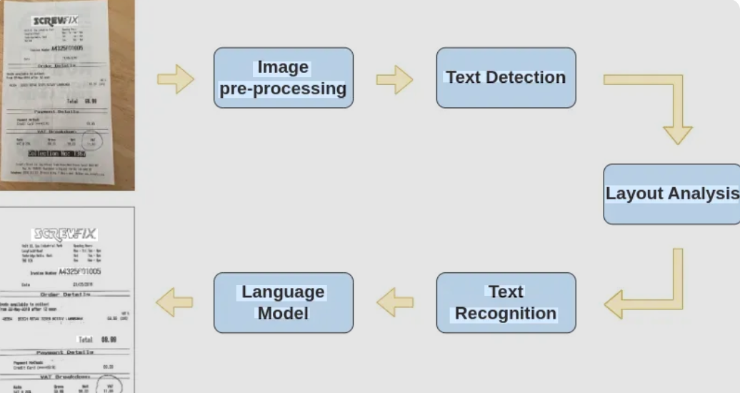

Conclusion
The Receipt and Invoice Digitizer represents a significant leap forward in financial document management. By meticulously addressing the challenges of manual data processing, this system offers a robust, scalable, and secure solution that promises to redefine operational efficiency for businesses. The implementation of advanced technologies such as OCR and machine learning, coupled with a flexible microservices architecture, ensures both immediate impact and long-term adaptability.
We are confident that this digitizer will not only alleviate the burden of manual data entry but also provide unprecedented accuracy and real-time insights into financial operations. Its ability to integrate seamlessly with existing accounting systems will empower organizations to make faster, more informed decisions, ultimately leading to enhanced productivity and reduced operational costs. The journey towards fully automated financial reconciliation begins here, with a system designed for the future.

THANK YOU

