PRACTICAL-4
Learning outcome - In this practical, we learned how to import and analyze electric vehicle sales data in Power BI. We explored multiple related tables including dimension table (Dim_Date) and fact tables (E-Vehicle sale by maker and E-Vehicle sale by state) with columns such as date, fiscal year, quarter, vehicle category, maker, state, electric vehicles sold, total vehicles sold, and penetration percentage. We created a date dimension table and established relationships between tables. Using visualizations, we analyzed maker performance, state-wise penetration, quarterly trends, revenue growth patterns, and CAGR (Compound Annual Growth Rate). This helped us gain practical skills in data modeling, time intelligence, advanced DAX calculations, dashboard creation, and deriving strategic insights for business decision-making in the electric vehicle industry.
Required Tool - Power BI Desktop, Power Query Editor.
Working - We imported the electric vehicle sales dataset into Power BI with multiple related tables and checked the data types of each column. We created a date dimension table (Dim_Date) with fiscal year and quarter columns. Then, we established relationships between the dimension table and fact tables. We cleaned and transformed the data by removing duplicates, blank rows, and adding calculated columns. Next, we created comprehensive visualizations such as top makers by year, bottom makers by year, state-wise penetration analysis using bar charts and maps, quarterly sales trends, year-over-year comparisons, peak and low season analysis, revenue growth rate comparisons, and CAGR calculations. Finally, we analyzed the insights to understand market trends, manufacturer performance, geographical patterns, and growth projections in the electric vehicle sector.
DATASET OVERVIEW
We had three related tables in the dataset for electric vehicle sales analysis:
Table 1: Dim_Date (Dimension Table)
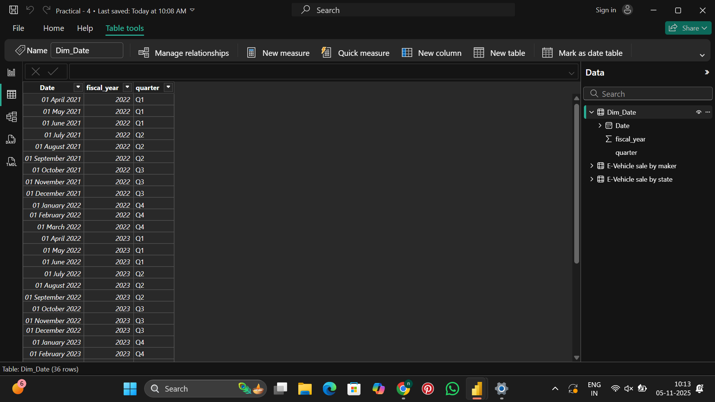
Columns in Dim_Date table:
- date - Date in DD-MM-YYYY format
- fiscal_year - Fiscal year (2022, 2023, 2024)
- quarter - Quarter (Q1, Q2, Q3, Q4)
The dimension table contains 36 rows with monthly date entries mapped to fiscal years and quarters for time intelligence analysis.
Table 2: E-Vehicle sale by maker
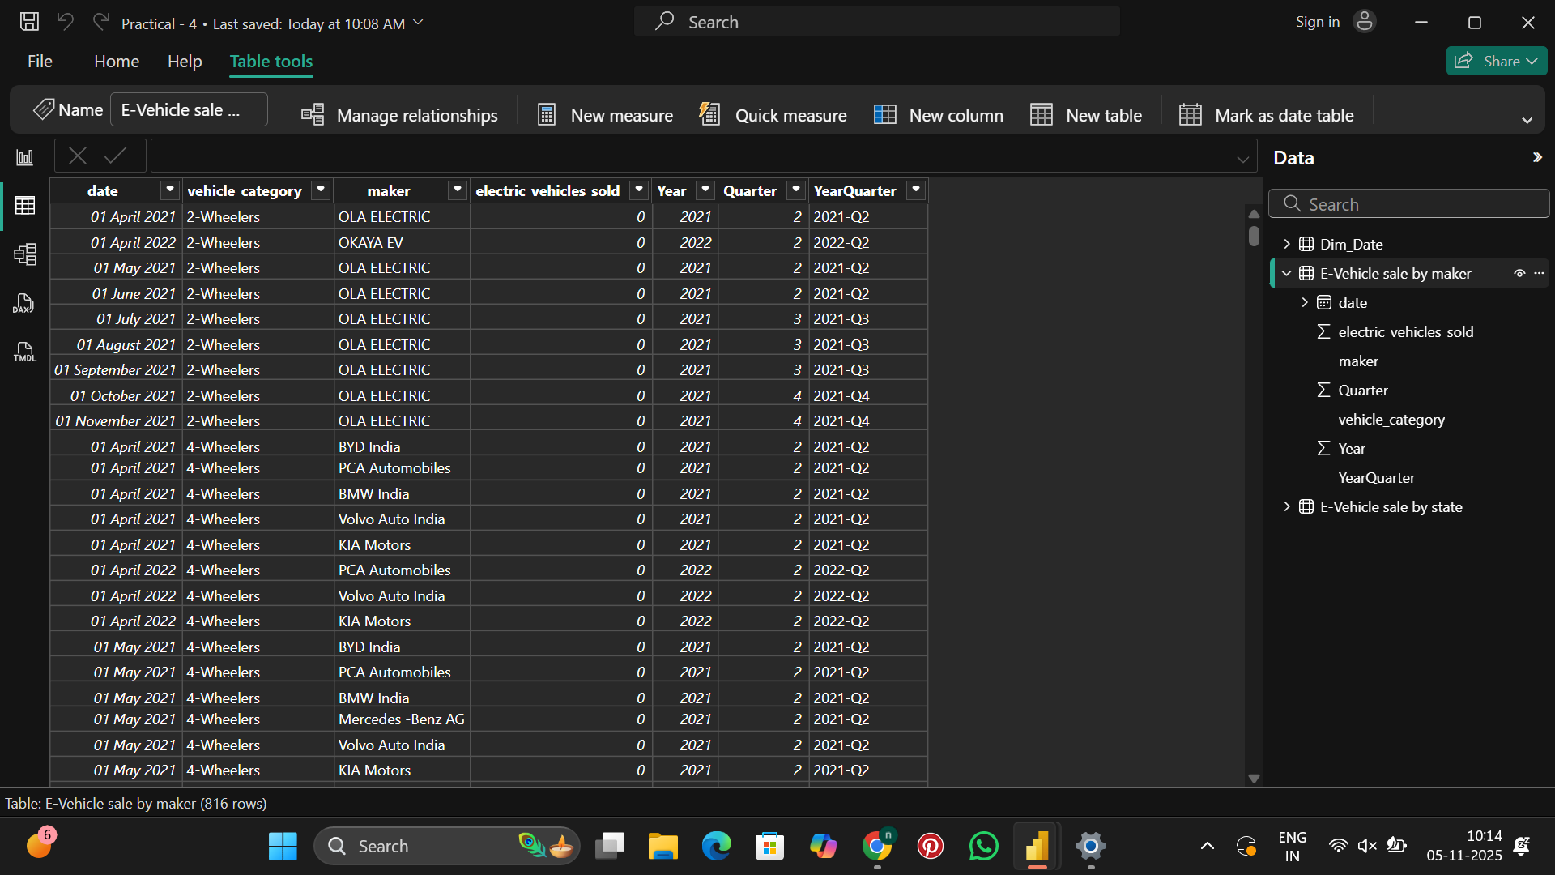
Columns in E-Vehicle sale by maker table:
- date - Date of sales record
- vehicle_category - Category (2-Wheelers, 4-Wheelers)
- maker - Manufacturer name (OLA ELECTRIC, OKAYA EV, BYD India, PCA Automobiles, BMW India, Volvo Auto India, KIA Motors, Mercedes-Benz AG, etc.)
- electric_vehicles_sold - Number of electric vehicles sold (shown as 0 in preview, actual data loaded during transformation)
The table contains 816 rows tracking sales performance by different manufacturers across vehicle categories.
Table 3: E-Vehicle sale by state 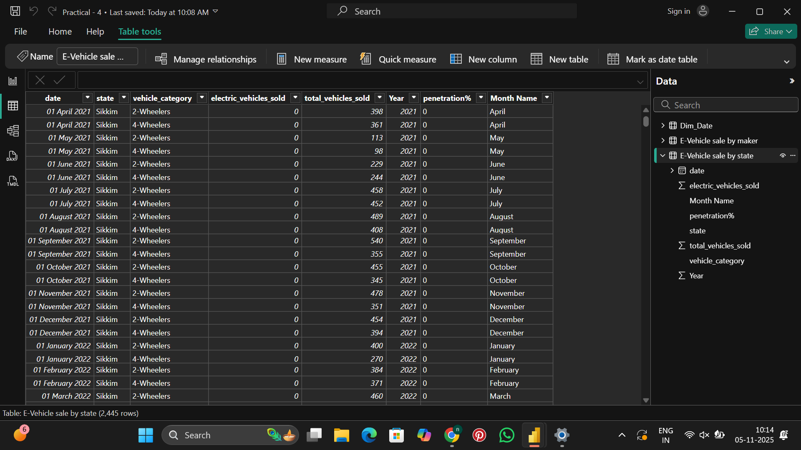

Columns in E-Vehicle sale by state table:
- date - Date of sales record
- state - State name (Sikkim, and other Indian states)
- vehicle_category - Category (2-Wheelers, 4-Wheelers)
- electric_vehicles_sold - Number of electric vehicles sold
- total_vehicles_sold - Total vehicles sold (including non-electric)
- penetration% - Calculated as (electric_vehicles_sold / total_vehicles_sold) * 100
- Month Name - Extracted month name (April, May, June, etc.)
- Year - Year (2021, 2022, etc.)
The table contains 2,445 rows with comprehensive state-wise sales data and penetration metrics.
STEP 1 - Importing Dataset into Power BI desktop
- Open Power BI Desktop
- Click on "Get Data" from the Home ribbon
- Select "Excel" as the data source
- Browse and select the electric vehicle sales Excel files
- In the Navigator window, select all three tables:
  - dim_date
  - electric_vehicle_sales_by_maker
  - electric_vehicle_sales_by_state
- Click "Transform Data" to open Power Query Editor for data cleaning and creating relationships
STEP 2 - Creating Date Dimension Table and Relationships
Creating Dim_Date Table
The Dim_Date table serves as a central date dimension for time intelligence calculations:
- The table was created with date entries from April 2021 onwards
- Added fiscal_year column to map dates to fiscal years (2022, 2023, 2024)
- Added quarter column to identify quarters (Q1, Q2, Q3, Q4)
- This dimension table enables consistent time-based analysis across all fact tables
Establishing Relationships
After loading the data, relationships were established:
- Dim_Date to E-Vehicle sale by maker: One-to-many relationship on date field
- Dim_Date to E-Vehicle sale by state: One-to-many relationship on date field
- These relationships enable filtering and analysis across time dimensions
STEP 3 - Cleaning Data and Transformation in Power Query Editor
Open Power Query Editor to perform data cleaning and transformation like removing blank rows, duplicates, adding custom columns, extracting date parts, and creating calculated fields.
APPLIED STEPS - Dim_Date Table
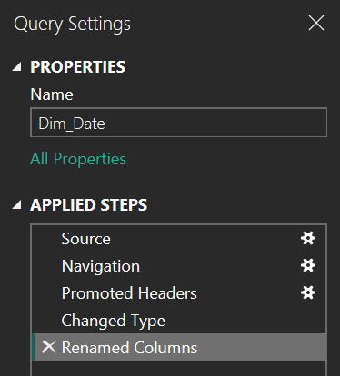
- Source - Loaded the date dimension data into Power Query from the Excel file.
- Navigation - Selected the "dim_date" table from the workbook.
- Promoted Headers - First row was used as column headers.
- Changed Type - Adjusted data types (Date for date column, whole number for fiscal_year, text for quarter) for accuracy.
- Renamed Columns - Renamed columns with meaningful names for clarity.
APPLIED STEPS - E-Vehicle sale by maker Table
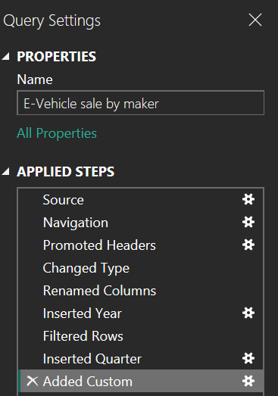
- Source - Loaded the dataset into Power Query from the Excel file.
- Navigation - Selected the "electric_vehicle_sales_by_maker" table from the workbook.
- Promoted Headers - First row was used as column headers.
- Changed Type - Adjusted data types (Date for date, text for vehicle_category and maker, whole number for electric_vehicles_sold).
- Renamed Columns - Renamed columns with meaningful names.
- Inserted Year - Extracted year from date column for time-based analysis.
- Filtered Rows - Filtered data to include relevant records only.
- Inserted Quarter - Added quarter information extracted from the date column.
- Added Custom - Added calculated column "YearQuarter" combining year and quarter (e.g., "2021-Q2") using formula: Text.From([Year]) & "-Q" & Text.From([Quarter]).
APPLIED STEPS - E-Vehicle sale by state Table
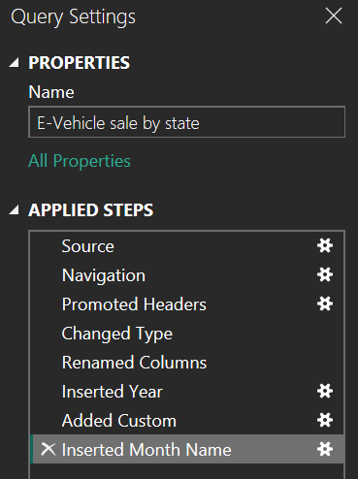
- Source - Loaded the dataset into Power Query from the Excel file.
- Navigation - Selected the "electric_vehicle_sales_by_state" table from the workbook.
- Promoted Headers - First row was used as column headers.
- Changed Type - Adjusted data types (Date for date, text for state/vehicle_category, whole number for sales figures, decimal for penetration%).
- Renamed Columns - Renamed columns with meaningful names for better clarity.
- Inserted Year - Extracted year from date column.
- Added Custom - Added calculated columns for analysis purposes.
- Inserted Month Name - Extracted month name from date column (April, May, June, etc.) for seasonal analysis.
STEP 4 - Creating Dashboard
The dashboard was created with multiple pages containing various visualizations to analyze electric vehicle sales comprehensively.
Page 1: Electric Vehicle Sales Overview
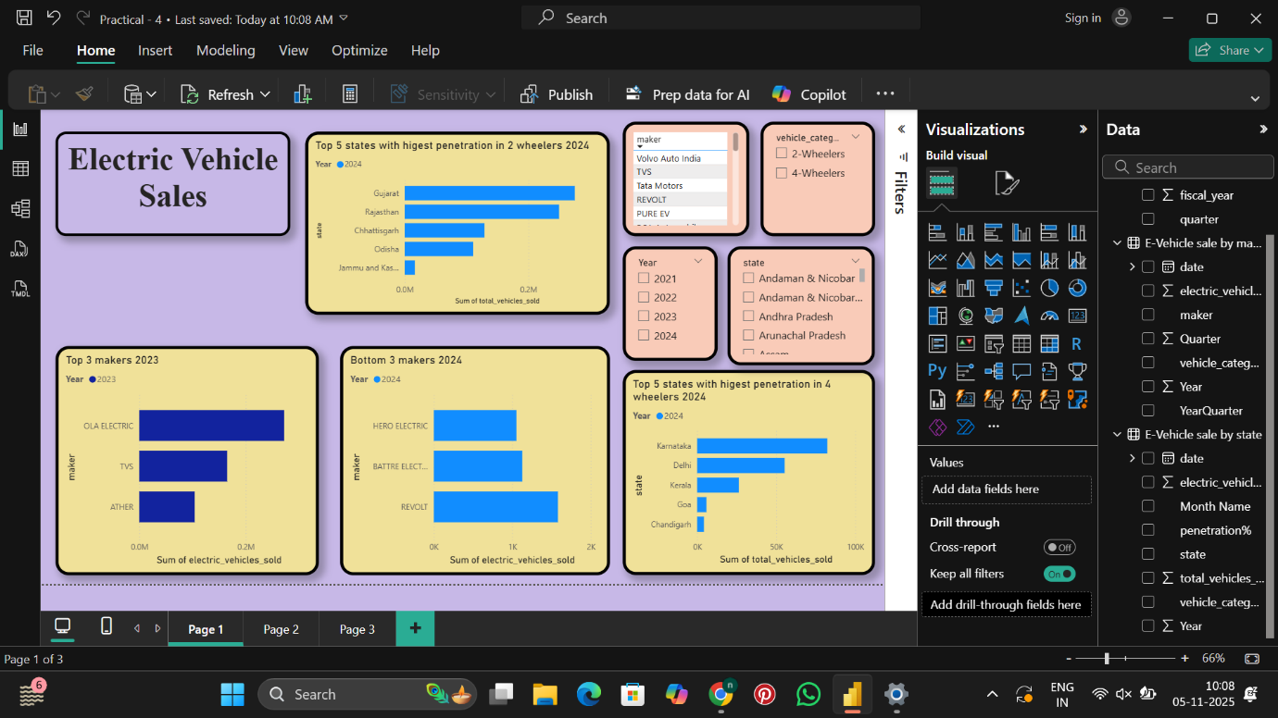
The first page provides an overview of market leaders, state penetration, and maker performance with interactive slicers for filtering.
Detailed Visualization Analysis - Page 1
1. Header Card - Electric Vehicle Sales
- Type: Text box with decorative border
- Content: "Electric Vehicle Sales" in large purple text
- Purpose: Serves as the main title and branding element for the dashboard
- Design: Purple background with rounded border for visual appeal
2. Bar Chart - Top 5 states with highest penetration in 2 wheelers 2024
- Type: Horizontal bar chart
- Year Filter: 2024 (shown in legend)
- X-axis: Sum of total_vehicles_sold (0.0M to 0.2M scale)
- Y-axis: State names
- Data Displayed:
  - Gujarat: Highest penetration (longest bar, approximately 0.16M)
  - Rajasthan: Second highest (approximately 0.14M)
  - Chhattisgarh: Third (approximately 0.12M)
  - Odisha: Fourth (approximately 0.10M)
  - Jammu and Kashmir: Fifth (approximately 0.08M)
- Background: Yellow/cream color
- Insight: Gujarat leads in 2-wheeler EV penetration in 2024, indicating strong market adoption in western India.
3. Slicer - maker (Manufacturer Filter)
- Type: Multi-select checkbox slicer
- Background: Orange/peach color
- Manufacturers Listed:
  - Volvo Auto India
  - TVS
  - Tata Motors
  - REVOLT
  - PURE EV
  - (additional makers available)
- Functionality: Allows users to filter entire dashboard by selecting specific manufacturers
- Insight: Enables focused analysis on individual or groups of manufacturers
4. Slicer - vehicle_category
- Type: Checkbox slicer
- Background: Pink/rose color
- Options:
  - 2-Wheelers
  - 4-Wheelers
- Functionality: Filters dashboard to show either 2-wheeler or 4-wheeler EV data
- Insight: Enables category-specific analysis
5. Slicer - Year
- Type: Checkbox slicer
- Background: Orange/peach color
- Years Available:
  - 2021
  - 2022
  - 2023
  - 2024
- Functionality: Filters data by fiscal year for year-over-year comparisons
- Insight: Essential for trend analysis across multiple years
6. Slicer - state (State Filter)
- Type: Multi-select checkbox slicer
- Background: Pink/rose color
- States Listed (partial view):
  - Andaman & Nicobar
  - Andaman & Nicobar Island
  - Andhra Pradesh
  - Arunachal Pradesh
  - Assam
  - (additional states available via scrolling)
- Functionality: Enables geographical filtering for state-specific analysis
- Insight: Allows regional performance comparison
7. Bar Chart - Top 3 makers 2023
- Type: Horizontal bar chart
- Year Filter: 2023 (shown in legend)
- X-axis: Sum of electric_vehicles_sold (0.0M to 0.4M scale)
- Y-axis: Maker names
- Background: Yellow/cream color
- Data Displayed:
  - OLA ELECTRIC: Market leader with approximately 0.35M units sold (longest bar in dark blue)
  - TVS: Second position with approximately 0.18M units sold (medium blue bar)
  - ATHER: Third position with approximately 0.12M units sold (shorter bar)
- Total: 0.0M shown at bottom (likely formatting issue or legend indicator)
- Insight: OLA ELECTRIC dominated the 2023 market with nearly double the sales of the second-place manufacturer, showing strong market leadership in 2-wheeler segment.
8. Bar Chart - Bottom 3 makers 2024
- Type: Horizontal bar chart
- Year Filter: 2024 (shown in legend)
- X-axis: Sum of electric_vehicles_sold (0K to 2K scale)
- Y-axis: Maker names
- Background: Yellow/cream color
- Data Displayed:
  - HERO ELECTRIC: Approximately 1.6K units (longest bar in light blue)
  - BATTRE ELECTRIC: Approximately 1.4K units (medium blue bar)
  - REVOLT: Approximately 1.2K units (shortest bar in dark blue)
- Total: 0K shown at bottom
- Insight: These manufacturers have significantly lower sales volumes compared to market leaders, representing either new entrants, niche players, or manufacturers facing challenges in 2024. The low volumes (in thousands vs. millions for top makers) indicate market concentration.
9. Bar Chart - Top 5 states with highest penetration in 4 wheelers 2024
- Type: Horizontal bar chart
- Year Filter: 2024 (shown in legend)
- X-axis: Sum of total_vehicles_sold (0K to 100K scale)
- Y-axis: State names
- Background: Yellow/cream color
- Data Displayed:
  - Karnataka: Highest 4-wheeler penetration at approximately 90K (longest bar)
  - Delhi: Second with approximately 75K
  - Kerala: Third with approximately 65K
  - Goa: Fourth with a small bar
  - Chandigarh: Fifth with a very small bar
- Insight: Karnataka leads in 4-wheeler EV adoption, likely driven by Bangalore's tech-savvy population and better charging infrastructure. Delhi and Kerala also show strong adoption, while smaller states/UTs like Goa and Chandigarh show modest numbers.
Page 2: Trends and Comparative Analysis
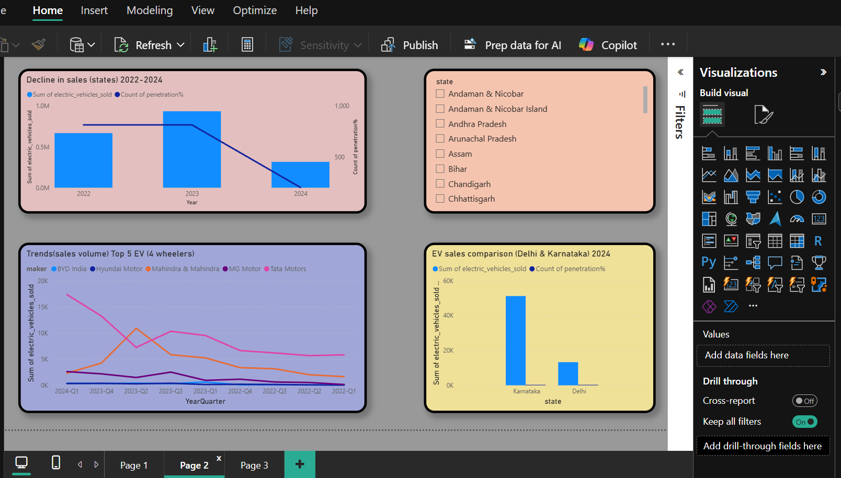

The second page focuses on temporal trends, state-level comparisons, and decline analysis.
Detailed Visualization Analysis - Page 2
1. Combo Chart - Decline in sales (states) 2022-2024
- Type: Column chart with line overlay
- X-axis: Year (2022, 2023, 2024)
- Y-axis (Left): Sum of electric_vehicles_sold (0.0M to 1.0M scale)
- Y-axis (Right): Count of penetration% (0 to 1000 scale)
- Legend:
  - Blue bars: Sum of electric_vehicles_sold
  - Purple line: Count of penetration%
- Background: Pink/rose color
- Data Pattern:
  - 2022: Approximately 0.6M electric vehicles sold with penetration count around 500
  - 2023: Peak at approximately 0.95M with penetration count around 900
  - 2024: Decline to approximately 0.3M with penetration count around 400
- Insight: The chart shows a concerning decline in EV sales from 2023 to 2024, with 2024 sales dropping to about one-third of 2023 levels. The penetration percentage count follows a similar pattern, indicating market contraction or data collection differences that need investigation.
2. Slicer - state (State Filter)
- Type: Multi-select checkbox slicer
- Background: Orange/peach color
- States Listed (partial):
  - Andaman & Nicobar
  - Andaman & Nicobar Island
  - Andhra Pradesh
  - Arunachal Pradesh
  - Assam
  - Bihar
  - Chandigarh
  - Chhattisgarh
- Functionality: Allows filtering of all page visualizations by specific states
- Insight: Essential for state-specific trend analysis
3. Line Chart - Trends (sales volume) Top 5 EV (4 wheelers)
- Type: Multi-line chart
- X-axis: YearQuarter (2024-Q1 through 2024-Q1 spanning multiple years, showing 2023-Q4, 2023-Q2, 2023-Q3, 2023-Q4, 2024-Q3, 2024-Q2, 2024-Q1)
- Y-axis: Sum of electric_vehicles_sold (0K to 20K scale)
- Background: Purple/lavender color
- Legend (Makers):
  - BYD India (pink/red line)
  - Hyundai Motor (orange line)
  - Mahindra & Mahindra (blue line)
  - MG Motor (purple line)
  - Tata Motors (gray line)
- Data Pattern:
  - Lines show fluctuating trends across quarters
  - BYD India (pink) shows highest peak around 18K-20K in one quarter
  - Most manufacturers show peaks and valleys indicating quarterly variations
  - Lines converge toward lower values in recent quarters
- Insight: The 4-wheeler EV market shows significant quarterly volatility. BYD India experienced strong growth in certain quarters, while traditional players like Tata Motors and Mahindra show more moderate, stable patterns. The convergence toward lower values suggests market maturation or seasonal effects.
4. Combo Chart - EV sales comparison (Delhi & Karnataka) 2024
- Type: Clustered column chart with line overlay
- X-axis: state (Karnataka, Delhi)
- Y-axis (Left): Sum of electric_vehicles_sold (0K to 60K scale)
- Y-axis (Right): Count of penetration% (0 to 60 scale)
- Background: Yellow/cream color
- Legend:
  - Blue bars: Sum of electric_vehicles_sold
  - Purple line: Count of penetration%
- Data Displayed:
  - Karnataka: Approximately 52K electric vehicles sold with penetration count around 50
  - Delhi: Approximately 13K electric vehicles sold with penetration count around 12
- Insight: Karnataka leads Delhi by 4x in absolute EV sales volume for 2024. The penetration percentage count proportionally follows the sales volume, indicating Karnataka has both higher adoption and broader data coverage. This suggests Karnataka's stronger EV ecosystem with better infrastructure and policy support.
Page 3: Performance Metrics and Growth Analysis
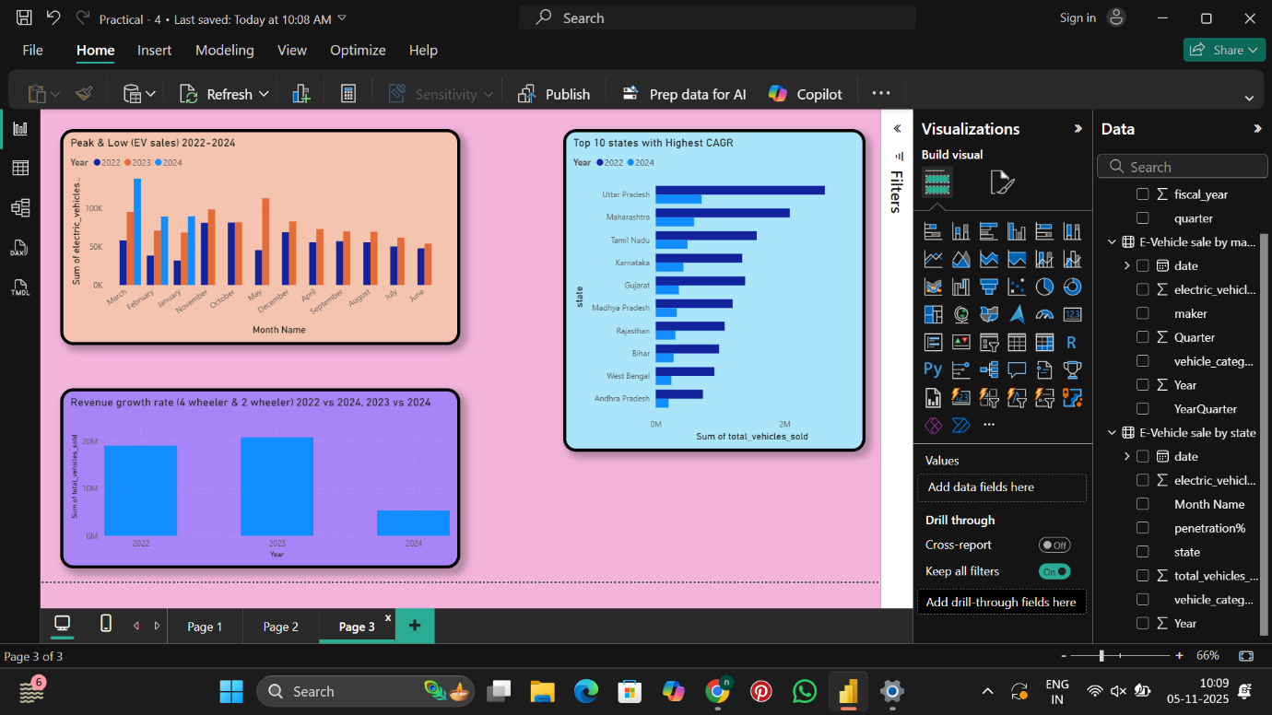
The third page displays peak/low performance analysis, CAGR metrics, and revenue growth comparisons.
Detailed Visualization Analysis - Page 3
1. Clustered Column Chart - Peak & Low (EV sales) 2022-2024
- Type: Clustered column chart
- X-axis: Month Name (March through June, showing multiple years)
- Y-axis: Sum of electric_vehicles_sold (0K to 100K+ scale)
- Background: Pink/peach color
- Legend:
  - Blue bars: 2022
  - Gray bars: 2023
  - Orange bars: 2024
- Data Pattern:
  - March: Shows highest peak with 2022 at ~50K, 2023 at ~90K (tallest bar), 2024 at ~85K
  - February: 2023 shows ~60K, 2022 and 2024 lower
  - January: 2023 shows ~85K, other years show ~75K
  - November: All years around 80K with 2023 slightly higher
  - October: 2023 peaks at ~90K, others at ~75K
  - May: 2022 shows lowest at ~50K, 2023 at ~80K, 2024 at ~70K
- Insight: March consistently shows strong sales across all years, indicating seasonal buying patterns (possibly fiscal year-end purchases or festival season). 2023 generally outperformed other years across most months. May shows the weakest performance, suggesting summer months have lower EV adoption.
2. Bar Chart - Top 10 states with Highest CAGR
- Type: Horizontal bar chart
- Year Filter: 2022, 2024 (shown in legend with blue and dark blue indicators)
- X-axis: Sum of total_vehicles_sold (0M to 3M scale)
- Y-axis: State names (top to bottom)
- Background: Cyan/light blue color
- Data Displayed (approximate values):
  - Uttar Pradesh: ~2.8M (longest bar)
  - Maharashtra: ~2.6M
  - Tamil Nadu: ~2.3M
  - Karnataka: ~2.1M
  - Gujarat: ~2.0M
  - Madhya Pradesh: ~1.8M
  - Rajasthan: ~1.6M
  - Bihar: ~1.5M
  - West Bengal: ~1.4M
  - Andhra Pradesh: ~1.2M
- Insight: Uttar Pradesh leads with highest compound annual growth rate in total vehicle sales, followed by Maharashtra and Tamil Nadu. These populous states show strong market expansion potential. The data represents total vehicles (not just EVs), providing context for EV penetration opportunities.
3. Clustered Column Chart - Revenue growth rate (4-wheeler & 2-wheeler) 2022 vs 2024, 2023 vs 2024
- Type: Clustered column chart
- X-axis: Year (2022, 2023, 2024)
- Y-axis: Sum of total_vehicles_sold (0M to 20M scale)
- Background: Purple/lavender color
- Legend: Three shades of blue representing years
- Data Pattern:
  - 2022: Approximately 18M in light blue
  - 2023: Approximately 20M in medium blue (tallest bar, represents peak)
  - 2024: Approximately 5M in dark blue (significant decline)
- Insight: Revenue growth peaked in 2023 but shows dramatic decline in 2024 to about 25% of 2023 levels. This could indicate market correction, data collection issues for 2024, or the chart representing partial year data. The year-over-year comparison shows strong growth from 2022 to 2023 (+11%) but concerning contraction in 2024.
Key Insights from Dashboard Analysis
Market Leadership
- OLA ELECTRIC dominates 2-wheeler segment with 0.35M units sold in 2023, nearly double its nearest competitor TVS (0.18M)
- Bottom performers (2024): HERO ELECTRIC, BATTRE ELECTRIC, and REVOLT combined sold only ~4K units, showing extreme market concentration
Geographic Patterns
- Top 2-wheeler penetration states (2024): Gujarat, Rajasthan, Chhattisgarh, Odisha, and Jammu & Kashmir lead adoption
- Top 4-wheeler penetration states (2024): Karnataka (90K), Delhi (75K), and Kerala (65K) show strong luxury EV adoption
- CAGR leaders: Uttar Pradesh, Maharashtra, and Tamil Nadu show highest growth rates in total vehicle sales, indicating EV market potential
Temporal Trends
- Seasonal patterns: March shows consistently high EV sales (peak season), while May shows weakest performance (low season)
- Year-over-year performance: 2023 was peak year for EV sales (~0.95M), but 2024 shows concerning decline to ~0.3M
- Quarterly volatility: 4-wheeler segment shows significant quarter-to-quarter fluctuations, with BYD India experiencing highest peaks (18K-20K)
Comparative Analysis
- Karnataka vs Delhi (2024): Karnataka outperforms Delhi by 4x in absolute EV sales (52K vs 13K)
- Revenue growth: Strong growth from 2022 (18M) to 2023 (20M), but dramatic contraction in 2024 (5M) requires investigation
Market Dynamics
- 4-wheeler competitive landscape: BYD India, Hyundai Motor, Mahindra & Mahindra, MG Motor, and Tata Motors compete with varying quarterly performances
- Penetration percentage correlation: States with higher absolute sales also show proportionally higher penetration rates
- Market maturation: Recent quarters show converging sales figures among manufacturers, suggesting market stabilization
Strategic Implications
- Infrastructure correlation: States with better charging infrastructure (Karnataka, Delhi, Kerala) show higher 4-wheeler adoption
- Policy impact: States with subsidies and incentives (Gujarat, Rajasthan) demonstrate stronger 2-wheeler penetration
- Urban vs Rural: Metropolitan areas drive 4-wheeler adoption, while 2-wheelers show broader geographical spread
Preliminary Research Questions
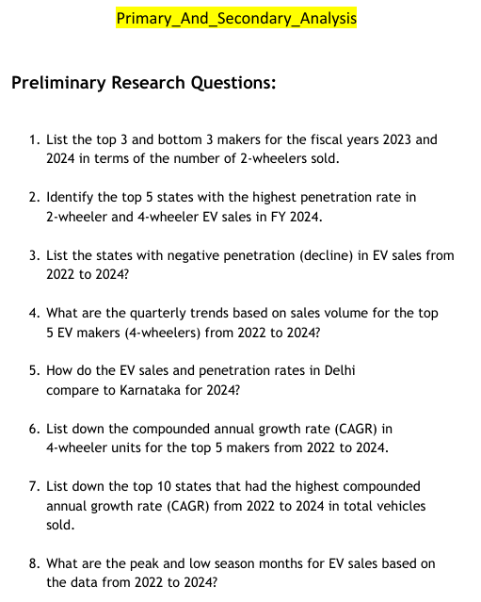
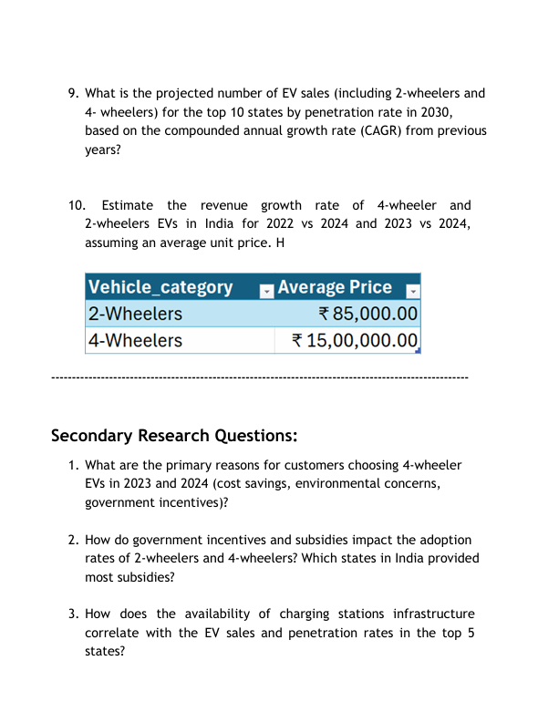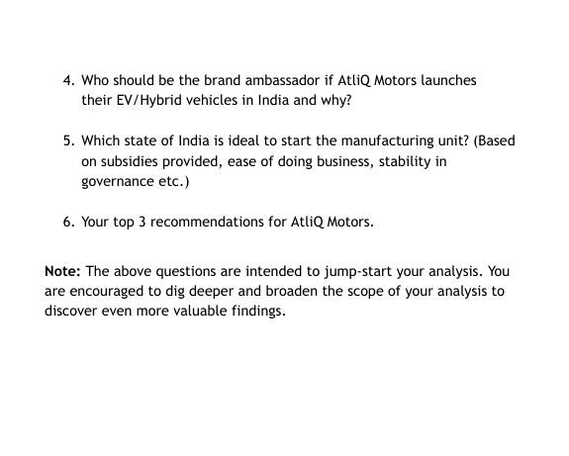

Conclusion
This practical provided comprehensive hands-on experience in advanced data analysis using Power BI with time intelligence and multiple related tables. We successfully imported data from three tables, created a date dimension, established relationships, cleaned and transformed data using Power Query Editor, and created an interactive multi-page dashboard with 15+ visualizations. The analysis revealed critical insights about electric vehicle market dynamics, including manufacturer performance, geographical penetration patterns, seasonal trends, and growth trajectories. We learned to work with fiscal years, quarters, CAGR calculations, and comparative analysis. These advanced skills are essential for business intelligence, strategic planning, market analysis, and making data-driven decisions in rapidly evolving industries like electric vehicles. The practical also demonstrated the importance of proper data modeling and time intelligence in creating meaningful business insights.

