PRACTICAL – 5
Learning Outcome- Learned to clean and transform NorthWind data in Power BI, merging table and adding conditional columns. Gained skills in calculating key metrics and creating visualizations to analyze order and shipping across different regions.
Required Tool- Power BI Desktop, Power Query Editor.
Working: The working of this practical involves importing the Northwind Orders dataset into Power BI and creating visualizations to analyze sales and customer data. The dataset is cleaned and processed by removing blanks or unwanted fields, and then measures such as count of customers, final amount, freight charges, and yearly totals are calculated. Various charts are created.

DATASET OVERVIEW
We had a dataset named “Northwind Order Details” and “Northwind Details” which have following columns.
“Northwind orders” data
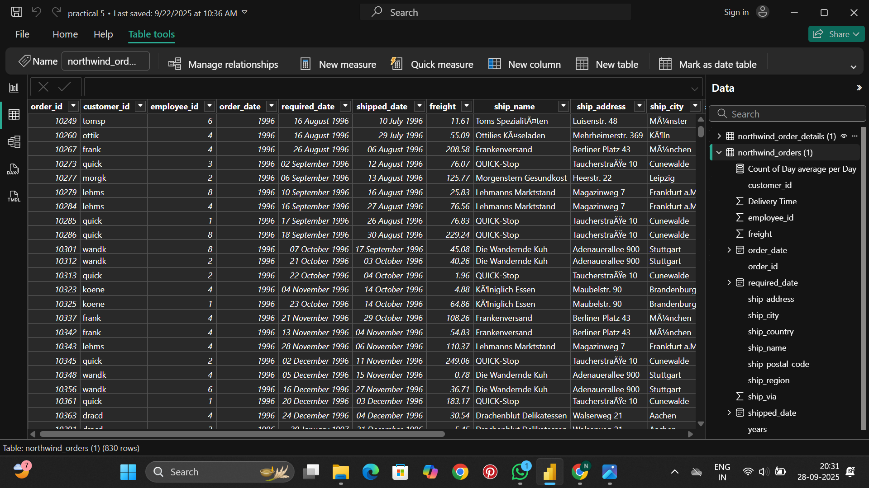

“Northwind order details” data
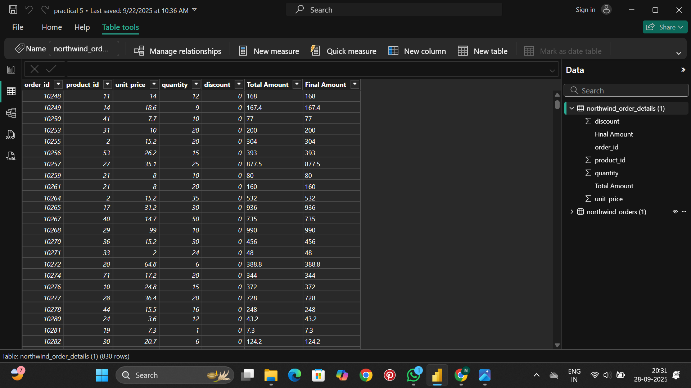

STEP 1- Importing Data into Power BI Desktop
Open Power BI Desktop > go to home tab> Get Data > Select the files from Excel / CSV and select the file, click on load. Data will be loaded into Power BI.
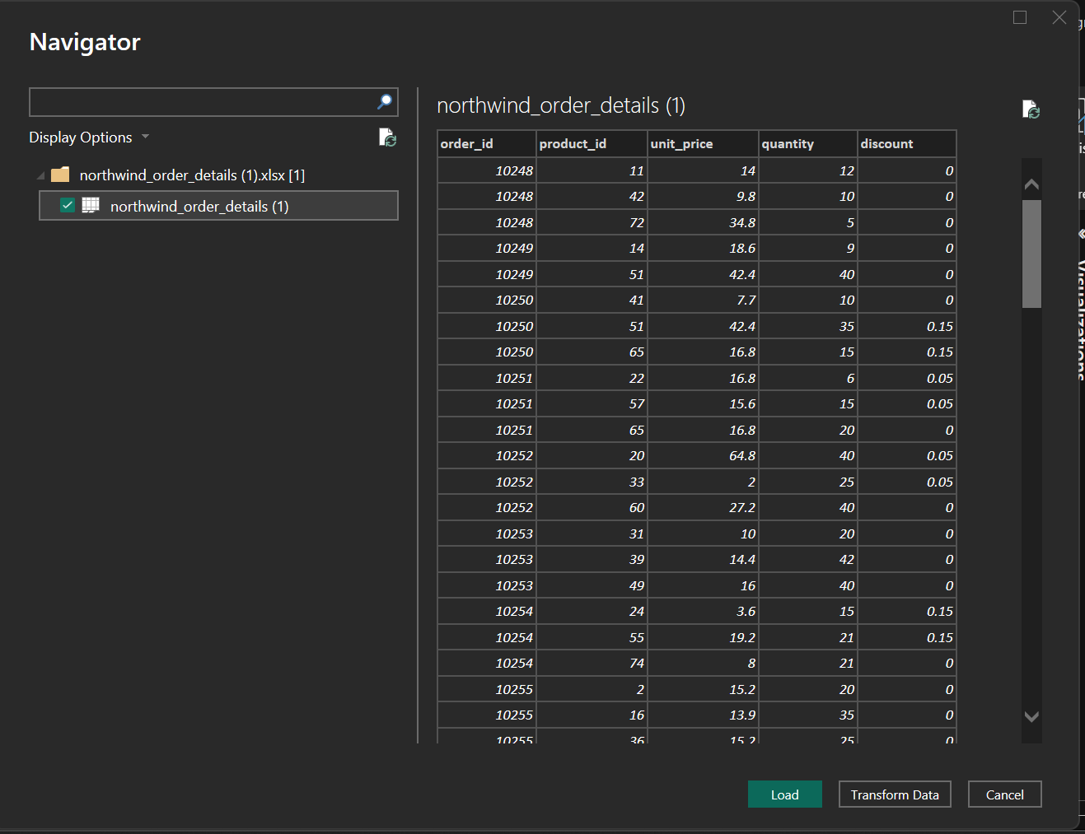
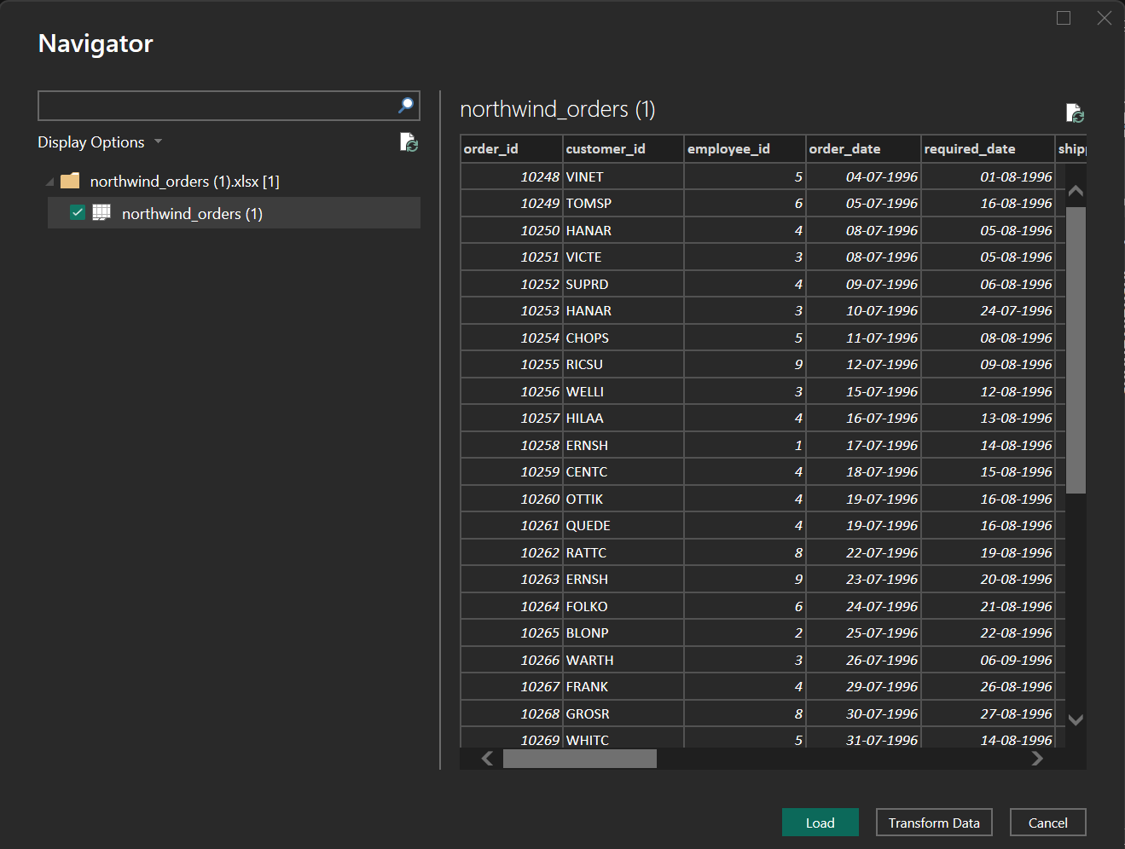

STEP 2- Data Cleaning and Transformation in Power Query Editor
In home tab, click on transform data to open power query editor to perform cleaning and data transformation.

APPLIED STEPS

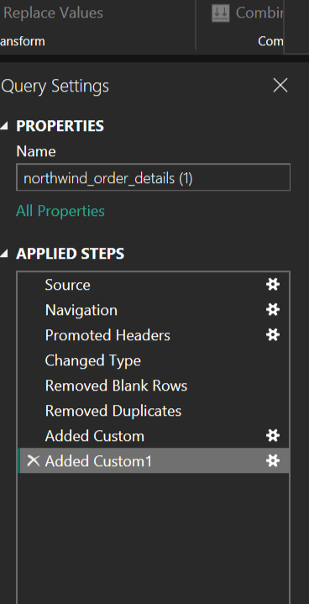

Northwind Order Details

- Source: This step loads the original data from the source (likely a dataset like a database or Excel file).
- Promoted Headers: This step promotes the first row to be the column headers for better readability.
- Changed Type: This step changes the data type of each column to match its appropriate type (e.g., number, text).
- Added Custom: New columns are added using custom formulas. (Total amount= Unit price* discount)
- Removed Columns: Unnecessary columns are removed from the dataset.
- Added Custom2: Another custom column is added, (final amount= Total amount-1)
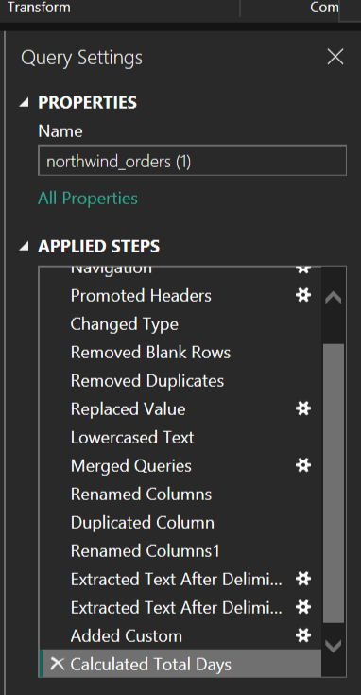

Northwind Orders

- Source: Loads the original data from the source file.
- Changed Type: Changes the type of data for each column to reflect its correct type.

- Removed Blank Rows: Any rows containing blank data are removed to clean up the dataset.
- Removed Duplicates: Duplicates in the dataset are removed.
- Replaced Value: Values in specific columns are replaced with new ones, possibly for standardization. (blank cells to not known)
- Lowercased Text: Converts all text data to lowercase for uniformity. (Customer ID)
- Removed Errors: Any rows with errors are filtered out.
- Cleaned Text: Performs further text cleansing (e.g., removing special characters).
- Filtered Rows: Filters the rows based on certain criteria, such as non-null postal codes

Question Asked

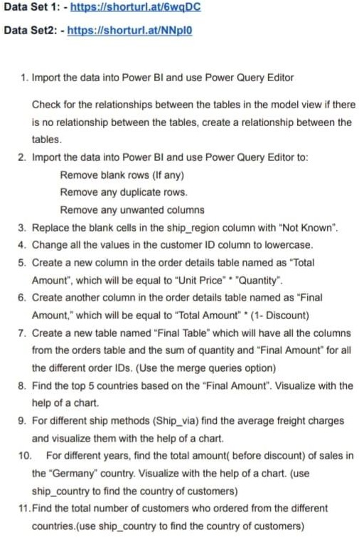

STEP 3- Visualizations

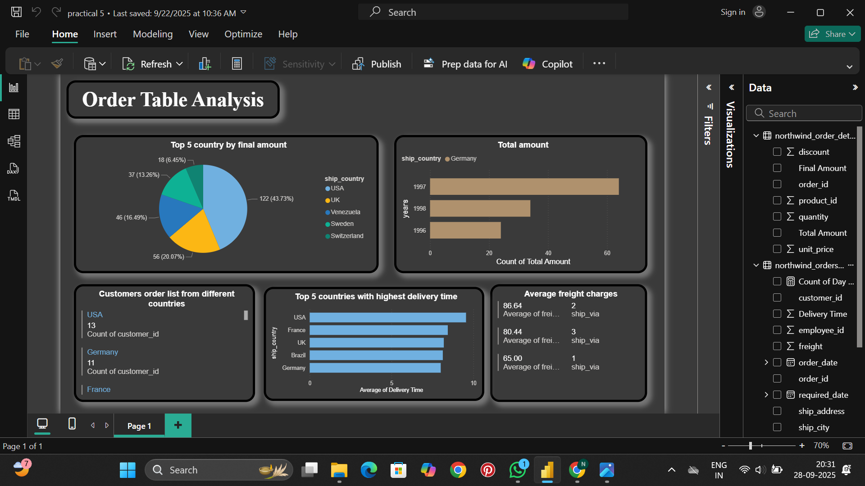

​Multi-row card: Count of Customers by Country

  - Purpose: This chart displays the number of customers in each country, sorted in descending order.

  - Details:

    - Countries such as Germany and USA have the highest number of customers, with Germany having the largest bar (over 120).
    - Other countries such as Brazil, France, UK, and Venezuela also have significant numbers of customers, but not as many as Germany and the USA.
    - The chart helps in understanding the geographical distribution of customers, which is useful for identifying the market share in each region.

​Pie Chart: Top 5 Countries by Final Amount
  - Purpose: This chart ranks the top 5 countries based on their total final amount (likely sales or total revenue).
  - Details:
- Mexico leads with the highest final amount, followed by Finland, Spain, Switzerland, and Norway.

- The chart shows how much each country contributed to the overall revenue or sales, with the values shown as a percentage of the total.
- The percentage labels (like 22.2%) show the proportion of the total for each country, highlighting Mexico's dominance in this dataset.

​Bar Chart: Total Amount for Germany in Different Years

  - Purpose: This chart illustrates the total amount (likely sales or revenue) for Germany across three years:
1996, 1997, and 1998.
  - Details:
    - In 1996, the total amount is low compared to the following years, with a small bar on the left.
    - 1997 shows a significant spike in the total amount, represented by a much larger bar, indicating a peak in sales or revenue during that year.
    - 1998 sees a drop in the total amount compared to 1997, but it is still above 1996.
    - This chart is useful to analyze trends in sales or order amounts in Germany over time and to identify any sudden increases or declines in a specific year.

Multi-row card: Average Freight Charges

  - Purpose: This chart compares the average freight charges (likely shipping costs) across different freight categories.
  - Details:
    - There are three categories in this chart, represented by the three rows: 1, 2, and 3 (likely indicating different freight charge categories).
    - The rows indicate the average freight charge for each category. Category 3 has the highest average freight charges, followed by category 2 and category 1, which is the lowest.
    - This chart helps to visualize the distribution of freight charges and how they vary between categories. It could be used to analyze the efficiency or cost-effectiveness of different shipping methods.

- Bar Chart: Top 5 Countries with Highest delivery time

- Purpose: This chart shows top 5 Countries with highest delivery time.
- Details:
- There are 5 bars representing Countries with highest delivery time.
- The rows indicate the average delivery time of top 5 Countries. USA has the highest average delivery time, followed by France, UK, Brazil and Germany which is the lowest among these 5 Countries.

Insights at a glimpse

The visualizations in this image provide insights into the geographical distribution of customers, the final amount (likely sales or revenue) in various countries, historical data on sales amounts for Germany, and the distribution of

average freight charges. These charts are essential for business analytics, helping organizations understand customer demographics, sales performance, and shipping costs, which are key factors for decision-making and strategy.

