PRACTICAL-1
Learning outcome - In this practical, we learned how to import and clean restaurant data in Power BI. We explored different columns such as restaurant name, address, locality, city, cuisine, rating, and votes to understand restaurant performance and customer preferences. Using visualizations, we analysed rating distributions, cost patterns, cuisine popularity, and voting trends. This helped us gain practical skills in data analysis, dashboard creation, and deriving insights for better business decision-making in the food service industry.
Required Tool - Power BI Desktop, Power Query Editor.
Working - We imported the restaurants dataset into Power BI and checked the data types of each column. Then, we cleaned and transformed the data by removing duplicates, blank rows, and handling errors. Next, we created visualizations such as average ratings, highest-rated restaurants, cost analysis, cuisine distribution, and correlation between ratings and votes. Finally, we analysed the insights to understand restaurant performance and customer behaviour patterns.
DATASET OVERVIEW
We had a dataset named "restaurants" having following columns
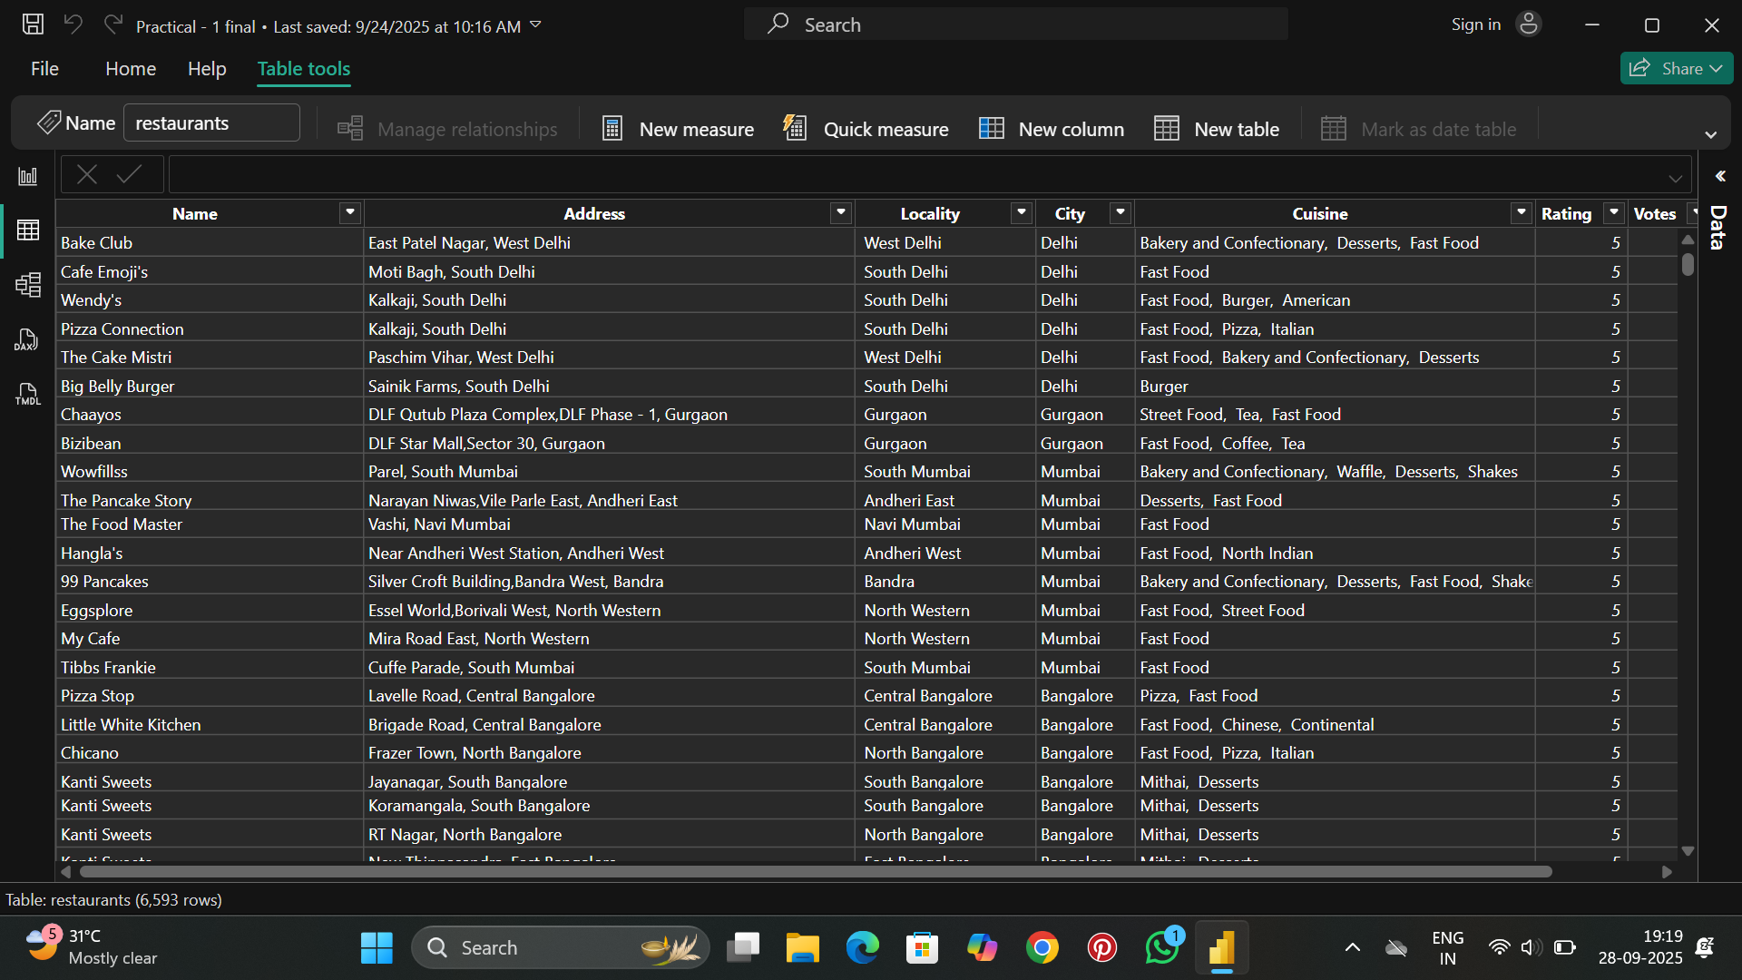

- Name - Restaurant name
- Address - Full address of the restaurant
- Locality - Specific locality/area
- City - City where restaurant is located
- Cuisine - Type of cuisine offered
- Rating - Customer rating (out of 5.00)
- Votes - Number of customer votes received
The dataset contains 6,593 rows of restaurant data across multiple cities in India.
STEP 1 - Importing Dataset into Power BI desktop
- Open Power BI Desktop
- Click on "Get Data" from the Home ribbon
- Select "Excel" as the data source
- Browse and select the "restaurants.xlsx" file
- In the Navigator window, select the "restaurants" table
- Click "Load" to import the data into Power BI
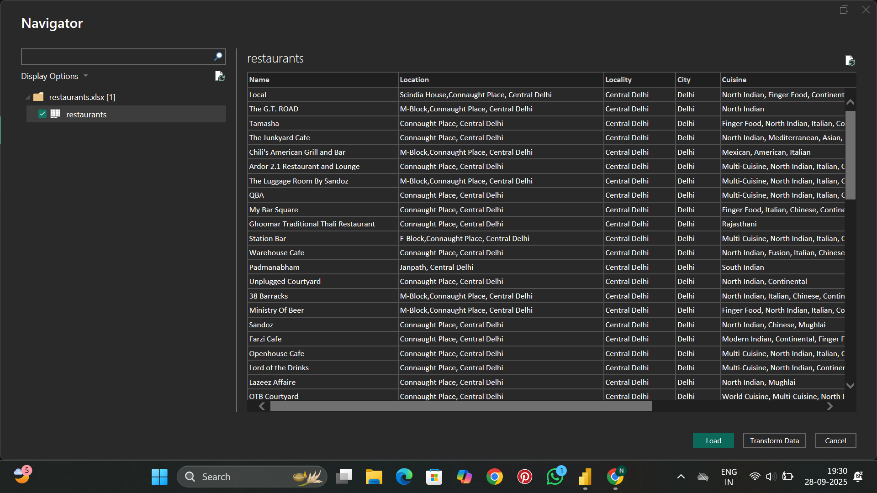
STEP 2 - Cleaning Data and Transformation in Power Query Editor
Open Power Query Editor to perform data cleaning and transformation like removing blank rows, duplicates, adding custom columns, etc.
APPLIED STEPS
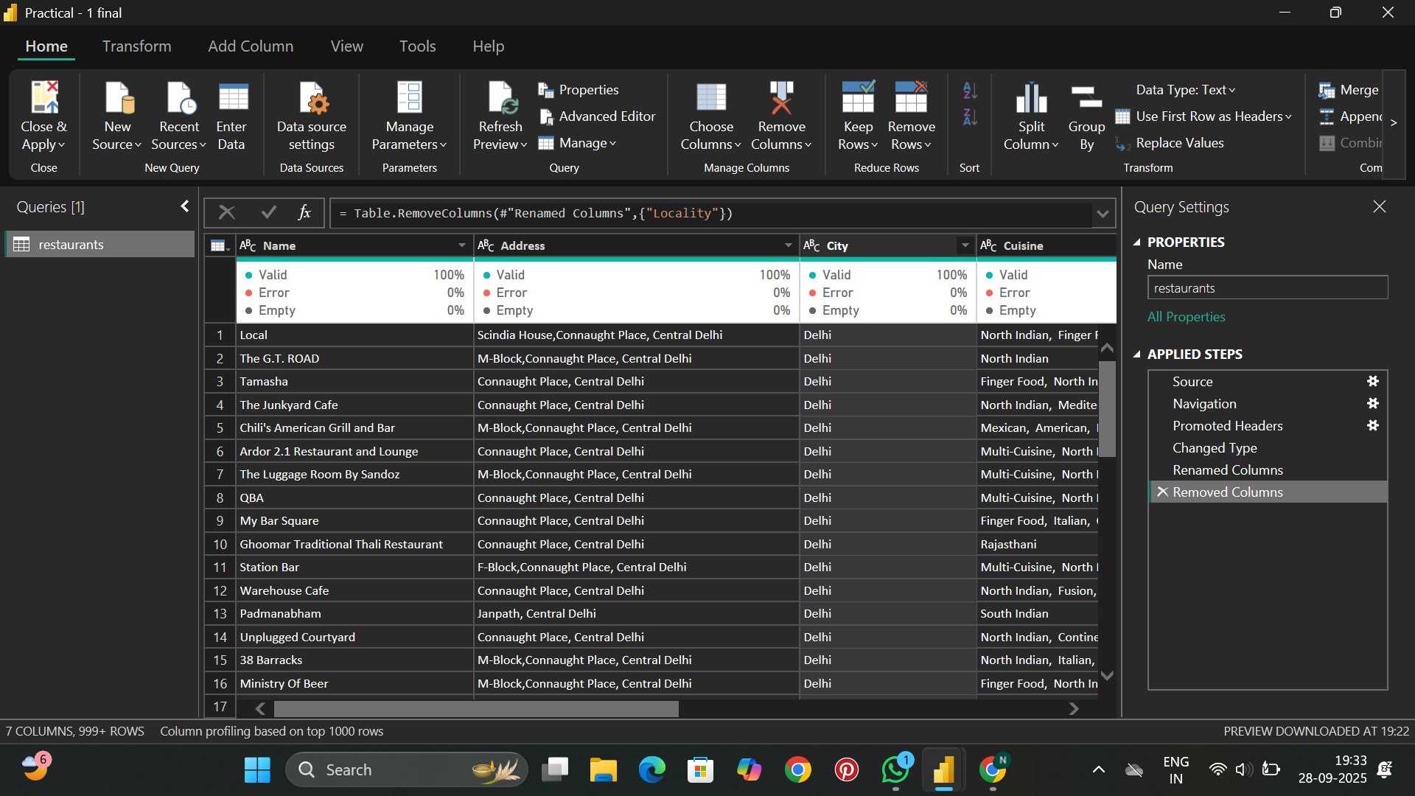
- Source - Loaded the dataset into Power Query from the Excel file.
- Navigation - Selected the "restaurants" table from the workbook.
- Promoted Headers - First row was used as column headers.
- Changed Type - Adjusted data types (e.g., text for Name/Address/City, decimal for Rating, whole number for Votes) for accuracy.
- Removed Columns - Deleted the "Locality" column as it was redundant after analysis requirements.
- Renamed Columns - Renamed columns with meaningful names for better clarity.

STEP 3 - Creating Dashboard
The dashboard was created with multiple pages containing various visualizations to analyze the restaurant data comprehensively.
Question Asked
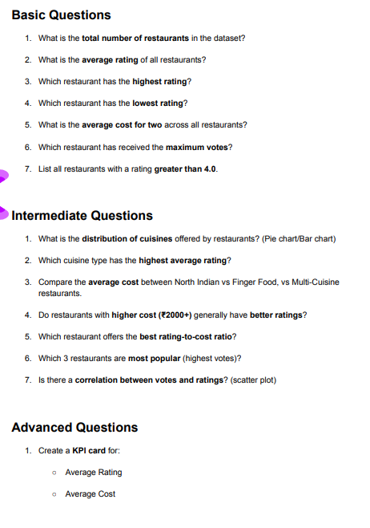
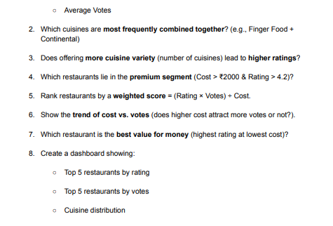
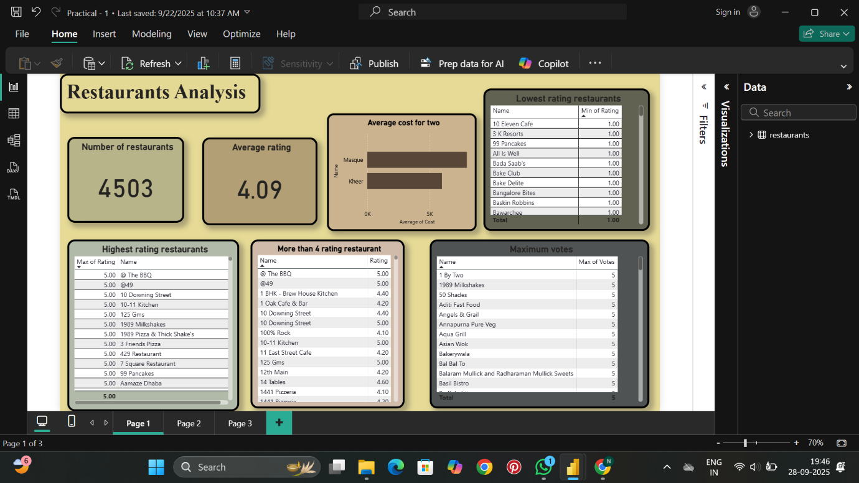
Page 1: Restaurants Analysis
- Card Visual - Number of restaurants
  - This card displays the total count of restaurants in the dataset: 4,503 restaurants.
  - It provides an overview of the dataset size and helps understand the scale of data being analyzed.
- Card Visual - Average rating
  - This card shows the average rating across all restaurants: 4.09 out of 5.00.
  - It indicates overall customer satisfaction and quality standards in the restaurant industry.
  - A rating above 4.0 suggests generally positive customer experiences.
- Bar Chart - Average cost for two
  - This horizontal bar chart displays the average cost for two people across different cuisine types.
  - The chart shows cuisine categories like Masque, Kheer, and OK with their respective average costs.
  - This visualization helps identify which cuisines are more premium or budget-friendly.
- Table Visual - Lowest rating restaurants
  - This table lists restaurants with minimum ratings of 1.00.
  - It includes restaurant names like "10 Eleven Cafe", "3 K Resorts", "99 Pancakes", "All Is Well", "Bada Saab's", "Bake Club", etc.
  - This helps identify underperforming restaurants that may need quality improvements.
- Table Visual - Highest rating restaurants
  - This table shows restaurants with maximum ratings of 5.00.
  - It includes top-rated establishments like "The BBQ", "@49", "10 Downing Street", "10-11 Kitchen", "12S Gms", "1989 Milkshakes", etc.
  - This identifies excellence in the industry and potential benchmarks for quality.
- Table Visual - More than 4 rating restaurant
  - This table lists restaurants with ratings above 4.00, showing Name and Rating columns.
  - It includes establishments like "The BBQ (5.00)", "@49 (5.00)", "1 BHK - Brew House Kitchen (4.40)", "1 Oak Cafe & Bar (4.20)", etc.
  - This helps focus on consistently high-performing restaurants.
- Table Visual - Maximum votes
  - This table displays restaurants with the highest number of customer votes (all showing 5 votes).
  - It includes restaurants like "1 By Two", "1989 Milkshakes", "50 Shades Of Brunches", "Aditi Fast Food", etc.
  - High vote counts indicate popular restaurants with strong customer engagement.

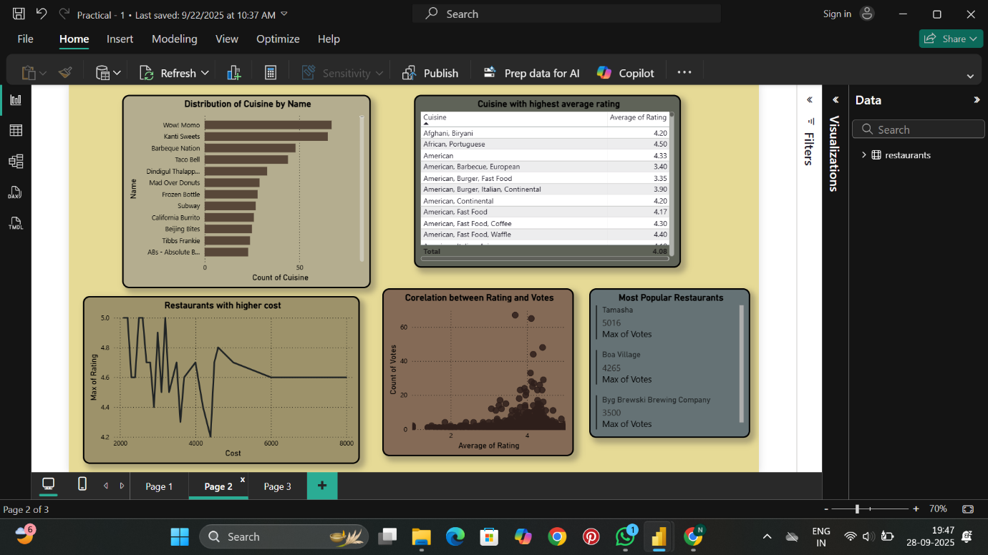
Page 2: Cuisine and Correlation Analysis
- Bar Chart - Distribution of Cuisine by Name
  - This horizontal bar chart shows count of cuisine types distributed by restaurant names.
  - It displays restaurants like "Wow! Momo", "Kanti Sweets", "Barbeque Nation", "Taco Bell", etc.
  - The visualization helps understand which restaurants offer diverse cuisine options.
- Table Visual - Cuisine with highest average rating
  - This table lists cuisine types ranked by their average ratings.
  - Top cuisines include "Afghani, Biryani (4.20)", "African, Portuguese (4.50)", "American (4.50)", "American, Barbecue, European (3.40)", etc.
  - This helps identify which cuisines receive better customer ratings overall.
- Line Chart - Restaurants with higher cost
  - This line chart displays the relationship between cost and rating for restaurants.
  - The x-axis shows cost values ranging from 2000 to 8000, while y-axis shows ratings from 4.2 to 5.0.
  - The trend shows fluctuating patterns, indicating that higher cost doesn't always guarantee higher ratings.
- Scatter Plot - Correlation between Rating and Votes
  - This scatter plot visualizes the relationship between average rating (x-axis) and count of votes (y-axis).
  - Most data points cluster between ratings of 3.0-5.0 with votes ranging from 0-60.
  - The visualization helps identify whether highly-rated restaurants receive more customer engagement.
- Card Visual - Most Popular Restaurants
  - This card displays information about the most popular restaurants based on maximum votes.
  - It shows "Tamasha" with 5016 votes, "Boa Village" with 4265 votes, and "Byg Brewski Brewing Company" with 3500 votes.
  - These are the restaurants with highest customer engagement and visibility.
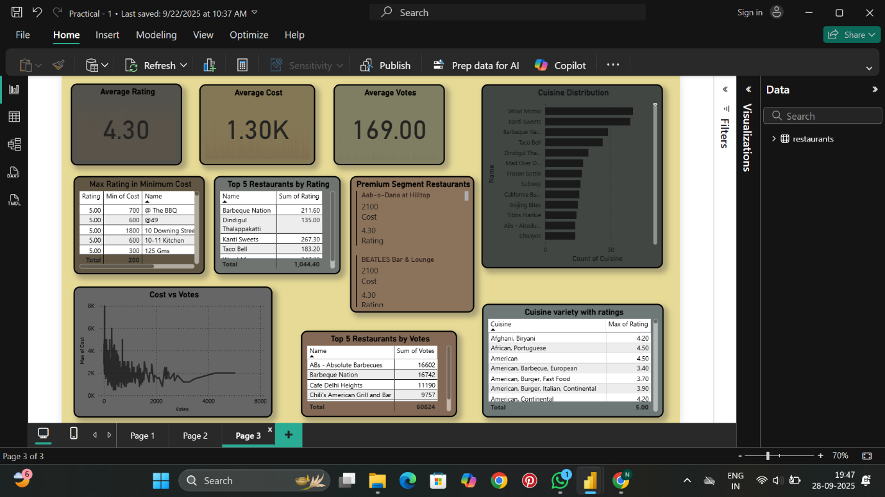
Page 3: Summary Statistics and Insights
- Card Visual - Average Rating
  - Displays 4.30 as the overall average rating across all restaurants.
  - Slightly higher than Page 1 due to filtered dataset or specific segment analysis.
- Card Visual - Average Cost
  - Shows 1.30K as the average cost for two people.
  - This provides a benchmark for pricing in the restaurant industry.
- Card Visual - Average Votes
  - Displays 169.00 as the average number of votes per restaurant.
  - Indicates typical customer engagement levels.
- Bar Chart - Cuisine Distribution
  - Horizontal bar chart showing count of different cuisine types.
  - Displays cuisines like "Wow! Momo", "Kanti Sweets", "Barbeque Nation", "Taco Bell", etc.
  - Helps understand cuisine diversity and popularity in the dataset.
- Table Visual - Max Rating in Minimum Cost
  - Lists restaurants offering best ratings at lowest costs.
  - Shows columns: Rating, Min of Cost, and Name.
  - All entries show 5.00 rating with costs ranging from 200-1800.
  - Includes restaurants like "@ The BBQ (700)", "@49 (600)", "10 Downing Street (1800)", "10-11 Kitchen (600)", "12S Gms (300)".
  - This identifies best value-for-money restaurants.
- Table Visual - Top 5 Restaurants by Rating
  - Displays top restaurants based on sum of ratings.
  - Shows "Barbeque Nation (211.60)", "Dindgul Thalappakatti (135.00)", "Kanti Sweets (267.30)", "Taco Bell (183.20)", "Wow Momo (182.30)".
  - Total sum: 1,044.40.
- Table Visual - Premium Segment Restaurants
  - Lists high-end restaurants with premium pricing.
  - Shows "Aab-o-Dana at Hilltop (2100 Cost, 4.30 Rating)" and "BEATLES Bar & Lounge (2100 Cost, 4.30 Rating)".
  - Identifies luxury dining options in the market.
- Area Chart - Cost vs Votes
  - Displays the relationship between maximum cost and votes.
  - X-axis shows votes (0-6K range), y-axis shows cost values.
  - The visualization shows fluctuating patterns with peaks around certain vote ranges.
- Table Visual - Top 5 Restaurants by Votes
  - Lists most popular restaurants by customer engagement.
  - Shows "ABs - Absolute Barbecues (16602)", "Barbeque Nation (16742)", "Cafe Delhi Heights (11190)", "Chili's American Grill and Bar (9757)".
  - Total votes: 60834.
- Table Visual - Cuisine variety with ratings
  - Displays different cuisine types with their maximum ratings.
  - Includes "Afghani, Biryani (4.20)", "African, Portuguese (4.50)", "American (4.50)", "American, Barbecue, European (3.40)", "American, Burger, Fast Food (3.70)", "American, Burger, Italian, Continental (3.90)", "American, Continental (4.20)".
  - Total max rating sum: 5.00.
Key Insights
- Overall Performance: The average rating of 4.09-4.30 indicates generally good customer satisfaction across restaurants.
- Cost Analysis: Average cost for two is approximately ₹1,300, with significant variation across cuisine types.
- Rating Distribution: Multiple restaurants achieve perfect 5.00 ratings, while some struggle with 1.00 ratings, showing quality variance.
- Cuisine Popularity: Certain cuisine types like American, African-Portuguese, and Afghani-Biryani combinations receive higher ratings.
- Engagement Patterns: Popular restaurants like Tamasha, Barbeque Nation, and ABs - Absolute Barbecues show significantly higher vote counts, indicating strong customer base.
- Value Proposition: Several restaurants offer excellent ratings (5.00) at moderate costs (₹200-800), representing good value for customers.
- Premium Segment: High-cost restaurants (₹2,100+) maintain good ratings (4.30), justifying their premium positioning.
- Cost-Rating Correlation: The analysis shows that higher cost doesn't automatically translate to higher ratings, suggesting quality depends on multiple factors beyond pricing.
Conclusion
This practical provided hands-on experience in data analysis using Power BI. We successfully imported, cleaned, and visualized restaurant data to derive meaningful business insights. The dashboard helps understand market dynamics, customer preferences, pricing strategies, and performance benchmarks in the restaurant industry. These skills are essential for data-driven decision-making in business analytics.

