PRACTICAL- 2
Learning outcome- In this practical, we learned how to import and clean supermarket sales data in Power BI. We explored different columns such as product line, customer type, payment method, and sales amount to understand customer behavior and business performance. Using visualizations, we analyzed sales trends, profit margins, and branch performance. This helped us gain practical skills in data analysis, dashboard creation, and deriving insights for better decision-making.
Required Tool- Power BI Desktop, Power Query Editor.
Working- We imported the supermarket sales dataset into Power BI and checked the data types of each column. Then, we cleaned and transformed the data by removing duplicates and adding calculated fields. Next, we created visualizations such as sales by branch, product line, and payment method. Finally, we analyzed the insights to understand customer behavior and business performance.

DATASET OVERVIEW
We had a dataset named “supermarket sales data” having following columns.
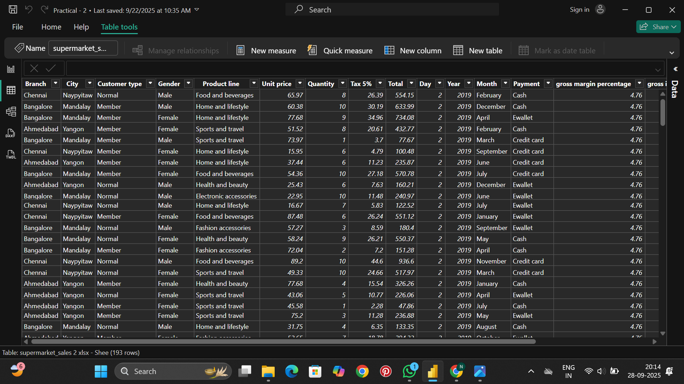
STEP 1- Importing Dataset into Power BI desktop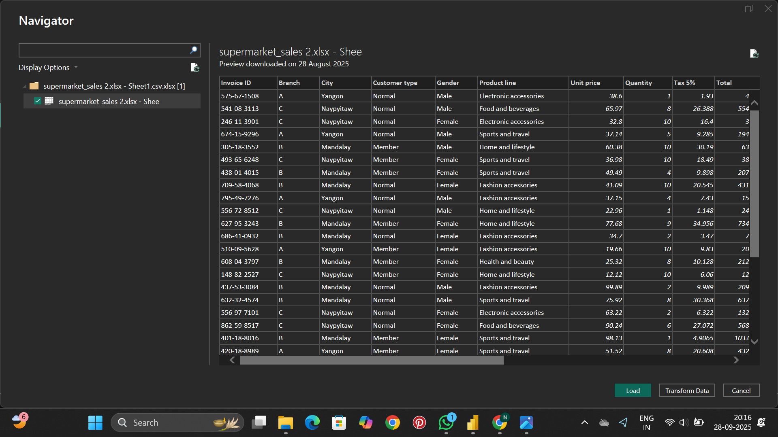
STEP 2- Cleaning Data and Transformation in Power Query Editor
Open Power Query Editor to perform data cleaning and transformation like removing blank rows, duplicated, adding custom column, etc.
APPLIED STEPS
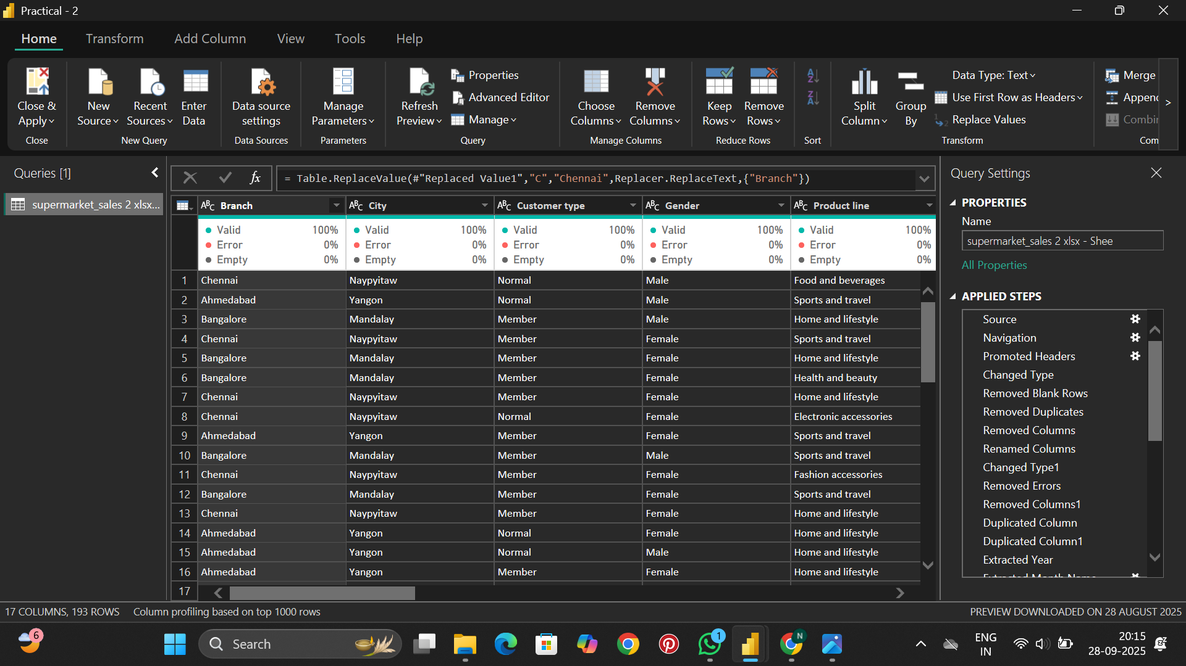

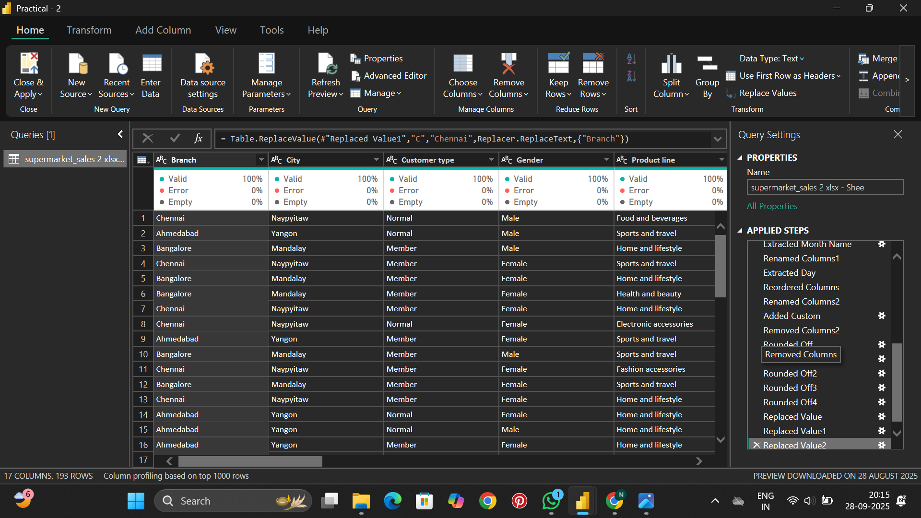

- Source – Loaded the dataset into Power Query from the Excel file.
- Promoted Headers – First row was used as column headers.
- Changed Type – Adjusted data types (e.g., text, number, date) for accuracy.
- Removed Blank Rows – Deleted empty rows from the dataset.
- Removed Duplicates – Removed duplicate records to ensure data quality.
- Removed Errors – Removed rows containing invalid or error values.
- Removed Columns – Deleted unwanted/extra columns.
- Renamed Columns – Renamed columns with meaningful names.
- Duplicated Column – Created a copy of an existing column for transformations.
- Extracted Year/Month/Day Name – Extracted parts of the date column (Year, Month, Day).
- Added Custom – Inserted a custom calculated column.
- Rounded Off – Rounded all decimal numeric values to required decimal places.
- Replaced Values – Replaced specific values (e.g., text/numbers) in a column.
- Changed Type2 – Final data type adjustments after transformations.

STEP 3- Creating Dashboard
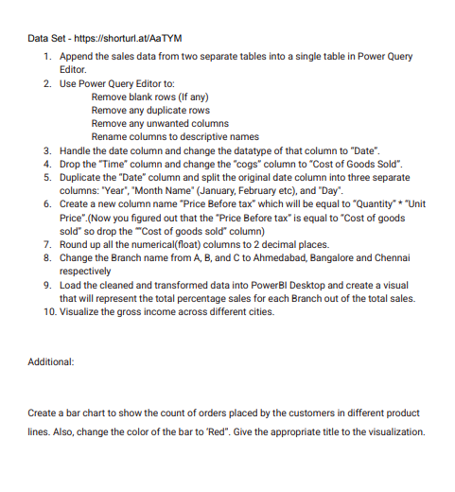
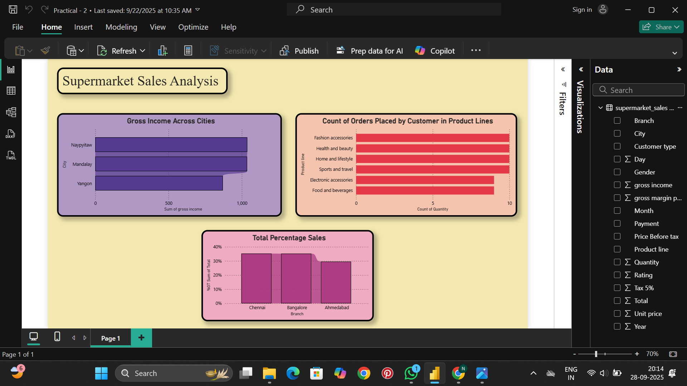

- Column Chart – %GT Count of Price Before Tax by Branch
  - This chart represents the percentage share of total sales before tax across the three supermarket branches: Bangalore, Ahmedabad, and Chennai.
  - The visualization highlights that Bangalore contributes the highest share (35.12%), followed closely by Ahmedabad (34.17%), while Chennai accounts for 30.71%.
  - It provides a clear comparison of how different branches are performing in terms of pre-tax revenue contribution.
- Bar Chart – Sum of Gross Income by City
  - This chart shows the gross income earned across three cities: Mandalay, Naypyitaw, and Yangon.
  - From the trend line, it is evident that Mandalay generates the highest gross income, while Yangon records the lowest.
  - The visualization is useful to identify which city markets are more profitable and where business expansion or improvement strategies might be required.
- Bar Chart – Count of Quantity by Product Line
  - This bar chart displays the distribution of quantities sold across six different product lines: Fashion accessories, Food and beverages, electronic accessories, Sports and travel, Home and lifestyle, and Health and beauty.
  - Fashion accessories lead with 98 units sold, followed by Food and beverages (90 units), while Health and beauty have the lowest sales (76 units).
  - This analysis highlights which product categories are most in demand, helping businesses focus on customer preferences and manage inventory effectively.

