[The Endeavour - Space Shuttle sts 49 mission, 1992] – Mission requirement and motor details

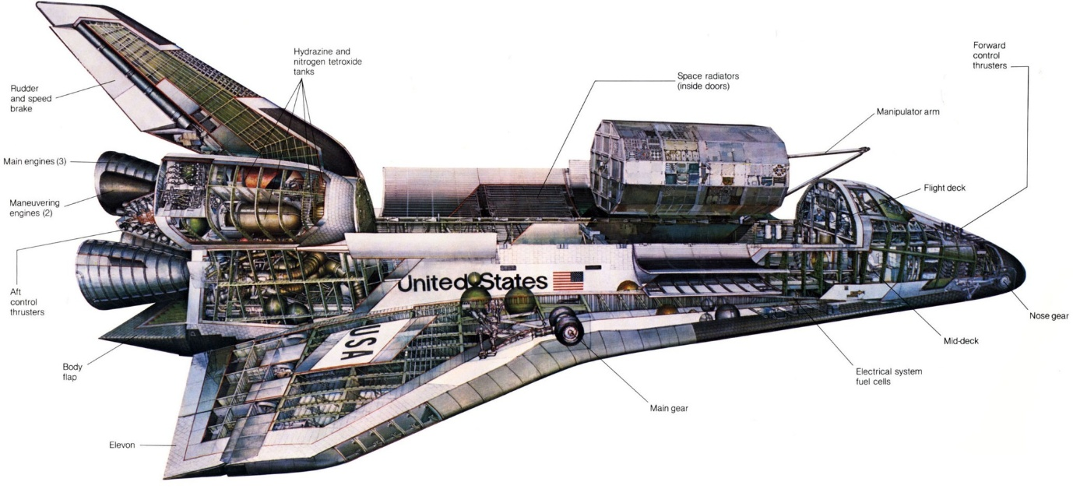

Mission requirements:
The mission involved attaching a live rocket motor to a satellite [the Intelsat VI] to boost it into its intended geosynchronous orbit. [It had failed to leave its low earth orbit].
Lift off: For the shuttle to reach its intended orbit it needed two solid rocket boosters and a liquid oxygen tank (which lasted longer than the srbs) for its main engines
Maneuvering once in space: For a project that demanded one of the first EVAs and rendezvous with a satellite, having control over the flight path was important. The engines are gimballed for easy maneuverability and scattered all over the Orbiter were smaller rocket nozzles. sometimes even finer control was needed for delicate docking procedures and for this the Orbiter had six smaller vernier thrusters capable of producing as little as 111 Newtons of thrust.
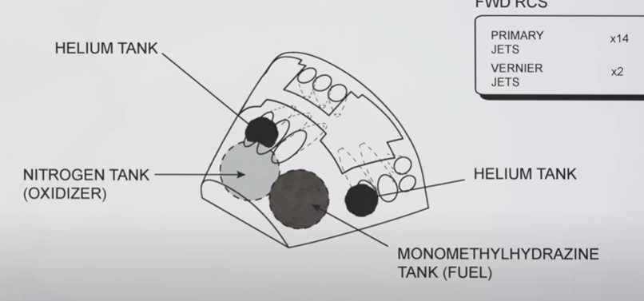[The smaller thrusters used a combination of two elements that would spontaneously combust on meeting each other without the need of an oxidiser]

The SRB:
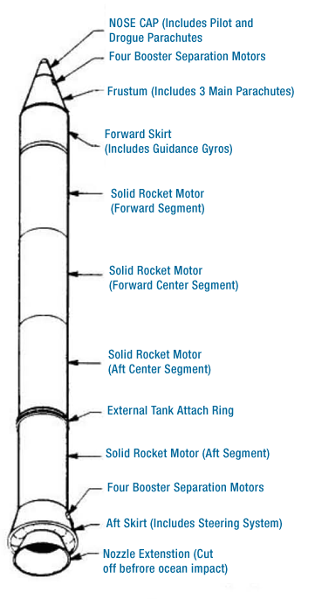
Thrust curve:
The upper section of the solid rocket booster had an 11 pointed star shape. This shape then transitioned into a circular section, however it wasn’t constant in diameter. The diameter increased toward the nozzle. This design provided elevated thrust at ignition, when it was needed most, and then reduced gradually to lower the maximum dynamic pressure the space shuttle experienced, with the thrust decreasing by 33% 50 seconds into flight.
(Below are pictures that show how star shaped SRB orifices provide greater thrust compared to circular ones due to greater surface area and then decreases as opposed to a circular one):
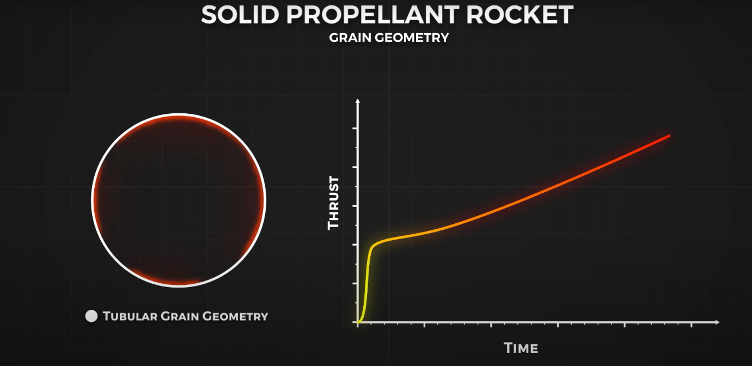

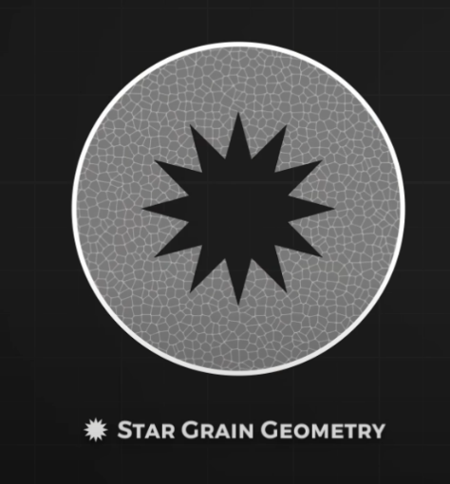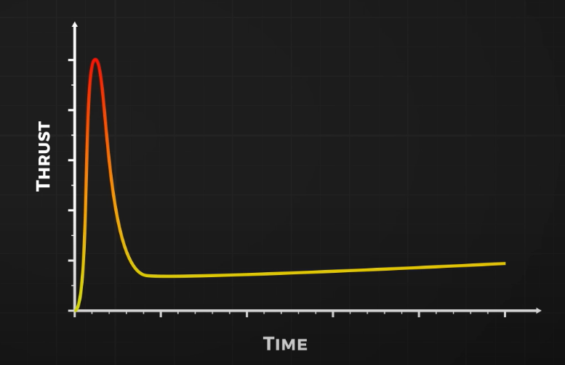

Credits: https://www.youtube.com/@RealEngineering
https://nssdc.gsfc.nasa.gov/nmc/spacecraft/display.action?id=1992-026A
https://www.nasa.gov/reference/the-space-shuttle/
https://historycollection.jsc.nasa.gov/JSCHistoryPortal/history/shuttle_pk/pk/Flight_ 047_STS-049_Press_Kit.pdf

