**SugarSins Database**

***What***: Creating a database for SugarSins to digitally start recording and storing details of customers, orders, products, inventory and transactions.

***Why***: Gather data to recognize patterns and carry out analysis that helps in business growth and expansion through SugarSins digital dashboard.

* ***Tables:***

*Master tables –*Customer, Customer Event, Menu

*Order –* Order Line, Order Header (Bills)

* ***Transactions***

*Customer Order*

*Customer Order Confirmation*

*Customer Order Entry*

*Customer Order Picture*

*Customer Order Billing*

*Customer Order Collection*

*Customer Campaigns*

*Customer Event Reminders*

**Tables**

|  |  |
| --- | --- |
| **Table name** | **Purpose** |
| *Customer_Master* | Master table capturing all customer details. |
| *Customer_Event_Master* | Master table of all possible occasions that customers place an order for. This table will capture the dates of the different occasions for customers as and when they order. |
| *Menu* | Product catalogue including their price. |
| *Order_Head* | Details of a bill head- delivery date and time, address, total bill amount, etc. |
| *Order_Line* | Details of the products bought, customization and their individual price. |
| *Order_For* | Capturing the relationship between a customer who orders products to be delivered for someone else. |

1. **Master Tables**
2. **Customer_Master**

|  |  |  |  |  |  |  |  |  |  |
| --- | --- | --- | --- | --- | --- | --- | --- | --- | --- |
| **Customer_ID** | *Name* | *Phone1* | *Phone2* | *Email_ID* | *Gender* | *City* | *Address* | *Address_Identifier* | Cutomer*_*Type |

* [Customer_ID = Name+Phone]
* Customer_ID – Should be auto generated from the application *(Non null)*
* Name – Full name *(Non null)*
* Phone1 – *(Non null)*
* Phone2
* Email_ID
* Gender - *(Non null)*
* City – The city where the customer who is placing an order resides.
* Address – If Customer type is IO and the customer city is not Mumbai, full address is not required. Adding a city for future reference is optional. If Customer type is SO, full address and address identifier is required. If Customer type is IS, full address and address identifier is required.
* Address_Identifier - <different areas in Mumbai, eg. Suncity, Vikhroli>
* Customer_Type –
* IO: Invoice only – A non-Mumbai/ Mumbai resident places an order to be delivered to someone in Mumbai (Address of person placing the order is not same as where the order is to be delivered)
* SO: Shipping Only – A Mumbai resident for whom an order was placed but order was not placed by him/her.
* IS: Invoice + Shipping – Address of person placing the order is same as delivery address.
* Reference_By – The IO customer (only non-Mumbai customers) who placed an order for this SO customer.

1. **Customer_Event_Master**

|  |  |  |  |  |  |
| --- | --- | --- | --- | --- | --- |
| **Customer_ID** | ***Event*** | ***Relation*** | *Event_Daymonth* | *Event_Year* | *Event_Type* |

* Customer_ID – Foreign Key to be picked up from Customer_Master.
* Event – Can be any of the following:
  + Birthday
  + Anniversary
  + Retirement
  + Baby Shower
  + 6-month birthday
  + Inauguration
  + NA
* Relation – The person in relation to the customer ordering. For example:
* Self
* Daughter
* Friend
* Fiancé
* Mother in law
* Boyfriend
* Event_Day – The day of event.
* Event_Month – The month of event.
* Event_Year – Year of event. Year of occurrence for non-recurring event. Year of first occurrence for recurring event.
* Event_Type – Can be any of the following:
* R - Recurring
* OT - Non-recurring

1. **Menu**

|  |  |  |  |  |  |
| --- | --- | --- | --- | --- | --- |
| **Product_ID** | *Category* | *Name* | *Quantity* | *Unit_of_measure* | *Rate* |

* [Product_ID = Category+Name+Quantity+UOM]
* Product_ID – Should be auto-generated based on category, name, Quantity.
* Category – Category of product. Can be any of the following:
* Celebration Cake
* Everything chocolate
* Name – Name of the product belonging to a category.
* Quantity – Can be any of the following:
* 1
* 1/2
* Unit_of_measure – Can be any of the following:
* Kg
* Pieces
* Rate – Price of dpecified quantity of product.

1. **Orders**
2. **Order_Head**

|  |  |  |  |  |  |  |
| --- | --- | --- | --- | --- | --- | --- |
| **Order_ID** | Delivered_To | Ordered_By | Total_Bill | *Delivery_Charge* | *Delivery_Date* | *Delivery_Time* |

|  |  |  |  |  |  |  |
| --- | --- | --- | --- | --- | --- | --- |
| *Delivery_Address* | *Address_Identifier* | *Payment_Method* | *Event* | *Relation* | *Source* | *Paid* |

* [Order_ID = Delivered_To+Delivery_Date+Address_Identifier]
* Order_ID – Auto generated based on Customer delivered to, date and address identifier of delivery
* Delivered_To – Customer_ID of the customer to whom the order is being shipped.
* Ordered_By – Customer_ID of the customer to whom the invoice will be sent to.
* Total_Bill – Will be calculated based on Order_Line by mapping the Order_ID.
* Delivery_Charge – The amount to be charged above the product cost for delivery.
* Delivery_Date – Date of delivery.
* Delivery_Time – Time of delivery.
* Delivery_Address – Address to be delivered to.
* Address_Identifier – Identifier of the delivery address.
* Payment_Method – Can be any of the following:
* Cash



* Paytm
* GPay
* PhonePay
* Event – Occasion for ordering. Can be any of the following:
  + Birthday
  + Anniversary
  + Retirement
  + Baby Shower
  + 6-month birthday
  + Inauguration
* Relation – The person in relation to the customer ordering. For example:
* Self
* Daughter
* Friend
* Fiancé
* Mother in law
* Boyfriend
* Source – Indicates the POS from where the first-time customer placed the order. Can be any of the following:
* Zomato
* Swiggy
* Friend
* Google
* Paid – Boolean field indicating if payment has been done by customer or not.

1. **Order_Line**

|  |  |  |  |  |  |  |  |
| --- | --- | --- | --- | --- | --- | --- | --- |
| **Order_ID** | **Product_ID** | *Quantity* | Rate | *Design_Description* | *Design_Charge* | *Fondant_Description* | *Fondant_Charge* |

* Order_ID – Auto-generated per bill.
* Product_ID – Referenced from the Menu.
* Quantity – The qty of the product_ID ordered.
* Rate – Rate as per quantity (picked up from the Menu)
* Design_Description – Text field indicating the customizations ordered for the specific product.
* Design_Charge- Price to be charged only for designing, if any.
* Fondant_Description – Text field indicating the fondant figures to be added onto the product.
* Fondant_Charge – Price to be charged only for the fondant figures, if any.

1. **Order_For**

|  |  |  |
| --- | --- | --- |
| Invoice_Customer | Shipping_Customer | Order_ID |

* Invoice_Customer – Customer_ID of the person who just places the order (IO type only).
* Shipping_Customer – Customer_ID of the person for whom the IO type customer ordered a product.
* Order_ID – Order ID of the order corresponding to the specific IO and Shipping customer.

order_master

Order_ID Ordered_By Delivered_To Delivery_Address Address_Identifier Delivery_Date Delivery_Time

PK

**order**_**finance**

Order_ID Product_charge Total_design_charge Total_fondant_charge Delivery_Charge Total_Bill Payment_Method paid

PK, FK

**order_event**

Order_ID Event Event_date Relation event_start_year

**order_line**

Order_ID Product_ID Quantity Design_Description Design_Charge Fondant_Description Fondant_Charge

**order_for**

Invoice_Customer Shipping_Customer Order_ID

**Order of execution**

Customer_Master



Order_For

Customer_Event_Master

Order_Line

Order_Head

Customer Form:

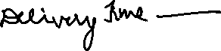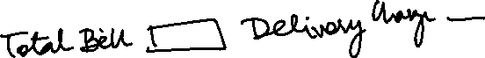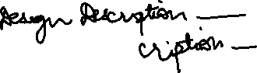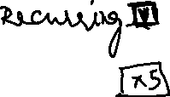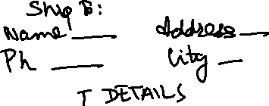

Payment Form

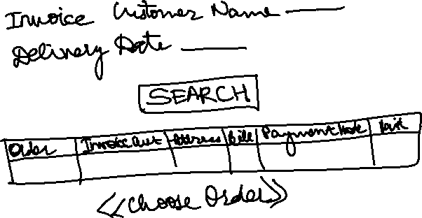

Use cases:

1. A person from Pune (X) places an order for a friend (Y) staying in Mumbai for Y’s Birthday on 5th June.

|  |  |  |  |  |  |  |  |  |  |
| --- | --- | --- | --- | --- | --- | --- | --- | --- | --- |
| **Customer_ID** | **Name** | **Phone1** | **Phone2** | **Email_ID** | **Gender** | **City** | **Address** | **Address_Identifier** | **Cutomer_Type** |
| C0001 | X | 1234567890 |  | [x@gmail.com](mailto:x@gmail.com) | M | Pune | NA | NA | IO |
| C0002 | Y | 9876543210 |  | [y@gmail.com](mailto:y@gmail.com) | F | Mumbai | 305, Glen Dale, High st, Hiranandani, Powai | Glen Dale, Hiranandani | SO |

|  |  |  |  |  |  |  |
| --- | --- | --- | --- | --- | --- | --- |
| Customer_ID | Event | Relation | Event_Day | Event_Month | Event_Year | Event_Type |
| C001 | Birthday | Friend | 5 | June |  | R |
| C002 | Birthday | Self | 5 | June |  | R |

Person Y now places an order for self/ someone else in Mumbai: Customer_Type for Y will change to IS.