1️⃣ Parent table: user_employees_master
-- Enable UUID generation CREATE EXTENSION IF NOT EXISTS "pgcrypto";
CREATE TABLE public.user_employees_master (
id uuid PRIMARY KEY DEFAULT gen_random_uuid(),
name text NOT NULL,
email text NOT NULL UNIQUE,
password text NOT NULL,
role text NOT NULL CHECK (role IN ('superadmin', 'admin', 'employee')),
created_at timestamp without time zone DEFAULT now(),
phone text,
address text,
mfa_secret text,
mfa_enabled boolean DEFAULT false,
is_email_verified boolean DEFAULT false,
profile_photo text,
employee_id text UNIQUE,
department text,
date_of_joining date,
dob date,
gender varchar,
resume text,
emergency_contact varchar,
rcre_id text, -- who modified the data(modifier id info)
rcre_date date, -- modified date
access_flag text NOT NULL CHECK (access_flag IN ('y', 'n'))
);

2️⃣ Child table: super_admins
Only contains superadmin-specific data, referencing user_employees_master:
CREATE TABLE public.super_admins (
id UUID PRIMARY KEY DEFAULT gen_random_uuid(),
user_id UUID NOT NULL REFERENCES public.user_employees_master(id) ON DELETE CASCADE,
name TEXT NOT NULL,
email TEXT NOT NULL UNIQUE,
password TEXT NOT NULL,
role TEXT NOT NULL DEFAULT 'superadmin'
CHECK (role = 'superadmin'),
created_at TIMESTAMP WITHOUT TIME ZONE DEFAULT now(),
updated_at TIMESTAMP WITHOUT TIME ZONE DEFAULT now()
);
⚠️ Notice: name/email/password/role are not duplicated here. They remain in the parent table.

3️⃣ Child table: registrations
For OTP, reset token, and temporary admin info:
CREATE TABLE public.registrations (
id UUID PRIMARY KEY DEFAULT gen_random_uuid(),
user_id UUID NOT NULL REFERENCES public.user_employees_master(id) ON DELETE CASCADE,
email_otp VARCHAR,
otp_code TEXT,
otp_expiry timestamptz,
reset_token TEXT,
reset_token_expiry timestamptz,
is_approved BOOLEAN DEFAULT false,
is_temp_admin BOOLEAN DEFAULT false,
temp_admin_expiry timestamptz
);

4️⃣ Relationship summary
Table | Relationship
user_employees_master | Parent table for all users
super_admins | user_id → user_employees_master.id (only superadmins)
registrations | user_id → user_employees_master.id (OTP and temp admin tracking)
✅ Key points:

- user_employees_master is the single source of truth for user info.
- super_admins only stores extra superadmin data, reducing duplication.
- registrations tracks temporary credentials/OTP.
- CASCADE ensures child rows are deleted automatically if the parent is deleted.

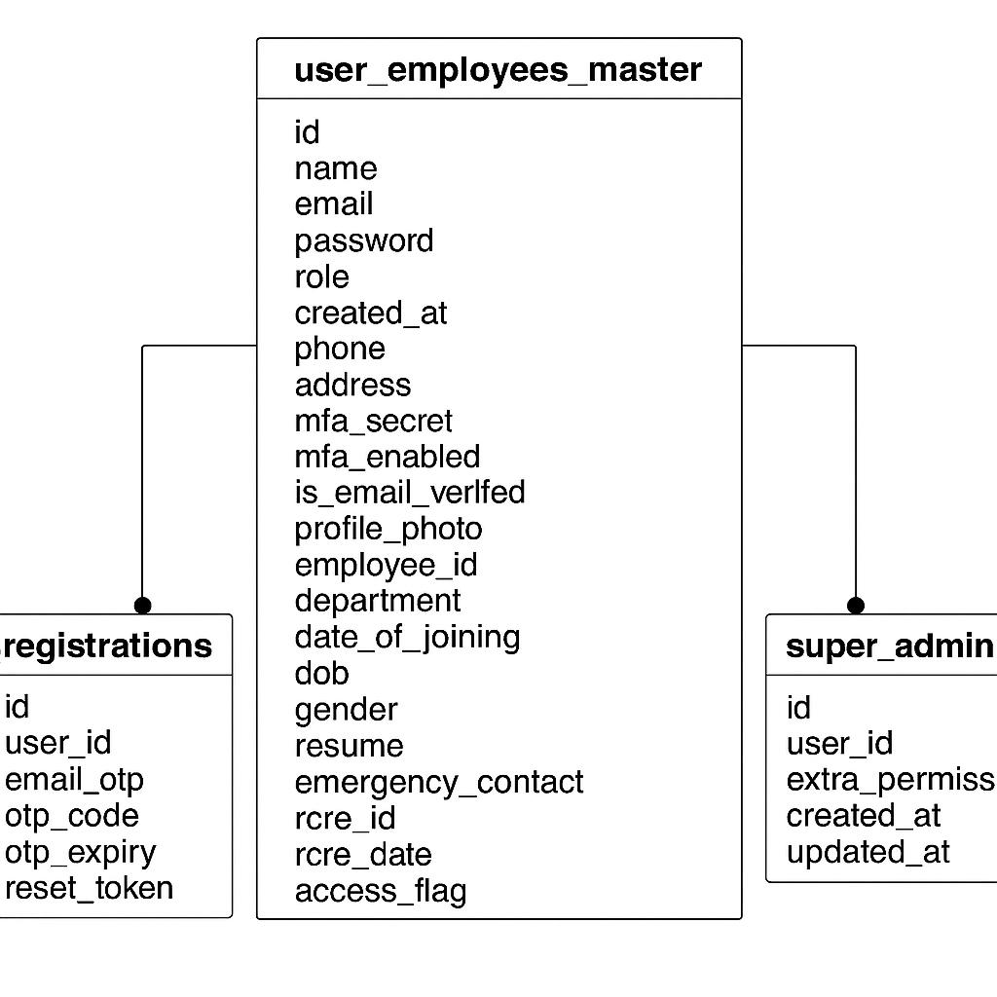
import bcrypt from "bcryptjs";
import jwt from "jsonwebtoken";
import supabase from "../supabaseClient.js";
import speakeasy from "speakeasy";
import qrcode from "qrcode";
import { UserModel } from "../models/user.model.js";
import { validateInput } from "../utils/validateInput.js";
import { SuperAdminModel } from "../models/superAdmin.model.js";

const USERS_TABLE = "user_employees_master";
const SUPERADMINS_TABLE = "super_admins";

// const USERS_TABLE = "users";

// Helper: issue JWT
function issueJwt({ email, role,id }) {
return jwt.sign({ email, role,id }, process.env.JWT_SECRET, { expiresIn: "1h" });
}

// ----------- Email check endpoint -----------
export const checkEmail = async (req, res) => {
try {
const { email } = req.body;
if (!email) return res.status(400).json({ error: "Email is required" });

const { data: user, error } = await supabase
.from(USERS_TABLE)
.select("*")
.ilike("email", email)
.eq("role", "superadmin")
.eq("access_flag", "y")
.maybeSingle();

if (error) throw error;

if (!user) return res.status(200).json({ authorized: false });

return res.status(200).json({ authorized: true, message: "Email authorized" });
} catch (err) {
console.error("CheckEmail Error:", err.message);
return res.status(500).json({ error: err.message });
}
};

// ----------- Registration endpoint -----------
export const superAdminRegister = async (req, res) => {
try {
const { fullName, email, password } = req.body;

if (!email) return res.status(400).json({ error: "Email is required" });

// Check if user exists in parent table
const { data: existingUser, error: fetchError } = await supabase
.from(USERS_TABLE)
.select("*")
.ilike("email", email)
.eq("role", "superadmin")
.eq("access_flag", "y")
.maybeSingle();

if (fetchError) throw fetchError;
if (!existingUser) {
return res.status(400).json({
error: "This email is not authorized as a SuperAdmin or access disabled.",
});
}

// Check if already registered (password exists)
if (existingUser.password && existingUser.password.trim() !== "") {
return res.status(400).json({
error: "SuperAdmin already registered with this email.",
});
}

// Validate input
const errors = validateInput(UserModel, { name: fullName, email, password });
if (Object.keys(errors).length > 0) return res.status(400).json({ errors });

// Hash password
const hashedPassword = await bcrypt.hash(password, 10);

// Generate MFA secret
const secret = speakeasy.generateSecret({
name: `EMS-${email}`,
issuer: "EMS SuperAdmin",
});

// Update parent table (user_employees_master)
const { data: updatedUser, error: updateError } = await supabase
.from(USERS_TABLE)
.update({
name: fullName,
password: hashedPassword,
mfa_secret: secret.base32,
mfa_enabled: false,
is_email_verified: false,
})
.eq("id", existingUser.id)
.select()
.single();

if (updateError) throw updateError;

// Insert into super_admins table
const { error: insertError } = await supabase
.from(SUPERADMINS_TABLE)
.insert({
user_id: updatedUser.id,
name: updatedUser.name,
email: updatedUser.email,
password: hashedPassword, // must fill for NOT NULL
role: "superadmin",
});

if (insertError) throw insertError;

// Generate MFA QR code
const qrCodeUrl = await qrcode.toDataURL(secret.otpauth_url);

return res.status(201).json({
message: "SuperAdmin registered successfully. Complete MFA setup.",
qrCodeUrl,
secret: secret.base32,
user: {
id: updatedUser.id,
email: updatedUser.email,
role: updatedUser.role,
},
});
} catch (err) {
console.error("SuperAdmin Register Error:", err.message);
return res.status(500).json({ error: err.message });
}
}

/**
* SuperAdmin Login (requires MFA if enabled)
* Body: { email, password, otp }
*/
export const superAdminLogin = async (req, res) => {
try {
const { email, password, otp } = req.body;
const role = "superadmin";

// Fetch user by email and role
const { data: user, error } = await supabase
.from(USERS_TABLE)
.select("*")
.ilike("email", email)
.eq("role", role)
.maybeSingle();

if (error) throw error;

// Check if user exists → Invalid Email
if (!user) {
return res.status(401).json({ error: "Invalid email" });
}

// Check password → Invalid Password
const isMatch = await bcrypt.compare(password, user.password);
if (!isMatch) {
return res.status(401).json({ error: "Invalid password" });
}

// Prevent login until MFA setup is done
if (!user.mfa_enabled) {
return res.status(403).json({
error: "MFA setup not completed. Please verify OTP first.",
});
}

// OTP required for login
if (!otp) {
return res.status(400).json({ error: "OTP required for login" });
}

// Verify OTP using speakeasy
const verified = speakeasy.totp.verify({
secret: user.mfa_secret,
encoding: "base32",
token: otp,
window: 1, // allow 1 step before/after
});

if (!verified) {
return res.status(401).json({ error: "Invalid OTP" });
}

// Issue JWT on successful login
const token = issueJwt({ email: user.email, role: user.role, id: user.id });

return res.status(200).json({
message: "SuperAdmin login Successful with MFA",
token,
user: {
id: user.id,
name: user.name,
email: user.email,
role: user.role,
mfa_enabled: user.mfa_enabled,
},
});
} catch (err) {
console.error("SuperAdmin Login Error:", err.message);
return res.status(500).json({ error: err.message });
}
};

// export const superadminAById = async (req, res) => {
// try {
// const { id } = req.params;
// if (!id || id === "undefined") {
// return res.status(400).json({ error: "Invalid or missing admin ID" });
// }
// const { data, error } = await supabase
// .from(USERS_TABLE)
// .select("*")
// .eq("id", id)
// .eq("role", "superadmin")
// .maybeSingle();

// if (error) throw error;
// if (!data) return res.status(404).json({ error: "SuperAdmin not found" });

// // Optionally: remove sensitive fields before sending
// const { password, mfa_secret, reset_token, ...safeData } = data;

// return res.json(safeData);
// } catch (err) {
// console.error("Get Admin By ID Error:", err.message);
// res.status(500).json({ message: err.message });
// }
// };

/**
* Verify MFA Setup (after registration)
* Body: { email, otp }
*/
export const verifyMfaSetup = async (req, res) => {
try {
const { email, otp } = req.body;

const { data: user, error } = await supabase
.from(USERS_TABLE)
.select("*")
.eq("email", email)
.maybeSingle();

if (error || !user) {
return res.status(404).json({ error: "User not found" });
}

if (user.mfa_enabled) {
return res.json({ message: "MFA already enabled" });
}

const verified = speakeasy.totp.verify({
secret: user.mfa_secret,
encoding: "base32",
token: otp,
window: 1,
});

if (!verified) {
return res.status(400).json({ error: "Invalid OTP, setup failed" });
}

// Enable MFA after successful verification
await supabase
.from(USERS_TABLE)
.update({ mfa_enabled: true })
.eq("id", user.id);

res.json({ message: "MFA setup verified and enabled", role: user.role });
} catch (err) {
console.error("MFA Setup Error:", err.message);
res.status(500).json({ error: err.message });
}
};

// export const updateSuperAdminProfile = async (req, res) => {
// try {
// const { id } = req.params; // SuperAdmin ID

// // ✅ Fetch existing superadmin row
// const { data: existingData, error: fetchError } = await supabase
// .from(USERS_TABLE)
// .select("*")
// .eq("id", id)
// .eq("role", "superadmin") // ensure only superadmin
// .single();

// if (fetchError) throw fetchError;
// if (!existingData) {
// return res.status(404).json({ error: "SuperAdmin not found" });
// }

// let updates = { ...existingData, ...req.body };

// // 🚫 Prevent restricted fields from being changed
// delete updates.role;
// delete updates.mfa_secret;
// delete updates.mfa_enabled;
// delete updates.password;

// // if (req.body.password) {
// // updates.password = await bcrypt.hash(req.body.password, 10);
// // }

// // ✅ Update DB
// const { data, error } = await supabase
// .from(USERS_TABLE)
// .update(updates)
// .eq("id", id)
// .select("*");

// if (error) throw error;

// return res.json({
// message: "SuperAdmin updated successfully",
// superAdmin: data[0],
// });

// } catch (err) {
// console.error("Update SuperAdmin Error:", err);
// res.status(500).json({ message: err.message });
// }
// };

// export const getSuperadminById = async (req, res) => {
// try {
// const { id } = req.params;

// const { data, error } = await supabase
// .from(USERS_TABLE)
// .select("*")
// .eq("id", id) // match database primary key
// .eq("role", "superadmin")
// .maybeSingle();

// if (error) throw error;
// if (!data) return res.status(404).json({ error: "Superadmin not found" });

// return res.json(data);
// } catch (err) {
// console.error("Get Superadmin By ID Error:", err.message);
// res.status(500).json({ message: err.message });
// }
// };

