CHRIST (Deemed to be University) / [Institution Name]
Department of Computer Science and Engineering

CIA-3 | Component 1: Case Study on a Real-Time RL Application
Course: Reinforcement Learning

Adaptive Traffic Signal Control at an Isolated Urban Intersection
using Tabular Temporal-Difference Reinforcement Learning

Team Members
Member 1
Member 2
Member 3
Member 4

September 2026

Abstract
This case study formulates dynamic traffic signal control at a single four-approach urban intersection as a real-time sequential decision-making problem. Fixed-time and actuated controllers remain the operational default in many cities, yet they react poorly to stochastic arrivals, directional peak flips, and the delayed cost of a bad green allocation. We model the intersection as a finite Markov Decision Process (MDP) whose state comprises discretised queue occupancies, the active phase, and a minimum-green timer; whose actions are keep-or-switch phase decisions; and whose reward penalises waiting, spillback, and needless switching. The recommended base algorithm is off-policy Q-learning, trained in a custom Gym-style simulator because live detector traces and a hardware-in-the-loop controller are unavailable. The same MDP later supports four related tabular methods (SARSA, Q-learning, Expected SARSA, and Dyna-Q) in Component 2. The proposed innovation is Safe Reinforcement Learning with an action shield that hard-enforces pedestrian clearance, maximum red time, and spillback limits that a purely reward-shaped agent can still violate.
Topic selection and justification
Final choice. Dynamic (adaptive) traffic signal control at an isolated four-leg intersection in the Transportation domain. We considered adaptive e-commerce pricing as an alternative, but traffic control has a clearer physical sequential structure, hard safety constraints, and a natural Gridworld-style lane abstraction that can be simulated without proprietary market data.
A signal controller must repeatedly decide which movement is served now, knowing that today’s green both discharges the current queue and delays the opposing movement. Arrivals are stochastic, demand is non-stationary within a peak period, and the cost of a decision is delayed: a slightly early switch may look harmless at time t and produce spillback two minutes later. These properties make the problem a canonical episodic, stochastic MDP rather than a one-shot classification task. A 1-D occupancy queue per approach is a legitimate Gridworld/Maze abstraction of detector cells on each lane. Four TD-family algorithms can be compared meaningfully because they share the same state–action encoding while differing in on-policy versus off-policy targets and in whether a learned model is used for planning.
Assumption (explicit). All numerical experiments use synthetic Poisson arrivals with a mild within-episode directional flip. They are not calibrated to a named city corridor. The formulation, however, is the same MDP a calibrated digital twin would present to a tabular or deep agent.
Rejected alternatives (why this topic won)
Adaptive e-commerce pricing is sequential and has a natural reward (revenue minus disutility), but a convincing simulator needs a demand curve, competitor responses, and inventory, all of which we would have fabricated even more aggressively than Poisson traffic. Hospital bed-to-ward assignment is sequential but ethically awkward to treat as a Gridworld and is closer to a stochastic assignment problem than to a keep/switch controller. A warehouse robot in a maze is already a textbook Gridworld and would look less like a real-time industrial case. Energy storage arbitrage is an excellent continuing MDP, yet the action is often continuous power, which fights the discrete algorithm list. Traffic control remains the best fit: public literature, discrete phases, delayed congestion cost, and a lane-cell abstraction that is honestly Gridworld-like without pretending to be Pac-Man.
Team-size note. Four members map cleanly onto (i) problem and rules critique, (ii) MDP and characteristics, (iii) algorithm and workflow, (iv) innovation, results, and close — which is how the speaker script is split.
A. Problem Definition
A.1 Real-world problem
Urban intersections are bottlenecks of surface transport. When a signal plan is poorly matched to demand, queues occupy upstream links, buses miss headways, and spillback can block neighbouring junctions. Traffic engineering practice still relies heavily on Webster-style fixed-time plans, time-of-day schedules, and gap-based actuated control. These methods estimate a cycle and splits from average volumes. They do not reason about the long-run discounted cost of serving North–South now versus holding green for a growing East–West platoon, nor do they automatically retune when the peak direction reverses inside the same hour.
The real-world decision problem studied here is: at each short control interval (a one-second to few-second tick in the field; one discrete step in our simulator), should the controller keep the current green phase or switch to the opposing phase, subject to a minimum green that protects pedestrians and start-up lost time? The objective is not to maximise instantaneous discharge, but to minimise waiting, overflow, and excessive phase chopping over an entire peak period.
A.2 Why the problem is sequential and real-time
Sequential structure. The occupancy that will be observed at t+1 depends on the phase chosen at t, on residual queues, and on random arrivals. Credit for a switch is therefore delayed. A myopic policy that always serves the currently longest approach can starve the opposing movement until a spillback event occurs. Sequential decision-making is required so that the agent can trade a short local wait against a larger future cost.
Real-time structure. Vehicles do not pause while an optimiser solves a mixed-integer programme. The controller must emit an action every tick from the latest detector (or simulated) state. Offline plans can be used as a prior, but the closed-loop policy has to run online. In this coursework we train in simulation and would deploy the greedy policy as a real-time lookup over discrete queue bins.
A.3 Decisions to be made
- Keep the current phase or request a switch to the complementary two-way phase.
- Respect a minimum green (and, in the Safe-RL extension, a maximum red and pedestrian clearance).
- Implicitly allocate green time over the episode by the sequence of keep/switch decisions rather than by a precomputed split.
We deliberately use a binary keep/switch action instead of a continuous green-time output. Discrete actions keep the problem inside the tabular methods of Units 4–5, match the suggested algorithm list (SARSA, Q-learning, Dyna-Q, …), and still express flexible splits: a long green is simply a streak of keep actions after min-green is met.
A.4 The agent
The agent is a signal controller for one isolated intersection. It observes a compact state (queues, phase, timer), selects keep or switch, and receives a scalar reward. It does not control vehicle routing or speed; those are part of the environment. In an operational reading, the agent sits in the cabinet logic above the conflict monitor: the conflict monitor (or our shield) remains the last safety authority.
A.5 Long-term objective
Let an episode be one simulated peak window of T discrete steps. The long-term objective is to maximise the expected discounted return G = Σ_{k=0}^{T-1} γ^k R_{t+k+1}, which in our reward design is equivalent to minimising a discounted mix of total waiting, spillback events, and switch churn. Discounting (γ = 0.95 in the experiments) encodes that congestion a few seconds ahead still matters, while an unbounded horizon inside a finite peak is unnecessary. Short-term greedy discharge is therefore not the objective: a policy may legally hold a slightly shorter queue if doing so prevents a later overflow on the cross street.
A.6 Why rule-based systems are insufficient
Fixed-time control assumes stationary mean flows and a known saturation flow. It cannot reallocate green when a bus bunch, a downstream blockage, or a special event changes the residual queue in real time. Gap-based actuation extends green while vehicles are present, which is reactive but myopic: it has no discounted value function for the opposing queue and can over-extend green on a greedy approach. Threshold rules of the form “switch if Q_EW − Q_NS > δ” require hand-tuned δ, ignore the min-green timer as a state variable, and do not generalise when arrival rates flip mid-episode. Optimisation-based model predictive control can in principle look ahead, but it needs an accurate predictive model at every tick and is computationally heavier than a learned tabular policy. Reinforcement learning is attractive precisely because it can learn a closed-loop mapping from occupancy patterns to phase decisions by interacting with a simulator, without committing to a single analytic arrival model at deployment time.
This is not a claim that RL should replace traffic engineering. Detector failure, legal timing constraints, and public accountability still require a rule layer. The case for RL is that the adaptive component—the split between competing movements—is a sequential stochastic control problem for which value-based methods are well studied.
B. RL Environment Formulation
B.1 Environment
The environment is a custom Gym-style simulator (TrafficSignalEnv) of an isolated two-phase intersection. North and South share phase 0; East and West share phase 1. Each approach is a one-dimensional occupancy stack with at most MAX_QUEUE discrete cells. This is a Gridworld/Maze-style abstraction: each cell is analogous to a stop-bar or advance detector bin. Vehicles arrive according to independent Poisson processes whose means differ by direction and drift slowly through the episode (North–South heavier early, East–West heavier later). A green approach discharges one vehicle per step unless a stall occurs with small probability, representing start-up lost time, a slow truck, or a pedestrian in the crosswalk. Arrivals that find a full approach are blocked (spillback / lost demand). Episodes last T = 120 steps. The environment is stochastic, discrete-time, and fully observed by construction.
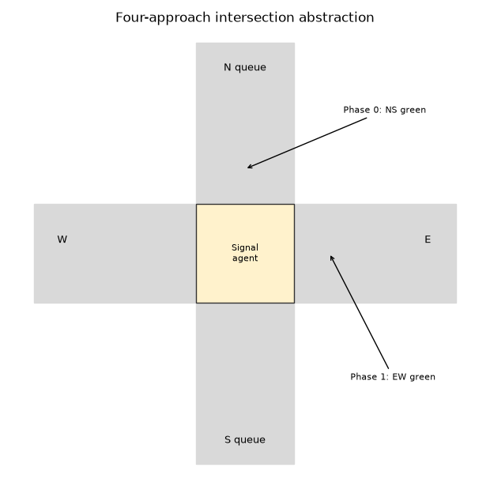
Figure 1. Four-approach intersection abstraction used in the case study.
B.2 Agent
The learning agent maintains an action-value table Q(s, a) ∈ ℝ^{|S|×2}. Behaviour during training is ε-greedy with linear decay of ε. Evaluation uses a greedy policy π(s) = argmax_a Q(s, a). The agent does not observe future arrivals; it only sees the current occupancy, phase, and timer.
B.3 State variables (with justification)
The state is the tuple (q_N, q_S, q_E, q_W, φ, t_green), encoded as a single integer for tabular methods. Each component is justified as follows.
Variable | Domain | Justification
q_N, q_S, q_E, q_W | 0 … 5 | Occupancy is the primary congestion signal; five bins keep |S| tabular while still distinguishing empty, moderate, and saturated approaches.
φ (phase) | {0, 1} | Discharge capability depends on who currently has green; the same queue vector is a different control problem under NS versus EW green.
t_green | 0 … MIN_GREEN | Switching is illegal until min-green is met. Including the timer lets the agent learn when a switch action is actually effective rather than a no-op.

With six occupancy levels, two phases, and five timer levels, |S| = 6^4 × 2 × 5 = 6,480 states and |A| = 2, which is tractable for NumPy Q-tables. Variables deliberately omitted (exact vehicle speeds, turning proportions, downstream occupancy) would push the problem into function approximation; they are listed as limitations rather than hidden in the model.
B.4 Action space
The action space is discrete: a = 0 keep the current phase; a = 1 request a switch. Constraint: if t_green < MIN_GREEN, the environment ignores a switch and treats it as keep. This is an environment-level safety constraint analogous to a conflict-monitor lock. There is no continuous green-time action in Component 1/2; continuous control would require policy-gradient methods outside the mandated tabular list. Illegal actions are therefore not crashing the simulator; they are simply ineffective, which the TD error will eventually reflect.
B.5 Reward function
At every step the environment returns
R = − Σ_i q_i − 8 · n_blocked − 0.35 · 1_{switched}.
Negative outcomes. Waiting is always costly (the sum of occupancies). Spillback is additionally costly so that saturating an approach is worse than spreading delay. A small switch cost discourages chatter that would be unrealistic for a field signal (yellow + all-red lost time is not modelled geometrically, so this term is a proxy).
Positive outcomes. Because the problem is a cost-minimisation task, “positive” performance appears as returns closer to zero: short queues, no blocked arrivals, and only necessary switches. Serving vehicles reduces future occupancy and therefore improves subsequent rewards; there is no separate bonus for throughput, which would double-count discharge already reflected in the queue term. Assumption (explicit): we do not encode passenger occupancy, bus priority, or emissions. Those would change the scalarisation of the reward and are left to the Safe-RL / multi-objective extension.
C. RL Problem Characteristics
Characteristic | Classification for this case study | Rationale
Episodic / continuing | Episodic (finite peak window) | Each training episode is a T-step peak period with a terminal time. Operation in the field is closer to continuing; we discuss that gap in limitations.
Static / dynamic | Dynamic | Arrival means drift within the episode (directional flip). The transition kernel therefore depends on time, not only on (s, a).
Deterministic / stochastic | Stochastic | Poisson arrivals and random stalls. The same (s, a) can yield different (s′, r).
Observability | Fully observed in the simulator | The agent sees exact discrete queues. Field detectors would make the problem POMDP; we treat that as a future extension, not as hidden state here.
State space | Discrete, finite, |S|=6480 | Tabular encoding of queues, phase, timer.
Action space | Discrete, |A|=2, constrained | Keep/switch with min-green lock.
Sequential? | Yes | Tomorrow’s queue is today’s residual plus arrivals minus discharge.
Learning regime | Simulation-based, online in-sim | No historical (s,a,r,s′) logs from the field. Updates are incremental after each simulated step (not batch offline RL).
Horizon / objective | Long-term (discounted episode return) | γ = 0.95; reward shaping still uses instantaneous waiting so short-term cost is visible, but Q captures delayed spillback.

Sequential decision-making rationale (expanded). If the controller only classified the current snapshot into “NS busy / EW busy”, it would ignore the timer, the asymmetric cost of switching too late, and the fact that serving a movement changes the snapshot. RL is used because the data-generating process is an MDP (approximately) and the decision is repeated under uncertainty.
Online versus offline versus simulation-based. Component 2 trains online inside the simulator: each real interaction updates Q. Dyna-Q additionally performs simulated (planning) updates from a learned model, which is still simulation-based rather than offline RL from a frozen industrial log. True offline RL would be relevant if a city released historical controller traces; we do not have that dataset.
Formal MDP tuple
Collecting the pieces, the coursework MDP is M = (S, A, P, R, γ, ρ0, T) where S is the finite occupancy–phase–timer set defined above; A = {keep, switch}; P(s′ | s, a) is induced by the (unknown to the agent) Poisson-and-stall simulator and by the min-green lock; R is the bounded cost-shaped reward; γ = 0.95; ρ0 randomises a small residual queue and a random initial phase so that the agent does not only see empty intersections; and T = 120 is the absorbing clock. The Bellman optimality equation for the action-value is Q*(s, a) = E[R + γ max_a′ Q*(S′, a′) | s, a], with the expectation over P. Q-learning is a sampled, asynchronous Robbins–Monro scheme for that equation. Because P is both stochastic and slowly non-stationary in t, there is no claim that the finite-horizon Q* of a stationary kernel is attained; the practical claim is that TD still produces a useful policy for this family of peak windows.
Credit assignment. A spillback at step t = 80 may be caused by a keep action at t = 50 that looked locally efficient. Monte Carlo would assign the entire episode return to every action, mixing many irrelevant decisions. One-step TD assigns blame locally through the bootstrap, which is the right inductive bias when congestion propagates on a short time scale (tens of steps), not only at the episode end. n-step TD and Dyna planning sit between those extremes; we implement the Dyna end of that spectrum in Component 2 rather than n-step λ-returns, to keep four methods conceptually nested: SARSA and Expected SARSA share a policy and differ in the target; Q-learning and Dyna-Q share a target and differ by an extra model.
D. Selection of RL Algorithm
Recommended base algorithm: Q-learning (off-policy one-step TD control).
Why Q-learning fits. First, the MDP is finite and discrete, so dynamic programming would be possible if P(s′, r | s, a) were known. It is not: arrivals are stochastic and time-varying, and we prefer to learn from sampled interaction. Monte Carlo control would wait until the end of a 120-step episode before any update, which is slow credit assignment when a harmful switch occurs at step 10. One-step TD methods bootstrap from Q(s′, ·) and update every tick, matching the real-time loop. Second, the intended deployed policy is greedy (a cabinet should not randomly switch phases at ε = 0.1). Q-learning learns exactly that greedy action-value while behaviour remains ε-greedy in simulation—the textbook off-policy setting. Third, Q-learning is the parent of Expected SARSA (on-policy expected targets) and of Dyna-Q (Q-learning plus planning), so it is the natural hub of the four-algorithm micro-project.
Why not DP, MC, or Actor–Critic as the base. DP needs the model; we would still have to estimate it, at which point Dyna-Q is the more honest algorithm. Monte Carlo is a valid comparison point but is not selected as the base because of high variance under Poisson noise. Actor–Critic and deep RL are reserved for larger occupancy encodings; they are not required to demonstrate Units 4–5 on this tabular MDP. SARSA remains important: if a city insisted on keeping exploratory probes at deployment, SARSA would be the safer on-policy choice. We still implement it in Component 2.
Hyperparameters chosen for the case (and used in the micro-project): learning rate α = 0.12, discount γ = 0.95, ε decaying linearly from 1.0 to 0.05 over 1,400 episodes. These values favour continued learning on a stochastic target without freezing exploration too early. They are engineering choices, not theoretically optimal stepsizes.
E. RL Workflow
The closed loop, specialised to this intersection, is as follows.
1. Environment. Occupancies, phase, and the min-green timer constitute the world. Poisson arrivals and random stalls are sampled by the simulator (stand-ins for unobserved demand and friction).
2. State. The environment encodes (q_N, q_S, q_E, q_W, φ, t_green) as integer S_t and presents it to the agent. In a field system this encoding would be produced by binning loop-detector occupancies.
3. Agent. With probability ε the agent selects a random keep/switch action; otherwise it selects argmax_a Q(S_t, a). Tie-breaking is uniform among maximisers so that symmetric queues do not lock onto action 0 by array-index bias.
4. Action. The chosen bit is applied. If a switch is requested too early, the environment leaves φ unchanged and increments t_green. Otherwise a switch flips φ and resets the timer.
5. Reward. After discharge and arrivals, the scalar R_{t+1} is computed from waiting, blocked vehicles, and whether a legal switch occurred. The agent does not see the decomposition at learning time—only the scalar—so it must discover that spillback is worse than ordinary delay.
6. Next state. The new occupancy vector and timer become S_{t+1}. If t = T the episode terminates and G is recorded for the learning curve.
7. Learning. Q-learning writes Q(S_t, A_t) ← Q(S_t, A_t) + α [R_{t+1} + γ max_a Q(S_{t+1}, a) − Q(S_t, A_t)] (with the bootstrap term zero at termination). SARSA uses Q(S_{t+1}, A_{t+1}) instead of the max; Expected SARSA uses Σ_a π(a|S_{t+1}) Q(S_{t+1}, a); Dyna-Q adds planning updates from an empirical model of experienced transitions. Policy improvement is greedy in Q after each update (implicit in ε-greedy).
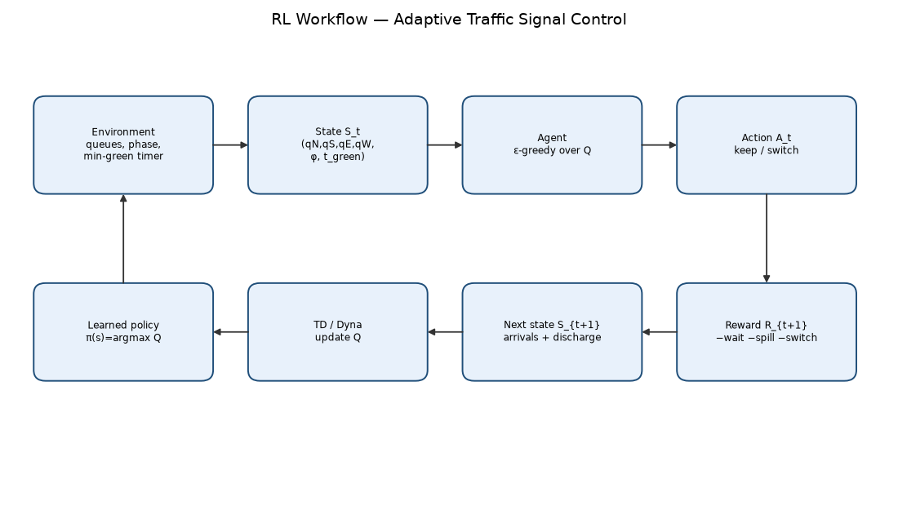
Figure 2. Environment–state–agent–action–reward–next-state–learning loop.
F. Innovation Component — Safe Reinforcement Learning
Proposed extension: Safe RL with a hard action shield and constrained returns, not reward shaping alone. Traffic signals are safety-critical. A learned policy that shortens pedestrian clearance, holds a movement beyond a legally implied maximum red, or ignores a queue that is about to spill into an upstream intersection is unacceptable even if its average return looks good. Our current simulator already implements one hard rule (minimum green). The innovation is to treat safety as a first-class layer.
Mechanism. A shield filters the agent’s action before it reaches the environment (or the cabinet). Let A_safe(s) be the subset of {keep, switch} that satisfies: (i) min green and yellow/all-red if we modelled them; (ii) maximum red for each approach so that a starved movement is forced green; (iii) a spillback veto that forbids keep when an approach is at MAX_QUEUE and the opposing phase could serve it; (iv) a pedestrian call lock when a walk interval is active. The agent maximises Q only inside A_safe(s). If the unconstrained greedy action is unsafe, the shield projects onto the safe set. This is more reliable than adding a large negative reward for violations, because a finite penalty can still be offset by throughput gains.
Constrained MDP view. One may also track an auxiliary cost C_t (for example, 1 if any approach waited more than τ_max steps) and require J_C(π) ≤ d. Lagrangian or PID-Lagrangian Safe RL would adapt a multiplier λ so that the agent maximises E[R] − λ (E[C] − d). In coursework terms, this remains tabular: we can store Q_R and Q_C. The shield handles hard instantaneous constraints; the Lagrangian handles long-run frequency constraints that cannot be judged from a single state.
Why this enhances this case study specifically. The keep/switch MDP already tempts the agent to chatter or to over-serve the currently cheaper direction after the within-episode demand flip. Component 2 results (Dyna-Q best on mean return, still with substantial return variance) show that average waiting can improve while individual episodes remain congested. A shield would convert “usually good” into “never illegal”, which is the actual municipal requirement. Digital twins and multi-agent corridor control are compatible later steps; safety is the prerequisite for either.
Mapping onto Units 4 and 5
Unit 4 (Monte Carlo and TD foundations) is represented by the contrast we draw between waiting for G and bootstrapping every tick, and by the on-policy versus off-policy split (SARSA versus Q-learning). Unit 5 (expected targets and planning) is represented by Expected SARSA and Dyna-Q. We did not implement MCTS because a two-action, 6,480-state signal MDP does not need tree search at decision time; the value is already stored in Q. We did not implement Prioritized Sweeping although it is a close cousin of Dyna-Q; eight uniform planning samples already show the planning effect, and priority queues would obscure the pedagogical nested structure. Double Q-learning is listed as future work to test overestimation, which is our working hypothesis for Q-learning’s weaker plateau.
What a deployed stack would add without changing the MDP idea. A mid-block detector would replace q_i with a filtered occupancy; a yellow plus all-red interval would extend the timer; a pedestrian button would add a binary bit to s. Each addition grows |S| multiplicatively, which is why the literature moved to deep Q-networks. For CIA-3 the correct pedagogical move is to keep the table visible so that the four updates can be read in a few lines of Python.
Preview of Component 2 (same case study)
The micro-project trains SARSA, Q-learning, Expected SARSA and Dyna-Q for 1,400 episodes on this exact environment. Learning is visible: first-50-episode means are near −930 to −970, last-100 means near −811 to −859. Dyna-Q is best on late return and on greedy evaluation; Q-learning meets a rolling-mean stability test earliest but at a worse plateau. Those results belong in Component 2, but they already support the Component 1 claim that off-policy one-step TD is a sensible base family and that planning is a high-value extension when transitions repeat.
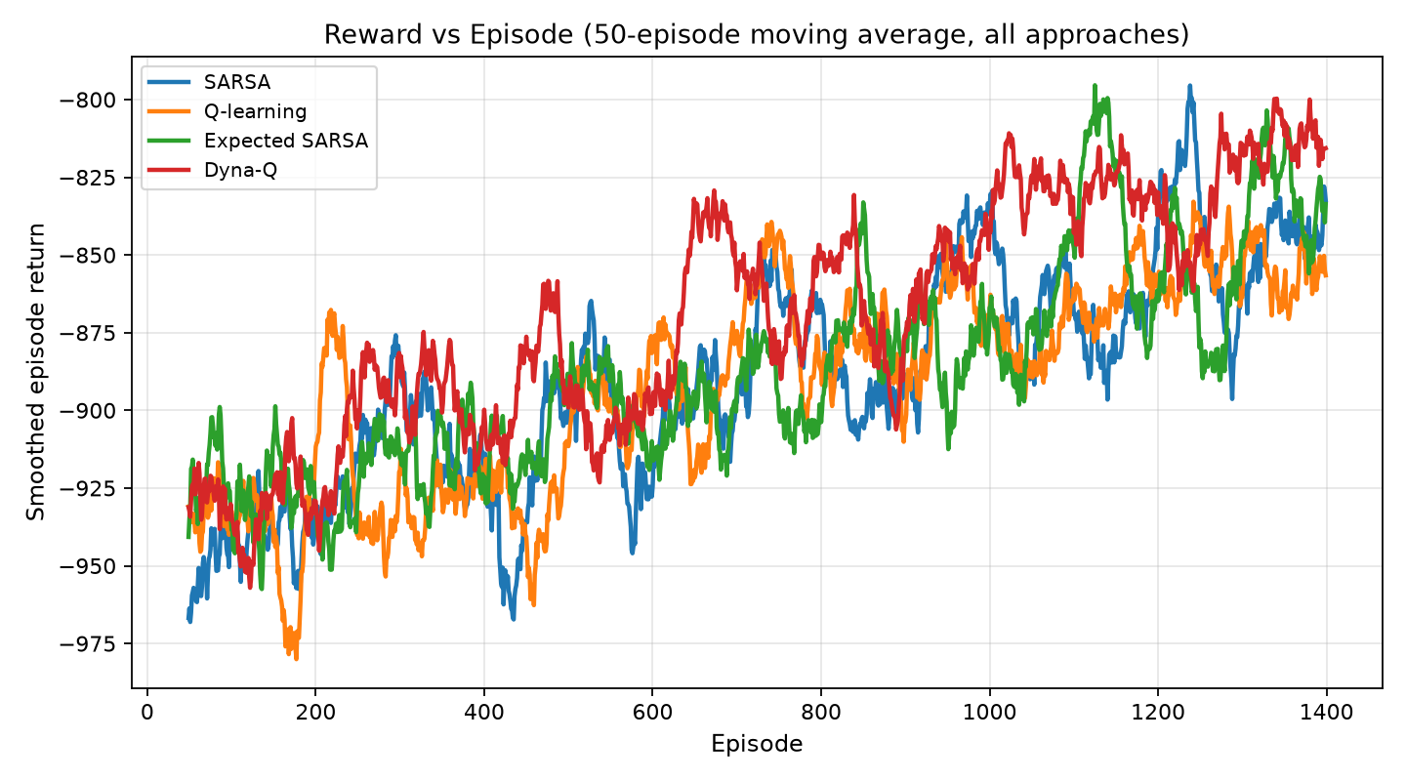
Figure 3. Component 2 preview: smoothed episode return for the four TD methods.
Worked one-step example (for the presentation)
Suppose at time t the occupancy is (3, 2, 5, 4), the phase is NS-green (φ = 0), and t_green = 4, so a switch is legal. Total waiting is 14. Action keep will discharge N and S (in expectation) while E and W sit at or near capacity, so the blocked-arrival term is likely to fire on East. Action switch forfeits 0.35 switch cost and begins serving the saturated East–West pair. A myopic rule that only looks at the current sum may keep NS green because N+S = 5 is not yet hopeless; the TD target, however, bootstraps from Q(s′, ·) in which s′ will often contain blocked=1 if we keep. This is exactly the sequential rationale: the value of switch is the avoided future spillback, not the instantaneous discharge. During early training Q is near zero, so the agent explores both actions; after many such saturations, Q(s, switch) becomes less negative than Q(s, keep). Dyna-Q can replay this (s, switch) pair during planning instead of waiting to see five-on-East again.
If instead t_green = 1, the same switch action is a no-op. The next state keeps φ = 0 and increments the timer. Without t_green in the state, the agent would mix legal and illegal switch samples into one Q(s, switch) estimate and appear ‘unable to learn switching’. Including the timer is therefore not an implementation convenience; it is part of making the MDP Markov for the constrained action.
Assumptions, limitations, and link to Component 2
Assumptions. Synthetic Poisson demand; two phases only (no protected lefts); no yellow interval geometry; perfect queue observation; isolated junction (no downstream blocking except via the spillback penalty); tabular occupancy cap of five vehicles per approach. Limitations. Results will not transfer to a named corridor without recalibration; |S| will explode if turning movements and multiple lanes are added, at which point Deep RL becomes the natural continuation of this case. Component 2 implements SARSA, Q-learning, Expected SARSA, and Dyna-Q on the identical environment, compares them on eight metrics, and reports Dyna-Q as the strongest mean performer under the stated hyperparameters.
Operational reading (how this would sit in a cabinet)
In an operations story, detectors (or a digital twin) emit occupancies every second. A preprocessor bins them into {0,…,5}, reads the ring-and-barrier phase, and reads how long the current green has been active. The Q-table — a 6,480 × 2 array, a few hundred kilobytes — is a lookup. The shield then accepts or rejects the switch bit. Only after that does the conflict monitor see a phase request. Training never happens on the live cabinet in this design; it happens in the simulator (or twin) with the same binning. That is why we classified the work as simulation-based rather than online field learning. Online field learning would raise exploration risk that Safe RL is meant to forbid.
Failure modes we want the team to be able to discuss in viva. (1) Detector bias: if East is systematically under-counted, the policy will starve East. (2) Demand regime unseen in training (stadium outflow) — tabular Q cannot extrapolate, which is an argument for Deep RL later. (3) Downstream blockage not in the state — the agent will dump cars onto a jammed link; a corridor multi-agent extension is the remedy. (4) Reward hacking: if switch cost is too large, the agent never switches; if spillback penalty is too large, it chatters. We chose 0.35 and 8.0 by inspection so that both terms are visible but waiting remains the main signal. Those numbers are assumptions, not calibrated economic costs.
Conclusion
Adaptive signal control is a genuine real-time sequential problem: today’s phase decision reshapes tomorrow’s queues under stochastic demand. We formulated an isolated intersection as a compact discrete MDP, argued that rule-based splits are myopic, selected Q-learning as the base off-policy TD method, described the full interaction loop, and proposed Safe RL with shielding as the innovation required before field consideration. The same MDP is the micro-project environment.
References (IEEE)
[1] R. S. Sutton and A. G. Barto, Reinforcement Learning: An Introduction, 2nd ed. Cambridge, MA, USA: MIT Press, 2018.
[2] F. V. Webster, “Traffic signal settings,” Road Research Technical Paper No. 39, Her Majesty’s Stationery Office, London, U.K., 1958.
[3] M. Wiering, “Multi-agent reinforcement learning for traffic light control,” in Proc. ICML, 2000, pp. 1151–1158.
[4] L. A. Prashanth and S. Bhatnagar, “Reinforcement learning with function approximation for traffic signal control,” IEEE Trans. Intell. Transp. Syst., vol. 12, no. 2, pp. 412–421, Jun. 2011.
[5] E. van der Pol and F. A. Oliehoek, “Coordinated deep reinforcement learners for traffic light control,” in NIPS Workshop on Learning, Inference and Control of Multi-Agent Systems, 2016.
[6] H. Wei, G. Zheng, H. Yao, and Z. Li, “IntelliLight: A reinforcement learning approach for intelligent traffic light control,” in Proc. KDD, 2018, pp. 2496–2505.
[7] C. Chen et al., “Toward a thousand lights: Decentralized deep reinforcement learning for large-scale traffic signal control,” in Proc. AAAI, 2020, pp. 3412–3419.
[8] J. García and F. Fernández, “A comprehensive survey on safe reinforcement learning,” J. Mach. Learn. Res., vol. 16, pp. 1437–1480, 2015.
[9] A. Haydari and Y. Yılmaz, “Deep reinforcement learning for intelligent transportation systems: A survey,” IEEE Trans. Intell. Transp. Syst., vol. 23, no. 1, pp. 11–32, Jan. 2022.
[10] N. H. Gartner, “OPAC: A demand-responsive strategy for traffic signal control,” Transp. Res. Rec., no. 906, pp. 75–81, 1983.

