NIHARIKA GAWADE 240905284
CSE-D
LAB4

PROCESS AND THREAD MANAGEMENT

1. Write a C program to create a child process. Display different messages in parent
process and child process. Display PID and PPID of both parent and child process.
Block parent process until child completes using wait system call.

#include <sys/types.h>
#include <sys/wait.h>
#include <unistd.h>
#include <stdio.h>
#include <stdlib.h>

int main(){
int status; pid_t pid;
pid = fork();

if(pid == -1){
printf("\nERROR child not created");
exit(1);
}
else if (pid == 0){
printf("\nI'm the child!\n");
printf("Child PID : %d\n", getpid());
printf("Parent PID : %d\n", getppid());
exit(0);
}
else{
printf("\nI'm the parent!\n");
printf("Parent PID : %d\n", getpid());
wait(&status);
printf("\n Child complete");
}

return 0;
}

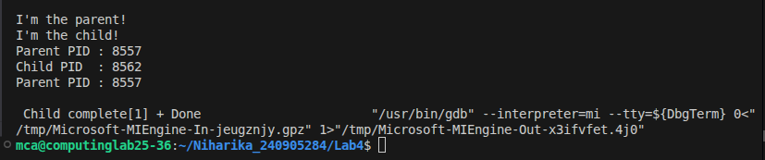

2. Write a C program to load the binary executable of the previous program in a child
process using exec system call.

#include <sys/types.h>
#include <sys/wait.h>
#include <unistd.h>
#include <stdio.h>
#include <stdlib.h>

int main(){
int status; pid_t pid;
pid = fork();

if(pid == -1){
printf("\nERROR child not created");
exit(1);
}
else if (pid == 0){
printf("\nI'm the child!\n");
execlp("./q1", "q1", NULL);
perror("exec failure");
exit(1);
}
else{
wait(&status);
printf("\n Child complete");
}

return 0;
}
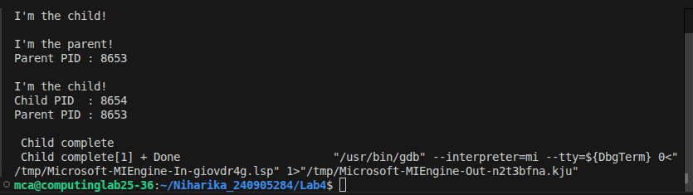

3. Create a zombie (defunct) child process (a child with exit() call, but no
corresponding wait() in the sleeping parent) and allow the init process to adopt it
(after parent terminates). Run the process as background process and run “ps”
command.

#include <sys/types.h>
#include <unistd.h>
#include <stdio.h>
#include <stdlib.h>

int main() {
pid_t pid;

pid = fork();

if (pid < 0) {
printf("Fork failed\n");
exit(1);
}
else if (pid == 0) {
printf("Child process exiting...\n");
exit(0);
}
else {
// Parent process
printf("Parent process sleeping...\n");
sleep(30);
printf("Parent exiting...\n");
}

return 0;
}
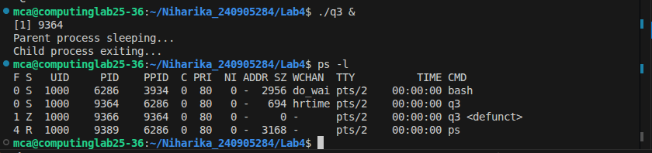

4. Write a multithreaded program that performs different sorting algorithms. The
program should work as follows: the user enters on the command line the number
of elements to sort and the elements themselves. The program then creates
separate threads, each using a different sorting algorithm. Each thread sorts the
array using its corresponding algorithm and displays the time taken to produce the
result. The main thread waits for all threads to finish and then displays the final
sorted array.

#include <stdio.h>
#include <stdlib.h>
#include <pthread.h>

int n;
int *arr;

void* bubbleSort() {
int a[n];
for (int i = 0; i < n; i++) a[i] = arr[i];

for (int i = 0; i < n-1; i++)
for (int j = 0; j < n-i-1; j++)
if (a[j] > a[j+1]) {
int t = a[j];
a[j] = a[j+1]; a
[j+1] = t;
}

printf("Bubble Sort: ");
for (int i = 0; i < n; i++) printf("%d ", a[i]);
printf("\n");

return NULL;
}

void* selectionSort() {
int a[n];
for (int i = 0; i < n; i++) a[i] = arr[i];

for (int i = 0; i < n-1; i++) {
int min = i;
for (int j = i+1; j < n; j++){
if (a[j] < a[min])
min = j;
}
int t = a[i];
a[i] = a[min];
a[min] = t;
}

printf("Selection Sort: ");
for (int i = 0; i < n; i++) printf("%d ", a[i]);
printf("\n");

return NULL;
}

void* insertionSort() {
int a[n];
for (int i = 0; i < n; i++) a[i] = arr[i];

for (int i = 1; i < n; i++) {
int key = a[i], j = i-1;
while (j >= 0 && a[j] > key) {
a[j+1] = a[j];
j--;
}
a[j+1] = key;
}

printf("Insertion Sort: ");
for (int i = 0; i < n; i++) printf("%d ", a[i]);
printf("\n");

return NULL;
}

int main() {
printf("Enter number of elements: ");
scanf("%d", &n);

arr = malloc(n * sizeof(int));
printf("Enter %d elements: ", n);
for (int i = 0; i < n; i++)
scanf("%d", &arr[i]);

pthread_t t1, t2, t3;

pthread_create(&t1, NULL, bubbleSort, NULL);
pthread_create(&t2, NULL, selectionSort, NULL);
pthread_create(&t3, NULL, insertionSort, NULL);

pthread_join(t1, NULL);
pthread_join(t2, NULL);
pthread_join(t3, NULL);

printf("Original array: ");
for (int i = 0; i < n; i++) printf("%d ", arr[i]);
printf("\n");

free(arr);
return 0;
}
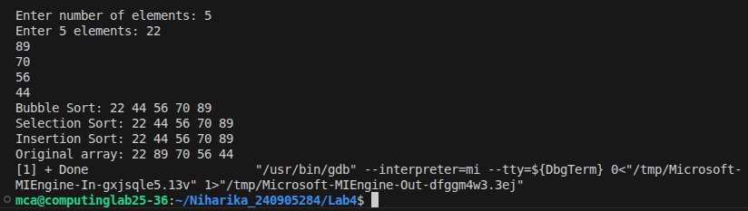

5. Write multithreaded program that generates the Fibonacci series. The program
should work as follows: The user will enter on the command line the number of
Fibonacci numbers that the program is to generate. The program then will create
a separate thread that will generate the Fibonacci numbers, placing the sequence
in data that is shared by the threads (an array is probably the most convenient
data structure). When the thread finishes execution the parent will output the
sequence generated by the child thread. Because the parent thread cannot begin
outputting the Fibonacci sequence until the child thread finishes, this will require
having the parent thread wait for the child thread to finish.

#include <stdio.h>
#include <stdlib.h>
#include <pthread.h>

int n;
int *a;

void* fib(){
if(n<=0) return NULL;

a[0] = 0;
if(n>1) a[1] = 1;

for(int i=2;i<n;i++){
a[i] = a[i-1] + a[i-2];
}

return NULL;
}

int main(){
printf("Enter number of elements: ");
scanf("%d",&n);

if(n<=0){
printf("Enter positive number\n");
return 1;
}
a = malloc(n*sizeof(int));

pthread_t t1;

pthread_create(&t1,NULL,fib,NULL);
pthread_join(t1,NULL);

printf("Fibonacci: ");
for (int i = 0; i < n; i++) printf("%d ", a[i]);
printf("\n");

free(a);

return 0;
}

