NIHARIKA GAWADE 240905284
CSE-D
LAB5

CPU SCHEDULING ALGORITHMS

1. Consider the following set of processes, with length of the CPU burst given in
milliseconds:
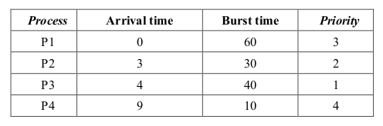
Write a menu driven C/C++ program to simulate the following CPU scheduling algorithms. Display Gantt chart showing the order of execution of each process. Compute waiting time and turnaround time for each process. Hence, compute average waiting time and average turnaround
time.
(i) FCFS (ii) SRTF (iii) Round-Robin (quantum = 10 ) iv) non-preemptive priority (higher the number higher the priority)

#include <stdio.h>

#define MAX 10

typedef struct {
char name[3];
int arrival;
int burst;
int priority;
int remaining;
int waiting;
int turnaround;
} Process;

void fcfs(Process p[], int n);
void srtf(Process p[], int n);
void rr(Process p[], int n, int quantum);
void priority_np(Process p[], int n);

int main() {
Process p[4] = {
{"P1", 0, 6, 3, 6, 0, 0},
{"P2", 3, 3, 2, 3, 0, 0},
{"P3", 4, 4, 1, 4, 0, 0},
{"P4", 9, 1, 4, 1, 0, 0}
};

int choice, n = 4;
int quantum = 10;

while(1) {
printf("\nCPU Scheduling Algorithms:\n");
printf("1. FCFS\n2. SRTF\n3. Round-Robin\n4. Non-preemptive Priority\n5. Exit\n");
printf("Enter choice: ");
scanf("%d", &choice);

switch(choice) {
case 1: fcfs(p, n); break;
case 2: srtf(p, n); break;
case 3: rr(p, n, quantum); break;
case 4: priority_np(p, n); break;
case 5: return 0;
default: printf("Invalid choice\n");
}
}
}

// ---------- FCFS ----------
void fcfs(Process p[], int n) {
int time = 0;
float total_wt = 0, total_tat = 0;

printf("\nGantt Chart: ");
for(int i=0; i<n; i++) {
if(time < p[i].arrival)
time = p[i].arrival;
printf("|%s ", p[i].name);
p[i].waiting = time - p[i].arrival;
time += p[i].burst;
p[i].turnaround = p[i].waiting + p[i].burst;
total_wt += p[i].waiting;
total_tat += p[i].turnaround;
}
printf("|\n");

printf("\nProcess\tArrival\tBurst\tWaiting\tTurnaround\n");
for(int i=0; i<n; i++)
printf("%s\t%d\t%d\t%d\t%d\n", p[i].name, p[i].arrival, p[i].burst, p[i].waiting, p[i].turnaround);

printf("Average waiting time = %.2f\n", total_wt/n);
printf("Average turnaround time = %.2f\n", total_tat/n);
}

// ---------- SRTF ----------
void srtf(Process p[], int n) {
int completed = 0, time = 0, min_idx;
int remaining[n];
for(int i=0;i<n;i++) remaining[i]=p[i].burst;
float total_wt = 0, total_tat = 0;

printf("\nGantt Chart: ");
while(completed < n) {
int min = 100000, found = 0;
for(int i=0;i<n;i++) {
if(p[i].arrival <= time && remaining[i]>0 && remaining[i]<min) {
min = remaining[i];
min_idx = i;
found = 1;
}
}
if(!found) { time++; continue; }

printf("|%s ", p[min_idx].name);
remaining[min_idx]--;
time++;
if(remaining[min_idx]==0) {
completed++;
p[min_idx].turnaround = time - p[min_idx].arrival;
p[min_idx].waiting = p[min_idx].turnaround - p[min_idx].burst;
total_wt += p[min_idx].waiting;
total_tat += p[min_idx].turnaround;
}
}
printf("|\n");

printf("\nProcess\tArrival\tBurst\tWaiting\tTurnaround\n");
for(int i=0;i<n;i++)
printf("%s\t%d\t%d\t%d\t%d\n", p[i].name, p[i].arrival, p[i].burst, p[i].waiting, p[i].turnaround);

printf("Average waiting time = %.2f\n", total_wt/n);
printf("Average turnaround time = %.2f\n", total_tat/n);
}

// ---------- Round-Robin ----------
void rr(Process p[], int n, int quantum) {
int time = 0, done = 0;
int remaining[n];
for(int i=0;i<n;i++) remaining[i]=p[i].burst;
float total_wt=0,total_tat=0;

printf("\nGantt Chart: ");
while(done<n) {
int all_idle = 1;
for(int i=0;i<n;i++) {
if(remaining[i]>0 && p[i].arrival<=time) {
all_idle=0;
printf("|%s ",p[i].name);
int t = (remaining[i] > quantum) ? quantum : remaining[i];
remaining[i]-=t;
time += t;
if(remaining[i]==0) {
done++;
p[i].turnaround = time - p[i].arrival;
p[i].waiting = p[i].turnaround - p[i].burst;
total_wt += p[i].waiting;
total_tat += p[i].turnaround;
}
}
}
if(all_idle) time++;
}
printf("|\n");

printf("\nProcess\tArrival\tBurst\tWaiting\tTurnaround\n");
for(int i=0;i<n;i++)
printf("%s\t%d\t%d\t%d\t%d\n", p[i].name, p[i].arrival, p[i].burst, p[i].waiting, p[i].turnaround);

printf("Average waiting time = %.2f\n", total_wt/n);
printf("Average turnaround time = %.2f\n", total_tat/n);
}

// ---------- Non-preemptive Priority ----------
void priority_np(Process p[], int n) {
int completed = 0, time = 0, done[n];
for(int i=0;i<n;i++) done[i]=0;
float total_wt=0, total_tat=0;

printf("\nGantt Chart: ");
while(completed<n) {
int max_priority=-1, idx=-1;
for(int i=0;i<n;i++) {
if(p[i].arrival<=time && !done[i]) {
if(p[i].priority>max_priority) {
max_priority=p[i].priority;
idx=i;
}
}
}
if(idx==-1) { time++; continue; }

printf("|%s ", p[idx].name);
time += p[idx].burst;
p[idx].turnaround = time - p[idx].arrival;
p[idx].waiting = p[idx].turnaround - p[idx].burst;
total_wt += p[idx].waiting;
total_tat += p[idx].turnaround;
done[idx] = 1;
completed++;
}
printf("|\n");

printf("\nProcess\tArrival\tBurst\tPriority\tWaiting\tTurnaround\n");
for(int i=0;i<n;i++)
printf("%s\t%d\t%d\t%d\t\t%d\t%d\n", p[i].name, p[i].arrival, p[i].burst, p[i].priority, p[i].waiting, p[i].turnaround);

printf("Average waiting time = %.2f\n", total_wt/n);
printf("Average turnaround time = %.2f\n", total_tat/n);
}
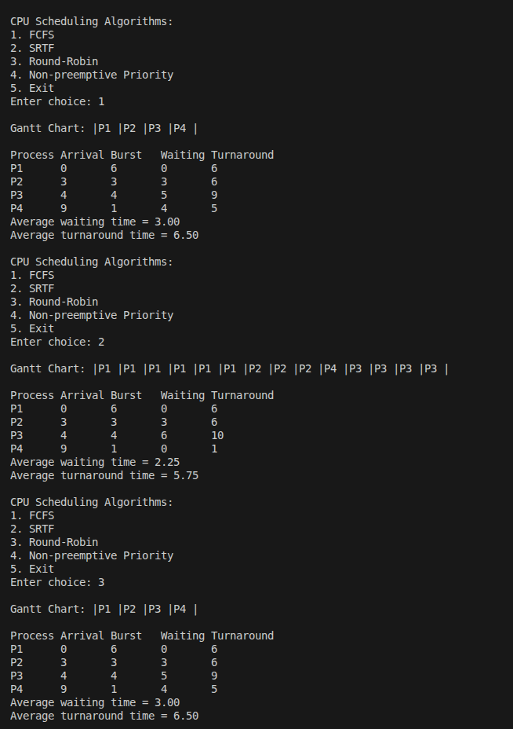
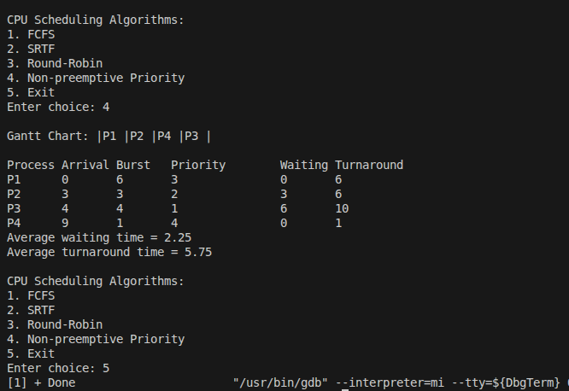
2. Write a C program to simulate multi-level feedback queue scheduling algorithm.

#include <stdio.h>
#include <string.h>

#define MAX 10

typedef struct {
char name[3];
int burst;
int remaining;
int queue_level;
int waiting;
int turnaround;
} Process;

int main() {
int n, i, j, time = 0;
int quanta[3] = {2, 4, 8};

printf("Enter number of processes (max 10): ");
scanf("%d", &n);

Process p[MAX];

for(i=0;i<n;i++) {
printf("Enter process name and burst time: ");
scanf("%s %d", p[i].name, &p[i].burst);
p[i].remaining = p[i].burst;
p[i].queue_level = 0;
p[i].waiting = 0;
p[i].turnaround = 0;
}

int done = 0;
printf("\nGantt Chart: ");
while(done < n) {
done = 0;
for(i=0;i<n;i++) {
if(p[i].remaining > 0) {
int q = p[i].queue_level;
int t = (p[i].remaining < quanta[q]) ? p[i].remaining : quanta[q];
printf("|%s ", p[i].name);
p[i].remaining -= t;
time += t;
if(p[i].remaining == 0) {
p[i].turnaround = time;
p[i].waiting = p[i].turnaround - p[i].burst;
} else if(p[i].queue_level < 2) {
p[i].queue_level++;
}
} else {
done++;
}
}
}
printf("|\n");

printf("\nProcess\tBurst\tWaiting\tTurnaround\n");
for(i=0;i<n;i++)
printf("%s\t%d\t%d\t%d\n", p[i].name, p[i].burst, p[i].waiting, p[i].turnaround);

return 0;
}

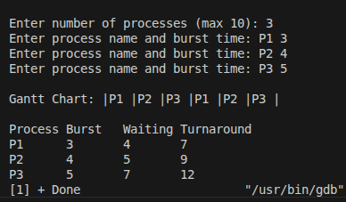

3. Write a C program to simulate Earliest-Deadline-First scheduling for real time systems.

#include <stdio.h>

#define MAX 10

typedef struct {
char name[3];
int burst;
int deadline;
int waiting;
int turnaround;
} Process;

int main() {
int n, i, j, time = 0;
printf("Enter number of processes (max 10): ");
scanf("%d", &n);

Process p[MAX], temp;

for(i=0;i<n;i++) {
printf("Enter process name, burst time, deadline: ");
scanf("%s %d %d", p[i].name, &p[i].burst, &p[i].deadline);
p[i].waiting = 0;
p[i].turnaround = 0;
}

for(i=0;i<n-1;i++) {
for(j=i+1;j<n;j++) {
if(p[i].deadline > p[j].deadline) {
temp = p[i];
p[i] = p[j];
p[j] = temp;
}
}
}

printf("\nGantt Chart: ");
for(i=0;i<n;i++) {
printf("|%s ", p[i].name);
p[i].waiting = time;
time += p[i].burst;
p[i].turnaround = time;
}
printf("|\n");

printf("\nProcess\tBurst\tDeadline\tWaiting\tTurnaround\n");
for(i=0;i<n;i++)
printf("%s\t%d\t%d\t\t%d\t%d\n", p[i].name, p[i].burst, p[i].deadline, p[i].waiting, p[i].turnaround);

return 0;
}

