NIHARIKA GAWADE 240905284
CSE-D
LAB7

CLASSICAL PROBLEMS OF SYNCHRONIZATION

1. Modify the above Producer-Consumer program so that, a producer can produce at the most 10 items more than what the consumer has consumed.

#include<stdio.h>
#include<pthread.h>
#include<semaphore.h>
#include<unistd.h>

#define SIZE 5

int buf[SIZE];
int f=-1,r=-1;

sem_t mutex, full, empty;
sem_t limit;

void* produce(void* arg){
for(int i=0;i<20;i++){

sem_wait(&limit);

sem_wait(&empty);
sem_wait(&mutex);

r=(r+1)%SIZE;
buf[r]=i;
printf("Produced: %d\n",i);

sem_post(&mutex);
sem_post(&full);

sleep(1);
}
return NULL;
}

void* consume(void* arg){
for(int i=0;i<20;i++){

sem_wait(&full);
sem_wait(&mutex);

f=(f+1)%SIZE;
int item=buf[f];
printf("Consumed: %d\n",item);

sem_post(&mutex);
sem_post(&empty);

sem_post(&limit);

sleep(2);
}
return NULL;
}

int main(){
pthread_t t1,t2;

sem_init(&mutex,0,1);
sem_init(&full,0,0);
sem_init(&empty,0,SIZE);

sem_init(&limit,0,10);

pthread_create(&t1,NULL,produce,NULL);
pthread_create(&t2,NULL,consume,NULL);

pthread_join(t1,NULL);
pthread_join(t2,NULL);

sem_destroy(&mutex);
sem_destroy(&full);
sem_destroy(&empty);
sem_destroy(&limit);

return 0;
}

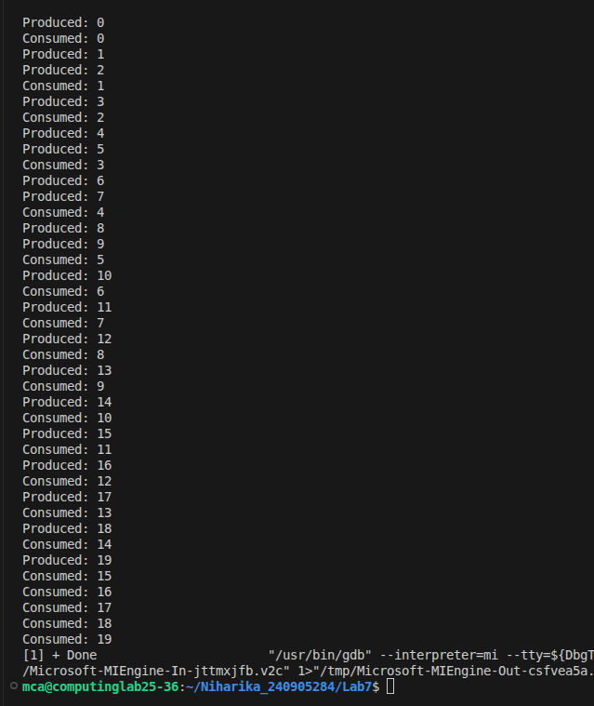

2. Write a C/C++ program for first readers-writers problem using semaphores.

#include<stdio.h>
#include<pthread.h>
#include<semaphore.h>
#include<unistd.h>

sem_t mutex;
sem_t wrt;

int readcount = 0;
int data = 0;

void* reader(void* arg){
for(int i=0;i<5;i++){
sem_wait(&mutex);
readcount++;
if(readcount == 1){
sem_wait(&wrt);
}
sem_post(&mutex);

printf("Reader %ld is reading data = %d\n",(long)arg,data);
sleep(1);

sem_wait(&mutex);
readcount--;
if(readcount == 0){
sem_post(&wrt);
}
sem_post(&mutex);

sleep(1);
}
return NULL;
}

void* writer(void* arg){
for(int i=0;i<5;i++){
sem_wait(&wrt);

data++;
printf("Writer %ld is writing data = %d\n",(long)arg,data);
sleep(1);

sem_post(&wrt);

sleep(1);
}
return NULL;
}

int main(){
pthread_t r1,r2,w1;

sem_init(&mutex,0,1);
sem_init(&wrt,0,1);

pthread_create(&r1,NULL,reader,(void*)1);
pthread_create(&r2,NULL,reader,(void*)2);
pthread_create(&w1,NULL,writer,(void*)1);

pthread_join(r1,NULL);
pthread_join(r2,NULL);
pthread_join(w1,NULL);

sem_destroy(&mutex);
sem_destroy(&wrt);

return 0;
}
