NIHARIKA GAWADE 240905284
CSE-D
LAB8

DEADLOCK MANAGEMENT ALGORITHMS

1. Consider the following snapshot of the system. Write C/C++ program to implement Banker’s algorithm for deadlock avoidance. The program has to accept all inputs from the user. Assume the total number of instances of A,B and C are 10,5 and 7 respectively.

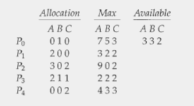

(a) What is the content of the matrix Need?
(b) Is the system in a safe state?
(c) If a request from process P1 arrives for (1, 0, 2), can the request be granted immediately?Display the updated Allocation, Need and Available matrices.
(d) If a request from process P4 arrives for (3, 3, 0), can the request be granted immediately?
(e) If a request from process P0 arrives for (0, 2, 0), can the request be granted immediately?

#include <stdio.h>
#include <stdbool.h>

#define MAXP 20
#define MAXR 3

bool isSafe(int n, int allocation[MAXP][MAXR], int need[MAXP][MAXR], int available[MAXR]) {
int work[MAXR], safeSeq[MAXP], count = 0;
bool finish[MAXP] = {false};

for(int j = 0; j < MAXR; j++)
work[j] = available[j];

while(count < n) {
bool found = false;
for(int i = 0; i < n; i++) {
if(!finish[i]) {
int j;
for(j = 0; j < MAXR; j++)
if(need[i][j] > work[j])
break;
if(j == MAXR) {
for(int k = 0; k < MAXR; k++)
work[k] += allocation[i][k];
safeSeq[count++] = i;
finish[i] = true;
found = true;
}
}
}
if(!found)
return false;
}

printf("\nSafe Sequence: ");
for(int i = 0; i < n; i++)
printf("P%d ", safeSeq[i]);
printf("\n");
return true;
}

bool requestResources(int n, int allocation[MAXP][MAXR], int need[MAXP][MAXR], int available[MAXR]) {
int process, request[MAXR];

printf("\nEnter process number: ");
scanf("%d", &process);
printf("Enter request (A B C): ");
for(int j = 0; j < MAXR; j++)
scanf("%d", &request[j]);

for(int j = 0; j < MAXR; j++)
if(request[j] > need[process][j]) {
printf("Error: Exceeded maximum claim.\n");
return false;
}

for(int j = 0; j < MAXR; j++)
if(request[j] > available[j]) {
printf("Resources not available. Process must wait.\n");
return false;
}

for(int j = 0; j < MAXR; j++) {
available[j] -= request[j];
allocation[process][j] += request[j];
need[process][j] -= request[j];
}

if(isSafe(n, allocation, need, available)) {
printf("Request granted.\n");
return true;
} else {
for(int j = 0; j < MAXR; j++) {
available[j] += request[j];
allocation[process][j] -= request[j];
need[process][j] += request[j];
}
printf("Request denied (Unsafe state).\n");
return false;
}
}

int main() {
int n, total[MAXR] = {10, 5, 7};
int allocation[MAXP][MAXR], max[MAXP][MAXR], need[MAXP][MAXR], available[MAXR];

printf("Enter number of processes: ");
scanf("%d", &n);

printf("\nEnter Allocation Matrix:\n");
for(int i = 0; i < n; i++)
for(int j = 0; j < MAXR; j++)
scanf("%d", &allocation[i][j]);

printf("\nEnter Max Matrix:\n");
for(int i = 0; i < n; i++)
for(int j = 0; j < MAXR; j++)
scanf("%d", &max[i][j]);

for(int i = 0; i < n; i++)
for(int j = 0; j < MAXR; j++)
need[i][j] = max[i][j] - allocation[i][j];

for(int j = 0; j < MAXR; j++) {
int sum = 0;
for(int i = 0; i < n; i++)
sum += allocation[i][j];
available[j] = total[j] - sum;
}

for(int i = 0; i < n; i++){
for(int j = 0; j < MAXR; j++){
printf("%d ",need[i][j]);
}printf("\n");
}

printf("\nInitial Safety Check:\n");
if(isSafe(n, allocation, need, available))
printf("System is initially SAFE.\n");
else {
printf("System is NOT SAFE.\n");
return 0;
}
int c=1;
while(c!=0){
printf("Resourse-request ? (y=1/n=0)");
scanf("%d",&c);
if(c==1){
requestResources(n, allocation, need, available);
}
}

return 0;
}

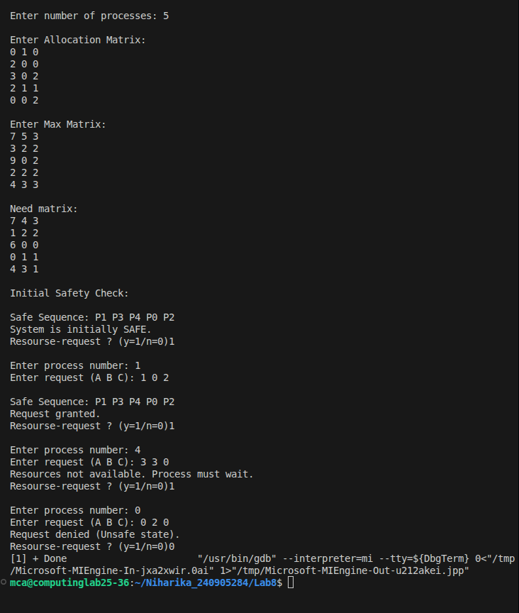

2. Consider the following snapshot of the system. Write C/C++ program to implement deadlock detection algorithm.
(a) Is the system in a safe state?
(b) Suppose that process P2 make one additional request for instance of type C, can the system still be in a safe state?

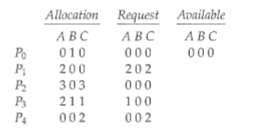

#include <stdio.h>
#include <stdbool.h>

#define MAXP 20
#define MAXR 3

bool isSafe(int n, int allocation[MAXP][MAXR], int need[MAXP][MAXR], int available[MAXR]) {
int work[MAXR], count = 0;
bool finish[MAXP] = {false};

for (int j = 0; j < MAXR; j++)
work[j] = available[j];

while (count < n) {
bool found = false;
for (int i = 0; i < n; i++) {
if (!finish[i]) {
int j;
for (j = 0; j < MAXR; j++)
if (need[i][j] > work[j])
break;
if (j == MAXR) {
for (int k = 0; k < MAXR; k++)
work[k] += allocation[i][k];
finish[i] = true;
count++;
found = true;
}
}
}
if (!found)
return false;
}
return true;
}

int main() {
int n, m = MAXR;
int allocation[MAXP][MAXR], max[MAXP][MAXR], need[MAXP][MAXR], available[MAXR];
int total_resources[MAXR] = {10, 5, 7};

printf("Enter number of processes: ");
scanf("%d", &n);

printf("Enter Allocation Matrix:\n");
for (int i = 0; i < n; i++)
for (int j = 0; j < m; j++)
scanf("%d", &allocation[i][j]);

printf("Enter Max Matrix:\n");
for (int i = 0; i < n; i++)
for (int j = 0; j < m; j++)
scanf("%d", &max[i][j]);

for (int i = 0; i < n; i++)
for (int j = 0; j < m; j++)
need[i][j] = max[i][j] - allocation[i][j];

for (int j = 0; j < m; j++) {
int sum_alloc = 0;
for (int i = 0; i < n; i++)
sum_alloc += allocation[i][j];
available[j] = total_resources[j] - sum_alloc;
}

if (!isSafe(n, allocation, need, available)) {
printf("System is NOT initially safe.\n");
return 0;
}
printf("System is initially SAFE.\n");

int p, request[MAXR];
printf("Enter process number making request: ");
scanf("%d", &p);
printf("Enter request vector (A B C): ");
for (int j = 0; j < m; j++)
scanf("%d", &request[j]);

for (int j = 0; j < m; j++) {
if (request[j] > need[p][j]) {
printf("Error: Request exceeds process maximum claim.\n");
return 0;
}
}

for (int j = 0; j < m; j++) {
if (request[j] > available[j]) {
printf("Request cannot be granted immediately. Not enough resources.\n");
return 0;
}
}

for (int j = 0; j < m; j++) {
available[j] -= request[j];
allocation[p][j] += request[j];
need[p][j] -= request[j];
}

if (isSafe(n, allocation, need, available))
printf("Request granted. System remains SAFE.\n");
else {
for (int j = 0; j < m; j++) {
available[j] += request[j];
allocation[p][j] -= request[j];
need[p][j] += request[j];
}
printf("Request cannot be granted as system would be UNSAFE.\n");
}

return 0;
}

