NIHARIKA GAWADE 240905284
CSE-D
LAB9

MEMORY MANAGEMENT I

1. Write a C/C++ program to simulate First-fit, Best-fit and Worst-fit strategies. Given memory partitions of 100K, 500K, 200K, 300K, and 600K(in order), how would each of the First-fit, Best-fit, and Worst-fit algorithms place processes of 212K, 417K, 112K, and 426K (in order)? Which algorithm makes efficient use of memory?

#include <stdio.h>

#define BLOCKS 5
#define PROCESSES 4

void firstFit(int blockSize[], int processSize[]) {
int allocation[PROCESSES];

for (int i = 0; i < PROCESSES; i++)
allocation[i] = -1;

for (int i = 0; i < PROCESSES; i++) {
for (int j = 0; j < BLOCKS; j++) {
if (blockSize[j] >= processSize[i]) {
allocation[i] = j;
blockSize[j] -= processSize[i];
break;
}
}
}

printf("\nFirst Fit Allocation:\n");
for (int i = 0; i < PROCESSES; i++) {
if (allocation[i] != -1)
printf("Process %d (%dK) -> Block %d\n", i+1, processSize[i], allocation[i]+1);
else
printf("Process %d (%dK) -> Not Allocated\n", i+1, processSize[i]);
}
}

void bestFit(int blockSize[], int processSize[]) {
int allocation[PROCESSES];

for (int i = 0; i < PROCESSES; i++)
allocation[i] = -1;

for (int i = 0; i < PROCESSES; i++) {
int bestIdx = -1;
for (int j = 0; j < BLOCKS; j++) {
if (blockSize[j] >= processSize[i]) {
if (bestIdx == -1 || blockSize[j] < blockSize[bestIdx])
bestIdx = j;
}
}

if (bestIdx != -1) {
allocation[i] = bestIdx;
blockSize[bestIdx] -= processSize[i];
}
}

printf("\nBest Fit Allocation:\n");
for (int i = 0; i < PROCESSES; i++) {
if (allocation[i] != -1)
printf("Process %d (%dK) -> Block %d\n", i+1, processSize[i], allocation[i]+1);
else
printf("Process %d (%dK) -> Not Allocated\n", i+1, processSize[i]);
}
}

void worstFit(int blockSize[], int processSize[]) {
int allocation[PROCESSES];

for (int i = 0; i < PROCESSES; i++)
allocation[i] = -1;

for (int i = 0; i < PROCESSES; i++) {
int worstIdx = -1;
for (int j = 0; j < BLOCKS; j++) {
if (blockSize[j] >= processSize[i]) {
if (worstIdx == -1 || blockSize[j] > blockSize[worstIdx])
worstIdx = j;
}
}

if (worstIdx != -1) {
allocation[i] = worstIdx;
blockSize[worstIdx] -= processSize[i];
}
}

printf("\nWorst Fit Allocation:\n");
for (int i = 0; i < PROCESSES; i++) {
if (allocation[i] != -1)
printf("Process %d (%dK) -> Block %d\n", i+1, processSize[i], allocation[i]+1);
else
printf("Process %d (%dK) -> Not Allocated\n", i+1, processSize[i]);
}
}

int main() {
int blocks[BLOCKS] = {100, 500, 200, 300, 600};
int processes[PROCESSES] = {212, 417, 112, 426};

int blocks1[BLOCKS], blocks2[BLOCKS], blocks3[BLOCKS];

for (int i = 0; i < BLOCKS; i++) {
blocks1[i] = blocks[i];
blocks2[i] = blocks[i];
blocks3[i] = blocks[i];
}

firstFit(blocks1, processes);
bestFit(blocks2, processes);
worstFit(blocks3, processes);

return 0;
}

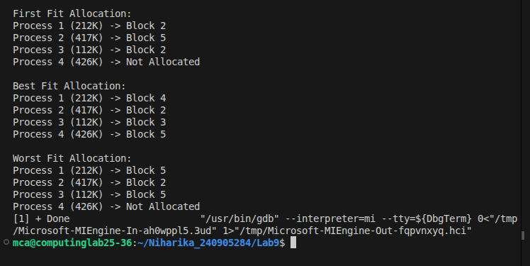

2. Assuming a page size of 32 bytes and there are total of 8 such pages totaling 256 bytes. Write a C program to simulate this memory mapping. The program should read the logical memory address and display the page number and page offset in decimal. How many bytes do you need to represent the address in this scenario? Display the page number and offset to reference the following logical addresses.
(i) 204 byte
(ii) 56 byte

#include <stdio.h>

int main() {
int logical_address;
int page_size = 32;

printf("Enter logical address (0 - 255): ");
scanf("%d", &logical_address);

int page_number = logical_address / page_size;
int offset = logical_address % page_size;

printf("\nLogical Address: %d\n", logical_address);
printf("Page Number: %d\n", page_number);
printf("Offset: %d\n", offset);

return 0;
}

