WEEK-6
Collective Communications and Error Handling in MPI
Niharika Gawade
240905284
Roll no:30
CSE-D

1) Implement a MPI program using N processes to find 1! + 2! +.....+N!. Use scan. Also, handle different errors using error handling routines.

#include <stdio.h>
#include <mpi.h>

int main(int argc, char *argv[])
{
int rank, size, i, fact = 1, sum, total;
int err;

err = MPI_Init(&argc, &argv);
if (err != MPI_SUCCESS)
{
printf("MPI_Init failed\n");
return 1;
}

err = MPI_Comm_rank(MPI_COMM_WORLD, &rank);
if (err != MPI_SUCCESS)
{
printf("MPI_Comm_rank failed\n");
MPI_Abort(MPI_COMM_WORLD, 1);
}

err = MPI_Comm_size(MPI_COMM_WORLD, &size);
if (err != MPI_SUCCESS)
{
printf("MPI_Comm_size failed\n");
MPI_Abort(MPI_COMM_WORLD, 1);
}

if (rank == 0)
printf("Number of processes = %d\n", size);

i = rank + 1;

for (int j = 1; j <= i; j++)
fact *= j;

err = MPI_Scan(&fact, &sum, 1, MPI_INT, MPI_SUM, MPI_COMM_WORLD);
if (err != MPI_SUCCESS)
{
printf("MPI_Scan failed\n");
MPI_Abort(MPI_COMM_WORLD, 1);
}

if (rank == size - 1)
total = sum;

MPI_Bcast(&total, 1, MPI_INT, size - 1, MPI_COMM_WORLD);

if (rank == 0)
printf("Sum = %d\n", total);

MPI_Finalize();
return 0;
}

OUTPUT
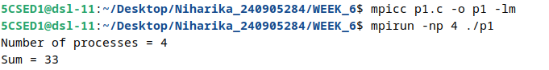

2) Implement a MPI program to read a 3 X 3 matrix. Enter an element to be searched in the root process. Find the number of occurrences of this element in the matrix using three processes.

#include <stdio.h>
#include <mpi.h>

int main(int argc, char *argv[])
{
int rank, matrix[3][3], row[3], key, count, total;

MPI_Init(&argc, &argv);
MPI_Comm_rank(MPI_COMM_WORLD, &rank);

if (rank == 0)
{
printf("Enter 3 X 3 matrix:\n");

for (int i = 0; i < 3; i++)
for (int j = 0; j < 3; j++)
scanf("%d", &matrix[i][j]);

printf("Enter element to search: ");
scanf("%d", &key);
}

MPI_Bcast(&key, 1, MPI_INT, 0, MPI_COMM_WORLD);

MPI_Scatter(matrix, 3, MPI_INT, row, 3, MPI_INT, 0, MPI_COMM_WORLD);

count = 0;

for (int i = 0; i < 3; i++)
{
if (row[i] == key)
count++;
}

MPI_Reduce(&count, &total, 1, MPI_INT, MPI_SUM, 0, MPI_COMM_WORLD);

if (rank == 0)
printf("Number of occurrences = %d\n", total);

MPI_Finalize();
return 0;
}

OUTPUT
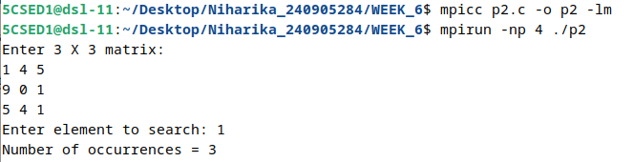

3) Implement a MPI program to read 4 X 4 matrix and display the following output using four processes.

I/p matrix:
1 2 3 4
1 2 3 1
1 1 1 1
2 1 2 1
O/p matrix:
1 2 3 4
2 4 6 5
3 5 7 6
5 6 9 7

#include <stdio.h>
#include <mpi.h>

int main(int argc, char *argv[])
{
int rank, size;
int a[4][4];
int row[4];
int result[4][4];

MPI_Init(&argc, &argv);

MPI_Comm_rank(MPI_COMM_WORLD, &rank);
MPI_Comm_size(MPI_COMM_WORLD, &size);

if (size != 4)
{
if (rank == 0)
printf("Run with 4 processes\n");

MPI_Finalize();
return 1;
}

if (rank == 0)
{
printf("Enter 4 X 4 matrix:\n");

for (int i = 0; i < 4; i++)
for (int j = 0; j < 4; j++)
scanf("%d", &a[i][j]);
}

MPI_Scatter(a, 4, MPI_INT, row, 4, MPI_INT,
0, MPI_COMM_WORLD);

MPI_Scan(row, result[rank], 4, MPI_INT,
MPI_SUM, MPI_COMM_WORLD);

if (rank == 0)
{
MPI_Gather(MPI_IN_PLACE, 0, MPI_INT,
result, 4, MPI_INT, 0, MPI_COMM_WORLD);
}
else
{
MPI_Gather(result[rank], 4, MPI_INT,
result, 4, MPI_INT, 0, MPI_COMM_WORLD);
}

if (rank == 0)
{
printf("O/p matrix:\n");

for (int i = 0; i < 4; i++)
{
for (int j = 0; j < 4; j++)
printf("%d ", result[i][j]);

printf("\n");
}
}

MPI_Finalize();

return 0;
}

OUTPUT
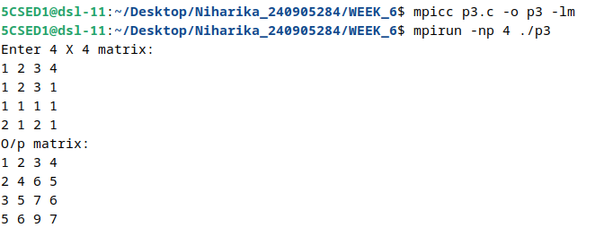

4) Implement parallel odd even transposition sort.

#include <stdio.h>
#include <mpi.h>

int main(int argc, char *argv[])
{
int rank, size;
int local, received;
int a[100], result[100];

MPI_Init(&argc, &argv);
MPI_Comm_rank(MPI_COMM_WORLD, &rank);
MPI_Comm_size(MPI_COMM_WORLD, &size);

if (rank == 0)
{
printf("Enter %d elements:\n", size);

for (int i = 0; i < size; i++)
scanf("%d", &a[i]);
}

MPI_Scatter(a, 1, MPI_INT, &local, 1, MPI_INT, 0, MPI_COMM_WORLD);

for (int phase = 0; phase < size; phase++)
{
if (phase % 2 == 0)
{
if (rank % 2 == 0 && rank + 1 < size)
{
MPI_Sendrecv(&local, 1, MPI_INT, rank + 1, 0,
&received, 1, MPI_INT, rank + 1, 0,
MPI_COMM_WORLD, MPI_STATUS_IGNORE);

if (local > received)
local = received;
}
else if (rank % 2 == 1)
{
MPI_Sendrecv(&local, 1, MPI_INT, rank - 1, 0,
&received, 1, MPI_INT, rank - 1, 0,
MPI_COMM_WORLD, MPI_STATUS_IGNORE);

if (local < received)
local = received;
}
}
else
{
if (rank % 2 == 1 && rank + 1 < size)
{
MPI_Sendrecv(&local, 1, MPI_INT, rank + 1, 0,
&received, 1, MPI_INT, rank + 1, 0,
MPI_COMM_WORLD, MPI_STATUS_IGNORE);

if (local > received)
local = received;
}
else if (rank % 2 == 0 && rank > 0)
{
MPI_Sendrecv(&local, 1, MPI_INT, rank - 1, 0,
&received, 1, MPI_INT, rank - 1, 0,
MPI_COMM_WORLD, MPI_STATUS_IGNORE);

if (local < received)
local = received;
}
}
}

MPI_Gather(&local, 1, MPI_INT, result, 1, MPI_INT, 0, MPI_COMM_WORLD);

if (rank == 0)
{
printf("Sorted array:\n");

for (int i = 0; i < size; i++)
printf("%d ", result[i]);

printf("\n");
}

MPI_Finalize();
return 0;
}

OUTPUT
