WEEK-7
Programs on 1D arrays, identifying device properties in CUDA
Niharika Gawade
240905284
Roll no:30
CSE-D

1. Implement CUDA program to determine the number of CUDA capable devices in the system. For each device, examine the following device's properties:
a. Device name
b. Number of Streaming Multiprocessors
c. Maximum number of threads per block
d. Maximum thread dimensions (x,y,z)
e. Maximum grid dimensions (x,y,z)
f. The device clock frequency.

#include <stdio.h>
#include <cuda_runtime.h>

int main() {
int n;
cudaGetDeviceCount(&n);
printf("CUDA Devices: %d\n", n);

for (int i = 0; i < n; i++) {
cudaDeviceProp p;
cudaGetDeviceProperties(&p, i);

printf("\nDevice %d: %s\n", i, p.name);
printf("SMs: %d\n", p.multiProcessorCount);
printf("Max Threads/Block: %d\n", p.maxThreadsPerBlock);
printf("Max Threads Dim: %d %d %d\n",
p.maxThreadsDim[0], p.maxThreadsDim[1], p.maxThreadsDim[2]);
printf("Max Grid Dim: %d %d %d\n",
p.maxGridSize[0], p.maxGridSize[1], p.maxGridSize[2]);
printf("Clock Frequency: %d kHz\n", p.clockRate);
}
return 0;
}

OUTPUT

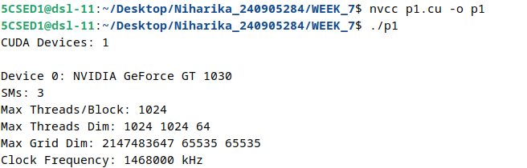

2. Given two vectors of length N, implement a program in CUDA that launches two kernel to do the following tasks
a) Add two vectors (kernel execution configuration: Block size as N)
b) Dot product of two vectors (kernel execution configuration: N threads)

#include <stdio.h>
#include <cuda_runtime.h>

__global__ void add(float *a, float *b, float *c) {
int i = threadIdx.x;
c[i] = a[i] + b[i];
}

__global__ void dot(float *a, float *b, float *r) {
int i = threadIdx.x;
r[i] = a[i] * b[i];
}

int main() {
int N = 10;
float a[10], b[10], c[10], r[10];
float *da, *db, *dc, *dr;

for (int i = 0; i < N; i++) {
a[i] = i;
b[i] = i * 2;
}

cudaMalloc(&da, N*sizeof(float));
cudaMalloc(&db, N*sizeof(float));
cudaMalloc(&dc, N*sizeof(float));
cudaMalloc(&dr, N*sizeof(float));

cudaMemcpy(da,a,N*sizeof(float),cudaMemcpyHostToDevice);
cudaMemcpy(db,b,N*sizeof(float),cudaMemcpyHostToDevice);

add<<<1,N>>>(da,db,dc);
dot<<<1,N>>>(da,db,dr);

cudaMemcpy(c,dc,N*sizeof(float),cudaMemcpyDeviceToHost);
cudaMemcpy(r,dr,N*sizeof(float),cudaMemcpyDeviceToHost);

printf("a b Add Dot \n");
for(int i=0;i<N;i++){
a[i] = i;
b[i] = i * 2;
printf("%.2f %.2f %.2f %.2f \n",a[i],b[i],c[i],r[i]);
}

cudaFree(da); cudaFree(db); cudaFree(dc); cudaFree(dr);
return 0;
}

OUTPUT
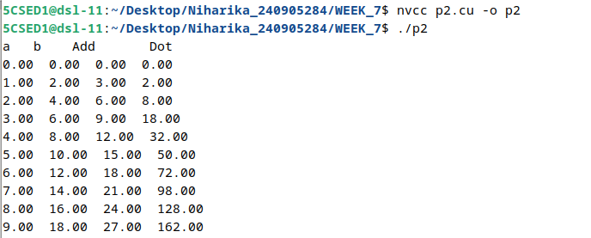

3. Implement a CUDA program to compute the Euclidean distance between two randomly initialized vectors A and B, each of length N. Keep the number of threads per block fixed at 256 and dynamically determine the number of blocks required to process all N elements.

#include <stdio.h>
#include <stdlib.h>
#include <math.h>
#include <cuda_runtime.h>

__global__ void distance(float *a, float *b, float *c, int n) {
int i = blockIdx.x * blockDim.x + threadIdx.x;
if(i < n)
c[i] = (a[i]-b[i])*(a[i]-b[i]);
}

int main() {
int N = 1000;
float *a,*b,*c,*d;
float sum=0;

a=malloc(N*sizeof(float));
b=malloc(N*sizeof(float));
c=malloc(N*sizeof(float));

for(int i=0;i<N;i++) {
a[i]=(float)rand()/RAND_MAX;
b[i]=(float)rand()/RAND_MAX;
}

cudaMalloc(&d,N*sizeof(float));
float *da,*db;
cudaMalloc(&da,N*sizeof(float));
cudaMalloc(&db,N*sizeof(float));

cudaMemcpy(da,a,N*sizeof(float),cudaMemcpyHostToDevice);
cudaMemcpy(db,b,N*sizeof(float),cudaMemcpyHostToDevice);

distance<<<(N+255)/256,256>>>(da,db,d);
cudaMemcpy(c,d,N*sizeof(float),cudaMemcpyDeviceToHost);

for(int i=0;i<N;i++) sum+=c[i];

printf("Euclidean Distance = %f\n",sqrt(sum));

cudaFree(da); cudaFree(db); cudaFree(d);
free(a); free(b); free(c);
return 0;
}

OUTPUT

4. Implement a program in CUDA to process a 1D array containing angles in radians to generate sine of the angles in the output array. Use appropriate function.

#include <stdio.h>
#include <cuda_runtime.h>
#include <math.h>

__global__ void sine(float *a, float *b, int n) {
int i = blockIdx.x * blockDim.x + threadIdx.x;
if(i < n)
b[i] = sinf(a[i]);
}

int main() {
int N = 10;
float a[10], b[10];
float *da,*db;

for(int i=0;i<N;i++)
a[i] = i * 0.5f;

cudaMalloc(&da,N*sizeof(float));
cudaMalloc(&db,N*sizeof(float));

cudaMemcpy(da,a,N*sizeof(float),cudaMemcpyHostToDevice);

sine<<<(N+255)/256,256>>>(da,db,N);

cudaMemcpy(b,db,N*sizeof(float),cudaMemcpyDeviceToHost);

for(int i=0;i<N;i++)
printf("%f -> %f\n",a[i],b[i]);

cudaFree(da);
cudaFree(db);
return 0;
}

OUTPUT
