WEEK-8
Programs using CUDA and CUDA-synchronization
Niharika Gawade
240905284
Roll no:30
CSE-D

1) Implement a program in CUDA which performs convolution operation on one dimensional input array N of size width using a mask array M of size mask_width to produce the resultant one-dimensional array P of size width.

#include <stdio.h>
#define MAX 100

__global__ void convolution(int *N, int *M, int *P, int width, int mw) {
int i = blockIdx.x * blockDim.x + threadIdx.x;
if (i < width) {
int sum = 0;
for (int j = 0; j < mw; j++) {
int k = i + j - mw / 2;
if (k >= 0 && k < width)
sum += N[k] * M[j];
}
P[i] = sum;
}
}

int main() {
int N[MAX], M[MAX], P[MAX], width, mw;
int *dN, *dM, *dP;
printf("Array width and mask width\n");
scanf("%d%d", &width, &mw);
printf("Array elements:");
for (int i = 0; i < width; i++) scanf("%d", &N[i]);
printf("Mask elements:");
for (int i = 0; i < mw; i++) scanf("%d", &M[i]);

cudaMalloc(&dN, width*sizeof(int));
cudaMalloc(&dM, mw*sizeof(int));
cudaMalloc(&dP, width*sizeof(int));

cudaMemcpy(dN,N,width*sizeof(int),cudaMemcpyHostToDevice);
cudaMemcpy(dM,M,mw*sizeof(int),cudaMemcpyHostToDevice);

convolution<<<(width+255)/256,256>>>(dN,dM,dP,width,mw);

cudaMemcpy(P,dP,width*sizeof(int),cudaMemcpyDeviceToHost);

for (int i = 0; i < width; i++) printf("%d ",P[i]);

cudaFree(dN); cudaFree(dM); cudaFree(dP);
}

OUTPUT
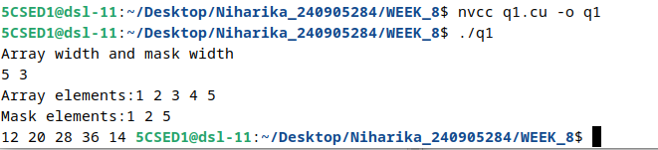

2) Implement a program in CUDA to perform odd even transposition sort in parallel.

#include <stdio.h>
#define MAX 100

__global__ void oddEven(int *a, int n, int phase) {
int i = 2 * (blockIdx.x * blockDim.x + threadIdx.x) + phase;
if (i < n-1 && a[i] > a[i+1]) {
int t=a[i];
a[i]=a[i+1];
a[i+1]=t;
}
}

int main() {
int a[MAX], n, *d;
printf("size: ");
scanf("%d",&n);
printf("elements: ");
for(int i=0;i<n;i++) scanf("%d",&a[i]);

cudaMalloc(&d,n*sizeof(int));
cudaMemcpy(d,a,n*sizeof(int),cudaMemcpyHostToDevice);

for(int i=0;i<n;i++) {
oddEven<<<(n+255)/256,256>>>(d,n,i%2);
cudaDeviceSynchronize();
}

cudaMemcpy(a,d,n*sizeof(int),cudaMemcpyDeviceToHost);

for(int i=0;i<n;i++) printf("%d ",a[i]);
cudaFree(d);
}

OUTPUT
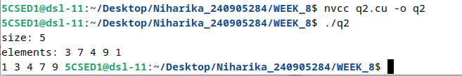

3) Implement a program in CUDA to perform parallel rank sort in parallel.

#include <stdio.h>
#define MAX 100

__global__ void rankSort(int *a, int *b, int n) {
int i = blockIdx.x * blockDim.x + threadIdx.x;
if(i<n) {
int rank=0;
for(int j=0;j<n;j++)
if(a[j]<a[i] || (a[j]==a[i] && j<i))
rank++;
b[rank]=a[i];
}
}

int main() {
int a[MAX], b[MAX], n, *da, *db;
printf("size: ");
scanf("%d",&n);
printf("elements: ");
for(int i=0;i<n;i++) scanf("%d",&a[i]);

cudaMalloc(&da,n*sizeof(int));
cudaMalloc(&db,n*sizeof(int));

cudaMemcpy(da,a,n*sizeof(int),cudaMemcpyHostToDevice);

rankSort<<<(n+255)/256,256>>>(da,db,n);

cudaMemcpy(b,db,n*sizeof(int),cudaMemcpyDeviceToHost);

for(int i=0;i<n;i++) printf("%d ",b[i]);

cudaFree(da); cudaFree(db);
}

OUTPUT
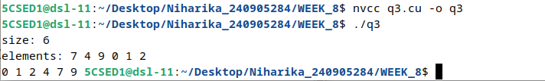

4) Implement a program in CUDA to count the number of times a given word is repeated in a sentence. (Use Atomic function)

#include <stdio.h>
#include <string.h>
#define MAX 1000

__global__ void countWord(char *s, char *w, int *count, int n, int m) {
int i = blockIdx.x * blockDim.x + threadIdx.x;

if(i <= n-m) {
int j;

for(j=0;j<m;j++)
if(s[i+j]!=w[j])
break;

if(j==m && (i==0 || s[i-1]==' ') &&
(i+m==n || s[i+m]==' ' || s[i+m]=='\n'))
atomicAdd(count,1);
}
}

int main() {
char s[MAX], w[MAX];
char *ds,*dw;
int *count, h=0;

printf("enter string: ");
fgets(s,MAX,stdin);

printf("enter word: ");
scanf("%s",w);

int n=strlen(s);
int m=strlen(w);

cudaMalloc(&ds,n);
cudaMalloc(&dw,m);
cudaMalloc(&count,sizeof(int));

cudaMemcpy(ds,s,n,cudaMemcpyHostToDevice);
cudaMemcpy(dw,w,m,cudaMemcpyHostToDevice);
cudaMemcpy(count,&h,sizeof(int),cudaMemcpyHostToDevice);

countWord<<<(n+255)/256,256>>>(ds,dw,count,n,m);

cudaMemcpy(&h,count,sizeof(int),cudaMemcpyDeviceToHost);

printf("Count = %d\n",h);

cudaFree(ds);
cudaFree(dw);
cudaFree(count);

return 0;
}

OUTPUT
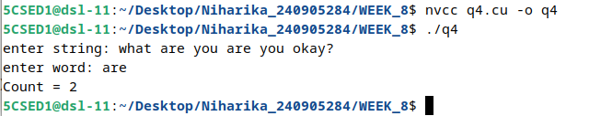

5) Implement a CUDA program that reads a string and replaces every vowel with '*". Use appropriate atomic function to replace the character with *.
Input String S: Parallel CUDA
Output String RS: P*r*ll*1 C*D*

#include <stdio.h>
#include <string.h>
#define MAX 1000

__global__ void replaceVowels(int *s, int n) {
int i = blockIdx.x * blockDim.x + threadIdx.x;

if(i < n) {
if(s[i]=='a'||s[i]=='e'||s[i]=='i'||s[i]=='o'||s[i]=='u'||
s[i]=='A'||s[i]=='E'||s[i]=='I'||s[i]=='O'||s[i]=='U')
atomicExch(&s[i], '*');
}
}

int main() {
char s[MAX];
int a[MAX];
int *d;
int n;

printf("Enter string: ");
fgets(s,MAX,stdin);

n = strlen(s);

for(int i=0;i<n;i++)
a[i] = s[i];

cudaMalloc(&d,n*sizeof(int));

cudaMemcpy(d,a,n*sizeof(int),cudaMemcpyHostToDevice);

replaceVowels<<<(n+255)/256,256>>>(d,n);

cudaMemcpy(a,d,n*sizeof(int),cudaMemcpy#include <stdio.h>
#include <string.h>
#define MAX 1000

__global__ void replaceVowels(int *s, int n) {
int i = blockIdx.x * blockDim.x + threadIdx.x;

if(i < n) {
if(s[i]=='a'||s[i]=='e'||s[i]=='i'||s[i]=='o'||s[i]=='u'||
s[i]=='A'||s[i]=='E'||s[i]=='I'||s[i]=='O'||s[i]=='U')
atomicExch(&s[i], '*');
}
}

int main() {
char s[MAX];
int a[MAX];
int *d;
int n;

printf("Enter string: ");
fgets(s,MAX,stdin);

n = strlen(s);

for(int i=0;i<n;i++)
a[i] = s[i];

cudaMalloc(&d,n*sizeof(int));

cudaMemcpy(d,a,n*sizeof(int),cudaMemcpyHostToDevice);

replaceVowels<<<(n+255)/256,256>>>(d,n);

cudaMemcpy(a,d,n*sizeof(int),cudaMemcpyDeviceToHost);

for(int i=0;i<n;i++)
printf("%c",(char)a[i]);

cudaFree(d);

return 0;
}DeviceToHost);

for(int i=0;i<n;i++)
printf("%c",(char)a[i]);

cudaFree(d);

return 0;
}

OUTPUT
